SWIPE FILE:

Of Proven Dentist Offers That Are Currently Working in the Market-Place Today.

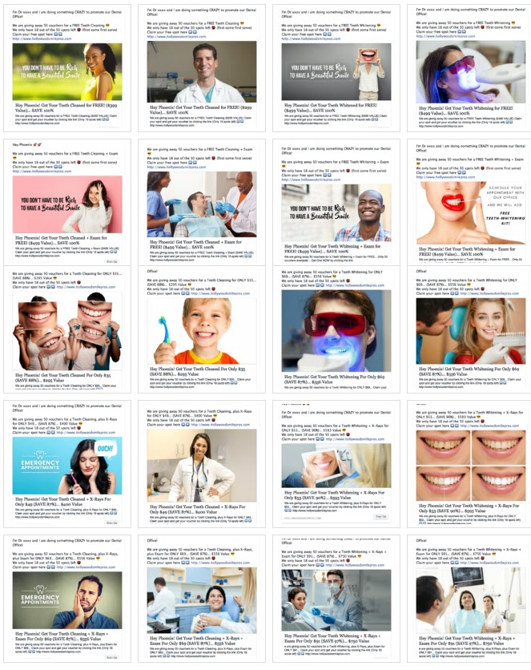

For a Free Training-Video On How This Works VISIT: www.DentalLeadConsulting.com/Info-Kit
Table of Content
(Click on description to be taken to section)

- First Off - Who Am I
- Goal of this Swipe-File
- Goal of Running a Special Offer
- What To Measure When Tracking Facebook-Ad Campaigns
- Money Math Example (10x Return-On-Investment)
- How To Work Out The “Lifetime Value” of a Patient
- Ideas To Think About
- Warning: Don’t Run Facebook Ads if...
- Ivan Notes on Special Offers
- Delivery System - How to Land 30-50 New Patients Per Month
- Where To Find Winning Offers
- Here Are Some Winning Offers (Thousands of Booked Appointments)
- Market Research - Combinations Used To Create Offers
- Sales Copy Formula for Facebook Ads
- SUMMARY of Facebook Offers Created

SWIPE FILE of “Free Offers” You Can Run… (8 Free Offers)

- OFFER 1: Free Teeth Cleaning (BONUS = Free Exam)
- OFFER 2: Free Teeth Cleaning (BONUS = Free X-Rays)
- OFFER 3: Free Teeth Whitening (BONUS = Free Exam)
- OFFER 4: Free Teeth Whitening (BONUS = Free X-Rays)
- OFFER 5: Free Teeth Cleaning + Exam (BONUS = Free X-Rays)
- OFFER 6: Free Teeth Cleaning + Exam (BONUS = Teeth Whitening Kit)
- OFFER 7: Free Teeth Whitening + Exam (BONUS = Free X-Rays)
- OFFER 8: Free Teeth Whitening + Exam (BONUS = Teeth Whitening Kit)

SWIPE FILE of “Discounted Offers” You Can Run… (12 Discounted Offers)

- OFFER 9: Teeth Cleaning (BONUS = Free Exam)... Was $295, Now Only $35
- OFFER 10: Teeth Cleaning (BONUS = Free X-Rays)... Was $295, Now Only $35
- OFFER 11: Teeth Whitening (BONUS = Free Exam)... Was $556, Now Only $69
- OFFER 12: Teeth Whitening (BONUS = Free X-Rays)... Was $556, Now Only $69
- OFFER 13: Teeth Cleaning + X-Rays (BONUS = Free Exam)... Was $400, Now Only $49
- OFFER 14: Teeth Cleaning + X-Rays (BONUS = $10 OFF)... Was $400, Now Only $49
- OFFER 15: Teeth Whitening + X-Rays (BONUS = Free Exam)... Was $593, Now Only $53
- OFFER 16: Teeth Whitening + X-Rays (BONUS = $10 OFF)... Was $593, Now Only $53
- OFFER 17: Teeth Cleaning + X-Rays + Exam (BONUS = Teeth Whitening)… $556, Now $69
- OFFER 18: Teeth Cleaning + X-Rays + Exam (BONUS = $10 OFF)... $556, Now Only $69
- OFFER 19: Teeth Whitening + X-Rays + Exam (BONUS = Teeth Cleaning)...$750, Now $91
- OFFER 20: Teeth Whitening + X-Rays + Exam (BONUS = $10 OFF)... Was $750, Now $91

SWIPE FILE of “Additional Offers” You Can Run… (13 Offers)

- OFFER 21 - Dental Implants
- OFFER 22 - Invisalign
- OFFER 23 - Cosmetic Dentistry
- OFFER 24 - Pre-Wedding Smile Consultation
- OFFER 25 - Orthodontics (Braces)
- OFFER 26 - Six Month Smiles (Clear Braces)
- OFFER 27 - Pediatric Dentistry
- OFFER 28 - Periodontics (Gum Health & Gum Disease)
- OFFER 29 - Wisdom Teeth Removal (Oral & Maxillofacial Surgeon)
- OFFER 30 - Meet the Dentist
- OFFER 31 - Sweepstakes/Contest/Raffle/Competition
- OFFER 32 - Dentures (Prosthodontist)
- OFFER 33 - Root Canal (Endodontist)

- Ivan Notes: On Running Facebook Campaigns
- WHAT TO DO NEXT – CHOOSE AN OFFER TO RUN
- Work Involved Running Facebook Ad Campaigns
- More Research on Dentist Ads Being Run in different Cities

BONUS SWIPE-FILE: Adverts from other Dentists… (from Facebook Library)

- Notes On Ads Being Run by Other Dental Practices (34 Examples)
- Free Offer examples being Run
- Discounted Offer examples being Run

- How To Create A “Marketing Calendar” (Includes: 12 Month Plan)
- My Risk Free Guarantee To You!
- In Closing
- My Contact Details

First Off - Who Am I



Hi, my name is Ivan

I own a Facebook Ad Agency and specialise in delivering new patients to dental practices.

I started off working in a family business where we manufactured and retailed kitchen and bedroom cabinets to the public.

I worked in that company for over a decade and expanded that business from 1 to 10 showrooms, and was responsible for all sales and marketing for that company.

From there I moved into the digital marketing space.

And for the past several years I have been helping small marketing agencies by building out lead generation websites and helping with SEO and have worked with digital agencies in 5 different countries.

And while working with these agencies, I was asked if there was a faster and more predictable way of bringing in new patients.

And for the past 18 months I have been studying Facebook Marketing in depth, and specialising in how to generate new patients specifically for Dental Practices.

With that in mind I have together this Swipe-File and hope you find it a useful resource to refer back to, that you can use to help market your own practice.

So Enjoy
Goal of This Swipe-File

This Bonus Swipe-File is for dental managers and dental owners.

It consists of dental special-offers that you can use to market your own practice and information on how to implement a Facebook Ads Campaign.

The goal is to show you what’s currently working, and for you to see which offers resonate with you, and to choose offers you wish to implement.

It’s a valuable resource, one that you can refer back to time and again.

These dental offers are responsible for thousands of booked appointments, and deliver new patients on autopilot when deployed correctly.

Why re-invent the wheel, when you can simply take what is already working and implement this into your own practice.

Instead of wasting money on trial and error, deploy what’s already working and profit in your own dental practice.

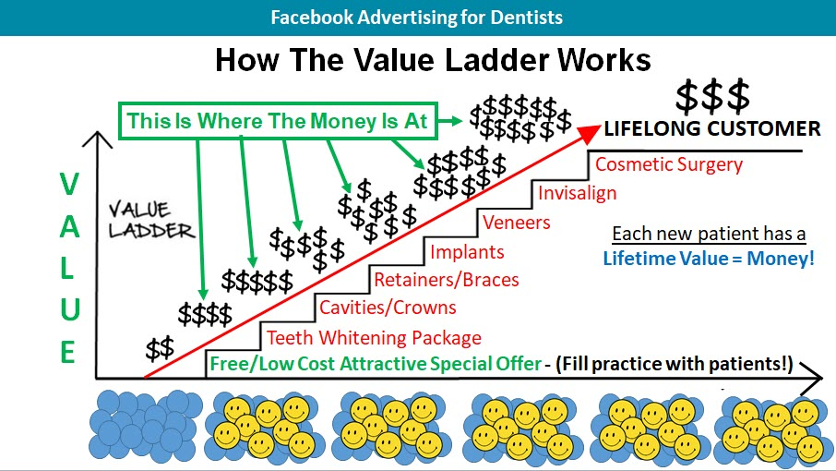

Bring new patients in with a proven “Irresistible Special Offer”

Goal of Running a Special Offer?

To flood your practice with a stream of new patients.

New patients you can now work with and make money from, by delivering your special offer and helping them with additional procedures they need to take care of NOW… plus by upselling monthly packages you offer.

Each patient you bring in is MONEY... Each patient has a LIFELONG VALUE!

You are not making huge profit on the initial special offer.... BUT you make ALL your money on additional procedures they need to take care of now and by selling continuity packages you offer.

Goal of running an offer is to get a 10x return on investment. (10x ROI) within a 30 day period.

Put $1 in on advertising and get $10 back every 30 days!

Example: Spend $2,500 on advertising and get back $25,000 in sales.

This is what we specialise in, running and managing facebooks campaigns for Dental Practices… Plus we offer a guarantee on our work!

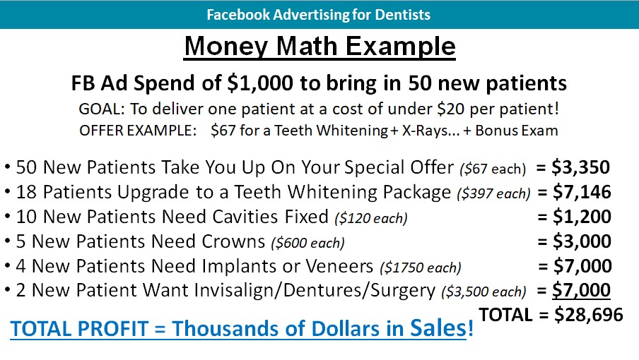
What To Measure When Tracking FB Ad Campaign

- You want to track how much you spent on your campaign.
- You want to measure how many patients came in on that special offer.
- You want to track how many of them did you help with additional One Time Procedures.
- Like: teeth cleaning, teeth whitening, x-rays, retainers, veneers, cavities, crowns, caps, braces, invisalign, implants, dentures, periodontics, pediatric dentistry, pre-wedding smiles, cosmetic dentistry etc.
- PLUS how many did you sign up to Packages and Recurring Services?
- That is the true indication of how much you made on a campaign!
- You want to know the Dollar Amount you brought in.
- Then compare the money spent vs the amount that came in.
- How much did you spend... and how much came in after the initial special offer with One Time Services + Recurring Programs.

Money Math Example on Facebook Ad Campaign

- Spent $2,500 total on campaign. (Ad budget + FB Agency fee)
- 50 Patients came in on the special offer… made $3,350
- One Time Services… made an additional $18,200
- Packages Sold (teeth whitening package)… made an additional $7,146
- TOTAL INCOME – on entire campaign $28,696… Successful

SUMMARY:

- $2,500 Ad Budget OUT.
- $3,350 IN on Special Offer + $18,200 IN on One-Time services + $7,146 IN on teeth whitening Package.
- Total Revenue Made = $28,696
- Return On Investment = $2,500 OUT… for… $31,950 IN
- RATE OF RETURN on money spent = 1,047%... (WOW)
- That’s a 10x return on money spent over 30 days.
- Compare that to parking your money in a bank at 5-7% interest over 12 months?
- Rinse and repeat campaigns… Grow your practice to capacity!

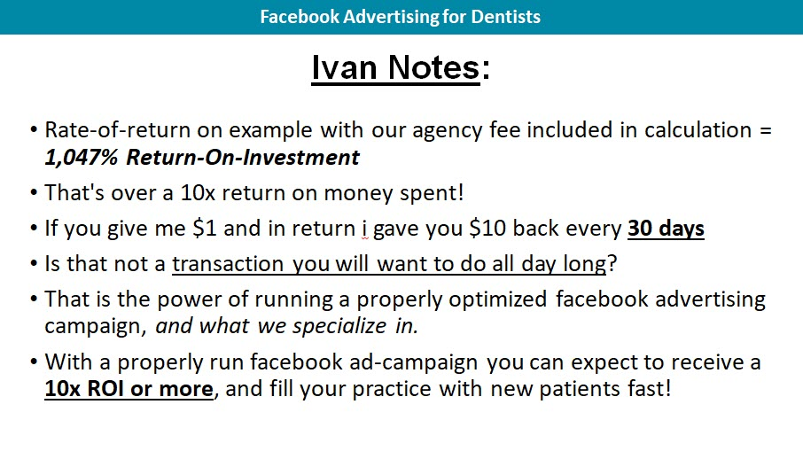

How to Work Out The “Lifetime Value” of a Patient

Simply pull 5-10 files of patients that have been with you for a few years, and add up how much each patient has spent with you.

Then average that out… And that is how much one patient is worth to you!

An important figure to know in your practice?

Example:

If I bring one patient into my practice, over a 3 year period, each patient is worth $4,000 to $8,000 in my practice.

That’s the average Lifetime Value of one patient.

Do you have this number?

EXAMPLE: Working Out Lifetime Value (LTV)

Let’s assume each patient stays with your practice for a period of 3 years

Patient 1: Spent $7350

- Teeth Cleaning - every year for 3 years
- X-rays done four times
- Teeth Whitening Package - 6 Sessions
- Infection treatment
- Tooth extractions
- Two dental implants (high transaction amount)

Patient 2: Spent $4,300

- Invisalign Braces
- X-Rays
- Teeth Cleaning
- Teeth Whitening Package - 6 Sessions

Patient 3: Spent $14,350

- Cosmetic Dentistry… (high transaction amount)
- 4 Dental Implants… (high transaction amount)
- Teeth Whitening – 6 sessions
- Dental Insurance – took you up on family package you offer… (recurring)

Patient 4: Spent $3,750

- Teeth cleaned – 2 years
- X-rays
- 2 Crowns

Patient 5: Spent $1,600

- Infection treatment
- 3 Cavities
- Tooth Extraction

Now all you need to do is, add them all up and divide it by 5… This will give you your Lifetime Value.

SUMMARY - Amount spent by each patient over 3 years

Patient 1 - $7,350
Patient 2 - $4,300
Patient 3 - $14,350
Patient 4 - $3,750
Patient 5 - $ 1,600

TOTAL = $31,350 (Money in from 5 patients)

$31,350 divided by 5 patients

= $6,270… This is the “Lifetime Value” of one patient in your practice!

With this number you now know that every time you sign up a new patient.
Over a 3 year period each patient will be worth $6,270 in your practice.

So all you have to now figure out is:
How many new patients you can afford to bring into your practice per month?
How much you are willing to spend on your monthly marketing budget?

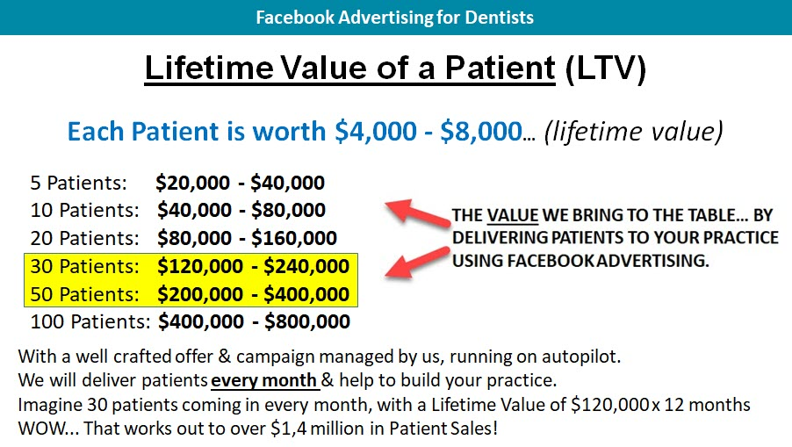

IDEAS TO THINK ABOUT

Ask yourself... How can you increase the “Lifetime Value” of each patient in your practice to increase your revenue?

- Examples of steps could be
- Monthly email newsletter, staying in front of existing patients & communicating monthly specials + showcasing work done with before and after pictures and discussing new procedures. (can set up one time)
- That’s known as Education Based Marketing.
- Secretary or manager can manually follow up with each patient, giving them a monthly courtesy call.
- Regular posts on your Facebook Business Page.
- Text messages sent every 2 weeks, informing of a special offer.
- Text messages sent daily reminding patients of booked appointments.
- Physical printed newsletters sent out once a month to patients.
- Postcard campaigns sent out every month.
- 3 Letter Marketing Campaigns advertising offers (with strong sales copy).
- Shock & Awe Box - given to new patient.
- Referral campaigns.
- Testimonial campaigns
- And Our Speciality... “Facebook Advertising Campaigns”

Increase Lifetime Value:

- If even just a few patients take you up on additional services.
- And you can increase lifetime value…. Example: increase by $800.
- And let’s say you have 300 patients in your practice.
- That’s an additional $240,000 in added revenue!
- Without having to find new patients… but simply working with your existing patients.

Point is... To know the “Lifetime Value” of each patient

- This allows you to determine how much you are able to spend to acquire new patients into your practice.
- Helps you to think about how you can increase Lifetime Value of each patient for more profits.
- QUESTION - What’s the "Lifetime Value" of YOUR PATIENT?
WARNING: Don’t Run Facebook Ads If…

You are expecting to make a lot of money on the initial Special Offer alone.
Then this will not work for you.

Or if you feel slighted or cheated or offended by offering a special offer.

If you have tried it your way and things are not working out or perhaps business is too slow.

Then take some time to learn what other successful dental practices are doing and mirror them.

Implement what they are doing.

This system is an exact duplicate of what other successful dental practices are doing to build their practice using Facebook Ads.

Facebook is the largest social media platform on earth with over 2.4 billion users…. And where all your patients hang out!

How many times do you or your staff visit Facebook today?

1 Billion People are on Facebook at any given time. With Facebooks Ads you can target patients in your immediate vicinity and also separate by age, gender, interests and get in front of your ideal patient.

With Facebook Advertising you can enter their Facebook feeds in the form of a Facebook Ad.

And with the use of an Irresistible Special Offer you can get in front of them and convert them into a stream of new patients fast.

I have put together a video explaining this process in more detail and explain the exact system being used.

If you have not yet had a chance to watch the video or if you want to watch it again, it’s less than 30 minutes and explains the exact process.

VISIT - www.DentalLeadConsulting.com/Info-Kit
Ivan Notes: On Special Offers

A Special Offer is a tool you use, to bring in a flood of new patients into your practice.

Once you have them, the majority of patients will stay with you for a period of time, and have a Lifetime Value that equals money.

Amateur’s try to make all their profits on just One Sale!

Professionals… use it as a tool to bring in new patients to fill up their practice and make ALL Their Profits by taking care of patients that need procedures now, plus by upselling patients on packages and continuity programs.

P.S. If you are not offering packages or monthly-quarterly programs or some type of continuity program. You need to implement one right away.

Create one where you offer something of value at a good price like teeth cleaning, teeth whitening, 6 month smiles, invisalign, veneer, braces payment plans or dental cover or family cover etc. that patients will take you up on.

It’s cash flow that will keep your business going. The more people that sign up to a monthly program the better you will do.

With a Special Offer you are delivering "upfront value" and the law of reciprocity kicks in.

You are now building up a relationship with new patients whereby they get to...Know, Like & Trust You.

And once you have given them upfront value. They will then be more inclined and receptive to taking you up on additional procedures.

You are also growing your LIST of patients you serve!

With all their contact details, and now have an audience you can communicate with on a regular basis.

Sending information about your practice via email and facebook posts. And you are also able to communicate additional specials you wish to offer.

You want to build an iron cage around them.

The way you do that is by having regular email newsletters (communication) going out to them every week or once a month.

(These can be automatic emails you set up one time and drip feed out to them)

You can also make use of printed newsletters that get delivered to your patient’s home. (Something physical)

In these emails and newsletters, you will share helpful tips and news on technology and happenings in your market. You will also highlight a happy patient every month with before and after pictures and explain the work you did for that patient.

Plus include and highlight a “Limited Special Offer” you have going for the month.

If you are doing all these things, and your competitors are not.

Who do you think patients will go to when they need work done?

They will go to YOU… because now you are communicating with them on a regular basis. You are providing value in the form of educational marketing, case studies and running regular specials.

You have built an iron cage around them making YOU the only option for dental work.

But first you need to have a SYSTEM in place to deliver new patients.

An automatic system - To bring in a predictable stream of new patients every month on autopilot.

Facebook Advertising Is That System!

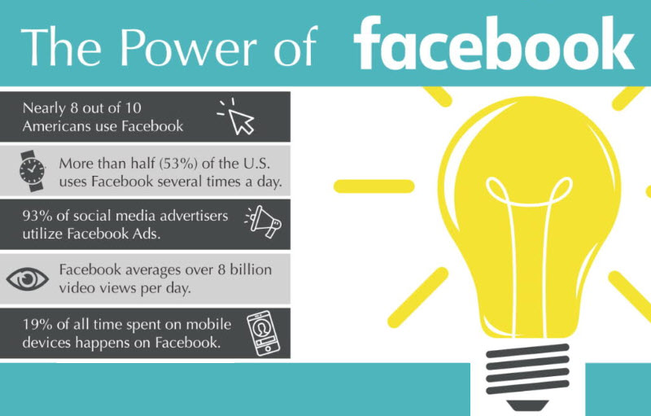

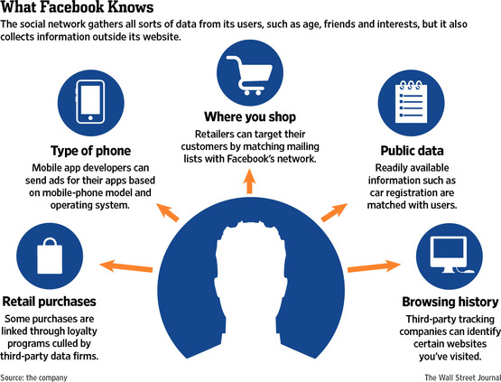
DELIVERY SYSTEM:
How to Land 30-50 Patients a Month!
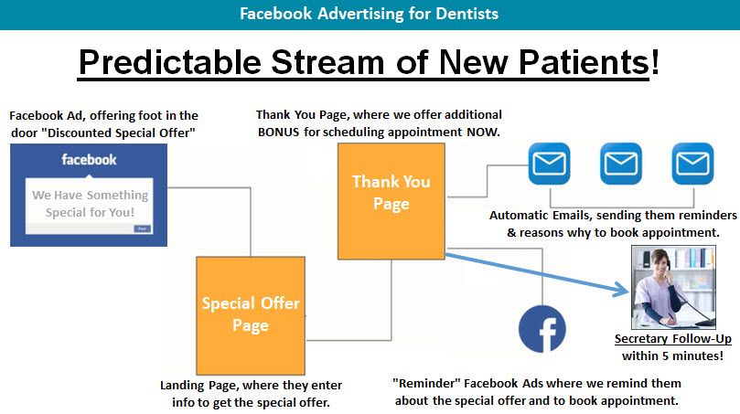

The whole strategy here is

- You run a Facebook Ad offering an “Irresistible Special Offer”… delivered to targeted people in your area, they click on the Ad and are taken to.
- Special Offer Page or Landing Page, where they fill out their information.
- They are then taken to a Thank You Page where you offer an “additional bonus” if they book an appointment in the next 5 minutes.
- And then you remind them with emails and retargeting FB Ads that we set up to go out automatically.
- PLUS you get your secretary to manually follow up.

And this system here... Is a complete system that will generate patients on autopilot.

It’s working for others and it will work for you, if you implement this.

It will BRING IN as many patients as you can handle, and fill your practice to capacity.

WHERE TO FIND WINNING OFFERS

“Special Offers Working For Other Dental Practices”

The fastest way to see what others are doing is to go to the website Groupon.com, and take a look at the offers being run there.

Another resource is to go to the Facebook Library, and take a look at competitor adverts and see what they are up to.

The great thing about Groupon is that you get to see the exact offer, PLUS you get to see how many people have purchased that offer.

So you can see exactly which offers are popular and which ones are not by the amount of people that purchased.

Then take those offers that are working and duplicate them for your Facebook Advertising campaigns.

By duplicating these offers and presenting them on Facebook, you will get a much better result and return because of the targeting we are able to implement, and the split testing we are able to perform within Facebook.

Another bonus is, you do not have to share the money that comes in with Groupon, you get to keep all of it… you have complete control.

Taking a look at Groupon is a trick many FB Ad Agency’s use to come up with those winning offers, and you are also able to search different cities within Groupon to see what’s working in your city.

No need to re-invent the wheel here… simply implement offers that are already working for others.

Here Are Some Winning Offers
(Summary of Offers found in Groupon by City)

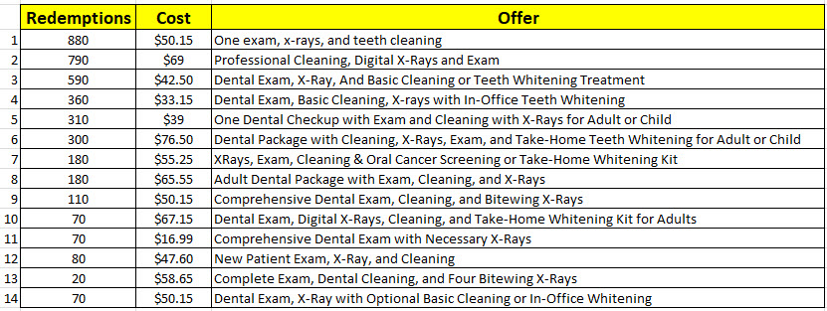
Chicago – Groupon Offers

As You Can See There Is a Common “Theme Here” With All Of Them.

The top performing Ads are all very similar.

Offer 1 – 880 patients took them up on a $50 package for:
(Exam, X-Rays + Teeth Cleaning)

Offer 2 - 790 patients took them up on a $69 package for:
(Cleaning, X-Rays + Exam)

Offer 3 - 590 patients took them up on a $42 package for:
(Dental Exam, X-Rays + Basic Cleaning or Teeth Whitening Treatment)

Offer 4 - 360 patients took them up on a $33 package for:
(Dental Exam, Basic Cleaning, X-rays with in-Office Teeth Whitening)

Offer 5 – 310 patients took them up on a $39 package for:
(Check-up with Exam and Cleaning with X-Rays for Adults or Child)

Offer 6 – 300 patients took them up on a $76 package for:
(Dental Package with Cleaning, X-Rays, Exam, and Take-Home Teeth
Whitening for Adult or Child.)
MARKET RESEARCH: Combinations Used

So based on this research, I would take this information and create a Facebook Advert offering the same.

- I can use a few different combinations and create different offers.
- Then split test them in Facebook, testing them side by side.
- Until I find the offers that deliver the most amount of patients.
- At the cheapest possible cost per lead.
- Then cancel non performing ads.
- And throw the entire Ad-Budget behind the top performing offers.

List To Work With (make combinations from these)

- Teeth Cleaning
- Teeth Whitening
- Exam
- X-Rays
- $10 OFF the initial Special Offer
- Teeth Whitening Kit
- Price Range between ($33 - $76)... or FREE

SALES COPY FORMULA
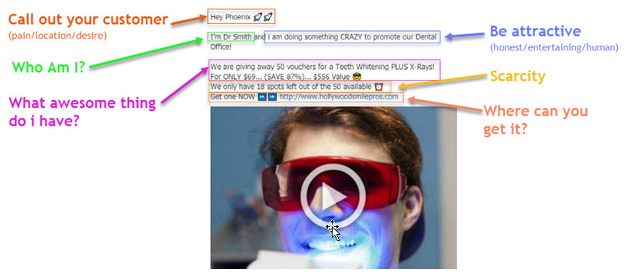

Summary of Facebook Offers Created
(Based off market research)
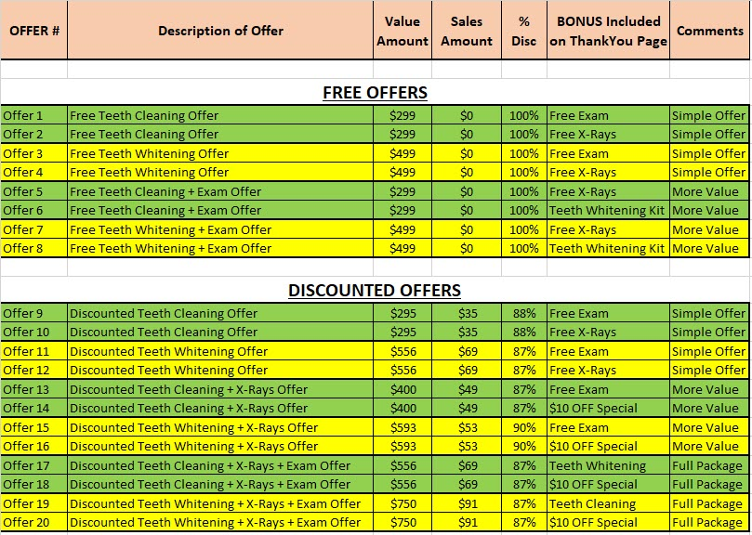

Any one of these Special Offers should work and bring in a flood of new patients into your practice... as per market research.

You can choose to run a discounted offer, or even a free offer.

We then take that offer and create a Facebook Advert, like examples below.

And run that advert to targeted people in your area and flood your practice with new patients.

COLLECTION OF 20 OFFERS YOU CAN RUN TODAY!

FREE SPECIAL OFFER EXAMPLES

FREE TEETH CLEANING OFFERS
BONUS = Free Exam or X-Rays

OFFER 1: Free Teeth Cleaning (BONUS = Free Exam)

Main Offer: Teeth Cleaning.. Was $299, Now FREE (Save 100%)

Thank You Page Offer: Free Exam if you schedule with office in next 5 minutes

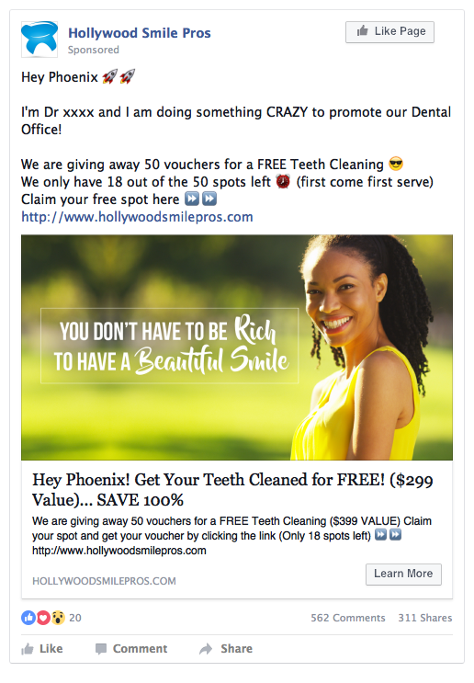
News Feed (PC display) Mobile (display)
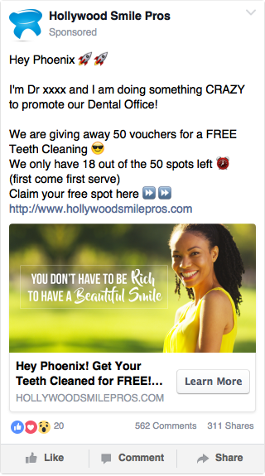

\

OFFER 2: Free Teeth Cleaning (BONUS = Free X-Rays)

Main Offer: Teeth Cleaning.. Was $299, Now FREE (Save 100%)

Thank You Page Offer: Free Exam if you schedule with office in next 5 minutes

News Feed (PC display) Mobile (display)
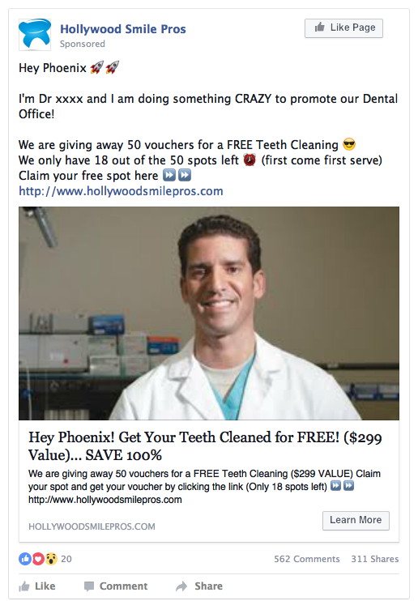
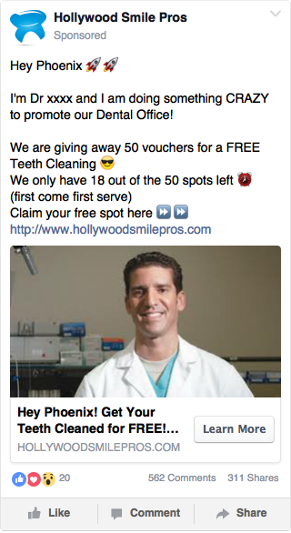

FREE TEETH WHITENING OFFERS
BONUS = Free Exam or X-Rays

OFFER 3: Free Teeth Whitening (BONUS = Free Exam)

Main Offer: Teeth Whitening.. Was $499, Now FREE (Save 100%)

Thank You Page Offer: Free Exam if you schedule with office in next 5 minutes

News Feed (PC display) Mobile (display)
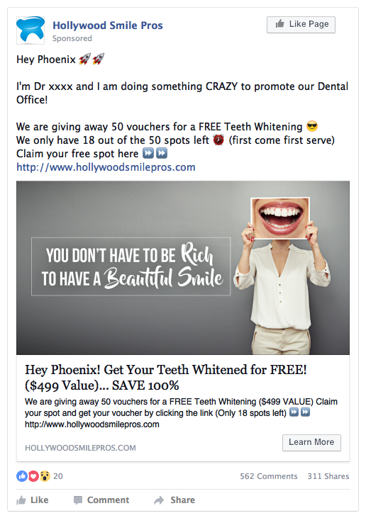
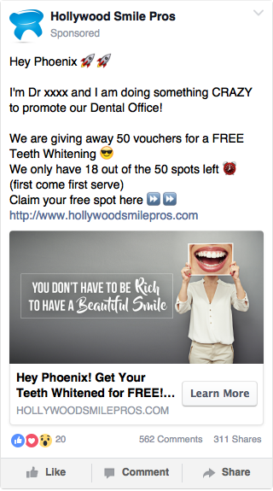

OFFER 4: Free Teeth Whitening (BONUS = Free X-Rays)

Main Offer: Teeth Whitening.. Was $499, Now FREE (Save 100%)

Thank You Page Offer: Free X-Rays if you schedule with office in next 5 minutes.

News Feed (PC display) Mobile feed (display)
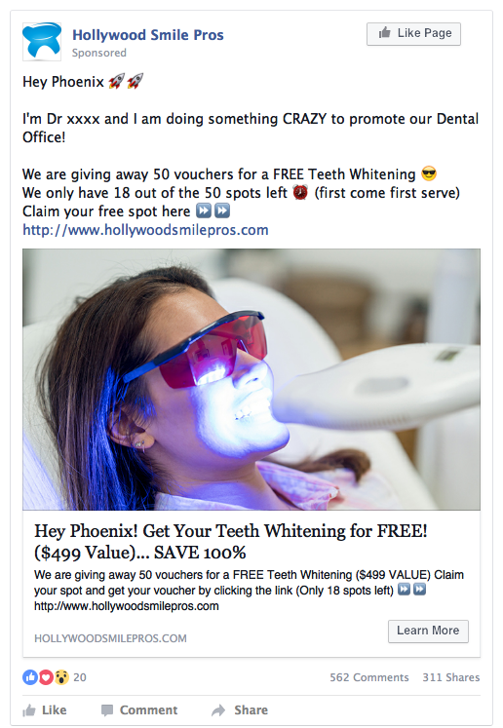
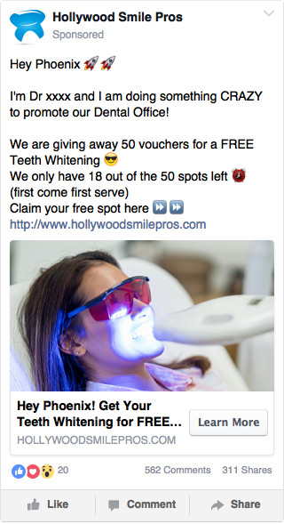

FREE TEETH CLEANING + EXAM OFFERS
BONUS = Free X-Rays or Teeth Whitening Kit

OFFER 5: Free Teeth Cleaning + Exam (BONUS = Free X-Rays)

Main Offer: Teeth Cleaning + Exam... Was $399, Now FREE (Save 100%)

Thank You Page Offer: Free X-Rays if you schedule with office in next 5 minutes

News Feed (PC display) Mobile (display)
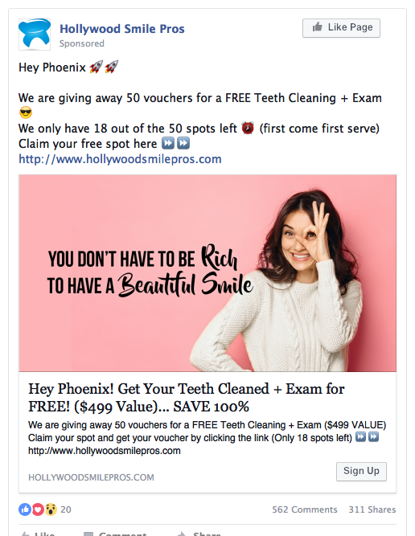
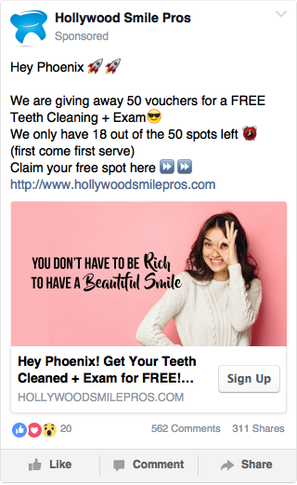

OFFER 6: Free Teeth Cleaning + Exam (BONUS = Teeth Whitening Kit)

Main Offer: Teeth Cleaning + Exam.. Was $399, Now FREE (Save 100%)

Thank You Page Offer: Free Teeth Whitening Kit, if you schedule with office in next 5 minutes

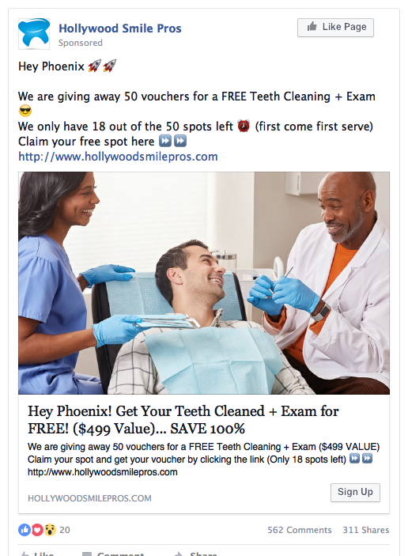
News Feed (PC display) Mobile (display)
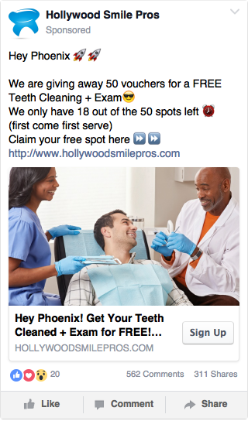

FREE TEETH WHITENING + EXAM OFFERS
BONUS = Free X-Rays or Teeth Whitening Kit

OFFER 7: Free Teeth Whitening + Exam (BONUS = Free X-Rays)

Main Offer: Teeth Whitening + Exam.. Was $499, Now FREE (Save 100%)

Thank You Page Offer: Free X-Rays if you schedule with office in next 5
Minutes

News Feed (PC display) Mobile (display)
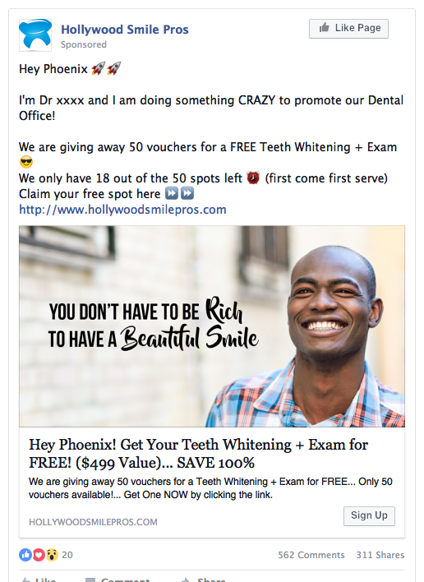
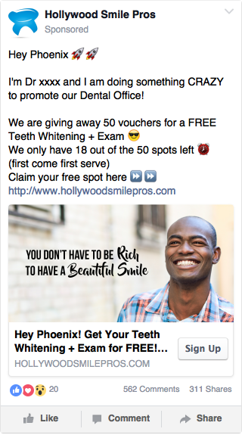

OFFER 8: Free Teeth Whitening + Exam (BONUS = Teeth Whitening Kit)

Main Offer: Teeth Whitening + Exam.. Was $399, Now FREE (Save 100%)

Thank You Page Offer: Free Teeth Whitening Kit, if you schedule with office in next 5 minutes

News Feed (PC display) Mobile (display)
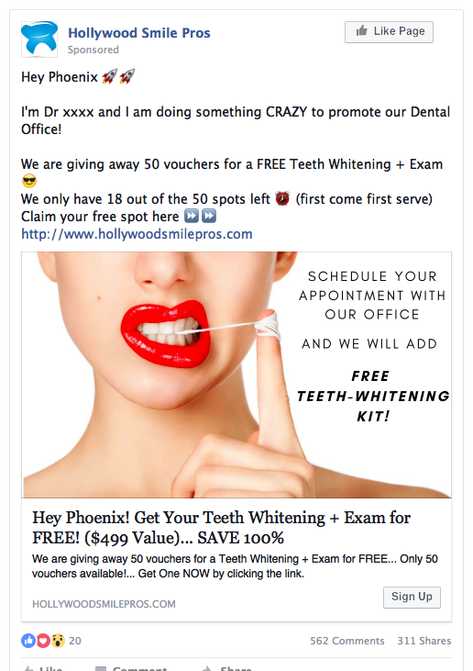
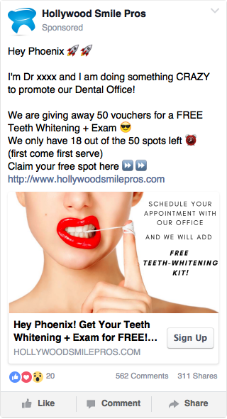

DISCOUNTED SPECIAL OFFER EXAMPLES

DISCOUNTED TEETH CLEANING OFFERS
BONUS = Free Exam or X-Rays

OFFER 9: Teeth Cleaning (BONUS = Free Exam)

Main Offer: Teeth Cleaning.. Was $295, Now Only $35 (Save 88%)

Thank You Page Offer: Free Exam if you schedule with office in next 5 minutes

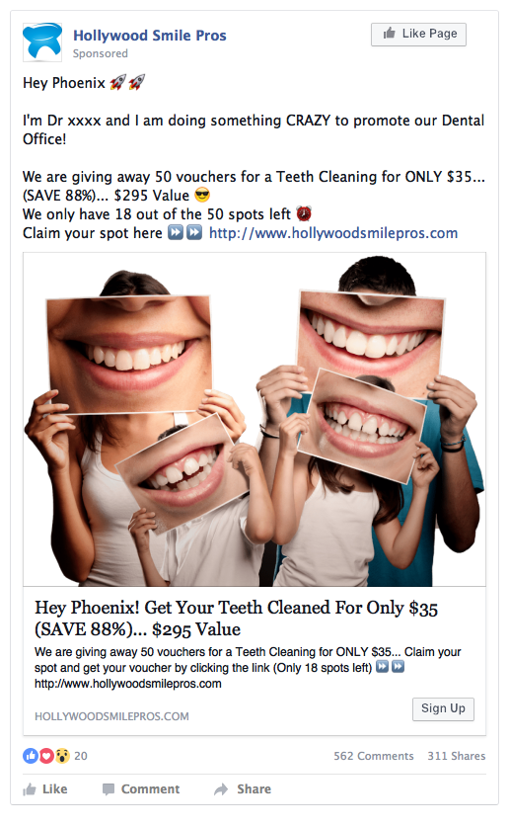
News Feed (PC display) Mobile feed (display)
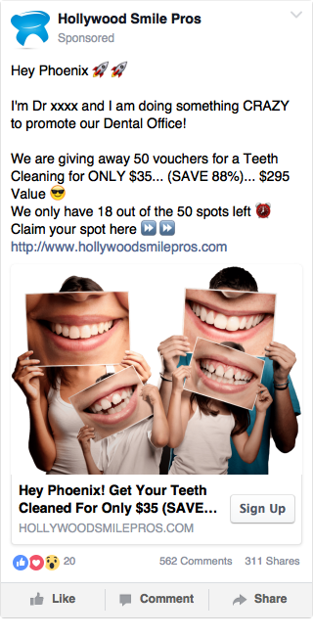

OFFER 10: Teeth Cleaning (BONUS = Free X-Rays)

Main Offer: Teeth Cleaning.. Was $295, Now Only $35 (Save 88%)

Thank You Page Offer: Free X-Rays if you schedule with office in next 5 minutes.

News Feed (PC display) Mobile feed (display)
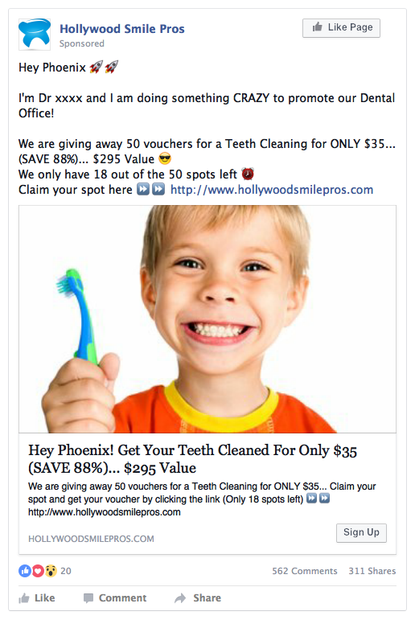
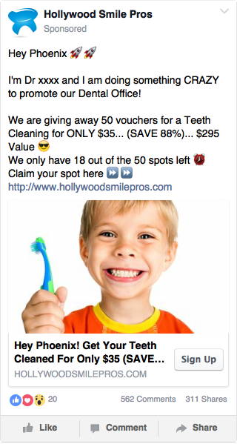

DISCOUNTED TEETH WHITENING OFFERS
BONUS = Free Exam or X-Rays

OFFER 11: Teeth Whitening (BONUS = Free Exam)

Main Offer: Teeth Whitening.. Was $556, Now Only $69 (Save 87%)

Thank You Page Offer: Free Exam if you schedule with office in next 5 minutes

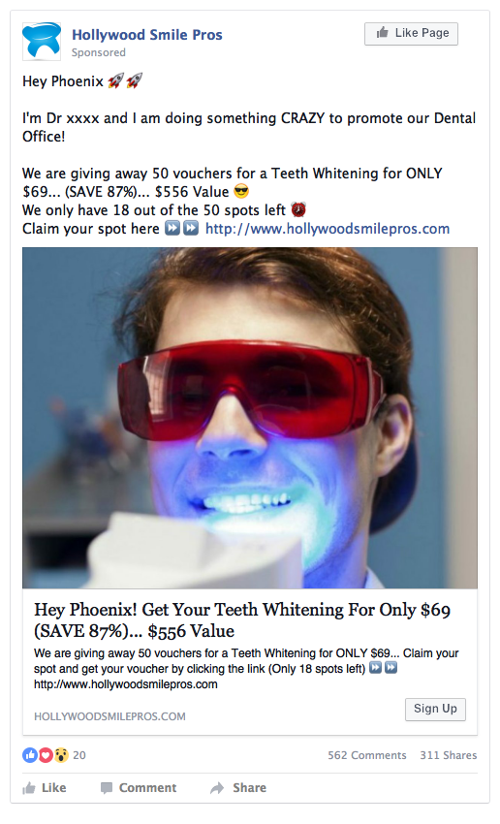
News Feed (PC display) Mobile feed (display)

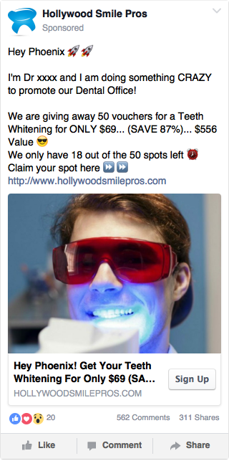

OFFER 12: Teeth Whitening (BONUS = Free X-Rays)

Main Offer: Teeth Whitening.. Was $556, Now Only $69 (Save 87%)

Thank You Page Offer: Free X-Rays if you schedule with office in next 5 minutes.

News Feed (PC display) Mobile feed (display)
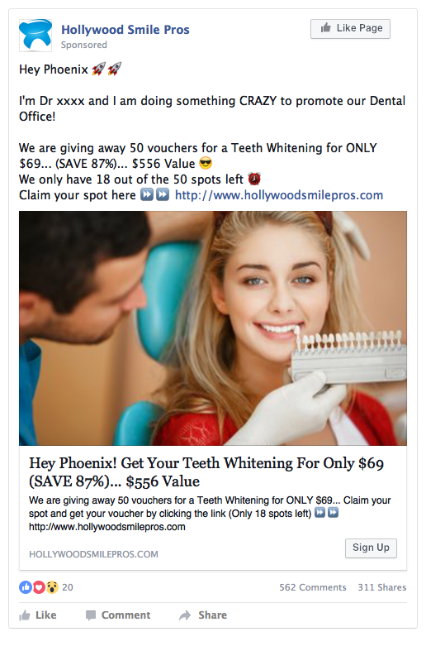
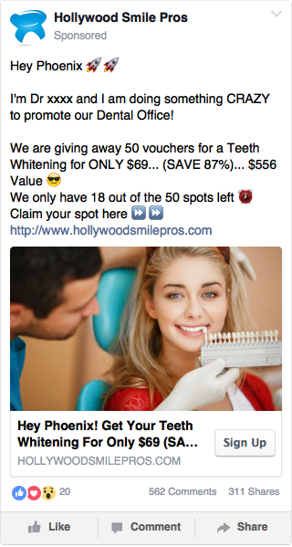

DISCOUNTED TEETH CLEANING + X-RAYS OFFERS
BONUS = Free Exam or $10 OFF

OFFER 13: Teeth Cleaning + X-Rays (BONUS = Free Exam)

Main Offer: Teeth Cleaning + X-Rays.. .. Was $400, Now Only $49 (Save 87%)

Thank You Page Offer: Free Exam, if you schedule with office in next 5 minutes

News Feed (PC display) Mobile feed (display)
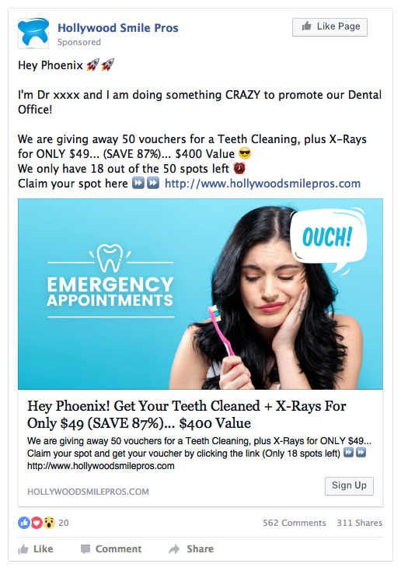
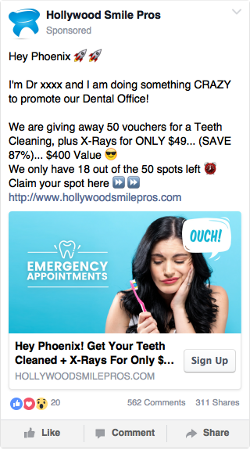

OFFER 14: Teeth Cleaning + X-Rays (BONUS = $10 OFF)

Main Offer: Teeth Cleaning + X-Rays.. .. Was $400, Now Only $49 (Save 87%)

Thank You Page Offer: Get an Addition $10 off on Special… Was $49, Now Only $39 if you schedule with office in next 5 minutes.

News Feed (PC display) Mobile feed (display)
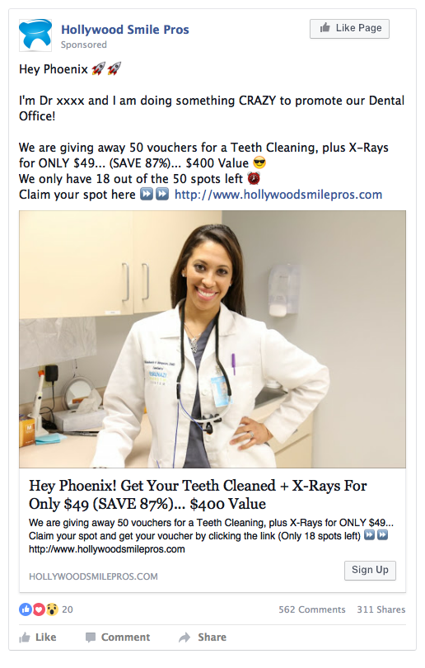
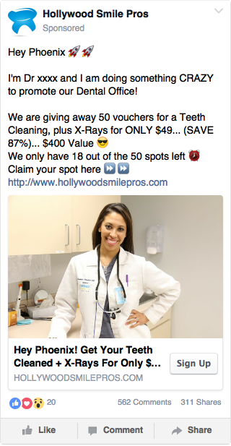

DISCOUNTED TEETH WHITENING + X-RAYS OFFERS
BONUS = Free Exam or $10 OFF

OFFER 15: Teeth Whitening + X-Rays (BONUS = Free Exam)

Main Offer: Teeth Whitening + X-Rays Was $593, Now Only $53 (90% Discount)

Thank You Page Offer: Free Exam, if you schedule with office in next 5 minutes

News Feed (PC display) Mobile feed (display)
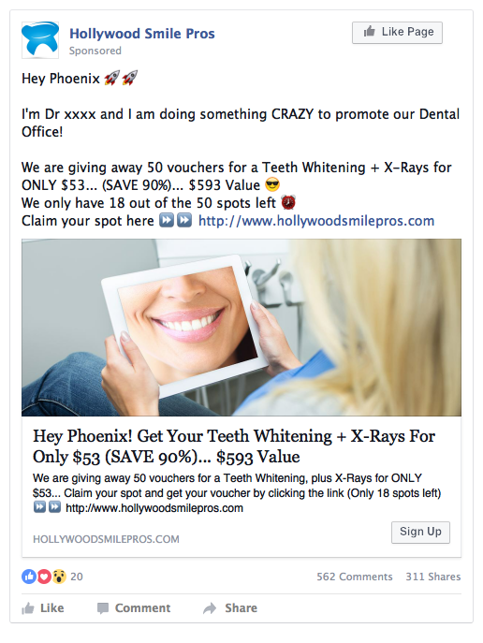
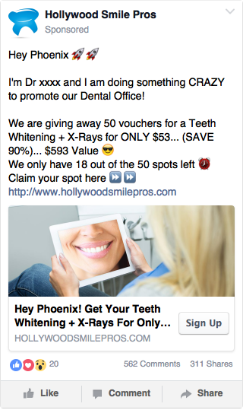

OFFER 16: Teeth Whitening + X-Rays (BONUS = $10 OFF)

Main Offer: Teeth Whitening + X-Rays Was $593, Now Only $53 (90% Discount)

Thank You Page Offer: Extra $10 off on Special… Was $53, Now Only $43 if you schedule with office in next 5 minutes.

News Feed (PC display) Mobile feed (display)
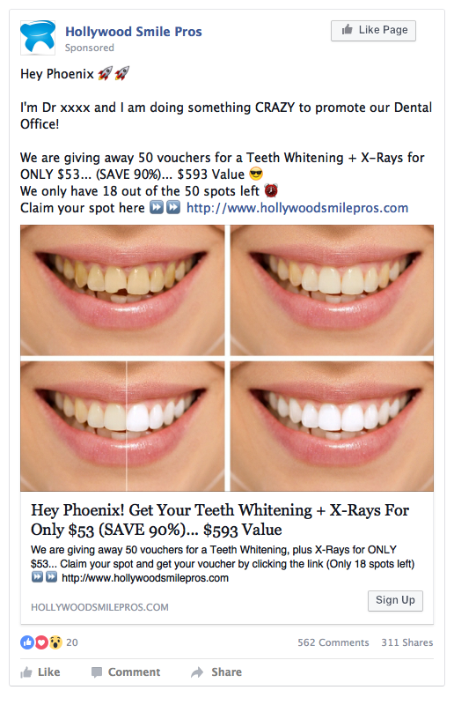
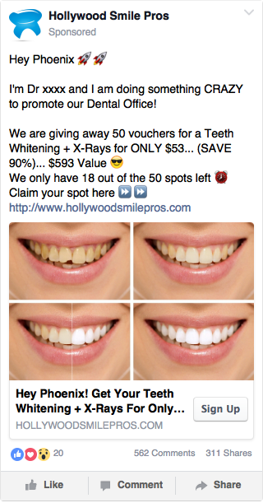
DISCOUNTED TEETH

CLEANING + X-RAYS + EXAM OFFERS
BONUS = Free Teeth Whitening or $10 OFF

OFFER 17: Teeth Cleaning + X-Rays + Exam (BONUS = Teeth Whitening)

Main Offer: Teeth Cleaning + X-Rays + Exam… Was $556, Now Only $69, (87 % Discount)

Thank You Page Offer: Free Teeth Whitening, if you schedule with office in next 5 minutes

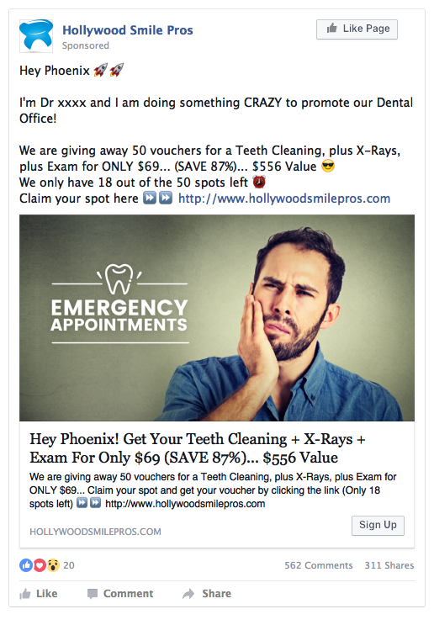
News Feed (PC display) Mobile feed (display)

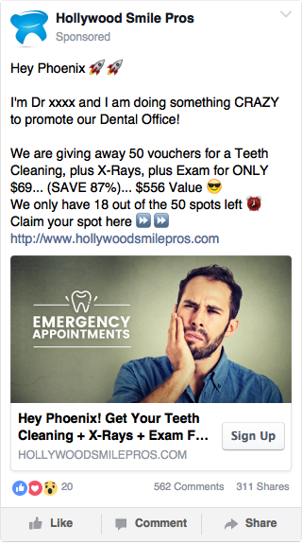

OFFER 18: Teeth Cleaning + X-Rays + Exam (BONUS = $10 OFF)

Main Offer: Teeth Cleaning + X-Rays + Exam… Was $556, Now Only $69, (87 % Discount)

Thank You Page Offer: Extra $10 off on Special… Was $69, Now Only $59 if you schedule with office in next 5 minutes.

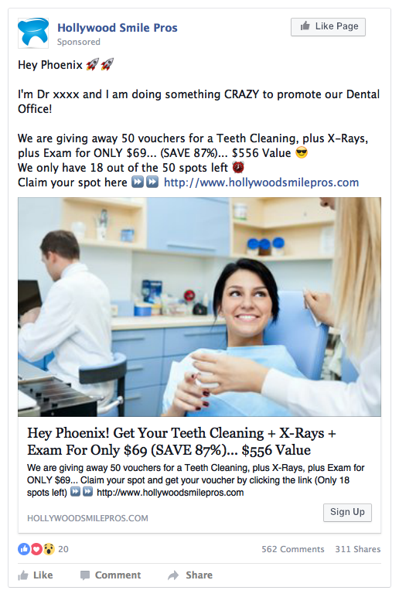
News Feed (PC display) Mobile feed (display)
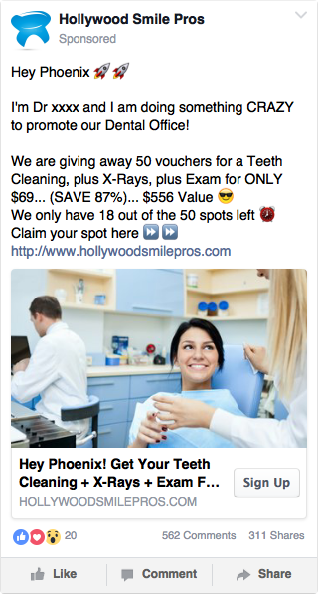

DISCOUNTED TEETH WHITENING + X-RAYS + EXAM OFFERS
BONUS = Free Teeth Cleaning or $10 OFF

OFFER 19: Teeth Whitening + X-Rays + Exam (BONUS = Teeth Cleaning)

Main Offer: Teeth Whitening + X-Rays + Exam… Was $750, Now Only $91 (87% Discount)

Thank You Page Offer: Free Teeth Cleaning, if you schedule with office in next 5 minutes

News Feed (PC display) Mobile feed (display)
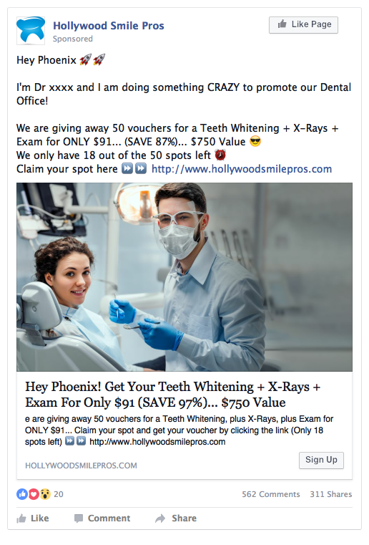
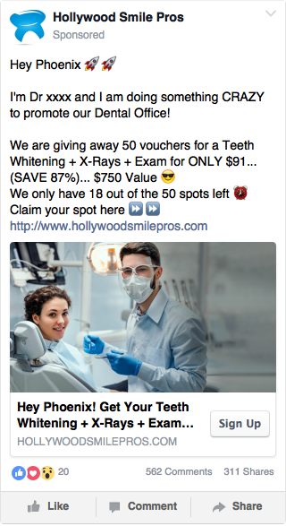

OFFER 20: Teeth Whitening + X-Rays + Exam (BONUS = $10 OFF)

Main Offer: Teeth Whitening + X-Rays + Exam… Was $750, Now Only $91 (87% Discount)

Thank You Page Offer: Extra $10 off on Special… Was $91, Now Only $81 if you schedule with office in next 5 minutes.

News Feed (PC display) Mobile feed (display)
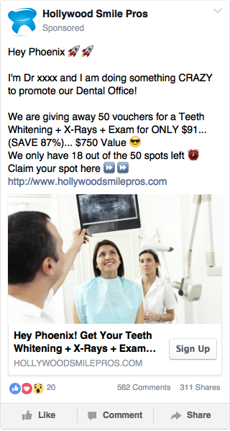
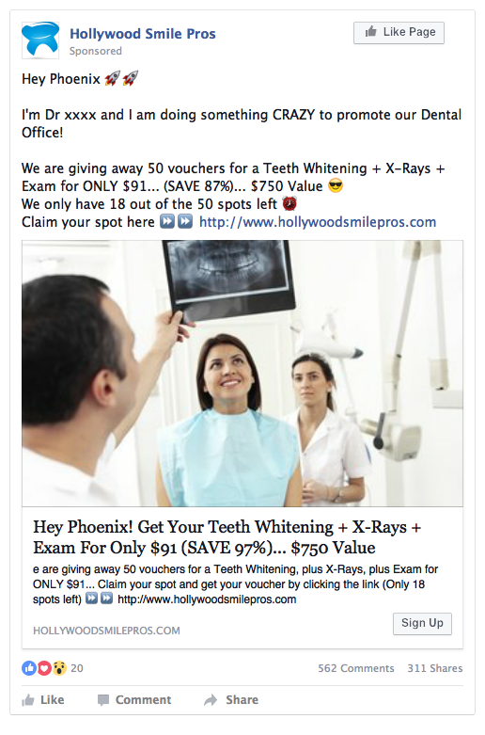

ADDITIONAL OFFERS YOU CAN RUN

OFFER 21: Dental Implants Consultation
(BONUS= Free X-Rays or Gift)

Main Offer: Dental Implant Consultation, Was $593 (100% Discount)

Thank You Page Offer: Free X-Ray/Gift, if you schedule in next 5 minutes.
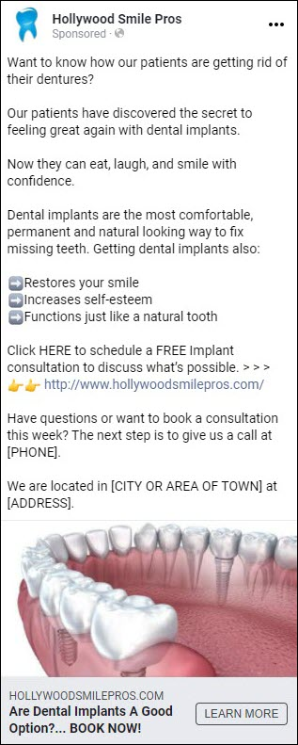

OFFER 22: Invisalign Exam (BONUS = Free X-Rays or Gift)

Main Offer: Invisalign Free Exam, Was $593 (100% Discount)

Thank You Page Offer: Free X-Ray/Gift, if you schedule in next 5 minutes.

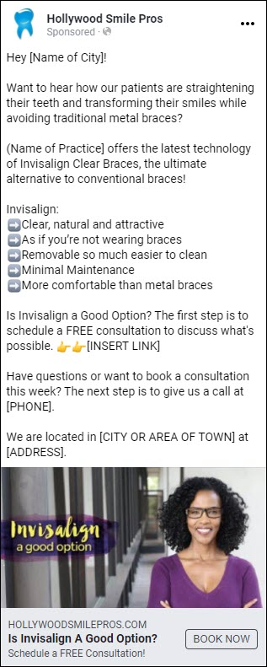

OFFER 23: Cosmetic Dentistry Exam (BONUS = Free X-Rays or Gift)

Main Offer: Cosmetic Dentistry Free Exam, Was $593 (100% Discount)

Thank You Page Offer: Free X-Ray/Gift, if you schedule in next 5 minutes.

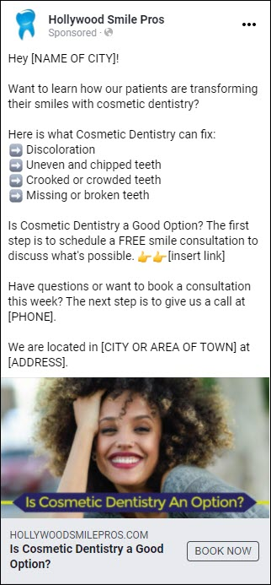

OFFER 24: Pre-Wedding Smile Consultation
(BONUS: Free X-Rays or Teeth Whitening Kit)

Main Offer: FREE Pre-Wedding SMILE Evaluation, Was $593 (100% Discount)

Thank You Page Offer: Free X-Rays or Teeth Whitening Kit, if you schedule now.

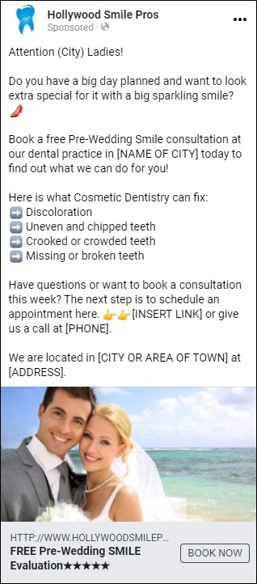

OFFER 25: Orthodontics (Braces) Consultation
(BONUS = Free X-Rays or Gift)

Main Offer: Orthodontics FREE Evaluation, Was $593 (100% Discount)

Thank You Page Offer: Free X-Ray/Gift, if you schedule in next 5 minutes.

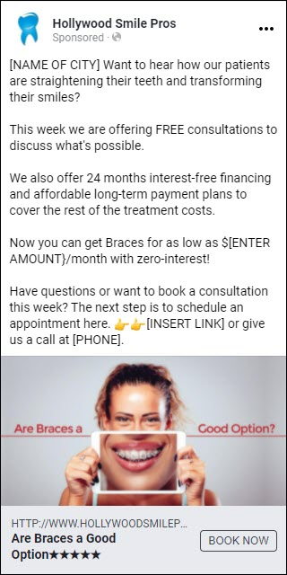

OFFER 26: Six Month Smiles Exam (Clear Braces)
(BONUS = Free X-Rays or Gift)

Main Offer: Clear Braces Free Exam, Was $593 (100% Discount)

Thank You Page Offer: Free X-Ray/Gift, if you schedule in next 5 minutes.

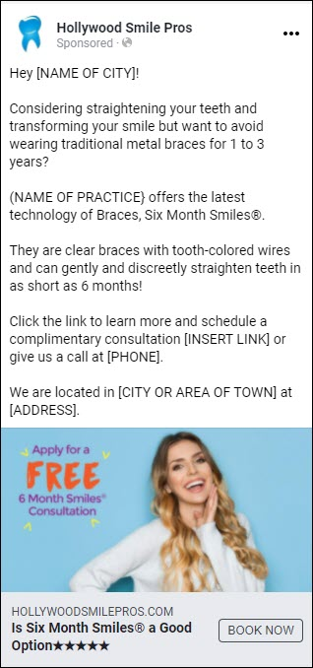

OFFER 27: Pediatric Dentistry (BONUS = Free X-Rays or Gift)

Main Offer: Pediatric Free Exam, Was $593 (100% Discount)

Thank You Page Offer: Free X-Rays/Toy, if you schedule in next 5 minutes.

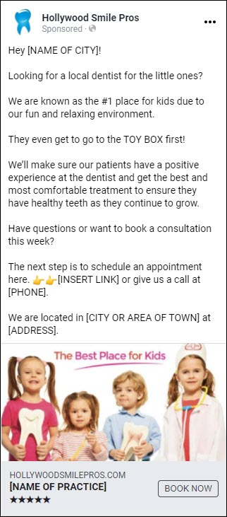

OFFER 28: Periodontics Exam (Gum Health & Gum Disease)
(BONUS = Free X-Rays or Gift)

Main Offer: Periodontics Free Exam, Was $593 (100% Discount)

Thank You Page Offer: Free X-Ray/Gift, if you schedule in next 5 minutes.

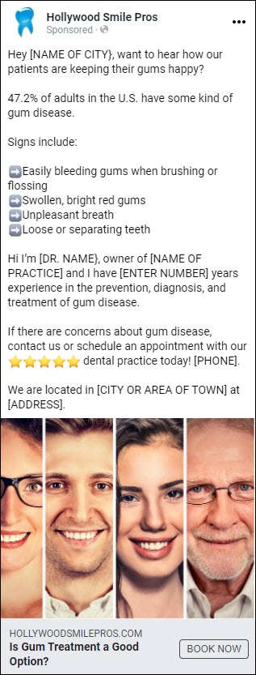

OFFER 29: Oral Surgery Exam (BONUS = Free X-Rays or Gift)

Main Offer: Oral Surgery Free Exam, Was $593 (100% Discount)

Thank You Page Offer: Free X-Ray/Gift, if you schedule in next 5 minutes.

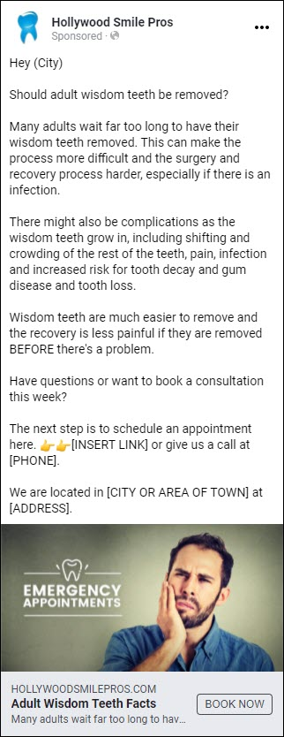

OFFER 30: Meet the Dentist (BONUS = Free X-Rays or Gift)

Main Offer: Meet the Dentist Free Exam, Was $593 (100% Discount)

Thank You Page Offer: Free X-Ray/Gift, if you schedule in next 5 minutes.

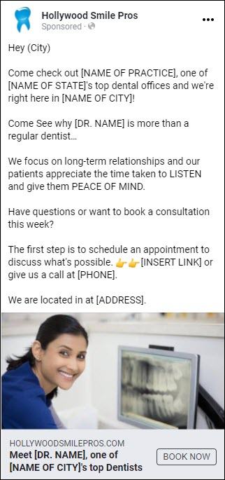

OFFER 31: Sweepstakes/Contest/Raffle/Competition
(BONUS = Free X-Rays or Gift)

Main Offer: Sweepstakes/Contest/Raffle/Competition

Thank You Page Offer: Free X-Ray/Gift, if you schedule in next 5 minutes.
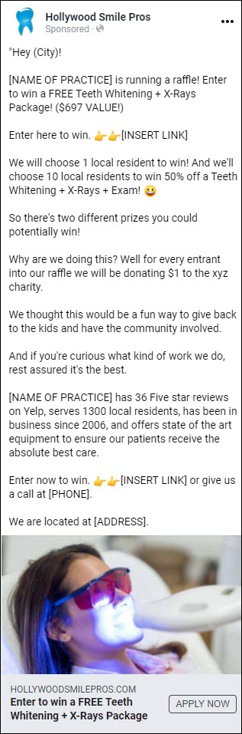

OFFER 32: Dentures Consultation (BONUS = Free X-Rays or Gift)

Main Offer: Dentures Free Exam, Was $593 (100% Discount)

Thank You Page Offer: Free X-Ray/Gift, if you schedule in next 5 minutes

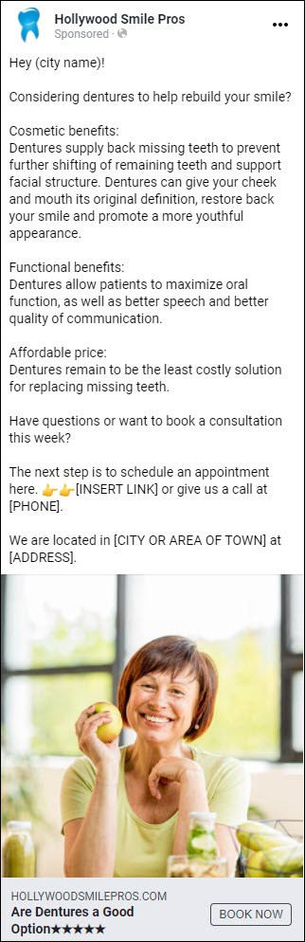

OFFER 33: Endodontist Exam (Root Canal & Oral Pain)
(BONUS = Free X-Rays or Gift)

Main Offer: Root Canal Free Exam, Was $593 (100% Discount)

Thank You Page Offer: Free X-Ray/Gift, if you schedule in next 5 minutes
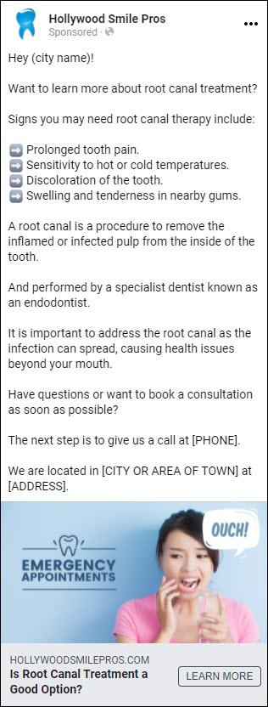

Ivan Notes: On Running FB Campaigns

These examples are all combinations, very similar to the ads we took a look at and will work. Simply decide on one that you would like to run and let’s implement a Facebook Ads Campaign for your practice.

You can also come up with your own combinations and decide on the price point you wish to use. As per the research popular price points are anywhere from $33 -$97. These prices are resonating within the market.

You can also decide on a Free Offer as per my examples, if you wish to bring in new patients even faster.

We will run your offer plus create variations of that offer, and run them side by side in Facebook and do a Split Test to see which ones convert the best at the lowest price.

Then we find the Winning Offer, we cancel the others and run with that winning advert and put the entire Ad Budget behind the winning offer.

When testing new offers you do not need to have a large budget. You can literally spend $1,000 to split test adverts and audiences and Facebook will very quickly tell us which ones are going to work.

The adverts I have supplied are all you need to test with.

Once you have the adverts dialled in and running properly, they will deliver as many patients as you need.

We will then know the exact cost to bring in one patient.

And you can then decide how many new patients you want to bring in per month by increasing or decreasing your ad spend.

We can also get creative and test different offers you may have in mind.

We would love to set this up for you… If interested go ahead and schedule a free call with me to discuss how we can help.

WHAT TO DO NEXT:

PICK ONE: Take a look at the offers and “PICK ONE xx OFFER” you would like us to implement for you. xxxxx

GOAL – To bring in patients using a $1,000 Ad Budget & deliver patients at the cheapest possible cost. Xxx xx

MONEY BACK GUARANTEE – I guarantee at a bare……. minimum to bring in patients to the value of what you spend with us… If not I will refund you the difference! ..

BOOK A CALL: Schedule a call with me by visiting my. calendar booking page... (Click the link below) …..….…

www.DentalLeadConsulting.com/Private-Consultations

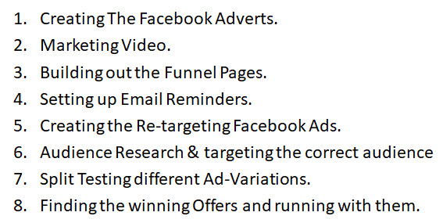
Work Involved Running a Proper FB Ads Campaign

More Research: Groupon Examples
From different cities... All the same!

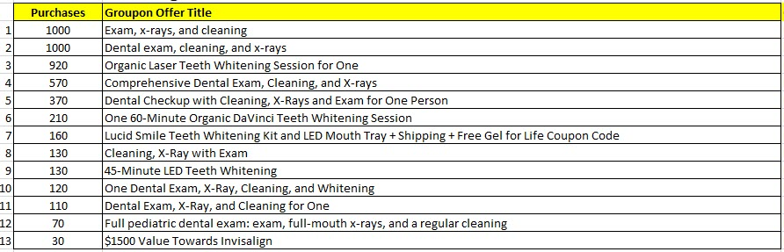
Las Vegas Offers

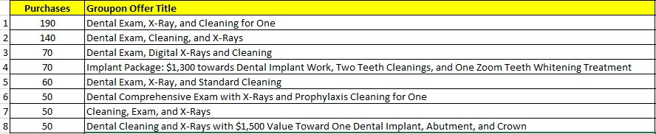
Houston Offers

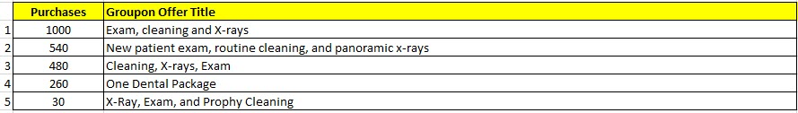
Orlando Offers

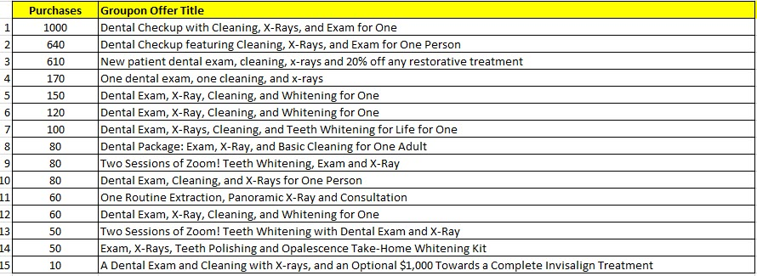
Dallas Offers

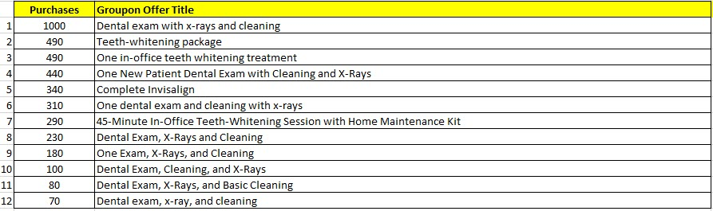
San Diego Offers

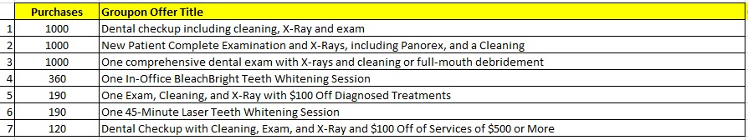
Tampa-Bay Area Offers

Bonus Swipe File – Ads from other Dentists
From Facebook Library (34 Examples)

Note: These are Ads currently being run by different dental practices. I wanted to show you real life examples.

They are all spending money on these Ads because they are generating patients and booked appointments.

On many of the Ads I found, they are not following our proven formula.

- Offering a very specific Special Offer
- Using persuasive Sales Copy
- Including a Video in the advert
- Sending them to a Landing Page, to capture contact details
- Then directing them to a Thank-You Page, offering another bonus if they take action in the next 5 minutes by scheduling an appointment.

But have also found examples of dental practices doing it correctly.

THIS IS EXCITING!

- Because it means very few are doing it properly.
- Which equals Huge Opportunity for YOU

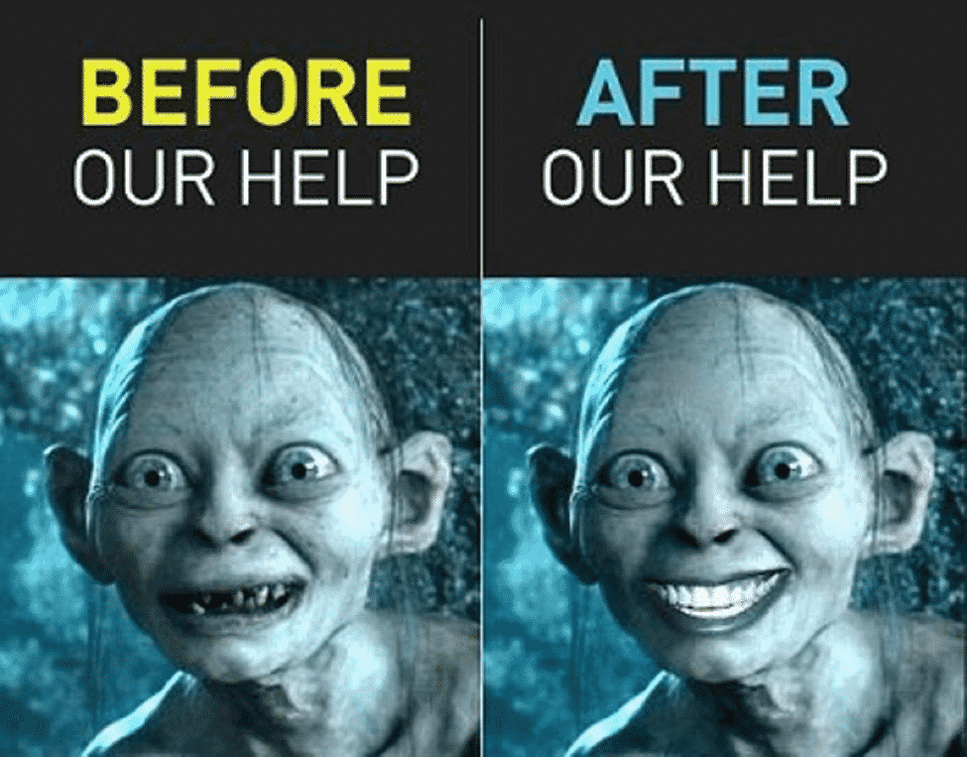

FACEBOOK AD EXAMPLES

Below are a few examples of dentists doing it correctly that understand the value of free or discounted special offers.

That understand the concept of the “Value Ladder”

And importance of filling up their practice with a predictable stream of new patients every month.

Patients they can now help and make money from:

- By delivering Special Offers.
- PLUS delivering “One Time Services” patients need to take care of NOW.
- PLUS upselling specials and continuity programs you offer.
- That understand each patient has a Lifelong Value that equals profits.

Scroll down for collection of 34 Adverts.

Includes examples of free offers & discounted offers being run by dental practices.

EXAMPLES OF FREE OFFERS BEING RUN
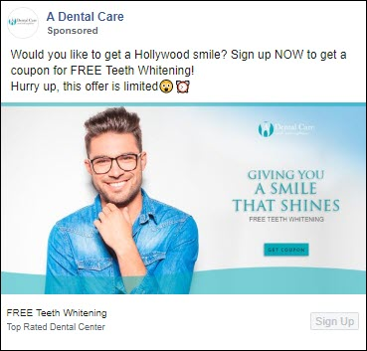
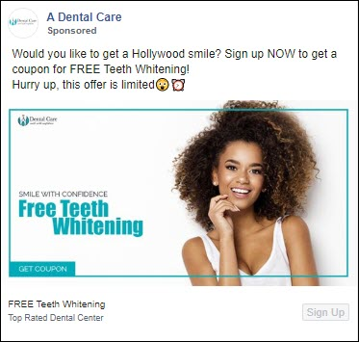

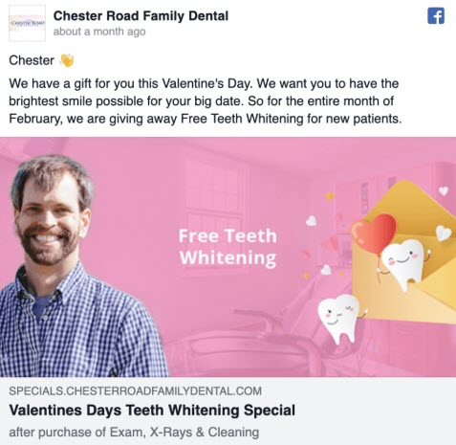
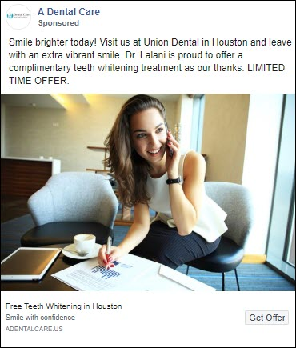

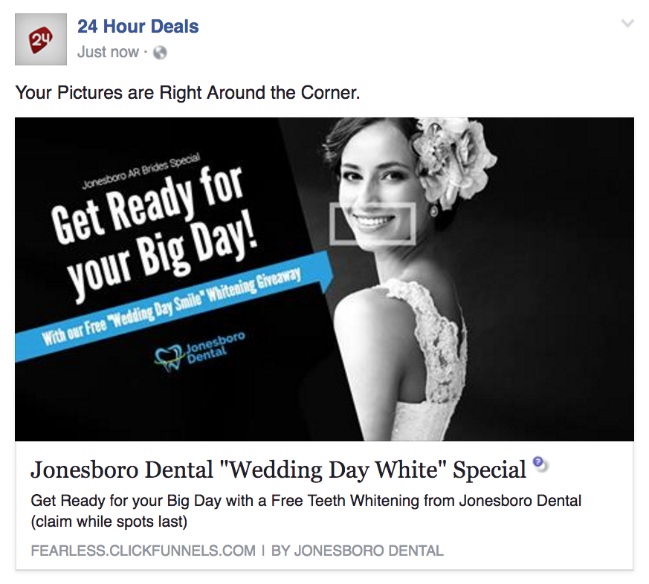
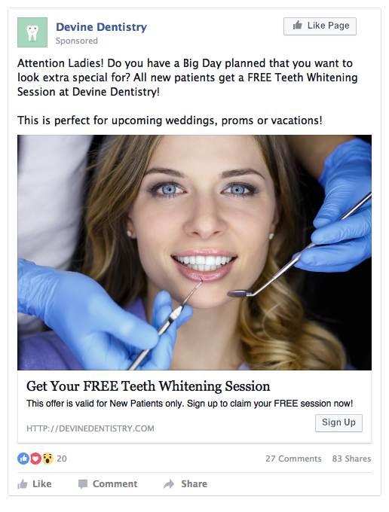
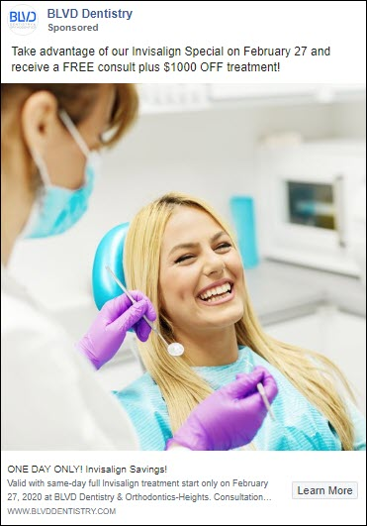
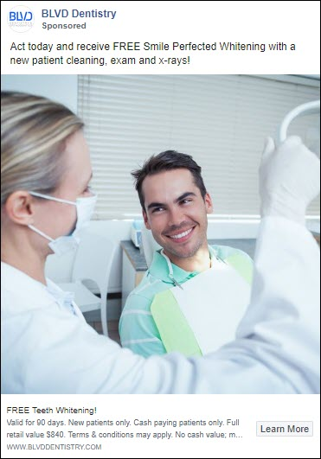

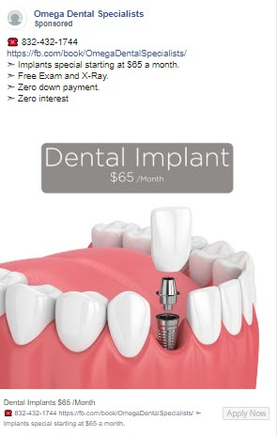
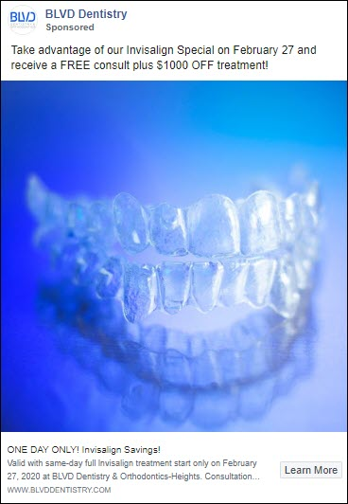
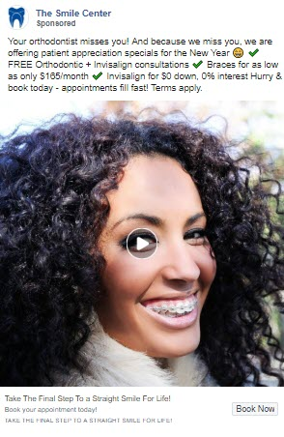
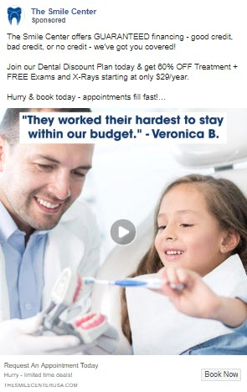
EXAMPLES OF DISCOUNTED OFFERS BEING RUN
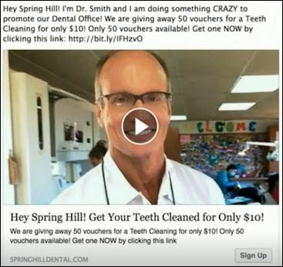
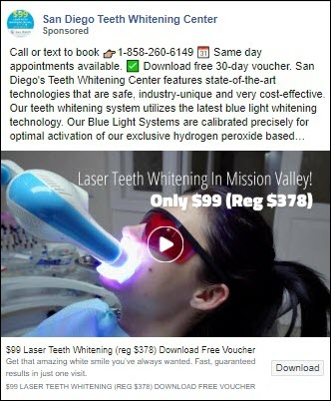

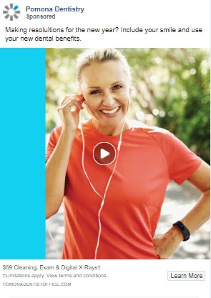

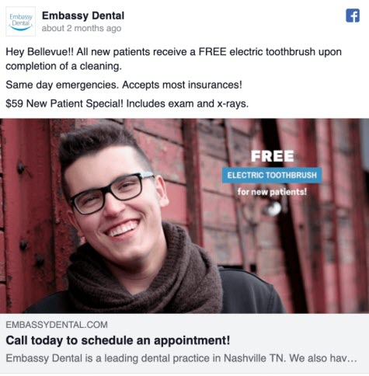
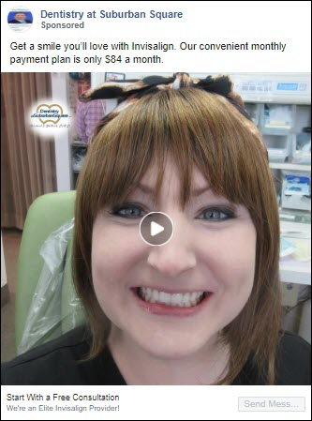
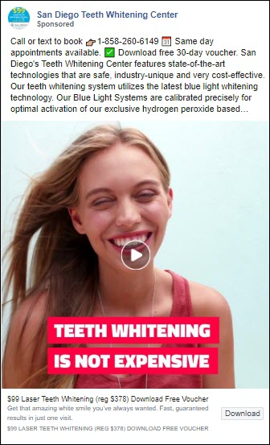

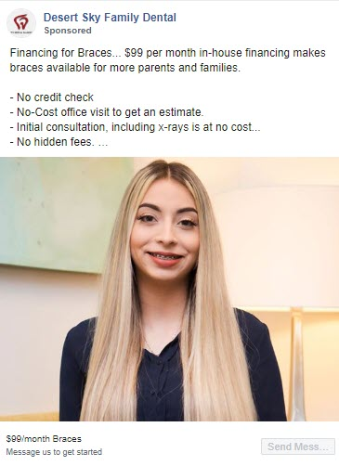

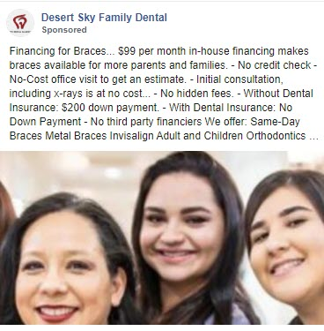

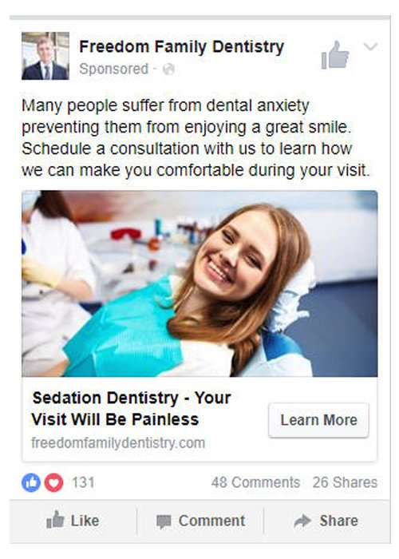
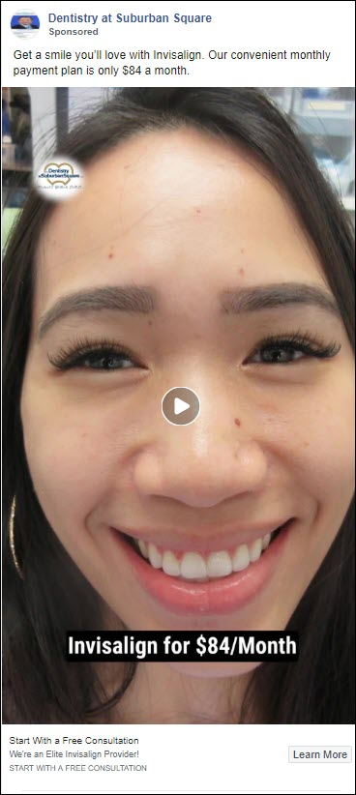
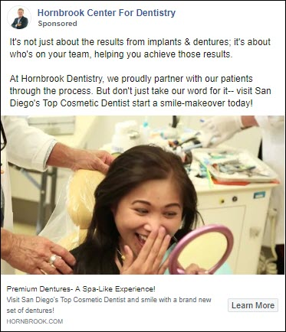

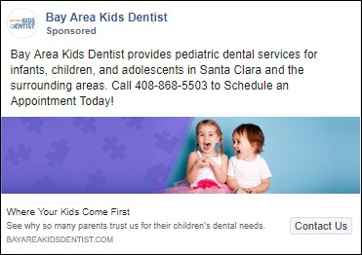
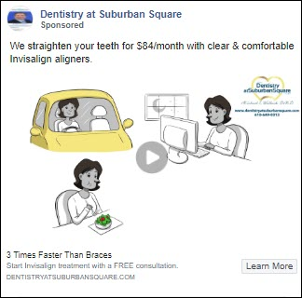
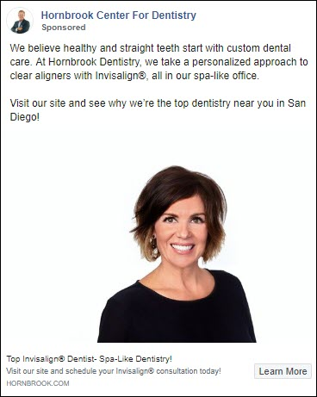
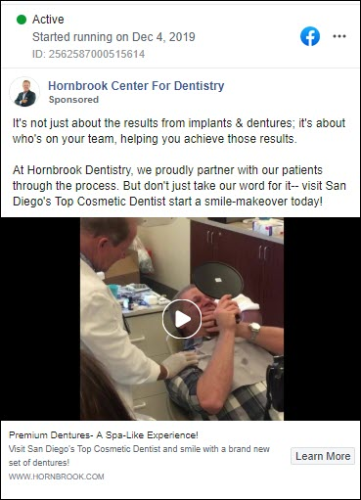

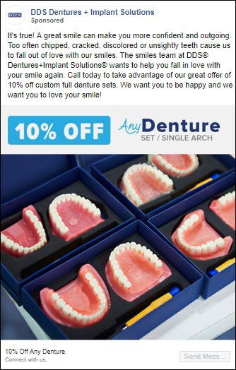
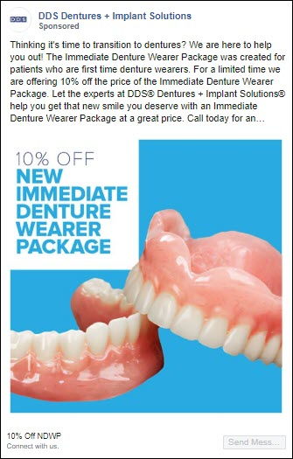
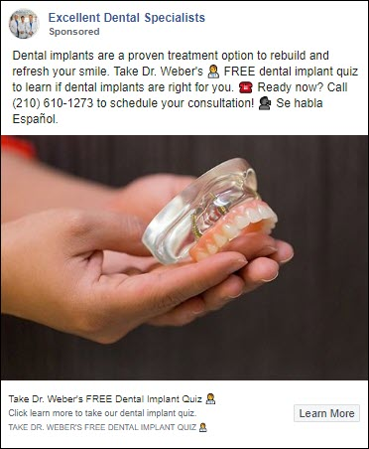
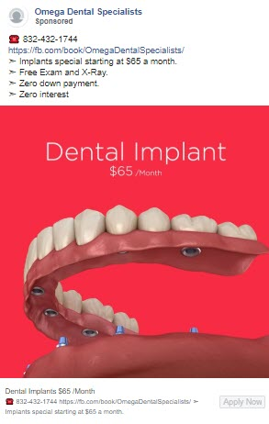
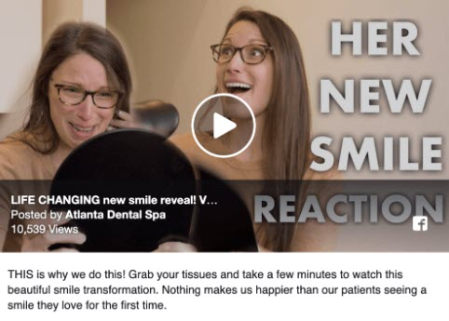
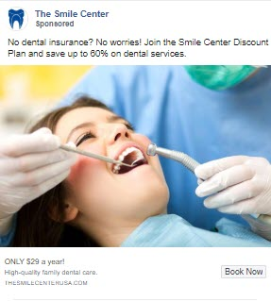

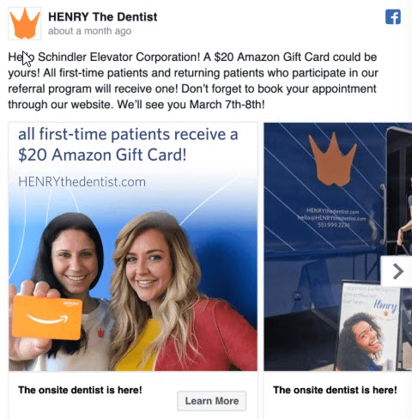

How To Create A Marketing Calendar
Fill your practice every month!
(Create a 12 Month Plan)
What you want to do is plan and schedule offers over a period of time.
There is no reason not to be running different kinds of offers. Every practice should have a marketing plan in place.
Without patients you don’t have a business!
Plan this out once a year… and know exactly how you will grow your practice and keep the doors open.
Example Marketing Calendar (12 Month Plan)
Month 1: (Offer 11) - Discounted Teeth Whitening Offer… (Only $69)
Month 2: (Offer 24) - Pre-Wedding Smile Consultation
Month 3: (Offer 22) - Invisalign Offer
Month 4: (Offer 14) - Dental Cleaning + Exam + X-Rays… (Only $49)
Month 5: (Offer 30) - Sweepstakes/Contest/Raffle/Competition
Month 6: (Created) - Teeth Whitening Program (5 Sessions) + X-Rays ($497)
Month 7: (Offer 26) - Six Month Smiles (Clear Braces)
Month 8: (Offer 25) - Orthodontics (Braces)
Month 9: (Offer 21) - Dental Implants
Month 10: (Offer 29) - Oral Surgery
Month 11: (Offer 28) - Dentures
Month 12: (Offer 27) - Pediatric Dentistry

With this “Swipe-File” it’s now easy.

Simply pick offers and run them or create your own programs… Never run out of ideas again!

Add all the holidays in a year and we could create another 30 Ads based on holidays alone… Plus we can target birthdays, weddings, anniversaries, etc.

At the end of each month track the offers - Do The Money Math!
Create a spreadsheet and track your numbers.
It will only take you or your secretary 2 hours a month… and you will know exactly how much money is coming into your practice... Full Control.
Things To Track:

How many people took you up on your offer – how much did that bring in?
How many people needed one-time services – How much came in?
How many packages/continuity programs did you upsell – How much came in?
Compare the monthly offers over time - which ones were most profitable?
How much did you spend on Ads for the month – versus income generated?
What was the ROI on each campaign – expenditure vs income?
Which ones were the easiest to implement and fulfil?

Never worry about your marketing again.
It does not take much to plan your yearly marketing – stay on top of this!

And if you’re looking for a Done-For-You Service!
Where we take care of all of this for you… this is what we specialise in.
Let’s hop on a call together and make it happen… Book your call here

My Risk-Free Guarantee To You!

We offer a guarantee on our work.

If we do not at least deliver patients to the value of what you spend with us in month one, I will refund you the difference!

Meaning if you spend $2,500 with us and we only deliver patients to the value of $2,000.

I will personally pay back the difference of $500 to you.

So you are able to take advantage of our Risk-Free Service without losing any money!

With this guarantee in place you are assured at a bare minimum to receive patients to the value of what you spend with us.

I would personally consider this a failed campaign… (only breaking even)

My goal is to consistently deliver a 10x (or more) return on your investment.

And build up a long term mutually beneficial relationship with you, where you see us as an integral part of your team, and you will be wanting to take out an insurance policy on our work

P.S. We only work with a maximum of 7 dental practices at a time.

So we can focus on getting results for our clients. And will only work with one dentist per city. First come first serve “book this service now“ to avoid missing out and thank me later once we fill your dental practice with new patients.

In Closing

I hope this Swipe-File helps and you got some valuable ideas and you are able to implement this into your own dental practice.

And again if you would like some help with this, and you’re looking for an automated Done-For-You service.

Where we focus on one thing only… delivering you RESULTS!

Plus you are backed by our No-Risk Guarantee.

All you have to do is visit my Calendar-Page to book a call with me.

Book-A-Call Here: www.dentalleadconsulting.com/private-consultations

And if you have not yet had a chance to watch the training Video, that explains everything in detail and accompanies this Swipe-File.

Plus I have included a Guide on how we run facebook campaigns from start to finish. Explaining a 3 step process called the Waterfall Campaign.

You can access the video & guide by clicking the link below.

Watch Video + Guide Here – www.DentalLeadConsulting.com/Info-Kit

I look forward to hearing from you, all the best.

Thanks
-Ivan

My Contact Details

Ivan du Plessis | Founder
DENTAL LEAD CONSULTING
Dental Marketing Specialist

Info-Kit Download: www.dentalleadconsulting.com/info-kit
(Includes Video, Swipe-File, FB Guide)
Visit Website: www.dentalleadconsulting.com
Book A Call: www.dentalleadconsulting.com/private-consultations
Pricing Page: www.dentalleadconsulting.com/pricing
Email: ivan@dentalleadconsulting.com
Pvt FB Messenger: www.messenger.com/t/IvanduPlessis21

