How To Run A Successful Facebook Advertising Campaign For Dentists

Introducing a 3 Part Game Plan Called the “Waterfall Campaign”

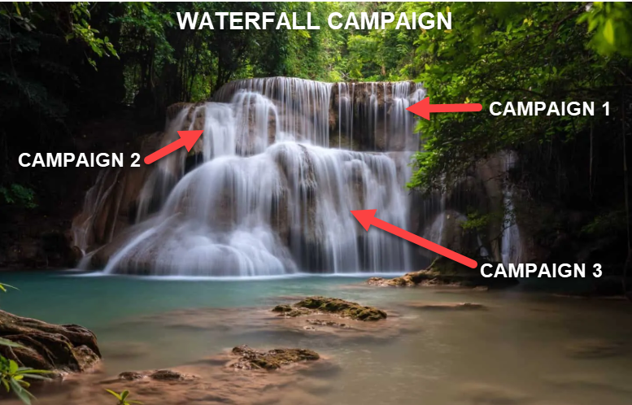

In this document I am going to lay out exactly how we run Facebook campaigns for Dentists from start to finish.
It consists of 3 separate campaigns we call the “Waterfall Campaign”.
With information obtained from the first campaign, we then use that information to launch the second campaign and then the third campaign.
This is a proven campaign that will produce patients into your practice on autopilot.
As we collect data from Facebook, we will sift and sort your audiences and adverts until we identify your ideal audience and highest converting adverts.
GOAL: To bring in patients at the lowest possible cost… (Target $20 a patient).
Table of Content
(Click on description to be taken to section)

CAMPAIGN 1: Let's begin

- The Goal of Our First Campaign
- Diagram of First Campaign
- How to Implement: First we create Audiences to Target
- Next Step is Adverts: And Split-Testing Ad Variations
- NOW… Depending on the Budget I Have To Work With?
- Cost To Do This
- Advantages of Split Testing Ads
- Once We Have Winning Offers
- And Have Achieved Our Goals For Campaign 1
- We Then Need To Analyse The Data from Facebook
- Example Image of What Facebook Data Will Look Like
- Example of Facebook “Data Analysis Form”
- CASE STUDY: Advert/ Offer used for this campaign

CAMPAIGN 2: Create Optimized Campaign

- The Goal of Campaign 2
- Diagram of Second Campaign
- Notes: On When to Create a New Campaign
- How to Implement: First we create a “Look-A-Like” Audience
- Step 2 – Create a New Bucket/Ad-Set With Our Winning Parameters
- Example Image of Campaign 1 & 2: Overview Level + Breakdown
- Evaluate Data on Campaign 2
- Campaign 2 Data Received

CAMPAIGN 3: The Golden Campaign

- The Goal of Campaign 3
- Diagram of Campaign 3
- How to Implement: First we create a “Look-A-Like” Audience
- Step 2 – Create a New Bucket And Apply Winning Parameters
- Example Image of Campaign 1, 2 and 3: Overview Level + Breakdown
- Evaluate Data on Campaign 3
- Campaign 3 Data Received

NOTES ON WATERFALL CAMPAIGN

- Summary of Lead Cost for all 3 Campaigns
- What Made This Possible?
- If We Take a Look At Our Results
- TIP: To Increase Daily Ad Budget
- End of Waterfall Campaign
- Diagram of Entire Waterfall Campaign
- Ivan Notes on Campaign
- Work Involved to Run Successful Campaigns

NEXT STEPS:

- Book a Call With Me
- Summary
- My Contact Details

Campaign 1: Let's begin

The Goal of Our First Campaign: (Ad-Set 1)
- Audience Targeting - Is to test and identify which audiences within your area are responding to your offer.
- Facebook Ads - To split test different version of the Facebook Ad, and find winning offers based on the cost-per-lead.
- Clicks - To show our ad until we receive 100 people that click on our advert
- Look-A-Like Audience - To create a "Look-A-Like" audience of people that clicked on our advert…. (A Lookalike Audience is a way to reach new people who are likely to be interested in your business because they're similar to your best existing customers.)

Diagram of First Campaign

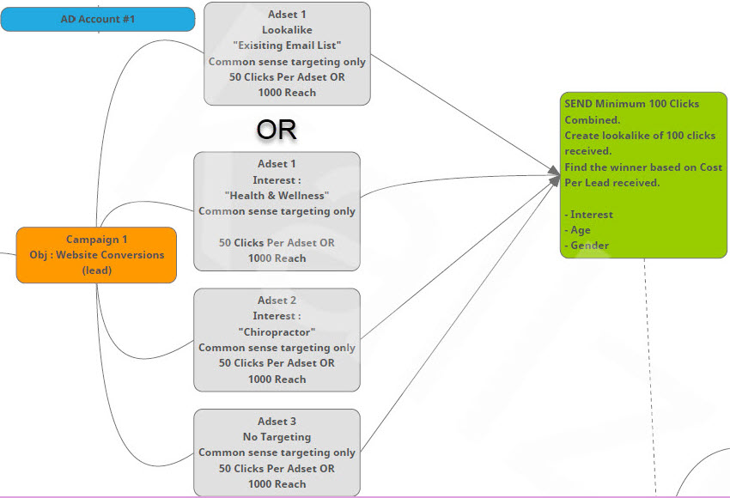

How to Implement: First we create Audiences to Target

- “4 Buckets” - First we create 4 buckets (also known as an Ad-Set), and each bucket will focus on 4 different audiences... We do research to find out which audiences are likely to purchase dental offers. And create 4 buckets targeting those 4 audiences... For example:

- Bucket 1 - You supply me a list of emails of existing and past patients in your practice, and I create a “Look-A-Like” audience from this list and we advertise to that bucket… So bucket 1 is a look-a-like audience of your current and past patients.

- Bucket 2 - Could be people within your area that have indicated they are interested in “health & wellness” in their profile… So we segment this group and advertise to them only.

- Bucket 3 - Next audience could be people that have indicated they are interested in anything “dental” in their profile… So we segment this group and advertise to them.

- Bucket 4 - And last bucket we could leave empty and say, lets show our Ad/Offer to all people residing in your area within a 15 mile radius. And we can tell Facebook to only show it to a certain age range, like people from 25 to 65 years of age.

So that’s how we test the Audiences… We create 4 buckets and will show our advert to those 4 audiences.
We will let the Ad’s run to those audiences and will receive data from Facebook.
And based on the data we will quickly see which audiences are working and which are not.

Next Step is Adverts: And Split-Testing Ad Variations

- Once we have created our 4 buckets (audience’s)
- We now need to place an Advert/Offer in those buckets to show to our audience.
- So we will create our offer/ad... and place that advert in each bucket.
- We then need to decide how much we are going to spend with Facebook every day to display that ad to our audience.
- We will choose $10 budget a day per ad.
- You can choose more but we will go with $10 for now.
- So 4 Ads (one in each bucket) x $10 = $40 per day to display your Ads.

NOW… Depending on the Budget I Have To Work With?
- I can take this a step further… And create multiple versions of the same advert for “Split-Testing” purposes.
- By this I mean, For example: I can create one “Video Advert”.
- And also create multiple “Image Adverts”.
- I do this by keeping the offer the same… BUT swopping out the images
- And this will allow me to see which images and adverts are working best and bringing in the most amount of patients at the lowest cost-per-lead.
- I can create 1 Video Advert and up to 5 Image Adverts… 6 Total
- And I can place those 6 Adverts in 3 of the buckets.
- I will leave the Look-A-Like bucket alone, and focus on only 3 buckets.

Cost To Do This:
- So if I have 6 ad variations.
- And place those 6 ad variations in 3 buckets.
- That’s 18 Ads running, plus the one in the Look-A-Like bucket.
- TOTAL of 19 Ads.
- And if we are spending $10 a day per Ad…. That’s’ $190 per day.
- We will be running these ads for a few days until each ad has been shown to 1,000 people.
- And then we can analyse the results.
- OPTIONS: So we can run one ad in each bucket at $40 a day, OR run 6 ads in each bucket at $190 a day.
Advantages of Split Testing Ads
- Our goal with Campaign 1 is to test and gather data.
- We want to test audiences and ad variations quickly.
- And get this data as soon as possible from Facebook.
- The sooner we get this data, the sooner we are able to turn off all ads and audiences that are not working and only work with winners.
- We will be receiving booked patient appointments during this process.
- After this phase the cost drops dramatically.
- Depending on your budget we can go fast… with six ad variations.
- Or we can go slow by only working with one ad.
- Or somewhere in between depending on the budget I have to work with.
- I recommend a $1,000 budget initially to start on Ad Spend.

Once We Have Winning Offers
- We then simply direct your budget to the winning ads.
- We will now know the average cost to land one patient in your area.
- And based off that, you can decide how many new patients you want to bring in per month into your practice.
- Bu simply increasing or decreasing your ad spend accordingly.
- EXCITING - Because now you can scale and grow your practice!

Once We Have Achieved Our Goals For Campaign 1:

- Audience Targeting - To test and identify which audiences within your area are responding to your offer.
- Facebook Ads - To split test different version of the Facebook Ad, and find winning offers based on the cost-per-lead.
- Clicks - To show our ad until we receive 100 people that click on our advert.
- Look-A-Like Audience - To create a "Look-A-Like" audience of people that clicked on our advert.

We Then Need To Analyse The Data from Facebook
- Once we have the data from Facebook
- It’s time to read and analyse the data
- For this we fill out a Data Analysis Form.
- Below is a diagram of how the data displays in Facebook.

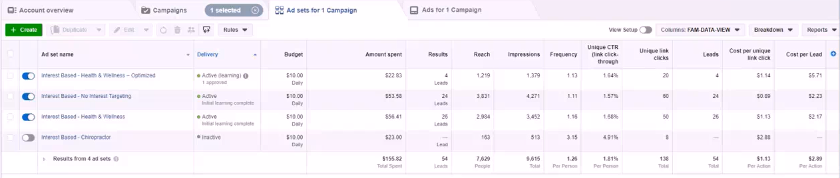
Example Image of What Facebook Data Will Look Like

(Image is small, but wanted to show you the layout)

Example of Facebook “Data Analysis Form”

Note: Follow the steps after you reach at least 1,000 people and 100 people collectively have clicked on the ads… Enter the data obtained from Campaign 1.

What is your target cost per lead?
A: Target Cost $20

CAMPAIGN LEVEL:

1. Age Range
A: 25-34 (cost per lead- $2.43)
A: 35-44 (cost per lead- $25.06) ... Too Expensive!
A: 45-54 (cost per lead- $2.72)
A: 45-54 (no leads generated)... Not-Profitable, delete age range

WOW – we are well below our target cost of $20 per lead… (Results not typical)
Decide which Age Ranges are profitable?
25-34 works
45-54 works
So when creating new campaign... Round it off and go for Age Range of 25-54.

2. Gender: Male / Female / Uncategorized
A: Male & Female

3. Device: Android Smartphone / Android Tablet / iPhone / Desktop / iPad / Other
A: Android Smartphone

4. Platform: Instagram / Facebook
A: Facebook

AD-SET LEVEL:

1. Which ad sets are profitable?
A: Interest Based - No Interest Targeting (This one is working)
A: Interest Based - Health & Wellness (This one is working)

2. Which ad sets are NOT Profitable?
A: Interest Based – Dentist (Not working)

STEPS TO COMPLETE

1. Turn off non profitable Ad sets. (Save a lot of money here)
2. Duplicate most profitable Ads-Set, apply winning demographics from sheet.
Once Done… We Have The Data And It’s Time To Move Onto Campaign 2 To Create Our Optimized Campaign & Reduce Cost.

CASE STUDY: Advert/ Offer used for this campaign
Facebook Advert Created
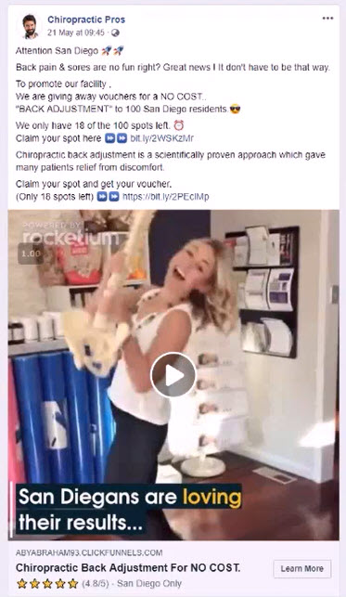
Ivan Notes:
- This campaign was run for a chiropractor, and he decided to make use of a free-offer to fill up his practice quickly.
- Made profits by getting new patients into his practice. (Value Ladder)
- Then upselling packages once he delivered free offer. (Lifetime Value)
- This exact campaign can be run for Dental Practices!
- 30 Dentist Offers: have been provided to you via “Swipe-File” and I have included free + discounted + additional offers you can run.
Campaign 2: Create Optimized Campaign
(with data received from Campaign 1)

The Goal of Campaign 2: (Ad-Set 2)
- Collect "100 LEADS/PATIENTS" Combined From Funnel
- Create "Look-A-Like" Audience of 100 LEADS Received
- Find Winning Offers Based On Cost-Per-Lead Received
- Find Winning Offers Based On Targeting: Interest, Age, Gender
Diagram of Second Campaign
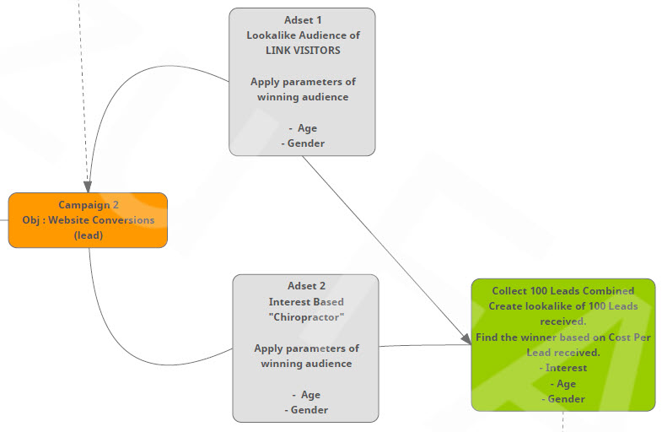

Notes: On When to Create a New Campaign
- Only create Campaign 2, once you have sent "100 Unique CLICKS to Funnel" from Campaign 1.
- In Campaign 1 we created 4 Buckets (Ad-Sets)... some of them worked and some of them didn't but all of those Ad-Sets combined sent 144 Clicks... (So we have completed goal of Campaign 1 with over 100 Clicks)
- Now we need to decide if it's necessary to create another campaign?
- If we are receiving leads below the $20 range and you have budgeted for $20 a lead.. Then it’s not necessary to run another campaign.
- But if your leads are running above that amount, and you want to bring costs down... Then we run a second campaign.
- We analyse the data and decide if you need another campaign.

How to Implement: First we create a “Look-A-Like” Audience
- This Look-a-Like audience is of people that clicked on our advert.
- Facebook will use their algorithm to create this audience.
- They will compare the profiles of all the people that clicked on our advert, and will go through ALL the profiles throughout the entire United States and find patterns and similarities.
- Then create us a database of 1 to 2 million peoples throughout the entire US that are also likely to click on our adverts.
- We can then take this new national database, and target only the people in your city and vicinity.
- Doing this will generate us more leads at a much cheaper cost-per-lead.
- So… Step 1 is to create our Look-A-Like database.

Step 2 – Create a New Bucket/Ad-Set with Our Winning Parameters
- In Campaign 1… some of our buckets will be turned off and our best buckets with the cheapest leads will still be running.
- Now it’s time to create a new bucket in Campaign 2, and apply everything we have learnt in Campaign 1.
- Goal - Is to target a new refined audience, plus the look-a-like audience and to apply all the winning parameters.
- And to try bring costs-per-lead down even further while gathering more data.
- Once we have reached our goals for Campaign 2,
- It’s time to evaluate data again, to turn off ads not working and only focus on winning offers.

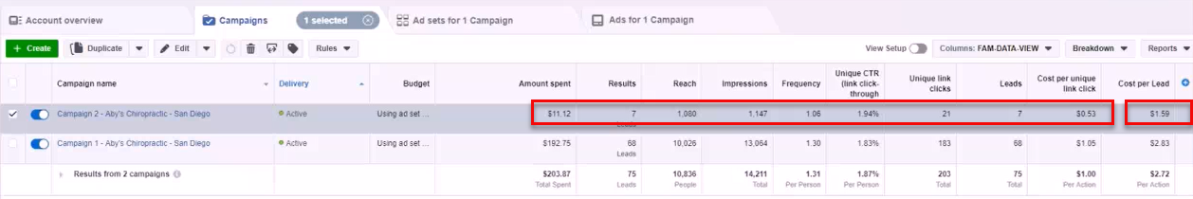
Example Image of Campaign 1 & 2: Overview Level + Breakdown

(Image is small, but wanted to show you the layout)

EVALUATE DATA: CAMPAIGN 2
Make sure Campaign 2 has been shown to at least 1,000 people
(Reach of over 1,000 people)… then can we evaluate.

CAMPAIGN 2: DATA RECEIVED
- Spent $39.90 on campaign 2
- 53 people clicked on the link in ad.
- 15 became Leads.. (reached our Thank-You page)
- Cost per Lead = $2.66 .... Fantastic result!... (falls within our budget)
- Note: The cost per lead will differ from city to city depending on the competition in your marketplace so we have to Test.
- We have beaten all 4 buckets (ad-sets) in Campaign 1.
- So Now… This is our winning campaign!
- Based on cost-per-lead it is NOT necessary to continue with Campaign 3
- We are well within our $20 per lead price range
- So I would stop the testing here… shut off all non performing ads.
- And throw the entire “Ad Budget” toward this ad, and produce patients at $2.66 all day long.
Let’s pretend that the lead cost was in the $36 range.
Which is above our maximum $20 limit.
In this case I would decide to move forward with Campaign 3.
Campaign 3… we call our “Golden Campaign”.

Let’s Move Onto Campaign 3
Campaign 3: The Golden Campaign

- We are going to be launching our 3rd Campaign of our Waterfall framework.
- The requirements to start this campaign are, you need to have at least 100 LEADS/Patients combined from Campaign 1 & 2
- We have collected 105 Leads as per our example. (patients signed up)
- We can now go ahead and start Campaign 3.

The Goal of Campaign 3:
- Create "Look-A-Like" Audience of 100 LEADS Received
- Apply Targeting Parameters Of Winning Audience Like: Age, Gender, Interest

Diagram of Campaign 3
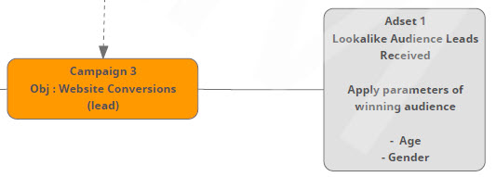

How to Implement: First we create a “Look-A-Like” Audience
- Same process as we did in Campaign 2

Step 2 – Create a New Bucket and Apply Winning Parameters
- Same process as we did in Campaign 2
- In Campaign 1 and 2… some of our buckets will be turned off and our best buckets with the cheapest leads will still be running.
- Now it’s time to create a new bucket in Campaign 3, and apply everything we have learnt in campaign 1 & 2.
- Goal - Is to target a new audience of LEADS and to apply all the winning parameters.
- To bring costs-per-lead down even further.
- Create our winning campaign.

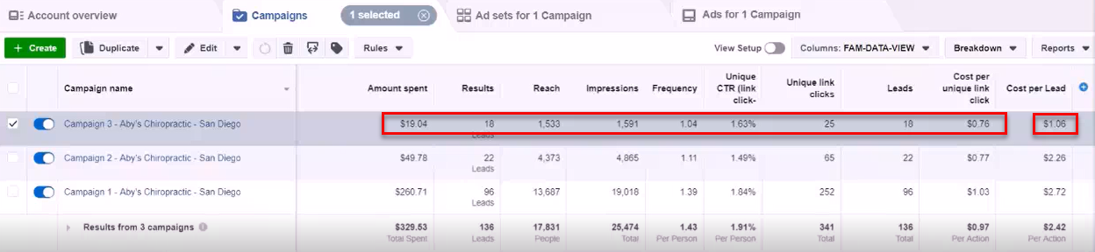
Example Image of Campaign 1, 2 and 3: Overview Level + Breakdown

(Image is small, but wanted to show you the layout)

EVALUATE DATA: CAMPAIGN 3 - The GOLDEN CAMPAIGN
- GOAL: Make sure Campaign 3 has been shown to at least 1,000 people... so we have a "Reach" of over 1,000 people... only then can we evaluate.
- Now lets take a look at the data for Campaign 3

CAMPAIGN 3: DATA RECEIVED
- Spent $19,04 on campaign so far.
- 25 people Clicked on the link in ad.
- 18 became Leads.. (reached our Thank-you page)... That's insane conversions... around a 70% conversion rate!
- Cost per Lead = $1.06 …. Fantastic Result!
- And suspect leads may get even cheaper as Facebook has not optimized fully yet, is still learning.
- Note: Again results will differ depending on location… we need to test.

SUMMARY OF LEAD COSTS
Running 3 Campaigns implementing the Waterfall Campaign
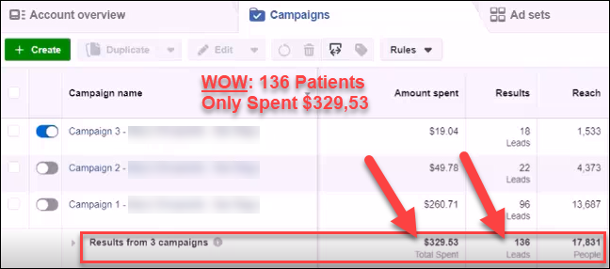
- Campaign 1: Lead Cost - $2.72/ Spent $260,71/ 96 Patients delivered
- Campaign 2: Lead Cost - $2.26/ Spent $ 49.78/ 22 Patients delivered
- Campaign 3: Lead Cost - $1.06/ Spent $ 19.04/ 18 Patients delivered
TOTAL - $329.53/ 136 Patients delivered
Incredible Result:
- Results will vary, but once campaign is dialled in properly.
- Lead Cost is reduced.
- Mission Accomplishes… campaign optimised and running on autopilot.

What Made This Possible?
- Step by step we were able to collect valuable data on our demographic and able to split test different ad variations.
- We were able to create a “Look-A-Like” audience of LEADS/Patients.
- We were able to apply winning parameters, which we learnt from our testing.
- And able to market to people with the highest possible chance of taking us up on our offer.
- All possible because we took it step by step and applied everything we learnt on each campaign until we got to our winning campaign.
If We Take a Look At Our Results:
- A number of the ads within our campaigns are working.
- Leads are coming in at under $20 for multiple ads being run.
- So we could actually leave all these ads on.
- BUT... Campaign 3 is working the best (optimised),
- So we can now turn off Campaign 1 and Campaign 2.
- And instead increase the "Ad Budget" on Campaign 3 to produce more leads faster at cheaper prices.

TIP: To Increase Daily Ad Budget
- This campaign has been running and is now dialled in.
- Time to increase the daily budget.
- TIP: Only Increase Budget by 40% Increments at a Time!
- Reason only 40% is Facebook has something called a learning process
- When that process is being done, Facebook is trying to produce the best leads in less than 7 days.
- If you increase the budget too much then Facebook will lose that learning process.
- And we will have to start the learning process over again, and this may increase your cost per lead and mess with your previous results.
- So to keep cost per lead steady.
- Only increase by 40% at a time.

End of Waterfall Campaign:
- So we have our Golden Campaign - It’s running great and producing patients at very cheap prices.
- We keep running with this campaign until it’s time to optimize again.
- And that completes the Waterfall Campaign method.
- Once lead cost starts rising above $20
- Then it’s time to start a new campaign to bring lead cost down again.

Diagram of Entire Waterfall Campaign
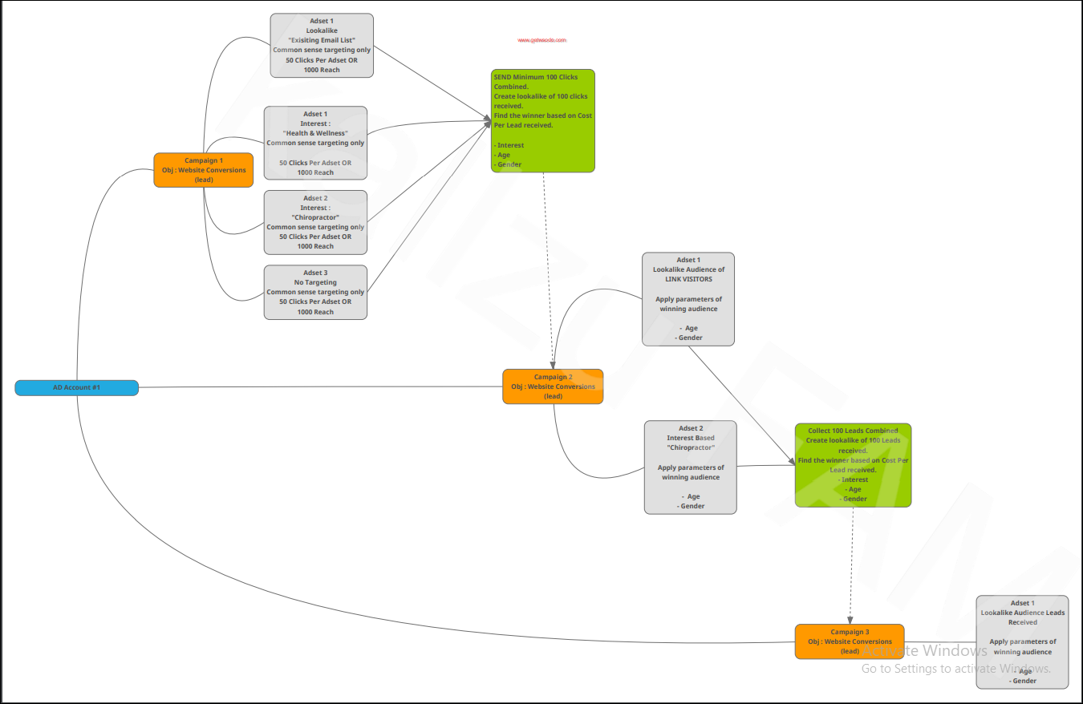

Ivan Notes:
- So what have we created here?
- We have created an automated “Patient Delivery Machine”
- That will deliver patients to your practice on demand.
- It is completely hands off
- We take care of all the technical stuff… We implement and deliver as many patients as you need.
- The exciting thing is, once we have the adverts and audience dialled in.
- And know the exact cost to generate one patient.
- You can literally sit down before the month and decide how many patients you want to bring in.
- And more importantly, know how much that will cost.
- You can decide to increase or decrease your Ad-Budget accordingly.
- Example: I want 100 patients this month
- No problem, it costs for example $20 per patient
- So that would be a $1,000 Ad-Budget to land 100 new patients.
- Never Again - Will you have to try and figure out marketing.
- No more relying on your website or yelp or SEO or having to advertise on groupon or expensive magazines or billboards with little to no results.
- With a properly executed Facebook Marketing Campaign.
- You have a system that delivers patients whenever you want.
- You can turn it on or off.
- Decide how many patients you want per month.
- And control it by increasing or decreasing you Ad-Spend accordingly.
- Very Very Exciting… and what we specialize in.

Work Involved to Run Successful Campaign

- Setting up Business Manager for campaign.
- Create a Marketing Video.
- Building out and hosting Funnel Pages.
- Audience Research & targeting correct audiences.
- Setting up Email Reminders.
- Creating the Offer and Facebook Advert.
- Split-Testing different ad variations.
- Creating Look-a-Like audience.
- Monitor & Manage the campaign.
- Finding the Winning Offers and running with them.
- Regular Feedback on campaign.
- Make you do the happy dance one we deliver you RESULTS!

NEXT STEPS: Book a Call With Me

This guide goes hand in hand with a "FREE VIDEO" I created outlining the exact steps to launching a highly successful Facebook Advertising Campaign.

Plus I include a SWIPE-FILE of 30+ Dentist Ads you can download and run today.

If you have not yet watched the video or received the Swipe-File.

You can access the video & guide by clicking the link below.

Watch Video + Swipe-File Here – www.DentalLeadConsulting.com/Info-Kit

BOOK A CALL HERE:

Once you have taken a look at those resources the next step is to book a call with me.

Where we can discuss how to implement this into your dental practice and make sure this will be a good fit for you.

All you have to do is visit my Calendar-Page to book a call with me.

Book-A-Call Here: www.dentalleadconsulting.com/private-consultations

Summary

I hope this breakdown helps and gives you a better understanding of what happens behind the scenes and the work that goes into creating and running a successful Facebook Ads campaign.

And hope this guide helps you should you want to go it alone.

And if you’re looking for an automated Done-For-You service

Where we take care of everything for you and focus on one thing only… which is delivering you RESULTS.

Plus you are backed by our No-Risk Guarantee!

All you have to do is visit my Calendar-Page to book a call with me.

Book-A-Call Here: www.dentalleadconsulting.com/private-consultations

I look forward to hearing from you.

Thanks
-Ivan

My Contact Details

Ivan du Plessis | Founder
DENTAL LEAD CONSULTING
Dental Marketing Specialist

Info-Kit Download: www.dentalleadconsulting.com/info-kit
(Includes Video, Swipe-File, FB Guide)
Book A Call: www.dentalleadconsulting.com/private-consultations
Pricing Page: www.dentalleadconsulting.com/pricing
Email: ivan@dentalleadconsulting.com
Pvt FB Messenger: www.messenger.com/t/IvanduPlessis21



