STEPS: To Launching A Facebook Advertising Campaign

Steps To Follow To Launch A Successful Facebook Ad-Campaign That Will Deliver 30-50 Patients a Month.

Outsourcing / White Label Providers

- Outsourcing / Vendors-- Outsource work for $500… (Charge One-Time Set-Up Fee to Client)
- Ankiita Mankotia – Facebook Ads Expert (Dental 100 campaigns) spoke to her
- Chris Niles - Google Ads + Facebook + YouTube (Local Guys Marketing)
- Rob Warner – Google Ads (Invisible PPC)
- Sean Rodinger – Facebook Real E state Niche (Up-South Media)
- Andrew Lewis – Facebook Ads + Retargeting Ads ($500pm) Agency Turn Key
- DashClicks.com – Facebook + Everything Else (CEO Chad Kodary)

2.) On-Boarding - Get Client Information (Must create this)

ClickFunnels Software

3.) Build Client Funnel (import funnel & edit)
4.) How To Edit Funnel Tutorials (21 Video Tutorials)

Active Campaign Software

5.) Connect ClickFunnels to Active Campaign
6.) Create List in Active Campaign & Connect to Funnel
7.) Add the Local Business as User in Active Campaign
8.) How Automations Work
------- Email: Sent to Business owner (notification of Lead)
------- SMS 1: Sent to client with coupon
------- SMS 2: Sent to Business owner (notification of new lead)
------- SMS 3: Sent to Business owner again in 15 minutes (reminder to follow up with lead)
9.) Installing Automations
10.) Email Series Sent Out to Customer that Opts-In (5 email series) ??? (Need Templates)

Video Software: (OFFEO or inVideo)

11.) Create Video
------- Why Make Video Ads & Funnel Congruency
------- Video Slides Size & Length
------- Easiest Methods to create video ad
------- EXAMPLE: Chiropractor Video (15 seconds in length)
------- Create Simple video with Rocketium (TUTORIAL)
------- EXAMPLE: Chiropractor Video (57 seconds in length)
------- Create videos with Rocketium Part 1 (Advanced Tutorial 1)
------- Create videos with Rocketium Part 2 (Advanced Tutorial 2)
------- Uploading Video To Asset Library
------- Using Creative Hub To Preview the Ad & Video
------- Writing the Ad

Setting Up: Business Manager Account

12.) Create "Business Manager Account"
13.) Create Your AD-Account
14.) Add Payment Method to AD-Account
CreateFacebook Page (To Advertise From)

15.) Create Master Facebook Page

Create Advert: (Creative Hub or AdParlour)

16.) Create FB Adverts (Creative Hub)
------- Using Creative Hub To Create & Preview The Ad
------- Chiropractor Advert: (That Delivered 100 Leads/Patients in Campaign)
------- Formula to Write Ad... (use Creative Hub)

17.) 20 Dentist Advert Templates (Offers I Created, Free & Discounted)

18.) More Dentist Templates (Dr Anissa Holmes)

------- Meet The Dentist

------- Dental Implants
------- Invisalign
------- Cosmetic Dentistry
------- Teeth Whitening
------- Pre-Wedding Smile Consultation
------- Orthodontics
------- Six Month Smiles
------- Pediatric Dentistry
------- Periodontics
------- Oral Surgery

19.) Sweepstakes Advert/Contest/Raffle/Competition (Dino Gomez)

Using Business Manager
20.) Install Pixels
------- Facebook Pixel Introduction
------- How Pixel Work (Diagrammatic Explanation)
------- Creating Your Master Facebook Pixel
------- Installing Pixel In ClickFunnels
------- Installing Pixel Helper Extension
------- Install Pixel Events
------- Assigning Pixel To An Ad Account

21.) Upload Customer Patient List + Lead List… (Create Audiences & Targeting)
------- The Anatomy of Business Manager
------- Structure of Ad Account (Diagrammatic Explanation)
------- Structure of Ad Account (Real Ad Account)
------- Audiences Overview (cold & warm, Interests, Age ranges)
------- Uploading Email Lists & Creating Facebook Audience
------- Creating Web-Retargeting Audiences from Website visitors
------- Creating "Look-A-Like" Audiences
------- What if you don’t have a customer list and pixel list (Targeting)

22.) Business Manager Account Login
------- We have Ad-Account, then Campaigns, then Ad-Sets, then Ads)

Waterfall Campaign Framework

23.) The Waterfall Campaign Framework
24.) Difference between Dino Gomez campaign... VS... Waterfall campaign
25.) How much should I spend for Facebook-Ads
26.) Campaign Launch Checklist

CREATE FIRST CAMPAIGN... (As Draft First)… THEN GO LIVE!

27.) GOAL OF CAMPAIGN 1
------- To Send "100 Unique CLICKS To Funnel"
------- Create "Look-A-Like" Audience of 100 CLICKS Received
------- Find Winning Offers Based On Cost-Per-Lead Received

28.) CREATE FIRST CAMPAIGN & AD-SET
----------1.) Create New Campaign (Draft)
----------2.) Create New Ad Set (Draft)
----------3.) Create Ad (Draft)
----------4.) DONE.. We Have Just Created Our First Campaign DRAFT, Now We EDIT
----------5.) Edit Campaign (Edit)
----------6.) Edit Ad-Set (Edit)
----------7.) Edit Ad (Edit)
----------8.) DONE.. We Have Just Completed Campaign 1 "DRAFT" Now Make It Go LIVE
----------9.) PUBLISH: Ad-Set For Review To Make It Go LIVE!
-------- 10.) DONE... Now Wait for AD To Go LIVE (24 Hours). Then Create 2nd & 3rd AD-SET.

29.) Dark Post Advantages & Why You Should Use It
------- Simply means to use the "POST ID NUMBER" when duplicating ad for other Ad Sets.
------- By doing this you do not have to create a new ad for each one.
------- But more importantly you carry ALL the Social Proof.
------- You use the same advert and collect and display all social comments which will ………..increase conversions.

30.) CREATE SECOND AD-SET
------- We only duplicate the other 2 Ad-Sets... AFTER first Ad-Set is approved!
------- Instructions: To Duplicate Ad-Set
------- Editing Second AD-Set
------- DONE... Second AD-SET "DRAFT" Is Complete... Now Create The Third AD-SET

31.) CREATE THIRD AD-SET
------- Instructions: To Duplicate Ad-Set
------- Editing Third AD-Set
------- DONE.. Third Ad-Set 'DRAFT' Is Complete.. NOW Make Both AD-SET's Go LIVE
------- Instructions: To Publish Both Ad-Set's For Review To Make Them Go LIVE!

32.) Reading The Relevant Data From Facebook Ads-Manager
------- How To Read The Data: What Each Column Means
------- Instructions: How To Edit Columns - Make Changes (Create Workflow Columns To ………..Analyse Data)
33.) #1 Reason Why Your Campaign Will Fail
------- You will fail if you stop ads too soon and do not allow Ads to run for long enough to ………..get accurate data.
------- Let them run till each Ad-Set gets a minimum 1,000 Reach (showing each ad to ………..minimum of 1,000 people) Or a minimum of 50 Clicks.
------- And for entire campaign... which consists of 3 Ad-Sets.
------- To collectively get a minimum of 100 Clicks (unique link clicks) combined from all 3 Ad-……….Sets…. (that's 100 people Total that click on link in the ads). So you get accurate data.
------- Once we have the data we will use it to run next "Optimised Campaign" to reduce lead ……….cost…. Trust in the process!

34.) Data Analysis Of Campaign 1 And Bringing the CPL Further Down
------- Instructions: STEP 1 - Fill Out Form
------- FORM DETAILS: (Where to Access Data)
------- DONE... We Have Collected ALL Data For This Campaign!

35.) Steps To Complete After Data Received (How many days?)
------- Turn off Non Profitable Ad-Sets:
------- DUPLICATE most profitable Ad-Sets... APPLY winning demographics from sheet above.

36.) CREATE NEW FOURTH AD-SET… (If necessary, after review to bring CPL down further)

------- Instructions on how to create new Ad-Set in Campaign 1
------- DONE: How This Will Help
------- OK, so we have created the new "Optimized Ad-Set" this will help with a lot of things
------- Will help me reach that 100 CLICKS we after for this Campaign,
- So i can graduate to the next level
------- Campaign 2, where we increase the budget and will also get a good number of leads

37.) Final Results of Waterfall Campaign 1

LAUNCHING WATERFALL CAMPAIGN 2

38.) GOAL OF CAMPAIGN 2
------- Collect "100 LEADS" Combined From Funnel
------- Create "Look-A-Like" Audience of 100 LEADS Received
------- Find Winning Offers Based On Cost-Per-Lead Received
------- Find Winning Offers Based On Targeting: Interest, Age, Gender

39.) When to Create a New Campaign

40.) INSTRUCTIONS
----------1.) Create Lookalike Audience (everybody who visited the funnel)
----------2.) Create New Campaign (Draft)
----------3.) Create New Ad Set (Draft)
----------4.) Create New Ad (Draft)
----------5.) EDIT New Campaign (Edit)
----------6.) EDIT Ad Set (Edit)
----------7.) EDIT Ad (Edit)
----------8.) Publish Campaign - Make It Go LIVE!
41.) Data Analysis of Campaign 2
LAUNCHING WATERFALL CAMPAIGN 3
The Golden Campaign!

42.) GOAL OF CAMPAIGN 3
------- Create "Look-A-Like" Audience of 100 LEADS Received.
------- Apply Targeting Parameters Of Winning Audience Like: Age, Gender, Interest

43.) Do You Really Want To Start a New Campaign?

44.) INSTRUCTIONS
----------1.) Confirm 100 Leads Collected From Campaign 1 & 2
----------2.) Turn OFF Ad-Sets That Are Costing Too Much
----------3.) CREATE: Look-A-Like Audience (converted into a LEAD, reached Thank-You Page)
----------4.) Create New Campaign (Draft)
----------5.) Create New Ad Set (Draft)
----------6.) Create New Ad (Draft)
----------7.) EDIT New Campaign (Edit)
----------8.) EDIT Ad Set (Edit)
----------9.) EDIT Ad (Edit)
---------10.) Publish Campaign - Make It Go LIVE!

45.) Data Analysis & Scaling of Campaign 3

BRAND WE CREATED

46.) The Brand You Created (The Beast)
------- So Here Is How a Normal Local Ad Agency Newbie Works
------- So What Have We Basically Created?... We have created a BRAND!
------- Second Biggest Advantage... You Never Have To Start From Scratch!
------- We can create "Look-A-Like Audience" in new clients account from data obtained from ------- previous clients campaign.
------- When We Get A New Client: All We Do Is Target a New City
------- So With New Clients: You Will NOT Have To Start All The Way From Scratch
------- Instructions on How To Implement

ADDING CLIENT TO BUSINESS MANAGER + CREDIT CARD

47.) Getting Paid
----------1.) When to stop free trial
----------2.) Different ways of processing payments
----------3.) Adding local business client to business manager
----------4.) How To Add Your Credit Card To Facebook (Walk through for client)
----------5.) Using Credit card authorization forms
48.) How To Create Re-Targeting Facebook Ads (CAM – Module 5)

49.) Targeting (from Dr Anissa Holmes & Dino Gomez)

OUTSOURCING / WHITELABEL VENDORS

Watch JR Video Talking About Them

WATCH VIDEO - http://ivantraining.com/kallzu/outsourcing-fb-campaigns/

Contact Them
- The way it works is you reach out to them and jump on a call with them.
- They will give you the information and their pricing information.
- And once you close a client, they will have On-Boarding process for you.
- To have them take over as the Fulfilment Team.

Ankita Mankotia – Facebook Ads Expert (Dental) 100+ campaigns
Ankita Mankotia
Tel: 270-316-4550
Website: https://ankitamankotia.com
FB Messenger Page: www.messenger.com/t/553659449
FB Page: www.facebook.com/ankita.mankotia

Pricing:
- Single Client USD 449 per month per client
- 3 or more clients USD 399 per month per client
- 10 or more clients USD 299 per month per client
- GHL- One Time setup fee of USD 99 per client
- (if you want me to setup GHL snapshot, campaigns, triggers, etc)

Notes:

- Found her on pvt FB Group Josh Nelson
- Specialises in FB Advertising, Dental Niche, Med Spas, Chiropractors and more
- Has worked with many agencies, has good reviews and testimonials
- Can set up ClickFunnels & Go High Level (owners Shaun Clark & Robbin Allen)
- She can run budges from $500 to $50,000 in Ad spend
- Have spoken to her… contact her when I have paid clients.
Niches:

- Realtors, Mortgage, Solar, Med Spas, Dental, HVAC, Docs, Chiros, Home Services, and many others

Google Ads+Facebook+Youtube (Chris Niles) - Local Guys Marketing
Chris Niles
Tel: 270-316-4550
Email: Chris@localguysmarketing.com
Website: LocalGuysMarketing.com
FB Page: ?

Notes:

- Ultimately what they specialise in is Google Ads. (Wonder if they do Pay Per Call?)
- But a lot of their campaigns focus on Google Ads + Facebook Ads combo
- A lot of times they will start on Google Ads and Re-Target on Facebook.
- They also handle some YouTube Ads as well.
- JR trusts this guy, knows they will do a good job for you.

Niches:

- Roofing
- Mold Removal
- Restaurant
- Chiropractor
- Salon
- Med Spa
- Gym
- Real Estate
- Home Remodelling
- Septic
- Pool Builder
- Roofing
- Mold Removal
- Restaurant
- Chiropractor
- Salon
- Med Spa
- Gym
- Real Estate
- Home Remodelling
- Septic
- Pool Builder
- Contractors
- Yoga Studio
- Massage Spa
- CrossFit
- Auto Detailing
- Auto Dealership
- Attorney
- Optometrist
- Invisalign
- Braces
- General Dental
- Lasik Eye Surgery
- Testosterone Replacement Therapy
- Boat Sales
- Ecommerce
- Plus more, talk to them.

Google Ads (Rob Warner) – Invisible PPC
Rob Warner
Invisible PPC
Email: gethelp@invisibleppc.com
Website: InvisiblePPC.com
FB Page: ?

Notes:

- They focus mainly on Google Ads
- Have a ton of niches

Niches:

- Auto Services - Body Shop
- Auto Services - Repair
- Mechanic - General
- Chiropractor - General
- Chiropractor - Pain Area
- Dental - Cosmetic Dentistry
- Dental - Dental Implants
- Dental - Dentures
- Dental - General Dentistry
- Dental - Invisalign
- Dental - Orthodontist
- Doctor - General Practioner
- Doctor - Urgent Care
- Electrician - General Electrician
- Electrical - Need Specific
- Electrical - Rewiring
- Funeral Services - Cremation
- Funeral Services - General
- House Cleaning - Carpet
- House Cleaning General Cleaning
- HVAC - AC Installation/Repair
- HVAC - Commercial
- HVAC - General
- HVAC - Heat Installation/Repair
- Landscaping - General
- Landscaping - Hardscaping
- Landscaping - Sprinkler Systems
- Legal - Bankruptcy - General
- Legal - Bankruptcy - Specific Types
- Legal - Criminal - DUI/DWI Lawyer
- Legal - Estate Planning - General
- Legal - Estate Planning - Probate
- Legal - Family - Divorce
- Legal - Family - General
- Legal - Immigration Lawyer - General
- Legal - Personal Injury - General
- Legal - Personal Injury - Vehicle Accident
- Legal - Workmans Compensation Law
- Moving & Storage - Movers
- Moving & Storage - Storage Solutions
- Paving - Commercial
- Paving - Driveways
- Paving - General
- Pest Control - General
- Pest Control - Indoor Bugs
- Pest Control - Indoor Mammals
- Pest Control - Mosquito
- Physical Therapy - General
- Physical Therapy - Pain Area
- Plumbing - Service Plumber
- Plumbing - Water Heater
- Remodeling - Basement Waterproofing
- Remodeling - Bathroom
- Remodeling - Countertops
- Remodeling - Kitchen
- Remodeling - Window Replacement
- Roofing - Commercial
- Roofing - General
- Roofing - Metal Roofs
- Roofing - Storm Damage
- Water Damage - General
- Water Damage - Mold Remediation
- Water Damage - Need Specific
- Weight Loss - Coolsculpting - Fat Reduction
- Weight Loss - Coolsculpting - General
- Weight Loss - General
- Weight Loss - Medical

Facebook Ads: Real Estate Niche (Sean Rodinger) – UpSouth Media
Sean Rodinger - Co-Founder & Head of Operations
Seth Killian - Co-Founder & Head of Business Development
Email: seth@upsouthmedia.com
Website: UpSouth.media
YouTube Channel: https://www.youtube.com/channel/UCDz9Vb3ihWXfObiYTtOa-BQ/videos
FB Page: ?

Preferred “Real Estate” white label provider who will let you leverage their case studies (Real Results for Real Estate Agencies)

Homegrown Instant Leverage Members

(Do not have link) - Watch this video explaining our services first

Contact Them:

- Fastest Response - Please send a direct message through Instant Leverage Slack channel to either Seth or Sean.
- Alternative Option - Please send email to seth@upsouthmedia.com

Notes:

- They started off as our agency clients, and we've promoted them to Whitelabel Providers
- So they focus specifically on the Real Estate niche.
- Might be a good route for you especially if you’re just getting starting.
- They will allow you to use their Case Studies, and leverage their case studies in order to close your clients since you are using their team as your Whitelabel providers.
- If your brand new and completely nicheless, then this might be a good route for you for the simple fact that they have a lot of support for new people.
- They will help you with the Demo Presentation
- And they will allow you to leverage their Case Studies.
- I Trust these guys a ton and they do a great job

Leaked MasterClass Training Demo - https://vimeo.com/591447843

Pricing

Items: | Apprentice ($400/mo) | Advanced ($800/mo)
180 Days Follow-Up Nurture Email Program | Copy Provided | Done For You
Ad Buying (Campaign Setup & Management) | Done For You | Done For You
Bi-Monthly Meetings | Included | Included
CRM Setup (LionDesk) |  | Done For You
AI Powered Text Messaging (Qualification) |  | Done For You

Important Caveats:

- Minimum $500 Ad Spend
- $400 one-time setup fee for Advances Package
- Apprentice setup fee waived for Instant Leverage
- 30 Day Cancellation Notice required

4 Resources Provided "on the house" for Instant Leverage Members Starting Out

- Sales Deck (17+ slides)
- First Call Framework Script for Qualifying REAs
- Case Studies (Only if you use us for fulfilment)
- Cold Call Framework Script for Setting Appts

Facebook Ads Agency + Retargeting (Andrew Lewis) - Agency Turnkey
Andrew Lewis
Contact through website: bit.ly/AgencyTurnKey
Website: https://www.themarketingco.co/agency-turn-key
FB Page: ?

PRICING: $497 month/client – No Contract

Notes:

- He is kind of a general Facebook Ads Agency
- So he handles all niches mentioned below
- He includes Re-Targeting
- His fee increases with the amount of Ad-Spend

Niches:

Health Insurance
Life Insurance
Beauty Spa
Auto Dealer
Personal Injury Attorney
HVAC
Restaurant
Pest Control
Fitness
Solar
Ask if he does others, like dental?

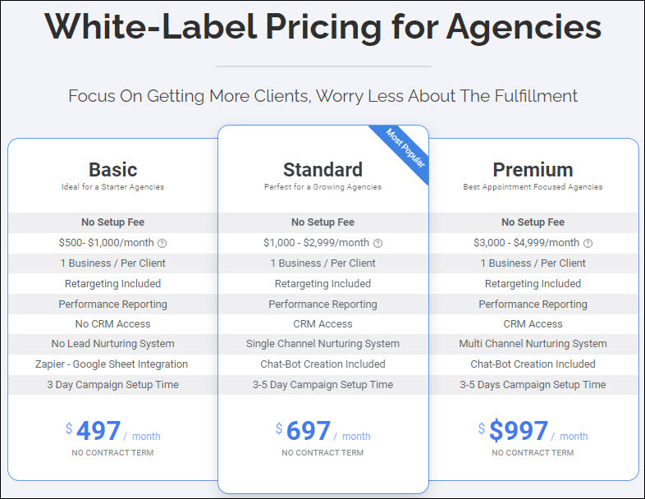

Facebook Ads + Everything Else (CEO Chad Kodary) - DashClicks

Login Credentials
Website URL: https://moreclientsconsulting093394.dashclicks.com/
Username: ivanhq007@gmail.com
Password: 3229

Social Media Pages
FB Group: https://www.facebook.com/groups/marketersmindset/
YouTube Page: https://www.youtube.com/c/DashClicks/videos (Some Good Training Here)

PRICING: $499 month + $350 Setup (Up to $2,999 Ad-Spend)

Details Used

Name - Ivan du Plessis
Email - ivanhq007@gmail.com
Password - 3229
Phone Number - +63 998 429 0103
Company Name - More Clients Consulting
Account - moreclientsconsulting093394.dashclicks.com

Can Do Any Type Of Paid Online Marketing & Work
(Reasonable Pricing)
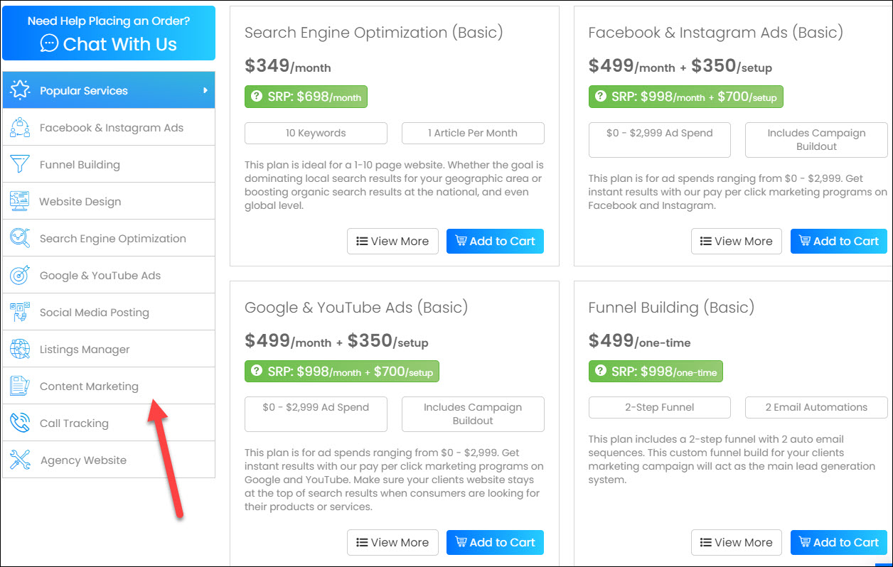

ON-BOARDING - Get Client Information

Make a list of things needed and get client to supply all information.

Plus can get resources from list below.

Finding Resources For Your Funnel

1.) Logo
- swipe a logo - use google (niche + area)
- FreeLogoDesign.org
- www.iloveimg.com/crop-image (Need to crop image)

2.) Background Image
- freepik.com
- pixels.com
- google image search - "chiropractic click"

3.) Video
- Groupon.com - Find a promotional video from an advertiser
- Google - "chiropractic click" find a video
- Rocketium – make a video
- Upwork, Fiverr, ???

4.) Testimonials
- Groupon.com - Swipe competitor testimonials
- Check competitors website and swipe
- Yelp or FB Page, can swipe from there

Build Client Funnel – ClickFunnels

http://ivantraining.com/kallzu/fam-module-2-download-install-mock-up-funnels/

INDEX

1.) Dentist Funnel
2.) Chiropractor Funnel
3.) Cryotherapy Funnel
4.) Jiu-Jitsu Funnel
5.) Kids Martial Arts Funnel
6.) Crazy Discount Funnel (Dan Henry)

FAM Funnels To Copy To ClickFunnels Account
Copy & Paste Links

Ivan Page With ALL Downloads - http://ivantraining.com/kallzu/fam-vault-templates/
Dentist - https://app.clickfunnels.com/funnels/6966492/share/zod5vuge3yglaxbo
Chiropractor - https://app.clickfunnels.com/funnels/7072882/share/9srckem8vkw80w1
Cryotherapy - https://app.clickfunnels.com/funnels/7588868/share/1dyei6mejdyybha6
Jiu-Jitsu - https://app.clickfunnels.com/funnels/5002508/share/vl6r56v4a7vyzori
Kids Martial Arts - https://app.clickfunnels.com/funnels/7075799/share/mehlvhhf5e1uipv1
Crazy Discount Funnel – https://app.clickfunnels.com/funnels/4480711/share/639t66jgpetqf4v9

CAM Agency Funnel

CAM Funnel - https://app.clickfunnels.com/funnels/6420781/share/wvx5wxfpjqxenliy
Agency Website - https://app.clickfunnels.com/funnels/6420769/share/8aejab215bdfb2qb

Dino Gomez Funnels To Copy To ClickFunnels Account

0.) Dino Page with ALL Downloads - https://dynamik365.com/free-niche-funnels-download/
0.) Ivan Page with ALL Downloads - http://ivantraining.com/kallzu/dino-templates/
1.) Gym & Fitness Funnel - https://app.clickfunnels.com/funnels/4164145/share/crxe67pxi3qox2pp
2.) Dentist Funnel - https://app.clickfunnels.com/funnels/3988481/share/m2xvdofw6a2m8h8b
3.) Local Business Retargeting - https://app.clickfunnels.com/funnels/4354875/share/5pgxpwmfng0iathm
4.) Dynamik Trifecto Authority - https://app.clickfunnels.com/funnels/4355189/share/i1zvenjvpo7pvp0w
5.) Entrepreneur Website - https://app.clickfunnels.com/funnels/4588262/share/2jtwyhsp9n2rfnhe
6.) Chiropractor / Surgeon Funnel - https://app.clickfunnels.com/funnels/4806057/share/pszydrhka1pgdqio
7.) Book Launch Funnel - https://app.clickfunnels.com/funnels/4806002/share/3sqgbnyych2jtl1t
8.) Agency PDF Lead Capture - https://app.clickfunnels.com/funnels/4806042/share/rv1obm4op4f9irk6
9.) Webinar Funnel - https://app.clickfunnels.com/funnels/4806027/share/nf16aihjfzij7l17
10.) Real Estate Buyer's Funnel - https://app.clickfunnels.com/funnels/4806015/share/vfoo0z11ozfqyven
11.) Supplement Funnel - https://app.clickfunnels.com/funnels/4806008/share/50quj6hh0pjh9zim
12.) ​High Ticket Coaching - https://app.clickfunnels.com/funnels/4806009/share/8j9a4d9f5ihyabig
13.) Yoga Studio Funnel - https://app.clickfunnels.com/funnels/4807393/share/fq0q0pliukh5n3h8
14.) ECOM: Free Product + Shipping - https://app.clickfunnels.com/funnels/4807396/share/mt8qjt58gsthm0jg
15.) SWEEPSTAKES Funnel (Standard) - https://app.clickfunnels.com/funnels/5763859/share/axqd1iostgjlp2if
16.) SWEEPSTAKES Funnel (Luxury) - https://app.clickfunnels.com/funnels/6495924/share/2c8n1pkv1tbenv2o
Dentist Funnel

Copy Funnel To Your Account:
https://app.clickfunnels.com/funnels/6966492/share/zod5vuge3yglaxbo

Niche: Dentist
Main Offer: Teeth Cleaning + X-Rays + Exam for Only $69 (87% Discount)
Thank You Page Offer: Additional $10 Off… Only $59

Funnel Optin Page Example:
http://www.hollywoodsmilepros.com/new-patient-offer
https://chriswintersemail.clickfunnels.com/fam-dentist

Funnel Thank You Page Example:
http://www.hollywoodsmilepros.com/thank-you-bonus
https://chriswintersemail.clickfunnels.com/new-patient-offer-a27463032

Video Example: http://ivantraining.com/kallzu/fam-vault-templates/

Ad Copy:
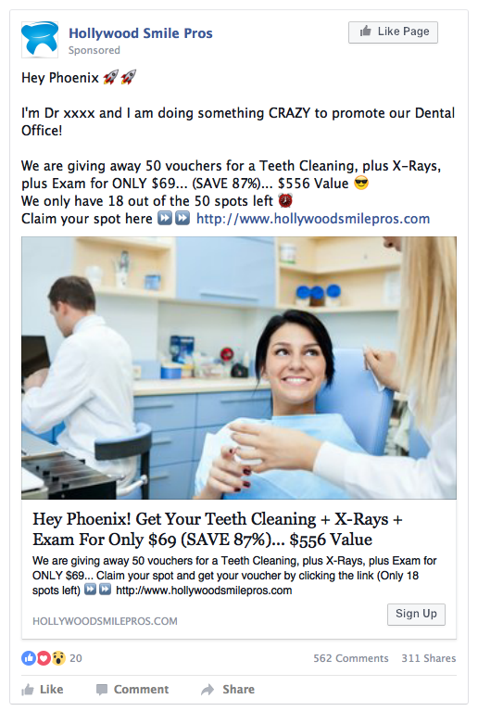

Optin Page (Image)

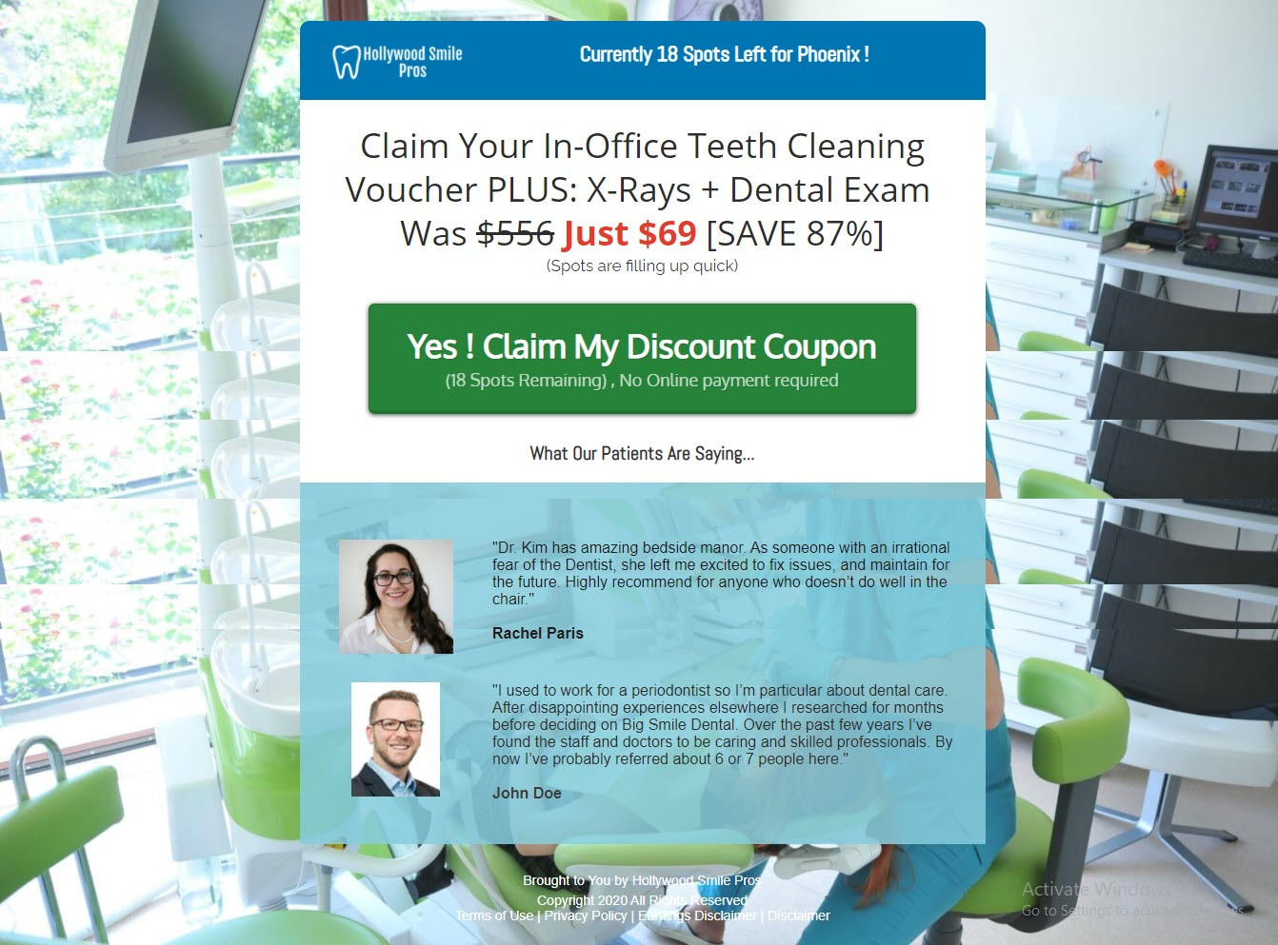

Pop-Up Box

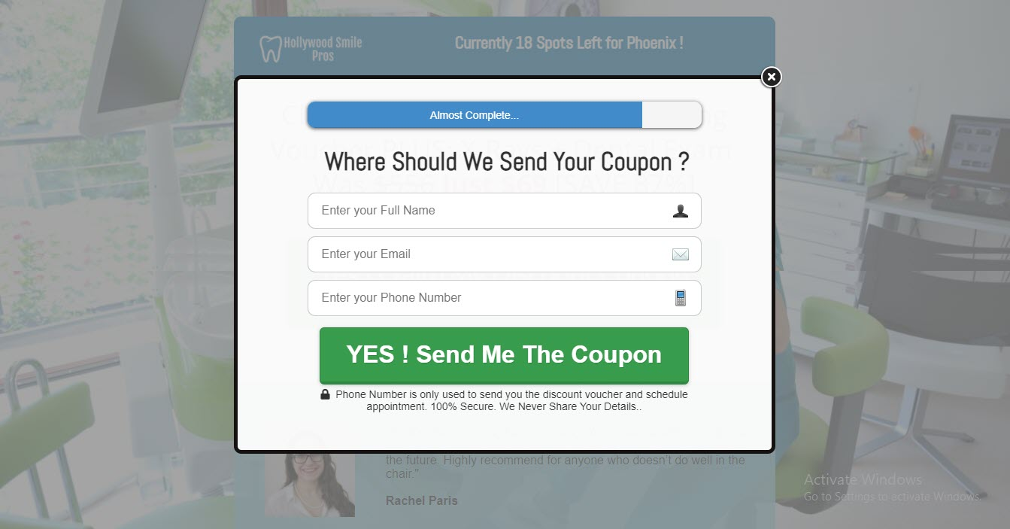
Thank You Page (Image)

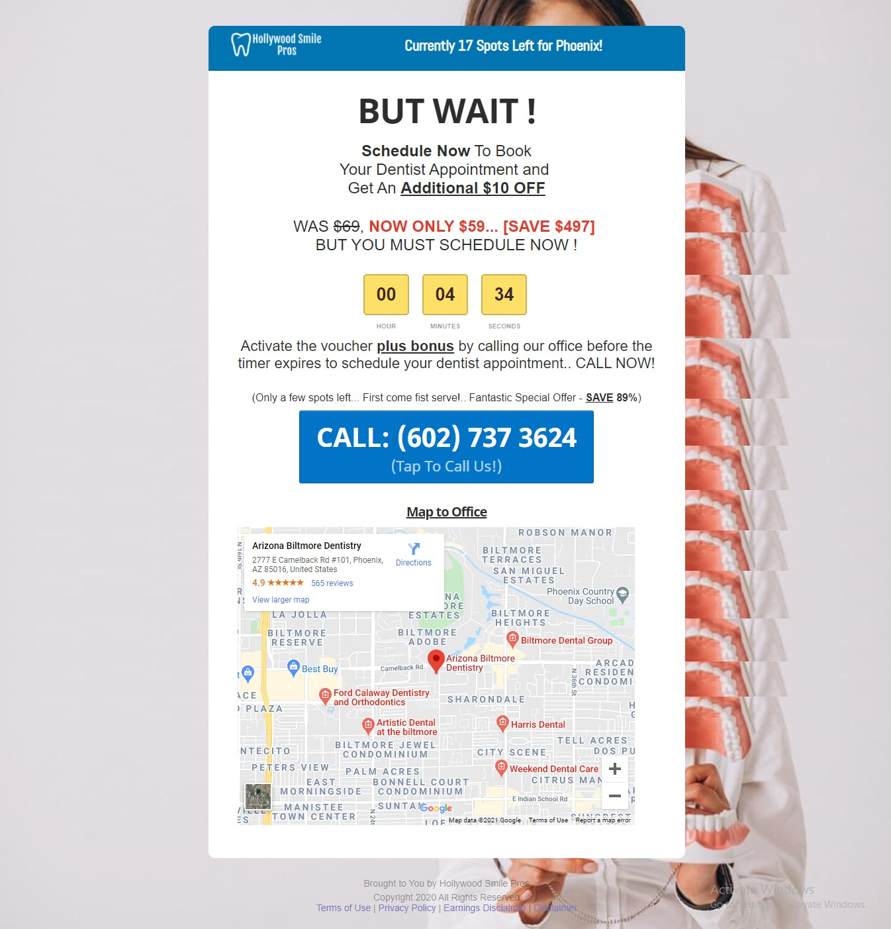

Chiropractor Funnel

Copy Funnel To Your Account:
https://app.clickfunnels.com/funnels/7072882/share/9srckem8vkw80w1

Niche: Chiropractor
Main Offer: 85% Off On Chiropractic Adjustment
Thank You Page Offer: Get an extra FREE Massage worth $105

Funnel Optin Page Example:
https://chriswintersemail.clickfunnels.com/new-patient-offer-ac

Funnel Thank You Page Example:
https://chriswintersemail.clickfunnels.com/new-patient-offer-a27980556szdsz

Video Example: http://ivantraining.com/kallzu/fam-vault-templates/

Ad Copy:

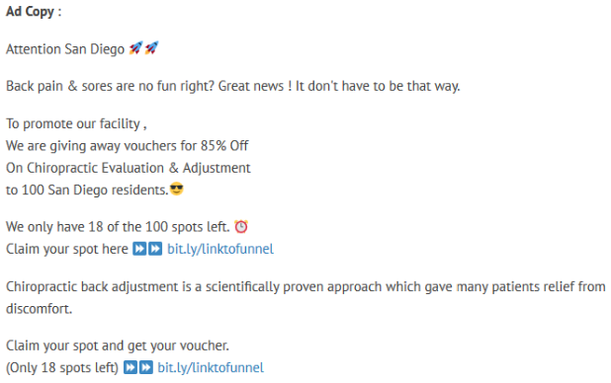

Optin Page (Image)

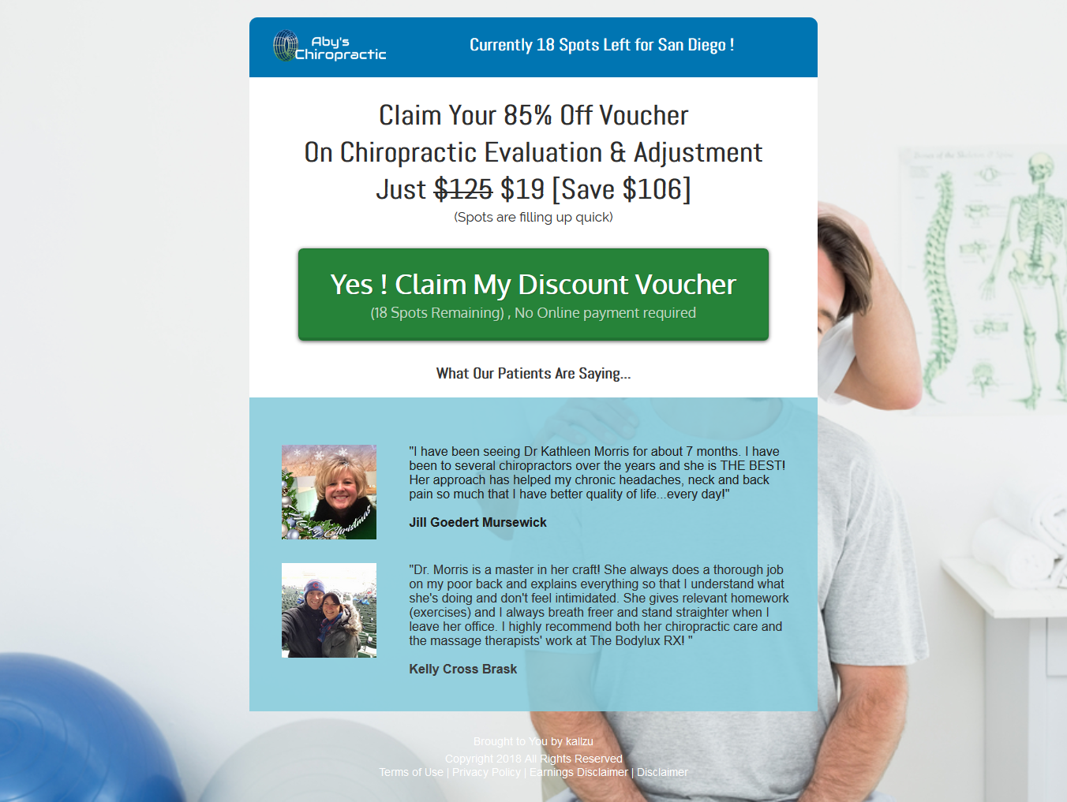

Pop-Up Box

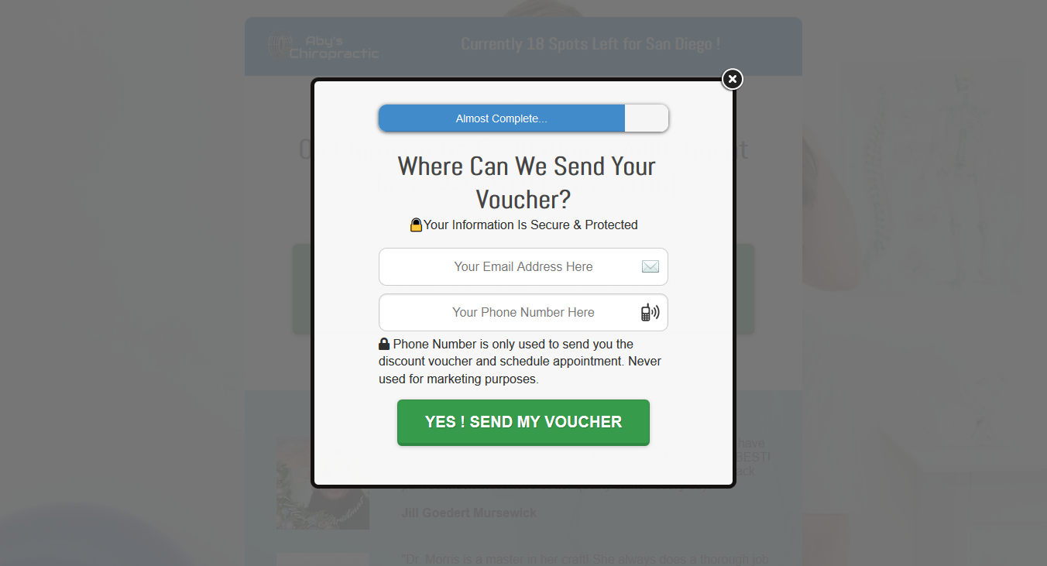
Thank You Page (Image)

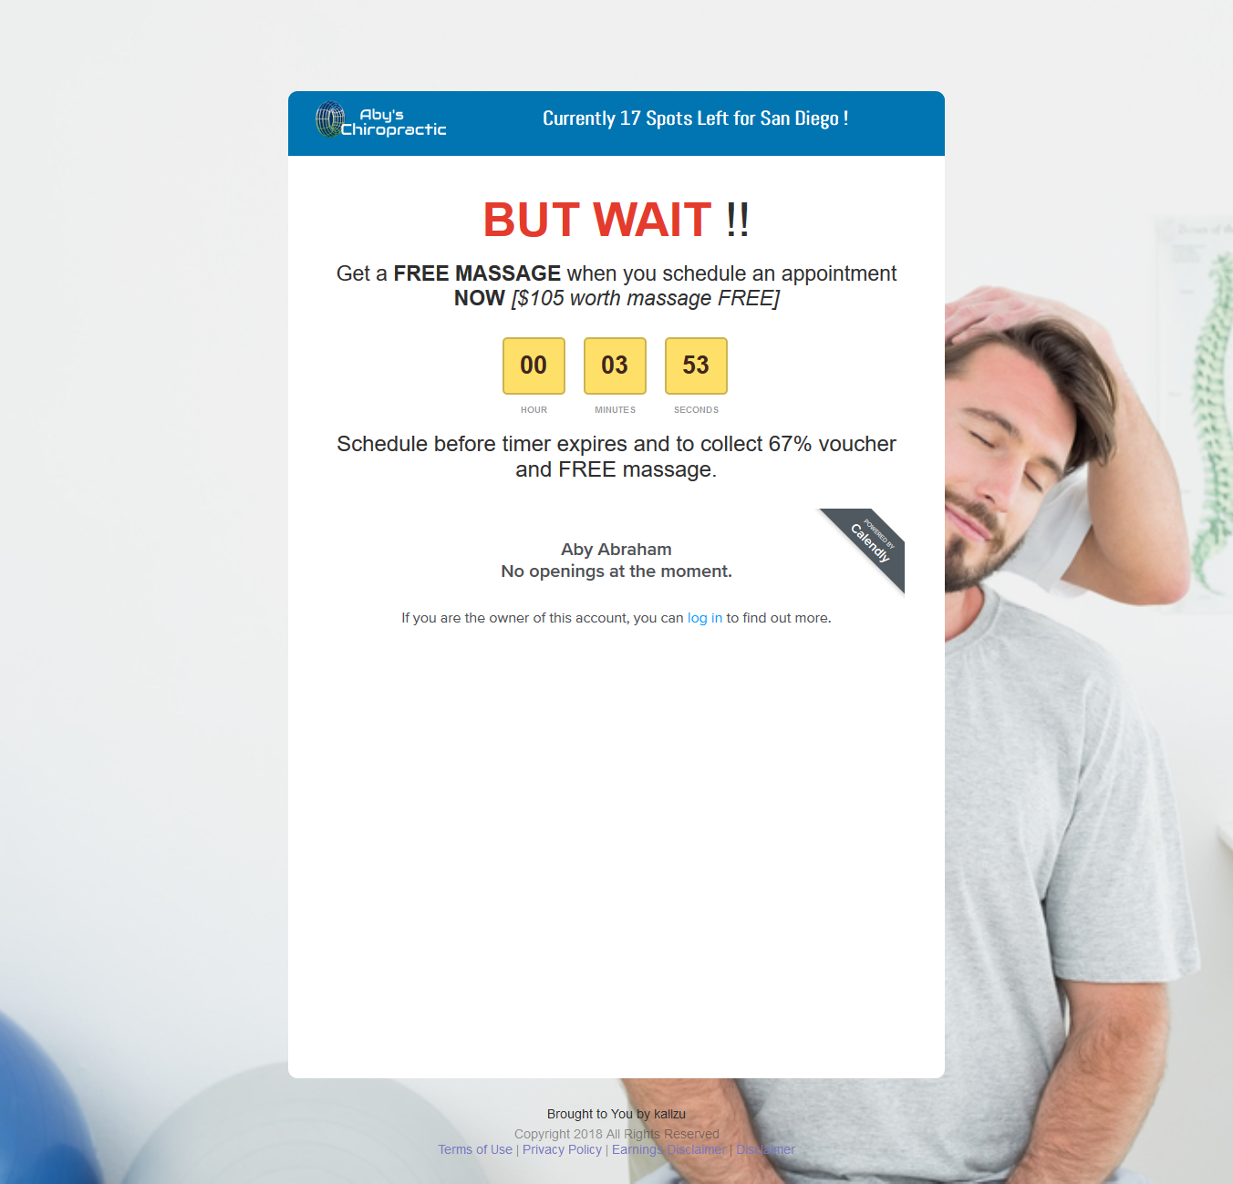

Cryotherapy Funnel

Copy Funnel To Your Account:
https://app.clickfunnels.com/funnels/7588868/share/1dyei6mejdyybha6

Niche: Cryotherapy
Main Offer: Cryotherapy Session for $27 Only
Thank You Page Offer: Schedule in the next 5 minutes to activate voucher

Funnel Optin Page Example:
https://chriswintersemail.clickfunnels.com/fam-cryotherapy

Funnel Thank You Page Example:
https://chriswintersemail.clickfunnels.com/new-patient-offer-a30524078

Video Example: http://ivantraining.com/kallzu/fam-vault-templates/

Ad Copy:
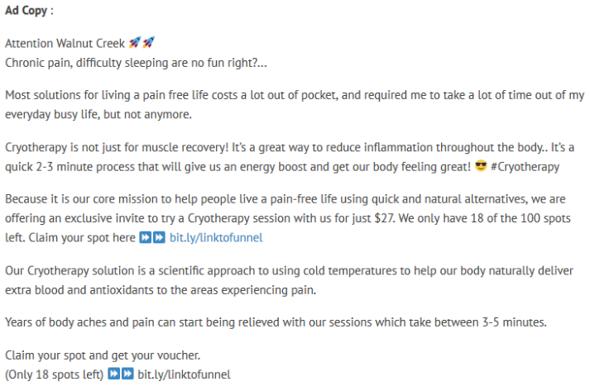

Optin Page (Image)

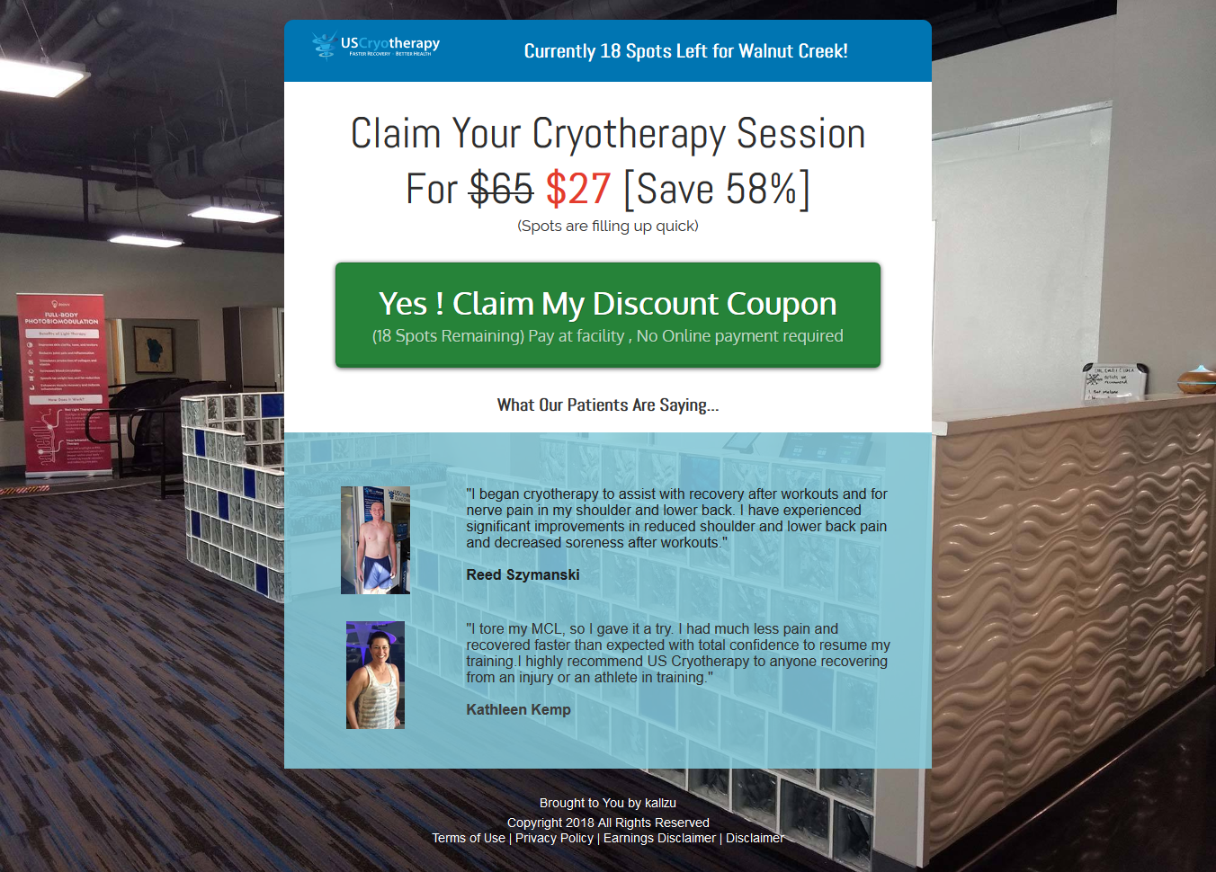

Thank You Page (Image)

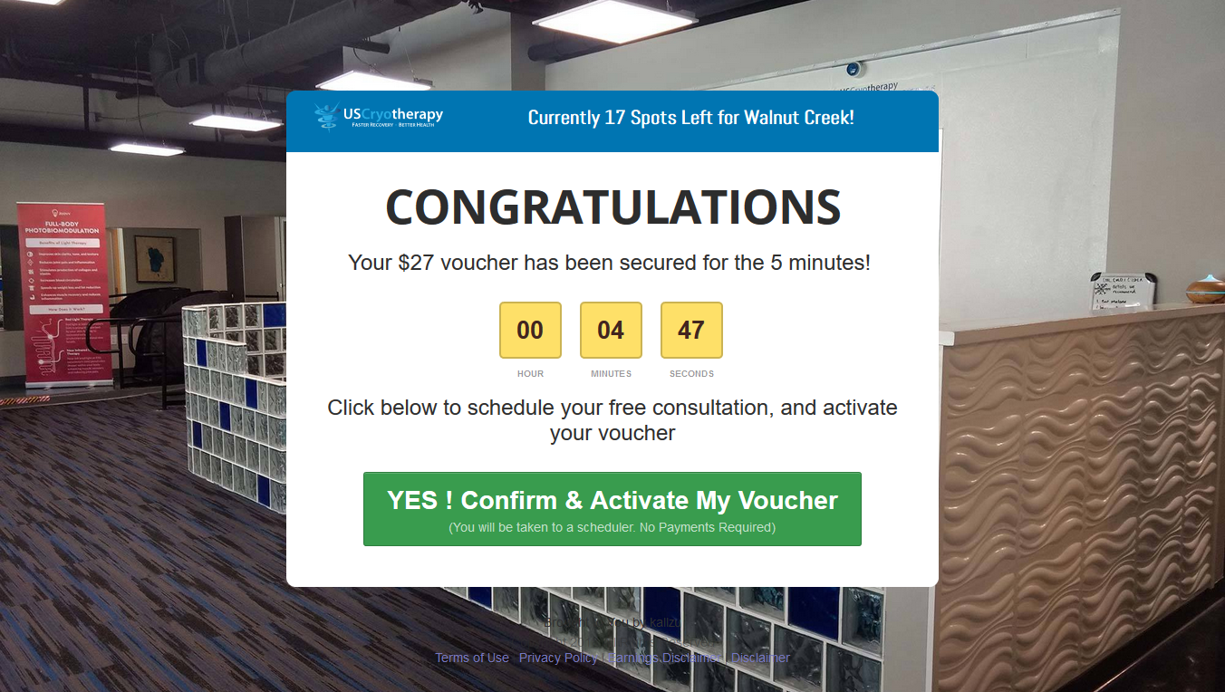
Jiu-Jitsu Funnel

Copy Funnel To Your Account:
https://app.clickfunnels.com/funnels/5002508/share/vl6r56v4a7vyzori

Niche: Jiu-Jitsu
Main Offer: 83% Off on The First Month Of Martial Arts Classes
Thank You Page Offer: Get A Free Uniform (Worth $89)

Funnel Optin Page Example:
https://chriswintersemail.clickfunnels.com/fam-jiu-jitsu-funnel

Funnel Thank You Page Example:
https://chriswintersemail.clickfunnels.com/posh-detailing-main-ty

Video Example: http://ivantraining.com/kallzu/fam-vault-templates/

Ad Copy:

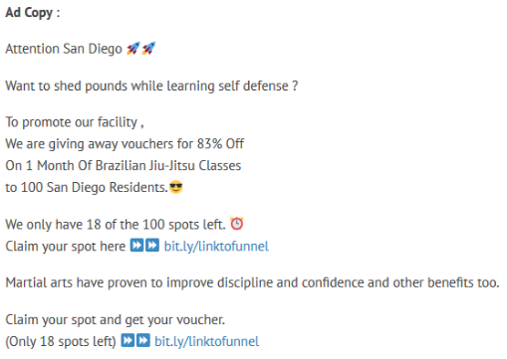

Optin Page (Image)

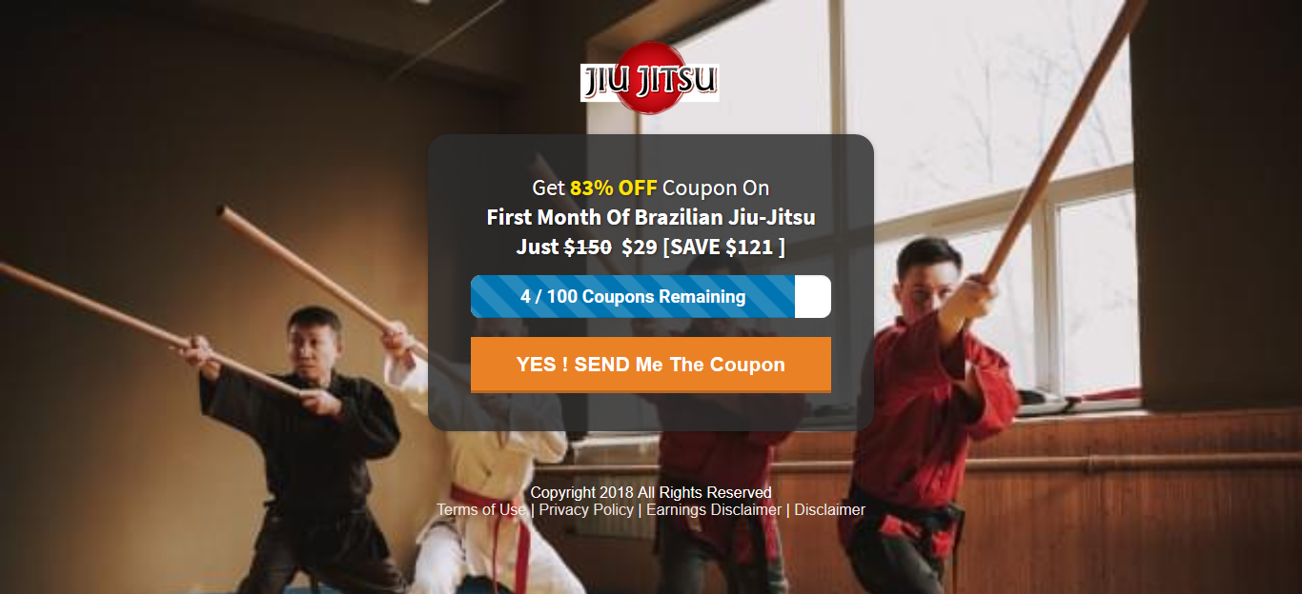

Thank You Page (Image)

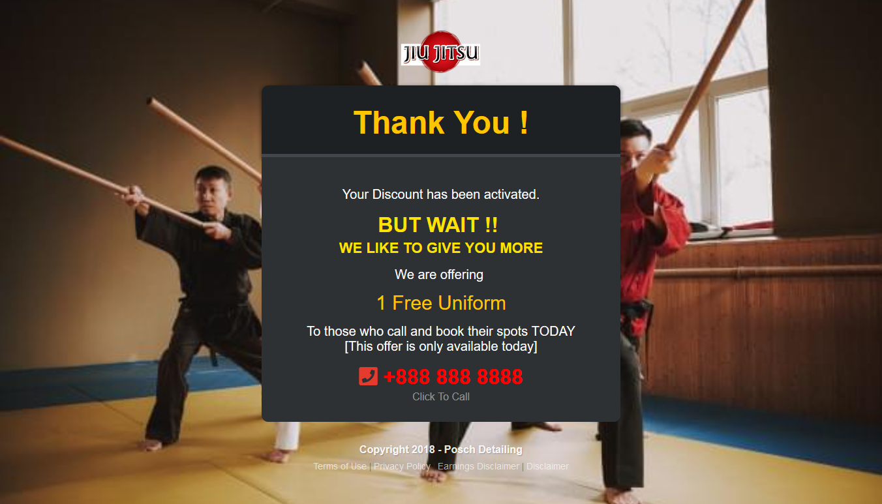

Kids Martial Arts Funnel

Copy Funnel To Your Account:
??????

Niche: Kids Martial Art
Main Offer: 8% OFF Kids Martial Arts Classes
Thank You Page Offer: Get A Free Uniform (Worth $89)

Funnel Optin Page Example:
https://chriswintersemail.clickfunnels.com/fam-martial-arts-asdsad3

Funnel Thank You Page Example:
https://chriswintersemail.clickfunnels.com/martial-arts-ty

Video Example: http://ivantraining.com/kallzu/fam-vault-templates/

Ad Copy:

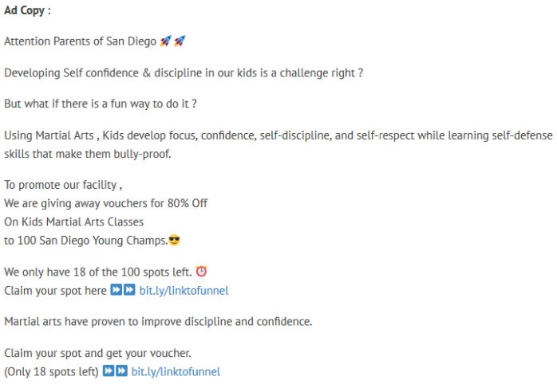

Optin Page (Image)

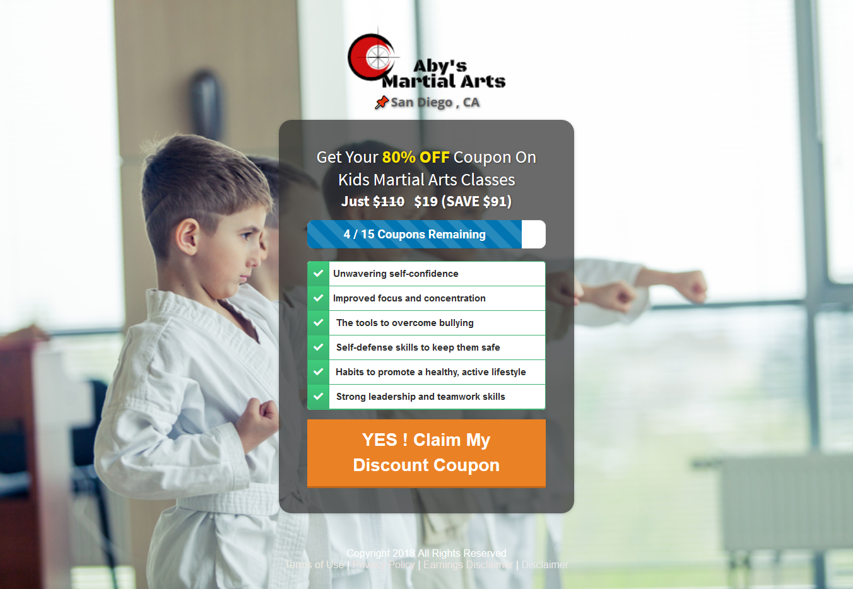

Thank You Page (Image)

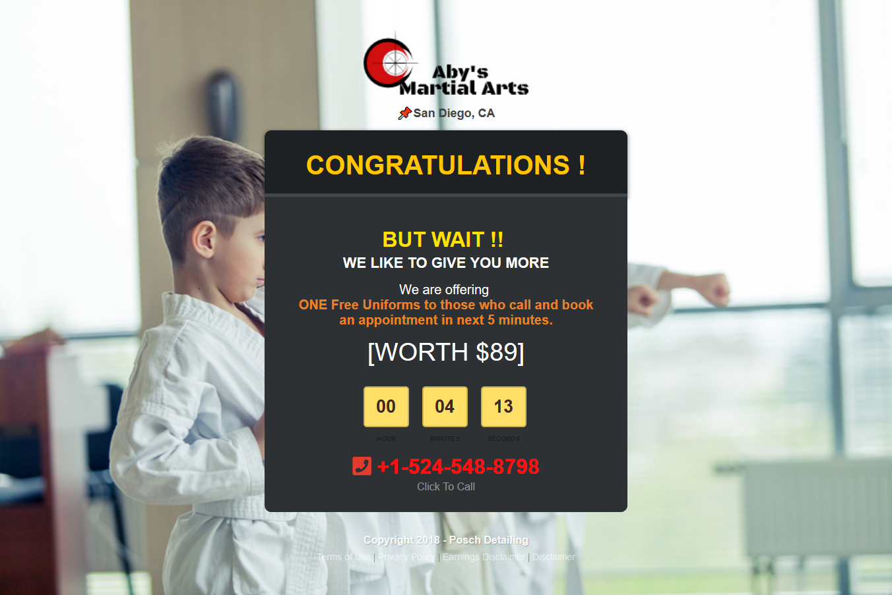

Crazy Discount Funnel (Dan Henry)

Copy Funnel To Your Account:
https://app.clickfunnels.com/funnels/4480711/share/639t66jgpetqf4v9

Niche: Dentist Example
Main Offer: Free Teeth Cleaning
Thank You Page Offer: Call Now & Get FREE X-rays!

Funnel Optin Page Example: Offline
Funnel Thank You Page Example: Offline

Watch Training Video: http://ivantraining.com/kallzu/fam-vault-templates/#offer6

Optin Page (Image)

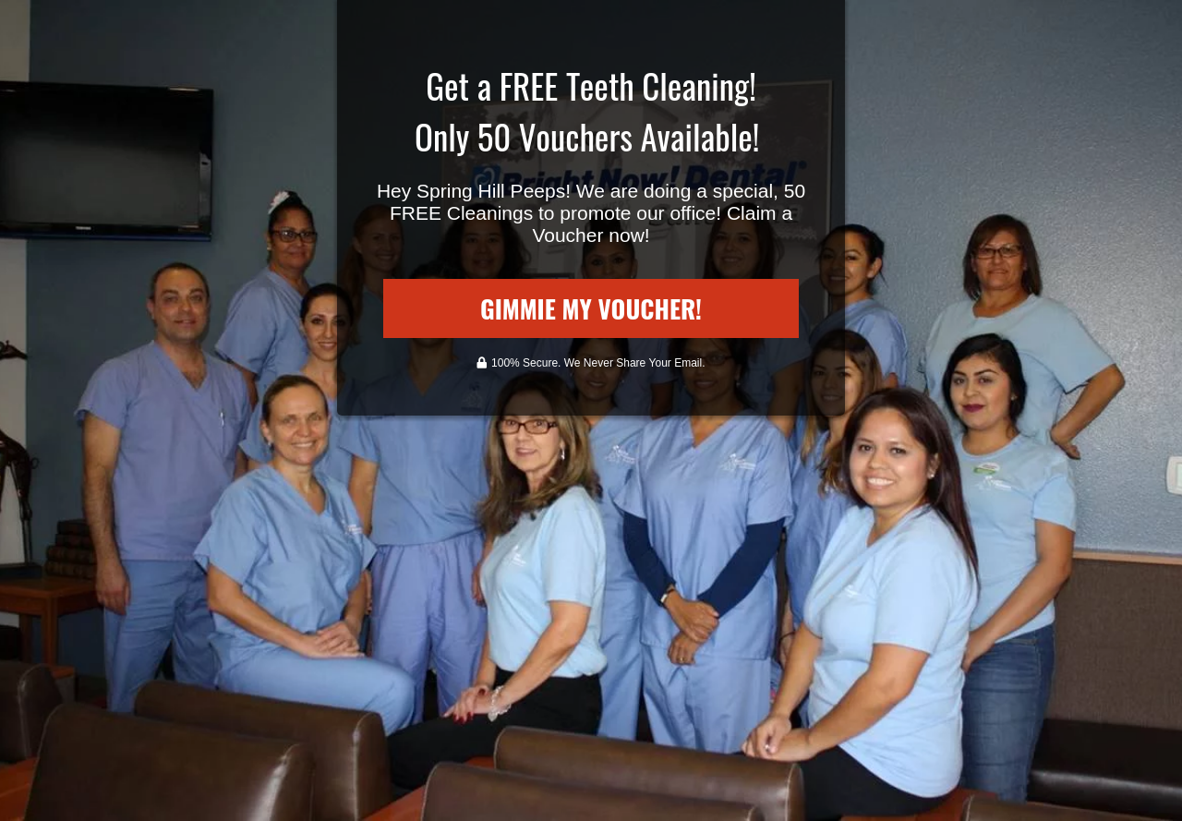

Thank You Page (Image)

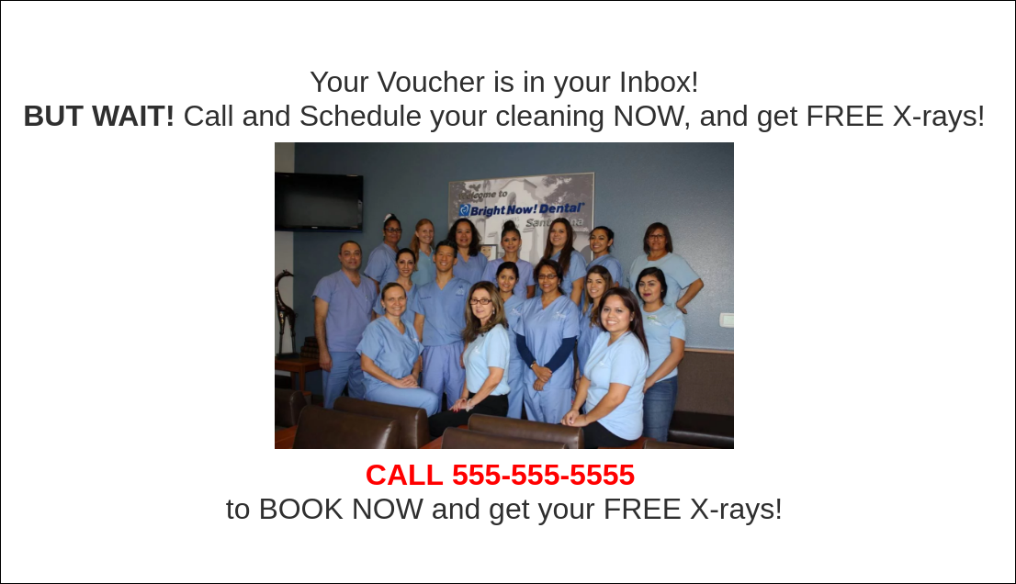

How To Edit Funnel Tutorials:

http://ivantraining.com/kallzu/clickfunnels/

0.) How to Change Absolute URL of ClickFunnels (http://ivantraining.com/kallzu/clickfunnels/#offer9)
1.) Introduction To Module 3
2.) Building Your Mock-Up Funnel
3.) Which Funnel To Choose
4.) Finding Resources For Your Funnel
5.) Update Logo of Your Funnel
6.) Troubleshoot Logos that look weird
7.) Changing the Background Of Funnel
8.) Editing Text Inside Funnel
9.) If the offer is not Free
10.) Editing Buttons In ClickFunnels
11.) Adding Videos To Funnel
12.) Editing Popup
13.) Adding Testimonials
14.) Footer Of Your funnel
15.) Editing Thank you page
16.) Thank You Page Offer change
17.) How To Add Calendly Appointment Calendar To Thank You Page
18.) Add Tap To Call Instead Of Scheduler
19.) Thank You Page Exit Popup
20.) Mock-up Funnel 2 (Auto Detailing to Martial Arts Funnel)
21.) Mock-up Funnel 2 (Auto Detailing to Martial Arts Funnel) Part 2
ACTIVE CAMPAIGN SOFTWARE

INDEX

- Connect ClickFunnels to Active Campaign
- Create List in Active Campaign & Connect to Funnel
- Add the Local Business as User in Active Campaign
- Install Automations
- Email: Sent to Business owner (notification of Lead)
- SMS 1: Sent to client with coupon
- SMS 2: Sent to Business owner (notification of new lead)
- SMS 3: Sent to Business owner again in 15 minutes (reminder to follow up with lead)
- Email series sent out to customer (5 email series) ??? (Need Templates)

Connect ClickFunnels to Active Campaign

http://ivantraining.com/kallzu/active-campaign/

Instructions:

- Log into Clickfunnels and have Active Campaign credentials ready namely "API & URL Key"
- We are going to connect Active Campaign account to Clickfunnels.
- Clickfunnels - Click on profile pic in top right corner and choose Account Settings... then on left choose "Integrations".
- Will give you a list of different email service integrations you already have connected, if any.
- Click on yellow button that says "Add New Integration".. find and click on Active Campaign... can also search for it in search bar.
- Will ask you for 3 things... "Integration Nickname" + "URL Key" + "API URL"
- Integration Nickname: Name which you give to your Active Campaign account...
- Example: "More Clients Consulting - Active Campaign Account" (name it anything you want)
- Make sure to include word Active Campaign in name, otherwise you will get confused when we connect the funnel.

Active Campaign:

- Need the "Plus-Plan" to be able to send SMS text alerts.
- Log into Active Campaign and at bottom left click on the "Gear" icon that says "Setting" and then choose "Developer"
- Here you will find the URL and API KEY
- API Key: insert into Clickfunnels.
- API URL: insert into Clickfunnels.
- Click on "Add Integration" and on the top right a box will pop us that says "Success"
- Now this Active Campaign account can be used in any funnel in Clickfunnels account.
- Next we need to create a "List" inside Active Campaign to collect all leads collected from funnel into this list... Go to next video.

Create List in Active Campaign & Connecting to Funnel

http://ivantraining.com/kallzu/fam-module-8-preparing-client-campaign/#offer6

Instructions:

- Here we are going to create a email list for business client in Active Campaign to receive leads.
- Then we will connect list to the clients funnel we built out in Clickfunnels.
- For every new client we have... we will create a separate email list and separate funnel and connect the 2 together.

Log into Active Campaign:

- Log into Active Campaign, on left hand side select 5th image that says "Lists"... then in top right corner click "Add a List" and box pops-up.
- List Name - (niche, client business name, city name) example: Martial Arts - Bob's Ju Jitsu - San Diego... (use same name used in Facebook)
- List URL - funnel URL of Opt-In page
- List Description - example: "Signed up for kids martial arts classes in Bob's Ju Jitsu Studio - San Diego"
- Click on "Add"... it will display in Lists section.

Log into Clickfunnels:

- Log in, and go to client funnel Opt-In Page... and click on "Edit"
- Top left click on "Settings" and choose "Integrations" box will appear on right side... make the following changes
- Select Integration: click drop-down and select "Active Campaign account"
- Action: click drop-down and select "Add to list"
- List to Add: lick drop-down and select "List name you just created"
- Once you click on that list name... green box on-top will appear that says CONNECTED!
- Then click outside that box... and on page click "Save".. finished

Now TEST:

- Visit the "Opt-In Page" and insert email plus details and press Submit... Should forward you to Thank-You page.
- Then go to Active Campaign, refresh page.. go to "Lists Page"... And you should see 1 contact under "Active Contacts"
- Can be a small delay.. so wait a bit then refresh and it will display
- And if you click on List, it will show you list of emails received with details you asked for on opt-in box.
- And if you click on actual email, it will show the whole profile of person.
- If these details appear... then you have tested and everything is working.

Add the Local Business as User in Active Campaign

http://ivantraining.com/kallzu/fam-module-8-preparing-client-campaign/#offer7

Instructions:

- WHY do we add a local business customer as a user inside Active Campaign?
- We do this because Active Campaign works in a certain way when it comes to SMS's
- Remember in your funnel which you create for your client, when a lead enters their details, email and phone number.
- You have to immediately send an sms to your client... asking them to follow up with this lead... This is very important!
- So for Active Campaign to do that, you have to ADD your client as a user inside Active Campaign.
- They do not have to log-in or have a password or whatever.
- Its just a rule in Active Campaign, if you have to send an sms to a client you have to add them as a user.
- You can give client access to their account. This way they can log in at any time and see how many leads we generated for them… Position it as a Bonus!

How to Add User:

- Log into Active Campaign, bottom left click on "Gear" icon which is Settings and select "Users"
- Inside Users - by default you will see a list of all users... in this case you will only have yourself as one user... Top right click on 'Add a new user" and box will pop-up.
- See image below
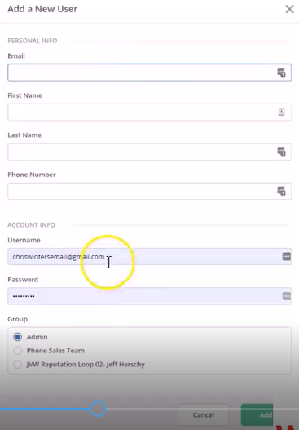

- Fill out the information
- The only thing that has to be correct is the Phone Number
- Everything else can be false... like
- Email: use something like Bob@My-Ad-Agency.com
- Aby recommends that we do-not actually add clients email, instead use a fake and do not give them the password.
- First Name: use clients real first name
- Last Name: type in city like San Diego
- Phone Number: use correct phone number, your using the number that will inform client with alerts of incoming leads.
- Username: use the false one you created
- Password: any random password you like (do-not have to give this password to client)
- Once complete... click on 'Add"
- And in Users page, you will see new user added to Active Campaign.
- Once user is added... we will be able to send sms notifications to client when leads Opt-In.
- In next video, we will set up sms notifications.
How Automations Work

http://ivantraining.com/kallzu/fam-module-8-preparing-client-campaign/#offer8

EMAIL: Sent to Business owner (notification of Lead)
SMS 1: Sent to client with coupon
SMS 2: Sent to Business owner (notification of new lead)
SMS 3: Sent to Business owner again in 15 minutes (reminder to follow up with lead)

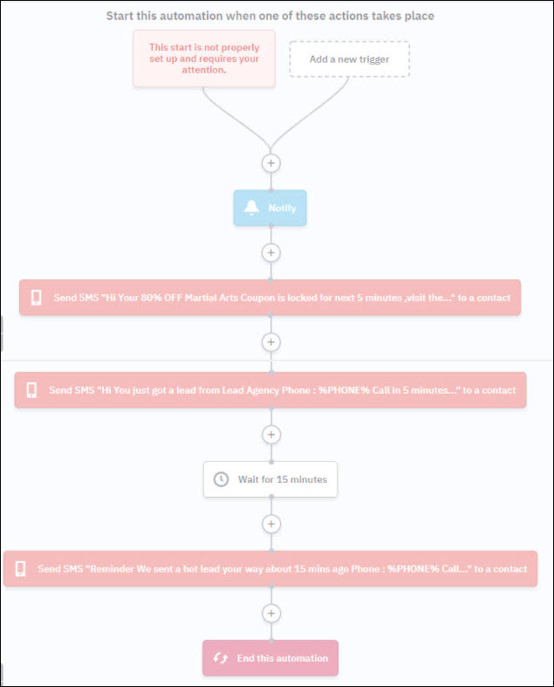

Notes: On How The Automation Works

- In earlier video we created a List in Active Campaign for client.
- When someone fills out Opt-In form, that lead gets added to client list.
- So the automaton starts, when contact subscribes to list... (automation gets activated)
EMAIL: Sent To Business Owner

- First thing that happens is an "Email" notification gets sent out to client, notifying of new lead that has come in.
- In automation, when you click on blue email tab (blue color = emails)
- It opens email notification, and box pops-up.

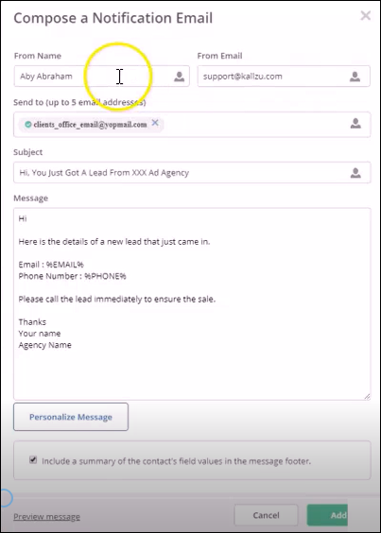

- Here you fill out details for email to be sent out (shown in next video)
- When email gets sent out to client... this is what email looks like.
- Image Below

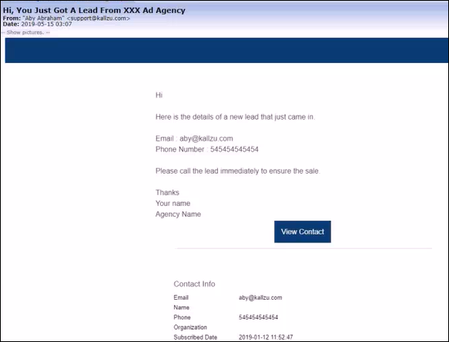

First SMS: Sent to Customer

- Next an SMS will get sent out to customer
- If you click on Red tab a box will pop-up where you can edit sms.
- SMS reads as follows

Hi
Your 80% OFF Martial Arts Coupon is locked in for the next 5 minutes.
Visit the link to activate the coupon before it expires.
http://bit.ly/2W1HrAp (This link takes them to the Thank-You page)
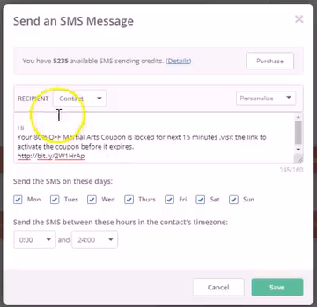

Second SMS: Sent Immediately to Business Owner Notifying of Lead

- Next an SMS will get sent out to business owner
- If you click on Red tab a box will pop-up where you can edit sms.
- SMS reads as follows

Hi
You just got a lead from, Ivan at "More Patients Consulting"
Name : %NAME%
Phone: %PHONE%
Call in 5 minutes while the lead is hot to close sale.

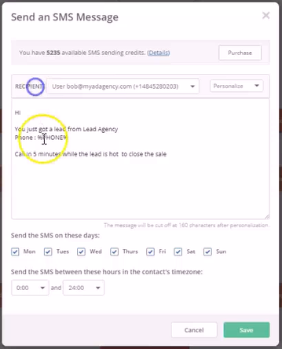

Then there is a Fifteen Minute Delay

Third SMS: Sent to Business Owner Again as Reminder (15 minutes later)

- Last SMS is sent out again to business owner, reminding to follow up with lead.
- If you click on Red tab a box will pop-up where you can edit sms.
- SMS reads as follows

Reminder
We sent a hot lead your way about 15 minutes ago.
Name : %NAME%
Phone: %PHONE%
Call while the lead is hot to close sale.

That's The END of the Automation.
Installing Automations

http://ivantraining.com/kallzu/fam-module-8-preparing-client-campaign/#offer9

Download Automation: Active Campaign Link

http://tplshare.com/4qsfzpz (Use this one)
http://tplshare.com/KU8LHpa (The one used in video, same as link above)

Requirements For Installation Of Automation

- You need a "LIST" created for client... And its connected to funnel.
- You have added a "USER" (with client phone number) in Active Campaign.
- Have the emails of you client to send notifications... (or use fake one to test)

Instructions: To Import Automation & Complete Wizard Setup

- Log into Active Campaign... then Automations... then Create an Automation... then Import an Automation... then copy and paste link in... then press Continue.
- Automation will import in... then click on Automation Setup Wizard "Get Started" button.
- And it will ask you a few questions to set up campaign.

Step 1: Start, Contact subscribers to a list

- Select List: Choose the list you created.
- Click on Next

Step 2: Send a notification email

- From name: enter my name
- From email: enter my email address
- Send to: email of my customer... If i want to add more emails, i can do that. (will support up to 5 emails).. so also add my own email.
- Click on Next

Step 3: Send an SMS

- Recipient: select clients user name
- Click on Next

Step 4: Send an SMS

- Recipient: again, select clients user name
- Click on Done

NOTE: Why Only 2 out of 3 SMS Settings

It did not ask for the SMS set-up in the middle, the reason for that is it’s automatically "assigned to contact".

NEXT: We Edit the Email and SMS Settings

Check Email LIST Setting: First Check That You Have Selected Correct LIST

- Log In: to Active Campaign, go to Automation's, choose our automation.
- Click: on white tab that says "Contact Subscribers" and make sure the correct email list has been chosen.

Email Settings: Sent to Business owner (notification of Lead)

- Click On: the blue tab that says "Notify Customers" and the email edit box will pop up.
- This is where we edit our email to be sent out to business owner. (diagram below)

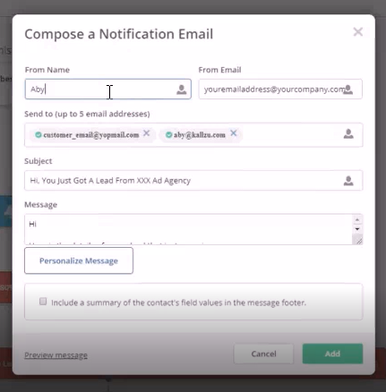

- From Name: Add your Agency email... ivanhq007@gmail.com
- From Email: Add your name... Ivan
- Send to (up to 5 emails): Add clients email + yours.. (plus any other like sales persons email)
- Subject: Hi, You Just Got A Lead From Ivan (More Clients Consulting)
- Message: see below

Hi

Here is the details of a new lead that just came in.

Name: %FULLNAME%
Email: %EMAIL%
Phone Number: %PHONE%

Please call the lead immediately to ensure the sale.

Thanks
Ivan
(More Patients Consulting)

- Personalize Message: If you wish to add a name field, all you need to do is type in Name into email... Then click on "Personalize Message" & choose "Full Name"
- And it will insert the code... The code is a dynamic changing variable that inserts client details from Opt-in form.
- TICK BOTTOM BOX: Make sure you tick the box that says "Include a summary of the contact's field values in the message footer"
- When you tick the box, it will send a summary of all the lead details at the end of the email.
- ADD: Once done click green "Add" button... done

SMS 1 Settings: Sent to client with coupon

- Click On: first red SMS button that says "Send SMS" and box will pop up
- Here we will edit the sms to be sent out to customer. (diagram below)

- RECIPIENT Tab: On top you will see this tab and make sure next to it you have chosen "CONTACT"... means it will get sent to person who filled out name and telephone number on our Opt-In Form in our funnel.
- This is an SMS that will get sent to that customer
- Credits: On the top it shows amount of credits available to send out SMS messages.
- If you do not have enough credits then you click on "Purchase" tab on right and purchase more credits. They are very cheap and its recommended that you have at least 500 credits... Buy in bulk.
- Message: type message in here... script below

Hi
Your 80% OFF Martial Arts Coupon is locked in for the next 5 minutes. Visit the link to activate the coupon before it expires.
http://bit.ly/2W1HrAp (This link takes them to the Thank-You page)

- Change Message: You will use above text to match your offer
- Link in SMS: The link has to be replaced with your Thank-You Page url... it needs to be shortened, so you use this service https://bitly.com/.
- Just copy url into bitly and it will create a bit.ly link which will forward to your Opt-In Page.
- Paste: that link into SMS copy.
- Select Day & Times: below the box is an option to select the days and times your SMS will get sent out.
- Choose your days: we will use all of them "Monday-Sunday".
- Choose your times: we will use entire day 0:00-24:00 (depends on niche, you can decide)
- If person opts in outside of our delivery times, then it gets queued up, and gets delivered the next morning.
- Save: click on green "Save" button

SMS 2 Settings: Sent to Business Owner (notification of new lead)

- Click On: second red SMS button that says "Send SMS" and box will pop up
- Here we will edit the sms to be sent out to business owner. (diagram below)

- RECIPIENT Tab: On top you will see this tab and make sure next to it you have chosen "USER - My Clients Name with Tel Number"... means it will get sent to business owner's telephone number.
- If you wish to test with your number... choose your details here.
- This is an SMS that will get sent to the business owner informing him of a new lead.
- Purchase Credits: On the top it shows amount of credits available to send out SMS messages.
- If you do not have enough credits then you click on "Purchase" tab on right and purchase more credits. They are very cheap and its recommended that you have at least 500 credits... Buy in bulk.
- Message: type message in here... script below

Hi

(You just got a lead from "Lead Agency Name")
You just got a lead from: Ivan at More Patients Consulting

Name: %FULLNAME%
Phone: %PHONE%

Call in 5 minutes while the lead is hot to close sale.

- Change Message: You will use above text to match your offer
- Select Day & Times: below the box is an option to select the days and times your SMS will get sent out.
- Choose your days: we will use all of them "Monday-Sunday".
- Choose your times: we will use entire day 0:00-24:00 (depends on niche, you can decide)
- If person opts in outside of our delivery times, then it gets queued up, and gets delivered the next morning.
- Save: click on green "Save" button

15 Minute Delay: If You Want To Change Time.. Click On It & Make Changes

SMS 3 Settings: Sent to Business Owner again in 15 minutes

(Reminder to follow up with lead)

- Click On: third red SMS button that says "Send SMS" and box will pop up
- Here we will edit the sms to be sent out to business owner. (diagram below)

- RECIPIENT Tab: On top you will see this tab and make sure next to it you have chosen "USER - My Clients Name with Tel Number"... means it will get sent to business owner's telephone number.
- If you wish to test with your number... choose your details here.
- This is an SMS that will get sent to the business owner reminding them to follow up with new lead.
- Purchase Credits: On the top it shows amount of credits available to send out SMS messages.
- If you do not have enough credits then you click on "Purchase" tab on right and purchase more credits. They are very cheap and its recommended that you have at least 500 credits... Buy in bulk.
- Message: type message in here... script below

Reminder

We sent a hot lead your way about 15 minutes ago.

Name : %NAME%
Phone: %PHONE%

Call while the lead is hot to close sale.

- Change Message: You will use above text to match your offer
- Select Day & Times: below the box is an option to select the days and times your SMS will get sent out.
- Choose your days: we will use all of them "Monday-Sunday".
- Choose your times: we will use entire day 0:00-24:00 (depends on niche, you can decide)
- If person opts in outside of our delivery times, then it gets queued up, and gets delivered the next morning.
- Save: click on green "Save" button

3 MORE STEPS REMAINING:

Rename Automation + Make Automation Active + Testing

STEP 1: Change the Name of Automaton to your client’s name.

- Example: "Bob Jiu-jitsu Studio - San Diego Lead Notifications - Automations" (just copy and paste your funnel name and paste into front part)
- Make Change: by clicking on name in top left corner, rename it and save it.
- This way we can easily find it from our list of automatons... You create one automaton for every client.

STEP 2: Make Automation Active

- In top right corner is a button called 'Active"
- Click on it... And that's it... The automation is ready.
- Job done!

STEP 3: TESTING (15:26 on video)

- Go to funnel and enter in fake details
- Then go to Active Campaign, Automations
- And see if contact was added to automation. (may have to wait a few minutes, then refresh)
- Then click on automation, so diagram shows up.
- And you should be able to see contact.
- Aby shows contact in 15 minute tab.. it says "Que (1)"

Another Way To Check Automations

- Is if you visit Automations Page again .. on the right side it will show a blue button with 1 contact displayed.
- Hover over blue button, and click on blue link that says "Contacts currently in the automation"
- And it will show a list of all the contacts currently in the automaton.
- You can then click on the contact and it will open profile.
- And look for the headline "Automations" under General Details section.
- If you click on box next to automations.
- It will open a box and beneath that box.. it will show a %.. like 57% Completion.. (which means this contact is 57% through the automation)

Check via Recent Activities

- If you x out of the pop-up.
- In client profile you can also see "Recent Activities" on right side with messages
- And it will tell you whats happening with this contact with actions taken.
- Read from the bottom and work your way up
- Example bottom message says, Subscribed to the list.
- The message above says, Entered Automation.
- Next message above says, Received SMS Message.
- The next one says, Triggered SMS message to Bob San Diego...and so on.
- So you can see exactly where they are in the sequence.

How To View a Diagram Representation

- Also if you want to see a diagrammatic representation of actions taken.
- While in the profile, you can again click on box next to Automation headline, and the box pops up.
- Bottom right is a button called "View" click on it.
- It will show you a diagram of how contact is passing through.

PLAY WITH TESTING

- Also test by setting up your telephone number in sms settings as the business owner
- And see if you are receiving those 2 lead notification SMS's and email notification
- Then replace them with actual business owners details again and test with your client
- Set him up, then while he is on the phone see if he is receiving those texts and email.
- Or test and phone him back after 20 minutes to see if its working... while you check Active Campaign.

MAKE SURE THIS IS WORKING PROPERLY... BEFORE SENDING TRAFFIC TO CLIENT FUNNEL!

(End of Setting Up Active Campaign)

Email Series Sent Out to Customer (Need Templates)

Email 1: xx

Email 2: xx

Email 3: xx

Email 4: xx

Email 5: xx

ROCKETIUM SOFTWARE (Make Video)

http://ivantraining.com/kallzu/fam-module-9-creating-the-ad/

INDEX

1.) Facebook Ads Compliance
2.) Why Make Video Ads & Funnel Congruency
3.) Video Slides Size & Length
4.) Easiest Methods to create video ad
5.) EXAMPLE: Chiropractor Video (15 seconds in length)
6.) Create Simple video with Rocketium (TUTORIAL)
7.) EXAMPLE: Chiropractor Video (57 seconds in length)
8.) Create videos with Rocketium Part 1 (Advanced Tutorial 1)
9.) Create videos with Rocketium Part 2 (Advanced Tutorial 2)
10.) Uploading video to asset library
11.) Using creative hub to preview the ad and video
12.) Writing the Ad

Facebook Ads Compliance

http://ivantraining.com/kallzu/fam-module-9-creating-the-ad/#offer1

Link To Read Policy:

https://www.facebook.com/policies/ads/

Why Make Video AD’s & Funnel Congruency

http://ivantraining.com/kallzu/fam-module-9-creating-the-ad/#offer2

Why Make Video:

- Video Ads get 20% more clicks and deliverability
- Better engagement
- Allow you to make audiences based on People who watch 50% - 100% of video
- Makes you unique
- Easy to create (easier than you think)

Funnel Congruency:

- Means using the same copy and words on your Ad, Opt-In Page and Thank-You Page.
- For Example: if you the word Voucher in your Ad... then also use that word in the funnel pages... do-not use another word like coupon.
- If you are offering 50% Discount on the Ad... then it has to be congruent and say 50% Discount on the funnel pages... very important.

Video Slides Size & Length

http://ivantraining.com/kallzu/fam-module-9-creating-the-ad/#offer3

Video Ad Specifications

- Square Type - Works in Facebook & Instagram
- 60 second duration (Max)
- Capture attention in first 3 seconds
- Recommended - Animated text over images/videos

Easiest Methods To Create Video Ad

http://ivantraining.com/kallzu/fam-module-9-creating-the-ad/#offer4

3 Methods To Create Video:

- Use existing video from client.
- Outsourcing video to freelancers like fiver, upwork etc.
- Use OFFEO or inVideo software (Rocketium was used for training)
- Allows you to create free video, will have a watermark
- Then pay Only $5 to have watermark removed
- Has a massive library of stock videos and images to use.

EXAMPLE: Chiropractor Video (15 seconds in length)

http://ivantraining.com/kallzu/fam-module-9-creating-the-ad/#offer6

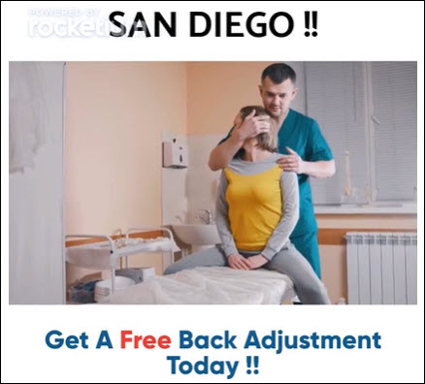

http://ivantraining.com/kallzu/fam-module-9-creating-the-ad/#offer6

Video Slides

- There are 2 video clips
- And 2 still pictures being used here to create the video.
- And 3 text messages being used... Sales Copy!

Text /Copy Used

- Slide 1: Attention San Diego !! .... Get A Free Back Adjustment Today !!
- Slide 2: We are giving away 100 Free Vouchers To San Diego Residents
- Slide 3: Click "Learn More" Button... Claim Your Free Adjustment... Only 18 spots remaining... Link in the description below


Create Simple Video With Rocketium (TUTORIAL)

http://ivantraining.com/kallzu/fam-module-9-creating-the-ad/#offer5

Can Create 3 Videos on Free Account!... Paid Plan $49 pm… Or pay $5 to remove watermark.

Website: https://rocketium.com/
Username: ivanhq1975@gmail.com
Password: 0126548995

Instructions: How To Use Rocketium

- Log into Rocketium: Create free account and log into dashboard.
- Top right click on blue button 'Create Video"
- Choose Template Called "Webinar Invite (Square)"
- Presented with a lot of templates... scroll down to "Technology" section and choose "Webinar Invite (Square)
- And click on blue button below called "Edit this video"
- Editor loads up with 2 screens... On left edit side, it show there are 3 steps.
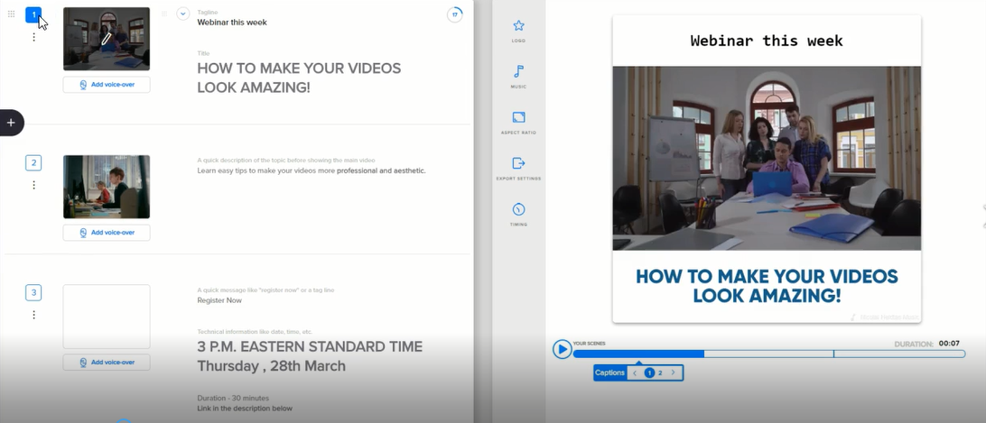

- How to Edit Video Template Size (Square): We recommend this template size because it is square... but if you choose one which is not square and you would like to make it square.

- Click on the third icon on right screen called "Aspect Ratio" and options will pop up... choose the square option.
- Now We Change The Text and Media

SLIDE 1:

Slide 1 Text: Attention San Diego !! .... Get A Free Back Adjustment Today !!

Instructions:

- Replace Video with Client Video: This is a video slide.. if you want to change the video
- On left edit side click on pencil image above the video clip: and box pops up with option on right side to "Replace Media"
- You can upload your clients video or other media: by clicking on arrow tab pointing upwards and uploading new video/image.
- Use Stock Video or Images: You can also replace with free video's and images from Rocketium.
- In the search bar: Type in a search for your niche like "chiropractor"
- And on right choose "Image" or "Video" tab: And all the videos or photos will appear for you to choose from.
- Choose the one you want: By ticking the box and press "Confirm" button in bottom right corner. It will automatically replace video with your choice.
- Play Video to See How it Displays: Once you have edited the text and have the correct video.
- Play and test video to see how it displays: With our example its way too fast for people to read our text.. So we need increase number of seconds for this video clip.
- Change Video Speed: Make sure correct slide is chosen, then on right window click on fifth icon called "Timing" and box pops up
- At very top is Duration with seconds: increase and change the seconds from example: 2 seconds to 7 seconds
- Play video to see if it displays better: Think 5 seconds will work better so make the change... play around until happy.

SLIDE 2:

Slide 2 Text: We are giving away 100 Free Vouchers To San Diego Residents

Instructions:

- Highlight Part of the Text: for example, want to highlight certain words to make them pop
- Highlight with mouse: The words "100 Free Vouchers" on left and blue ribbon with images will automatically appear when you select words.
- Click on 3rd image from the left called Highlight button: and it will automatically change text to blue
- Change Colour of Text: On right side screen, click on the text and "Edit Box" will pop-up
- Text colour is set to black: if you want to change the Highlight colour then click on tab, and change to red (any option you choose)
- Once selected you can close boxes out.
- Change Background: Can also change background by clicking on Background tab and choosing options.
- Slide 2 Media: Pencil icon, Change Media button, search bar type in "Chiropractic" and choose video...
- TIP On Movie Clip Selection: Choose video clips that are easy to do and not complicated stuff or anything that looks painful.
- Play Video From Beginning: and check timings and flow, on second clip check speed and make changes if necessary... was too fast, so changed from 2 seconds to 4 seconds and looks good.

SLIDE 3: Call To Action!

Slide 3 Text: Click "Learn More" Button... Claim Your Free Adjustment... Only 18 spots remaining... Link in the description below

Instructions:

- Highlight Words in Text: Can play with this.. change colours etc.
- Move Text Around: If you want to move text around, on right screen click on text box and move it where you want.
- Increase Timing of Video Clip: increase from 2 seconds to 4 seconds, so people can read it.
- Play Entire Video: Review to make sure its good... notices that preview highlights did not display, looks like a bug but should work when we export video.
- Change Font Size: if you want to change the font size, click on text and box pops-up, click on drop-down arrow next to font size.
- Example 13, and font size actions will display for you to choose
- So you can change font size to all caps, medium size etc... Plus at top is a slide bar to increase or decrease size of text.
- Change Text Font: while in pop-up box can also change font type by clicking dropdown next to current font and change with options provided.
- 15 Second Minimum Video Length: Make sure your video is at least 15 seconds in length, adjust timings on slide if needed... And under 60 seconds maximum.
- Change Music: if you want to change the music, on right screen click on second icon called "Music" and a list pops-up with many free tracks to choose from.
- In top right corner can choose the Genre and choose a track.
- You can also upload your own music
- NOTE: if you do not have the rights to the music....DO-Not use it you will get into big trouble... Instead choose from Rocketium free music list.
- Finalize: Play one last time and make sure you are happy with video.

EXPORT VIDEO:

- Click Next Button: In top right corner of page is a green button called "Next"... click on it .
- Will be redirected to a page that says "Generating Your Video".
- Go To Home Page: Can then click on top left corner and go to home page (also clicked on 2nd icon that looks like grid) and once video is generated will see it displayed and published.
- Notification: Bottom left will also see a notification that video is published.
- View Video & Download: To view the video hover over it and press play button, it will open in new tab and press play... and if you want to download the video can click on download arrow on right side.
- Watermark: The video has a watermark of Rocketium. To remove it and have all rights to video & audio.
- Click on blue button beneath video called "Remove Watermark" and click on $5 to pay and remove it
- Very sweet deal... Most other software's will charge you a monthly fee!
- This Is The Short Version Tutorial: On how to make a 15 second video
- To create a longer video (57 seconds), follow tutorial videos below.

EXAMPLE: Chiropractor Video (57 seconds in length)

http://ivantraining.com/kallzu/fam-module-9-creating-the-ad/#offer8.1

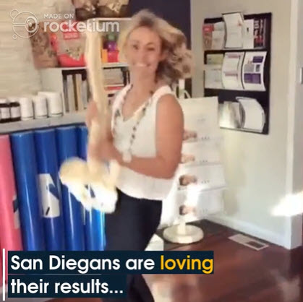

http://ivantraining.com/kallzu/fam-module-9-creating-the-ad/#offer8.1
Video Slides

- There are 10 video clips being used here to create the video.
- And 14 text messages being used... Sales Copy!

Text /Copy Used

Slide 1: San Diego !! ... Say Good Bye To Back Pain
Slide 2: Last month we helped 193 San Diego Residents
Slide 3: To Find Relief from Body Aches, Neck Pain & Back Pain
Slide 4: AND WE WANT TO Do MORE...
Slide 5: To Celebrate Our Anniversary
Slide 6: We are giving away 85% OFF ON Back Adjustments
Slide 7: To 100 San Diego Residents
Slide 8: Our Experienced Experts Perform a Thorough Exam
Slide 9: And finds the root cause of discomfort
Slide 10: An adjustments for the appropriate area is applied
Slide 11: To give pain relief to the patient
Slide 12: San Diegans are loving their results...
Slide 13: BUT NOW, THERE ARE JUST 18 FREE VOUCHERS LEFT BEFORE THE OFFER EXPIRES
Slide 14: CLICK LEARN MORE AND CLAIM YOUR VOUCHER BEFORE THEY ARE GONE

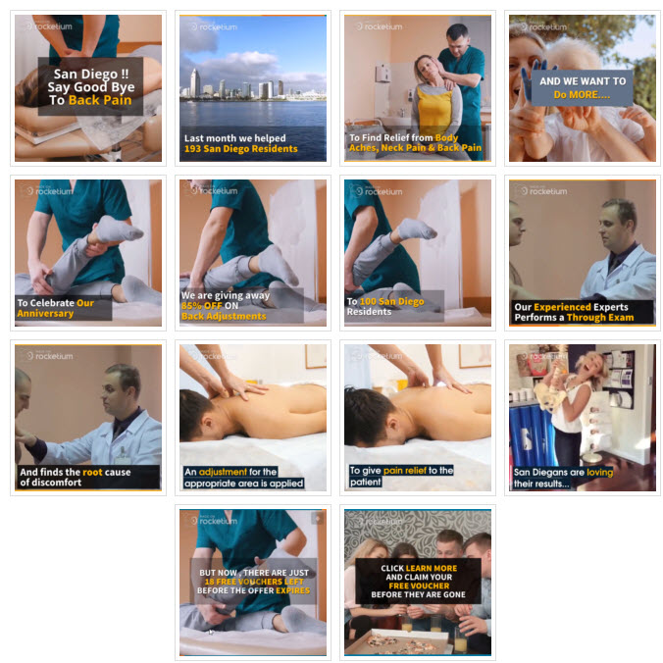

Create Videos with Rocketium (Advanced 1 & 2)

Too Expensive & No Longer Able To Create FREE Demo Video

REPLACE: Rocketium with software called inVideo.io

COST: (inVideo.io)
- Free: Can create free video with watermark
- Monthly Paid Plan: $20 per month
- Yearly Paid Plan: $120 per year (Save 50%)

https://invideo.io/make/facebook-video-ads/

Uploading Video To Asset Library

http://ivantraining.com/kallzu/fam-module-9-creating-the-ad/#offer10

Instructions

- First need an Mp4 file & rename it so its relevant to client
- Once uploaded am unable to change name of video in Facebook
- Name Formula: Niche name + City name + Client name
- Example: Chiro, San Diego, Total-Balance Chiropractic
- Open Business Manager: (business.facebook.com)
- Choose Correct Ad Account: (hamburger, business settings, ad-accounts & choose correct one, top right click "Open in Ads Manager")
- Go To Videos: Again click on hamburger, under Assets Column click on "Videos"
- Upload Video: Click on Upload Videos, select video and click on Open.. and it will upload.. then click on OK
- Refresh Page: Refresh page to see that its uploaded, then open video and play video in FB
- TEST: Always make sure to watch video in full to make sure its uploaded properly, and to make sure you have uploaded the correct video.
- DONE: Once you have uploaded video, you will be able to use video in actual Ad we create.

Create: Business-Manager Account

http://ivantraining.com/kallzu/fam-module-7-facebook-ad-account-setup/#offer1

Instructions: To Create Facebook "Business Manager Account"

- Type url into Google: https://business.facebook.com/create
- Click blue button "Create Account".. top right corner
- Box pops-up that says "Create your Business manager Account"

Create Your Business Manager Account: Fill out form

- Your business and account name: Your agency name here example "More Clients Consulting"
- Your name: enter you name "Ivan du Plessis"
- Your business email address: enter email address.. it is recommended to give an email that has a custom domain like "Ivan@MoreClientsConsulting.com"... but a gmail will also work.
- Click "Next" button: and next box pops up called "Add your business details"

Add Your Business Details: Fill out form

- Country: United States
- Street Address 2/locality: Suite #K230490, 13820 NE Airport Way
- Town/City: Portland
- County/Region: Oregon
- Postal Code: 97251
- Business phone number: (503) 461-4277
- Website: www.MoreClientsConsulting.com
- Business use: Choose Option 2 that says "Provide services to other businesses.
- Click "Submit" button: and that will create account.. a box will pop-up that says "More Clients Consulting" has been created!

Email Process: Need to confirm email address

- There is an email confirmation process where they ask you to confirm email... if using Gmail make sure to check the social or promotions tab.
- When you click on the blue button on the email that says 'Confirm Now" it will open up your new "Business Manger Setting Page"
- And you will see a "Green Tick"... and it will say "Your new address has been confirmed".

To Access Business Manager Account: How to navigate to account

- You can type in business.facebook.com into Google... OR... Log into your private Facebook account and click on "Drop-Down Arrow" in top blue menu bar and choose Business Manager.
- Once in account you can do the basic things like add a Cover Photo and add anything else you need... self explanatory, very easy to do.
- JOB DONE!

Ivan Note: Details on my Business Manager Account

- I have registered account using my "USA Mailbox Address" from https://www.reship.com/
- Am using an Portland Oregon Twilio Number that matches address... Number forwards to my Philippines telephone number.
- I added a South African Savings Card, with Rand denomination for AD-Set 1 account.
- Am accessing Facebook on a Philippines IP address (live here)
- SHIT.. i wonder if the card and IP address could flag my account?
- We shall see.

Create: AD-Account

http://ivantraining.com/kallzu/fam-module-7-facebook-ad-account-setup/#offer2

Instructions: How to Create New Ad-Account

- For every new "City" i target.. I would need a new Funnel targeting that specific city.
- I would also be working with a new client... And would need to create a "New Ad Account".
- Open Business Manager, click hamburger.. click Business Settings... (This is like a central hub or everything)
- On left click "Ad Account"
- Click on blue drop-down button click "Add" ... and there are 3 options.
- Add an account... OR... Request Access to an Ad Account... OR... Create a New Ad Account
- Choose "Create a New Ad Account"

Ivan Note: PROBLEM

- I have already created One Ad Account.
- When i try to create another one.
- Two of them a grayed out, not allowing me to choose "Create a New Ad Account"...
- Why is that?... Only giving me the option to "Request access to an ad account"...
- Does not seem right to me.
- Not Sure Why?

------- I am having trouble creating a Second AD-Account, only giving me 1 out of 3 options.
------- Only option i have is to "Request Access To An Ad-Account"
------- This is also where i would set up the client’s credit card for Ad-Budget
------- When i created my fist Ad- Account... i set up the new Ad-Account with my own card xxxxxxdetails. (South Africa Savings Card)
------- Used a Philippines IP address… where I am located.
------- But using a USA physical address… Clients I serve are from USA
------- I Think this is causing the problem… could be getting flagged?
------- My GOAL: Is to get my first client and run their campaign.
------- So, what do i do here... shall i delete the first existing ad-account i set up... it has my xxxxx card attached.
------- And try creating a New Ad-Account with first client’s card attached for payment?
------- Did reach out to groups, and they said I need to spend a bit on 1st account to unlock.

Create a New Ad Account: Fill out form

- Ad account name: name it something that makes sense to me.
- Advertising on behalf of: leave it, will automatically fill in my business manager name.
- Time zone: make sure its your time zone
- Currency: Important can-not be changed once ad account is created. Make sure to select the currency of your card being billed... why... because when you increase your spending your gonna get hid hard by currency conversions that will add up, and it will hurt real bad. So for me, a South African card.. so use Rand currency.
- Payment method: he did not mention this one.
- Click "Create Ad Account"
- Once Ad Account is created you will see a pop-up screen that says" Add People".. but there are no people to add, this is because it's a new Ads Manager account and the so called people is you, don't have team mates or anything like that... So you can click on "Skip".
- Window will pop-up that says "Well done" and you can press Close
- DONE.. you have created an account!

To Access or View your Ad-Account: How to navigate to Ad Account Page

- Make sure you are in "Business Settings" and click on "Open in Ads Manager" tab in top right and it will open in Ads Manager.
- Next we need to add a card as payment method.

Add Payment Method: To AD-Account

http://ivantraining.com/kallzu/fam-module-7-facebook-ad-account-setup/#offer3

Instructions: How to Add a Payment Method To Ad-Account

- Navigate to Business Manager, hamburger, Business Settings (which is your central hub)
- On left side click on "Ad Accounts" to view the Ad-Account.
- We only have 1 Ad-Account, so we only see one account in column... if we have more accounts they will be listed here.
- We select Ad-Account, and click on drop-down button in top right that says "Open in Ads Manager" and choose "View Payment Methods"
- It will open a "Payments Page" and you can click on "Add Payments Method" to add a payment method.

Adding Payment Method Form: Fill Out Form

- When adding a payment card: There are different options depending on the country you are from... Example: you may or may not have a PayPal option, Facebook Coupon and in USA they have Bank Transfer option.
- Enter your Card details: once done.
- Click "Continue".. and it will add your card.
- Once you add it.. you will see your card number, and also see a Edit/Remove button to make changes.

It Is Recommended to Use "ONLY ONE CARD" per Ad-Account

- Do not use same card for multiple accounts... It is possible.. BUT we DO-NOT recommend it.
- The reason for that is every payment method is linked with an Ad-Account.
- If it is linked to multiple Ad-Accounts then all those Ad-Accounts will be tied up and if something happens to one Ad-Account.
- For example one of your Ad-Accounts gets suspended... Then ALL the other Ad-Accounts which use the same Credit Card Number will be suspended as well.
- Not Good!
- Take Away: Always use a New Card for a new Ad-Account.

Create Master Facebook Page (To Advertise From)

http://ivantraining.com/kallzu/fam-module-7-facebook-ad-account-setup/#offer4

NOTES: On Master Facebook Page

- So what is a Business Master Page?
- Its normally a page that you own that you create, and you will be using that page to run Facebook Ads for your clients who are on Free Trial.
- So you might be wondering... I heard we need to request access to a business Facebook Pages and we run the ads through their pages... Your right that can be done.
- But doing it our way, is much easier and a better approach.
- Let me explain why... Lets assume you land a Chiropractic client "Bob from San Diego" and he has a Facebook Page called "Chiropractic San Diego"
- When you land him on a Free Trial, you will have to request access to his page and properties... Chances are Bob does not have a clue on how to give you access, so you will have to teach him... and even if you teach him, he might probably make some mistakes.
- All these are frictions, and when there is friction in business... You lose money!
- So to avoid all that.. What you could do is have a "Master Facebook Page" that says "Chiropractic Pros" and you can create your own AD, and run that traffic to a Funnel which you created.
- ALL Bob needs is the leads right... So you can send him the Leads through Active Campaign.
- So you do not have to request access to Bob's Pages or Pixels or anything.
- You can do it all on your end... And once the Trial is complete and Bob agrees to sign up as a paying client with you.
- THEN you can teach him all that and request access to his page and all that good stuff.
- But before, we recommend you create your "OWN Master Facebook Page" and start ads with the Master Page.
- And another huge advantage of this is... You can use the same Ad over and over again for multiple people in the same City.
- So if Bob says.. oh i did not like it... you can use the same Ad for Jon from the other end of town.
- Since you own the page, the asset... you can control it.

Instructions: How to Create a Master Facebook Page

- Open Business Manager, hamburger, Business Settings, on left side select "Pages"
- Click blue button "Add" and gives you 3 options... Select "Create a New Page"
- Box pops-up called "Choose a Category'... giving you options... Select one... he went for "Cause or Community" ... Click on it.
- Box pops-up called "Create Page"... enter a Page Name: should be something closely related to your niche... example "Chiropractic Pros"... it's like a Brand Name... then click "Create Page" button
- And that will create the Page inside my Business Manager. and it will appear as a "Page" inside Business Settings, Page section.
- Now ALL the Ads i create for my trial clients will run from my Chiropractic Pros Page... and this way you control the asset and there is no friction, having to teach and struggle with clients.
- Once page is created.. go into page and add a profile pic and banner and add a bit on info to make it look a little bit real.. Do not have to do much here... just add a few things here... easy to do, self explanatory.

Create the FB Advert

http://ivantraining.com/kallzu/fam-module-9-creating-the-ad/#offer12

Log into Business Manager - http://business.facebook.com
Username - ivanconsulting16@gmail.com
Password - Idp32291%

Using Creative Hub To Create & Preview Ad

http://ivantraining.com/kallzu/fam-module-9-creating-the-ad/#offer11
http://admocks.adparlor.com/#facebook/website_clicks/image

Instructions

- Best way to stay organized is to create mockup-ads for clients in Creative Hub inside Facebook
- Can then copy and paste into Ads-Manager when ready
- Business Manager: log into Business Manager (business.facebook.com)
- Creative Hub: click on hamburger and select Creative Hub
- Benefits: Can name your Ad, and view how ad will display on desktop and mobile
- Preview: (top right down arrow), can choose "Open in new tab" to preview ad
- Create Project: click on Create Project, then name it, under Project Team can add members (leave blank) and click Save.
- Create Mockup: top right click on green button (dropdown) that says Create Mockup and under Facebook heading, choose either "Single Video" or "Single Image"
- Name It: click on Untitled and name the mockup, like clients name and city
- Page Name: Clients Business Name or anything i want
- Page Profile Pic: Logo or Image of Owner
- Ad Content Text: Advert copy goes here
- Select Video: choose video you created and uploaded to asset library or import a video, select one that is pattern interrupting
- Thumbnail: need to choose attention grabbing thumbnail from video
- Customizing Video: next to video click on Customizing Video and FB will show multiple images from video, select one that is pattern interrupting and stands out, that will trigger curiosity.
- Preview: Will start populating in right hand side
- Website URL: add the url of your funnel opt-in page (ClickFunnels url works fine, if you want can use your own url)
- Preview URL: click on Preview URL and make sure it takes you to correct funnel page... very very important!
- Display Link: normally leave it off, because FB had some requirements for this and if you put the wrong kind of display link, they will disapprove the ad. Leave it and let FB do what they want there.
- Headline: Add headline copy
- Newsfeed Link Description: Add copy here (short description of the offer beneath headline)
- Save: click on save on top right.. mockup complete

CHIROPRACTOR ADVERT

OFFER THAT DELIVERED 136 PATIENTS!!!
(Wow, Proof Right Here)
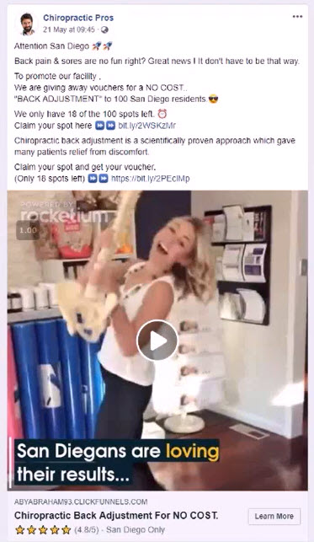

COPY FOR ADVERT

Attention San Diego 🚀🚀

Back pain & sores are no fun right? Great news ! It don't have to be that way.

To promote our facility ,
We are giving away vouchers for a NO COST..
"BACK ADJUSTMENT" to 100 San Diego residents.😎

We only have 18 of the 100 spots left. ⏰
Claim your spot here ⏩⏩ bit.ly/2WSKzMr

Chiropractic back adjustment is a scientifically proven approach which gave many patients relief from discomfort.

Claim your spot and get your voucher.
(Only 18 spots left) ⏩⏩ bit.ly/2WSKzMr

Headline: Chiropractic Back Adjustment For NO COST.

News Feed Description: ⭐️⭐️⭐️⭐️⭐️ (4.8/5) - San Diego Only

For emojis , Use → https://www.emojicopy.com/

Formula to Write Ad: (Use Creative Hub)

1.) Attention City Name
2.) Paint The Picture Of a Pain Point
3.) Solution
4.) Present Offer + Scarcity
5.) Scarcity Again
6.) Where To Get It
7.) Benefit They Are Going To Get
8.) Call To Action + Scarcity Again
9.) Headline
10.) News Feed Description

1.) Attention City Name

Example: Attention San Diego 🚀🚀

2.) Paint The Picture Of a Pain Point

Example: Back pain & sores are no fun right?

Notes:
- We are NOT saying, do you have back pain or if you have back pain we can cure, NO!
- We are just painting a general picture (staying as politically correct as possible)
- Avoiding any compliance breach from Facebook

3.) Solution

Example: Great news ! It don't have to be that way.

4.) Present Offer + Scarcity

Example:
To promote our facility ,
We are giving away vouchers for a NO COST..
"BACK ADJUSTMENT" to 100 San Diego residents.😎

Notes:
- Use the word NO-COST, instead of word FREE
- You can use the word FREE (but not recommended)
- For new ad-accounts advert might get disapproved (depends on person checking the ad)
- Last part of offer: "100 San Diego Residents" very important
- Not available to everyone, scarcity element in Ad and Funnel

5.) Scarcity Again

Example: We only have 18 of the 100 spots left. ⏰

6.) Where To Get It

Example: Claim your spot here ⏩⏩ bit.ly/2WSKzMr

7.) Benefit They Are Going To Get

Example:
Chiropractic back adjustment is a scientifically proven approach which gave many patients relief from discomfort.

Notes:
- Without saying or calling them out
- We are not saying they are going to get relief, instead stating more of a fact.
- Its a politically correct statement and not calling out anybody... That's the point here!
- VERY VERY IMPORTANT
- Aby had 11 Ad-Accounts banned before he got this lesson and tested it.

8.) Call To Action + Scarcity Again

Example:
Claim your spot and get your voucher.
(Only 18 spots left) ⏩⏩ bit.ly/2WSKzMr

9.) Headline

Example: Chiropractic Back Adjustment For NO COST.

Notes:
Very simple headline
It has to clearly say what the offer is, the offer in one sentence

10.) News Feed Description

Example:

Notes:
- Does not display on every device
- I add one with emoji 5 stars (4.8/5) - City Name Only
- Add city so it looks exclusive only to them, community mind-set
- Highly recommend using emoji's in copy, keeps them engaged and not get bored

INDEX: For ALL 20 Dentist Adverts

INDEX: Free Special Offers

OFFER 1: Free Teeth Cleaning (BONUS = Free Exam)
OFFER 2: Free Teeth Cleaning (BONUS = Free X-Rays)
OFFER 3: Free Teeth Whitening (BONUS = Free Exam)
OFFER 4: Free Teeth Whitening (BONUS = Free X-Rays)
OFFER 5: Free Teeth Cleaning + Exam (BONUS = Free X-Rays)
OFFER 6: Free Teeth Cleaning + Exam (BONUS = Teeth Whitening Kit)
OFFER 7: Free Teeth Whitening + Exam (BONUS = Free X-Rays)
OFFER 8: Free Teeth Whitening + Exam (BONUS = Teeth Whitening Kit)

INDEX: Discounted Special Offers

OFFER 9: Teeth Cleaning (BONUS = Free Exam)... Was $295, Now Only $35
OFFER 10: Teeth Cleaning (BONUS = Free X-Rays)... Was $295, Now Only $35
OFFER 11: Teeth Whitening (BONUS = Free Exam)... Was $556, Now Only $69
OFFER 12: Teeth Whitening (BONUS = Free X-Rays)... Was $556, Now Only $69
OFFER 13: Teeth Cleaning + X-Rays (BONUS = Free Exam)... Was $400, Now Only $49
OFFER 14: Teeth Cleaning + X-Rays (BONUS = $10 OFF)... Was $400, Now Only $49
OFFER 15: Teeth Whitening + X-Rays (BONUS = Free Exam)... Was $593, Now Only $53
OFFER 16: Teeth Whitening + X-Rays (BONUS = $10 OFF)... Was $593, Now Only $53
OFFER 17: Teeth Cleaning + X-Rays + Exam (BONUS = Teeth Whitening)… $556, Now $69
OFFER 18: Teeth Cleaning + X-Rays + Exam (BONUS = $10 OFF)... $556, Now Only $69
OFFER 19: Teeth Whitening + X-Rays + Exam (BONUS = Teeth Cleaning)...$750, Now $91
OFFER 20: Teeth Whitening + X-Rays + Exam (BONUS = $10 OFF)... Was $750, Now $91

INDEX: More Dentist Templates (Dr Anissa Holmes)

- Meet The Dentist
- Dental Implants
- Invisalign
- Cosmetic Dentistry
- Teeth Whitening
- Pre-Wedding Smile Consultation
- Orthodontics
- Six Month Smiles
- Paediatric Dentistry
- Periodontics
- Oral Surgery

INDEX: Sweepstakes Advert Template (Dino Gomez)

- Sweepstakes Advert/Contest/Raffle/Competition (Dino Gomez)
FREE SPECIAL OFFERS

OFFER 1: Free Teeth Cleaning (BONUS = Free Exam)

Main Offer: Teeth Cleaning.. Was $299, Now FREE (Save 100%)
Thank You Page Offer: Free Exam if you schedule with office in next 5 minutes

Image Used: http://ivantraining.com/kallzu/wp-content/uploads/2020/06/BeautifulSmile2-1.jpg
Video for Ad: xxxxxxxxxxxxxxxx

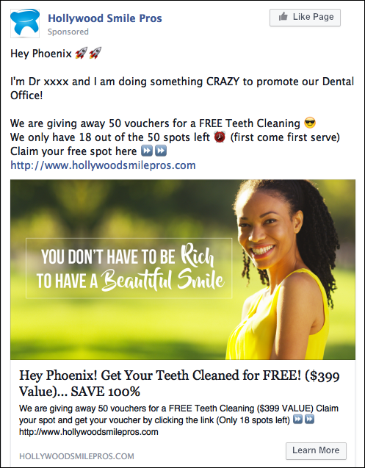
TEXT FOR AD:

Company Name: (Add Company Name)

Hey (City) 🚀🚀

I'm Dr (Name) and I am doing something CRAZY to promote our Dental Office!

We are giving away 50 vouchers for a FREE Teeth Cleaning 😎
We only have 18 out of the 50 spots left ⏰ (first come first serve)
Claim your free spot here ⏩⏩ (ClickFunnels Opt-in Page URL)

(IMAGE OR VIDEO)

Headline:
Hey (City)! Get Your Teeth Cleaned for FREE! ($299 Value)... SAVE 100%

News Feed Description
We are giving away 50 vouchers for a FREE Teeth Cleaning ($299 VALUE)
Claim your spot and get your voucher by clicking the link
(Only 18 spots left) ⏩⏩ (ClickFunnels Opt-in Page URL)
OFFER 2: Free Teeth Cleaning (BONUS = Free X-Rays)

Main Offer: Teeth Cleaning.. Was $299, Now FREE (Save 100%)
Thank You Page Offer: Free X-Rays if you schedule with office in next 5 minutes.

Image Used: Use Clients Picture
Video for Ad: xxxxxxxxxxxxxxxx

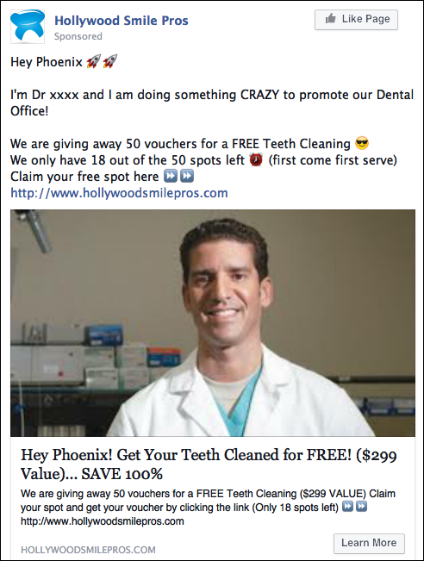
TEXT FOR AD:

Company Name: (Add Company Name)

Hey (City) 🚀🚀

I'm Dr (Name) and I am doing something CRAZY to promote our Dental Office!

We are giving away 50 vouchers for a FREE Teeth Cleaning 😎
We only have 18 out of the 50 spots left ⏰ (first come first serve)
Claim your free spot here ⏩⏩ (ClickFunnels Opt-in Page URL)

(IMAGE OR VIDEO)

Headline:
Hey (City)! Get Your Teeth Cleaned for FREE! ($299 Value)... SAVE 100%

News Feed Description:
We are giving away 50 vouchers for a FREE Teeth Cleaning ($299 VALUE)
Claim your spot and get your voucher by clicking the link
(Only 18 spots left) ⏩⏩ (ClickFunnels Opt-in Page URL)
OFFER 3: Free Teeth Whitening (BONUS: Free Exam)

Main Offer: Teeth Whitening.. Was $499, Now FREE (Save 100%)
Thank You Page Offer: Free Exam, if you schedule with office in next 5 minutes

Image Used: http://ivantraining.com/kallzu/wp-content/uploads/2020/06/BeautifulSmile5-1.jpg
Video for Ad: xxxxxxxxxxxxxxxx

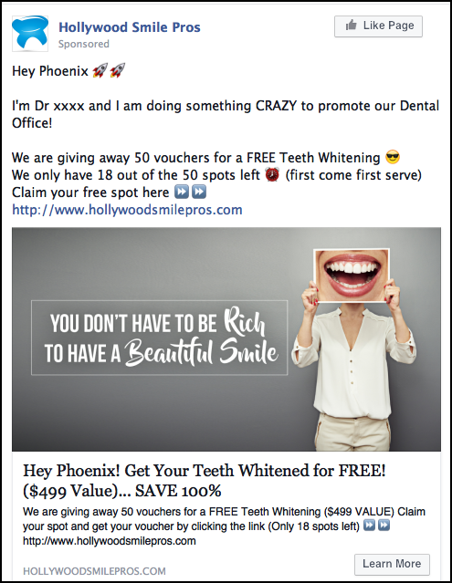
TEXT FOR AD:

Company Name: (Add Company Name)

Hey (City) 🚀🚀

I'm Dr (Name) and I am doing something CRAZY to promote our Dental Office!

We are giving away 50 vouchers for a FREE Teeth Whitening 😎
We only have 18 out of the 50 spots left ⏰ (first come first serve)
Claim your free spot here ⏩⏩ (ClickFunnels Opt-in Page URL)

(IMAGE OR VIDEO)

Headline:
Hey (City)! Get Your Teeth Whitening for FREE! ($499 Value)... SAVE 100%

News Feed Description:
We are giving away 50 vouchers for a FREE Teeth Cleaning ($499 VALUE)
Claim your spot and get your voucher by clicking the link
(Only 18 spots left) ⏩⏩ (ClickFunnels Opt-in Page URL)
OFFER 4: Free Teeth Whitening (BONUS: Free X-Rays)

Main Offer: Teeth Whitening.. Was $499, Now FREE (Save 100%)
Thank You Page Offer: Free X-Rays, if you schedule with office in next 5 minutes

Image Used: http://ivantraining.com/kallzu/wp-content/uploads/2020/06/teeth-whitening.jpg
Video for Ad: xxxxxxxxxxxxxxxx

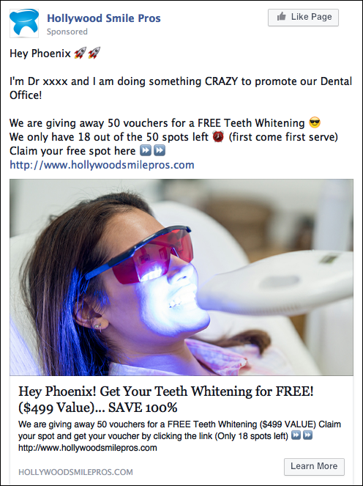
TEXT FOR AD:

Company Name: (Add Company Name)

Hey (City) 🚀🚀

I'm Dr (Name) and I am doing something CRAZY to promote our Dental Office!

We are giving away 50 vouchers for a FREE Teeth Cleaning 😎
We only have 18 out of the 50 spots left ⏰ (first come first serve)
Claim your free spot here ⏩⏩ (ClickFunnels Opt-in Page URL)

(IMAGE OR VIDEO)

Headline:
Hey (City)! Get Your Teeth Cleaned for FREE! ($299 Value)... SAVE 100%

News Feed Description:
We are giving away 50 vouchers for a FREE Teeth Cleaning ($299 VALUE)
Claim your spot and get your voucher by clicking the link
(Only 18 spots left) ⏩⏩ (ClickFunnels Opt-in Page URL)
OFFER 5: Free Teeth Cleaning + Exam Offer (BONUS: Free X-Rays)

Main Offer: Teeth Cleaning + Exam.. Was $499, Now FREE (Save 100%)
Thank You Page Offer: Free X-Rays, if you schedule with office in next 5 minutes

Image Used: http://ivantraining.com/kallzu/wp-content/uploads/2020/06/BeautifulSmile3.jpg
Video for Ad: xxxxxxxxxxxxxxxx

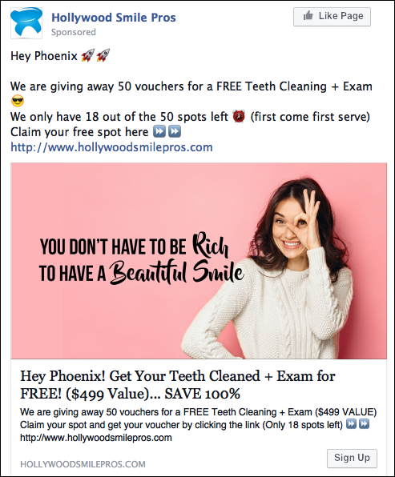
TEXT FOR AD:

Company Name: (Add Company Name)

Hey (City) 🚀🚀

I'm Dr (Name) and I am doing something CRAZY to promote our Dental Office!

We are giving away 50 vouchers for a FREE Teeth Cleaning + Exam 😎
We only have 18 out of the 50 spots left ⏰ (first come first serve)
Claim your free spot here ⏩⏩ (ClickFunnels Opt-in Page URL)

(IMAGE OR VIDEO)

Headline:
Hey Phoenix! Get Your Teeth Cleaning + Exam for FREE! ($499 Value)... SAVE 100%

News Feed Description:
We are giving away 50 vouchers for a FREE Teeth Cleaning ($299 VALUE)
Claim your spot and get your voucher by clicking the link
(Only 18 spots left) ⏩⏩ (ClickFunnels Opt-in Page URL)
OFFER 6: Free Teeth Cleaning + Exam (BONUS: Teeth Whitening Kit)

Main Offer: Teeth Cleaning + Exam.. Was $499, Now FREE (Save 100%)
Thank You Page Offer: Free Teeth Whitening Kit, if you schedule in next 5 minutes

Image Used: http://ivantraining.com/kallzu/wp-content/uploads/2020/06/BeautifulSmile3.jpg
Video for Ad: xxxxxxxxxxxxxxxx

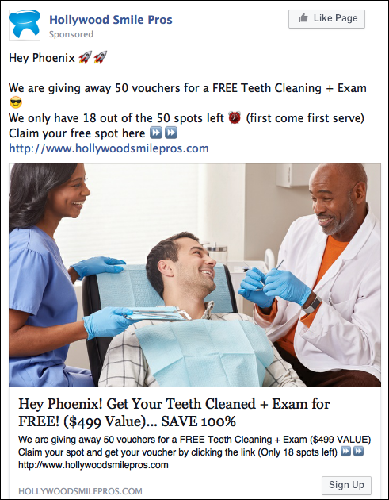
TEXT FOR AD:

Company Name: (Add Company Name)

Hey (City) 🚀🚀

We are giving away 50 vouchers for a FREE Teeth Cleaning + Exam 😎
We only have 18 out of the 50 spots left ⏰ (first come first serve)
Claim your free spot here ⏩⏩ (ClickFunnels Opt-in Page URL)

(IMAGE OR VIDEO)

Headline:
Hey (City)! Get Your Teeth Cleaning + Exam for FREE! ($499 Value)... SAVE 100%

News Feed Description:
We are giving away 50 vouchers for a Teeth Cleaning + Exam for FREE
Only 18 vouchers available!
Get One NOW by clicking the link ⏩⏩ (ClickFunnels Opt-in Page URL)
OFFER 7: Free Teeth Whitening + Exam (BONUS: Free X-Rays)

Main Offer: Teeth Whitening + Exam.. Was $499, Now FREE (Save 100%)
Thank You Page Offer: Free X-Rays if you schedule with office in next 5 minutes

Image Used: http://ivantraining.com/kallzu/wp-content/uploads/2020/06/BeautifulSmile1.jpg
Video for Ad: xxxxxxxxxxxxxxxx

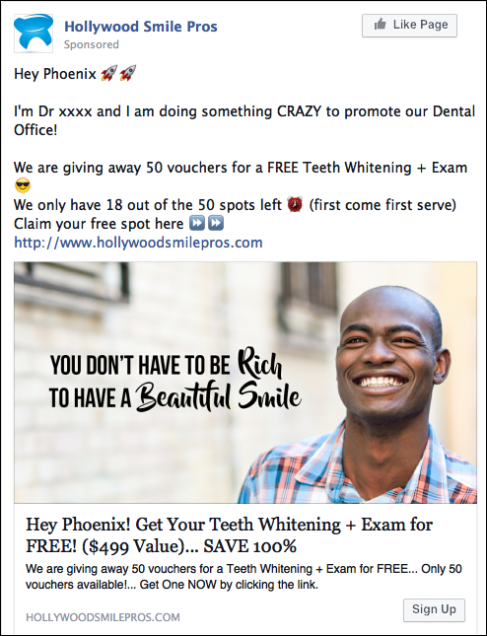
TEXT FOR AD:

Company Name: (Add Company Name)

Hey (City) 🚀🚀

I'm Dr (Name) and I am doing something CRAZY to promote our Dental Office!

We are giving away 50 vouchers for a FREE Teeth Whitening + Exam 😎
We only have 18 out of the 50 spots left ⏰ (first come first serve)
Claim your free spot here ⏩⏩ (ClickFunnels Opt-in Page URL)

(IMAGE OR VIDEO)

Headline:
Hey (City)! Get Your Teeth Whitening + Exam for FREE! ($499 Value)... SAVE 100%

News Feed Description:
We are giving away 50 vouchers for a Teeth Whitening + Exam for FREE
Only 18 vouchers available!
Get One NOW by clicking the link ⏩⏩ (ClickFunnels Opt-in Page URL)
OFFER 8: Free Teeth Whitening + Exam (BONUS: Teeth Whitening Kit)

Main Offer: Teeth Whitening + Exam.. Was $499, Now FREE (Save 100%)
Thank You Page Offer: Free Teeth Whitening Kit, if you schedule in next 5 minutes

Image Used: http://ivantraining.com/kallzu/wp-content/uploads/2020/06/Offer-8-image.png
Video for Ad: xxxxxxxxxxxxxxxx

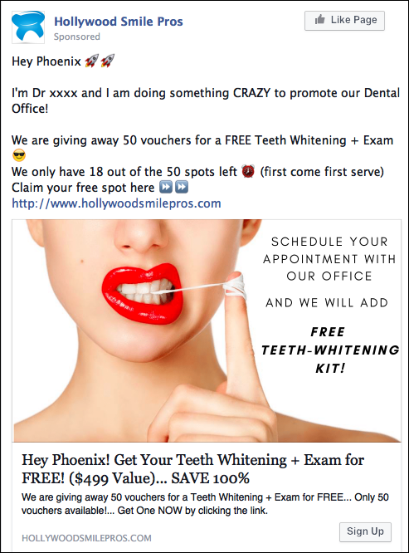
TEXT FOR AD:

Company Name: (Add Company Name)

Hey (City) 🚀🚀

I'm Dr (Name) and I am doing something CRAZY to promote our Dental Office!

We are giving away 50 vouchers for a FREE Teeth Whitening + Exam 😎
We only have 18 out of the 50 spots left ⏰ (first come first serve)
Claim your free spot here ⏩⏩ (ClickFunnels Opt-in Page URL)

(IMAGE OR VIDEO)

Headline:
Hey (City)! Get Your Teeth Whitening + Exam for FREE! ($499 Value)... SAVE 100%

News Feed Description:
We are giving away 50 vouchers for a Teeth Whitening + Exam for FREE
Only 50 vouchers available!
Get One NOW by clicking the link ⏩⏩ (ClickFunnels Opt-in Page URL)
DISCOUNTED SPECIAL OFFERS

OFFER 9: Discounted Teeth Cleaning (BONUS: Free Exam)

Main Offer: Teeth Cleaning.. Was $295, Now Only $35 (Save 88%)
Thank You Page Offer: Free Exam if you schedule with office in next 5 minutes

Image Used: http://ivantraining.com/kallzu/wp-content/uploads/2020/06/Offer-9-1.png
Video for Ad: xxxxxxxxxxxxxxxx

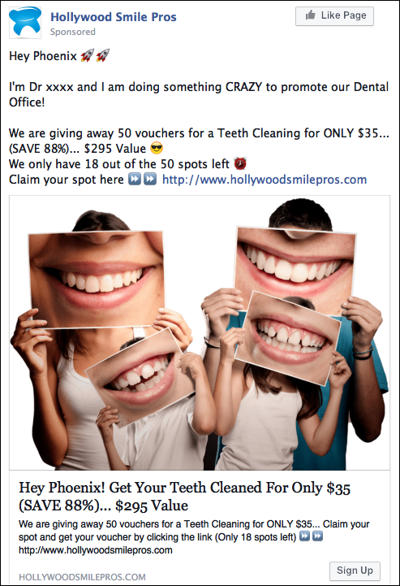
TEXT FOR AD:

Company Name: (Add Company Name)

Hey (City) 🚀🚀

I'm Dr (Name) and I am doing something CRAZY to promote our Dental Office!

We are giving away 50 vouchers for a Teeth Cleaning for ONLY $35...
(SAVE 88%)... $295 Value 😎
We only have 18 out of the 50 spots left ⏰
Claim your spot here ⏩⏩ (ClickFunnels Opt-in Page URL)

(IMAGE OR VIDEO)

Headline:
Hey (City)! Get Your Teeth Cleaned For Only $35 (SAVE 88%)... $295 Value

News Feed Description:
We are giving away 50 vouchers for a Teeth Cleaning for ONLY $35
Claim your spot and get your voucher by clicking the link
(Only 18 spots left) ⏩⏩ (ClickFunnels Opt-in Page URL)
OFFER 10: Discounted Teeth Cleaning (BONUS: Free X-Rays)

Main Offer: Teeth Cleaning.. Was $295, Now Only $35 (Save 88%)
Thank You Page Offer: Free X-Rays if you schedule with office in next 5 minutes

Image Used: http://ivantraining.com/kallzu/wp-content/uploads/2020/06/c349x211q85-1-1.jpg
Video for Ad: xxxxxxxxxxxxxxxx

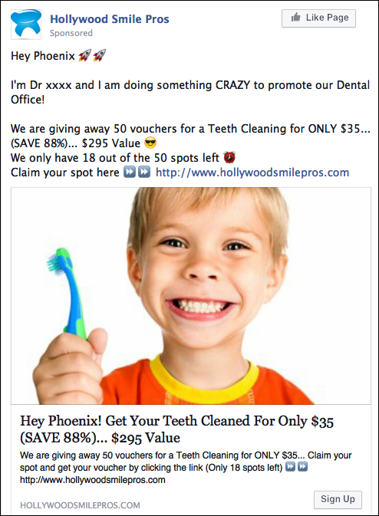
TEXT FOR AD:

Company Name: (Add Company Name)

Hey (City) 🚀🚀

I'm Dr (Name) and I am doing something CRAZY to promote our Dental Office!

We are giving away 50 vouchers for a Teeth Cleaning for ONLY $35
(SAVE 88%)... $295 Value 😎
We only have 18 out of the 50 spots left ⏰
Claim your spot here ⏩⏩ (ClickFunnels Opt-in Page URL)

(IMAGE OR VIDEO)

Headline:
Hey (City)! Get Your Teeth Cleaned For Only $35 (SAVE 88%)... $295 Value

News Feed Description:
We are giving away 50 vouchers for a Teeth Cleaning for ONLY $35... Claim your spot and get your voucher by clicking the link
(Only 18 spots left) ⏩⏩ (ClickFunnels Opt-in Page URL)
OFFER 11: Discounted Teeth Whitening (BONUS: Free Exam)

Main Offer: Teeth Whitening.. Was $556, Now $69 (Save 87%)
Thank You Page Offer: Free Exam if you schedule with office in next 5 minutes

Image Used: http://ivantraining.com/kallzu/wp-content/uploads/2020/06/Dental-Teeth-Whitening-1200x900-1.jpg
Video for Ad: xxxxxxxxxxxxxxxx

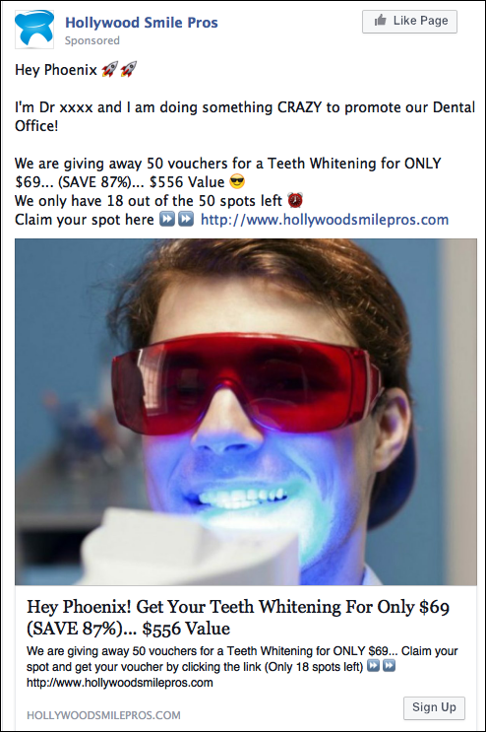
TEXT FOR AD:

Company Name: (Add Company Name)

Hey (City) 🚀🚀

I'm Dr (Name) and I am doing something CRAZY to promote our Dental Office!

We are giving away 50 vouchers for a Teeth Whitening for ONLY $69
(SAVE 87%)... $556 Value 😎
We only have 18 out of the 50 spots left ⏰
Claim your spot here ⏩⏩ (ClickFunnels Opt-in Page URL)

(IMAGE OR VIDEO)

Headline:
Hey (City)! Get Your Teeth Whitening For Only $69 (SAVE 87%)... $556 Value

News Feed Description:
We are giving away 50 vouchers for a Teeth Whitening for ONLY $69... Claim your spot and get your voucher by clicking the link
(Only 18 spots left) ⏩⏩ (ClickFunnels Opt-in Page URL)
OFFER 12: Discounted Teeth Whitening (BONUS: Free X-Rays)

Main Offer: Teeth Whitening.. Was $556, Now $69 (Save 87%)
Thank You Page Offer: Free X-Rays, if you schedule with office in next 5 minute

Image Used: http://ivantraining.com/kallzu/wp-content/uploads/2020/06/gfszdf-1.jpg
Video for Ad: xxxxxxxxxxxxxxxx

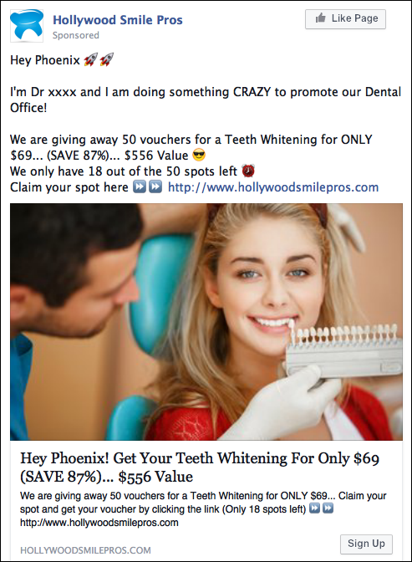
TEXT FOR AD:

Company Name: (Add Company Name)

Hey (City) 🚀🚀

I'm Dr (Name) and I am doing something CRAZY to promote our Dental Office!

We are giving away 50 vouchers for a Teeth Whitening for ONLY $69
(SAVE 87%)... $556 Value 😎
We only have 18 out of the 50 spots left ⏰
Claim your spot here ⏩⏩ (ClickFunnels Opt-in Page URL)

(IMAGE OR VIDEO)

Headline:
Hey (City)! Get Your Teeth Whitening For Only $69 (SAVE 87%)... $556 Value

News Feed Description:
We are giving away 50 vouchers for a Teeth Whitening for ONLY $69... Claim your spot and get your voucher by clicking the link
(Only 18 spots left) ⏩⏩ (ClickFunnels Opt-in Page URL)
OFFER 13: Discounted Teeth Cleaning + X-Rays (BONUS: Free Exam)

Main Offer: Teeth Cleaning + X-Rays... Was $400, Now Only $49 (Save 87%)
Thank You Page Offer: Free Exam if you schedule with office in next 5 minutes

Image Used: http://ivantraining.com/kallzu/wp-content/uploads/2020/06/EMERGENCY1.jpg
Video for Ad: xxxxxxxxxxxxxxxx

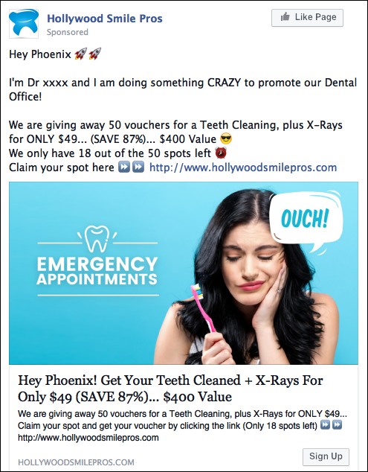
TEXT FOR AD:

Company Name: (Add Company Name)

Hey (City) 🚀🚀

I'm Dr (Name) and I am doing something CRAZY to promote our Dental Office!

We are giving away 50 vouchers for a Teeth Cleaning, plus X-Rays for ONLY $49
(SAVE 87%)... $400 Value 😎
We only have 18 out of the 50 spots left ⏰
Claim your spot here ⏩⏩ (ClickFunnels Opt-in Page URL)

(IMAGE OR VIDEO)

Headline:
Hey (City)! Get Your Teeth Cleaned + X-Rays For Only $49 (SAVE 87%)... $400 Value

News Feed Description:
We are giving away 50 vouchers for a Teeth Cleaning, plus X-Rays for ONLY $49... Claim your spot and get your voucher by clicking the link
(Only 18 spots left) ⏩⏩ (ClickFunnels Opt-in Page URL)
OFFER 14: Discounted Teeth Cleaning + X-Rays (BONUS: $10 OFF Special)

Main Offer: Teeth Cleaning + X-Rays... Was $400, Now Only $49 (Save 87%)
Thank You Page Offer: $10 OFF Special if you schedule with office in next 5 minutes

Image Used: http://ivantraining.com/kallzu/wp-content/uploads/2020/06/Female-dentist-1.jpg
Video for Ad: xxxxxxxxxxxxxxxx

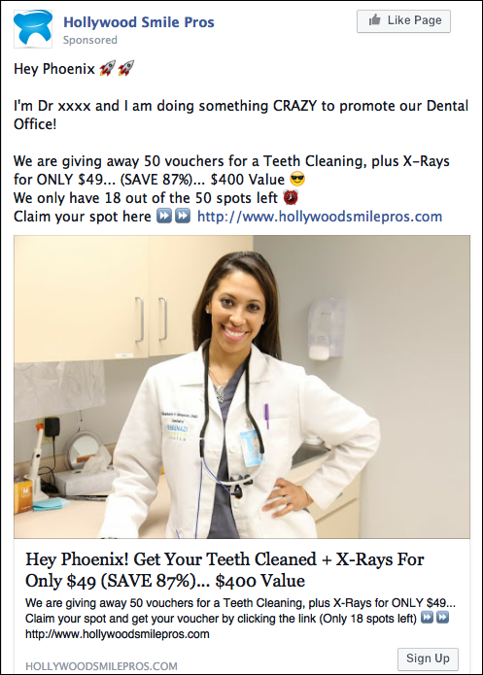
TEXT FOR AD:

Company Name: (Add Company Name)

Hey (City) 🚀🚀

I'm Dr (Name) and I am doing something CRAZY to promote our Dental Office!

We are giving away 50 vouchers for a Teeth Cleaning, plus X-Rays for ONLY $49
(SAVE 87%)... $400 Value 😎
We only have 18 out of the 50 spots left ⏰
Claim your spot here ⏩⏩ (ClickFunnels Opt-in Page URL)

(IMAGE OR VIDEO)

Headline:
Hey (City)! Get Your Teeth Cleaned + X-Rays For Only $49 (SAVE 87%)... $400 Value

News Feed Description:
We are giving away 50 vouchers for a Teeth Cleaning, plus X-Rays for ONLY $49... Claim your spot and get your voucher by clicking the link
(Only 18 spots left) ⏩⏩ (ClickFunnels Opt-in Page URL)
OFFER 15: Discounted Teeth Whitening + X-Rays (BONUS: Free Exam)

Main Offer: Teeth Whitening + X-Rays.. Was $593, Now $53 (Save 90%)
Thank You Page Offer: Free Exam, if you schedule with office in next 5 minutes

Image Used: http://ivantraining.com/kallzu/wp-content/uploads/2020/06/smile-makeover-1.jpg
Video for Ad: xxxxxxxxxxxxxxxx

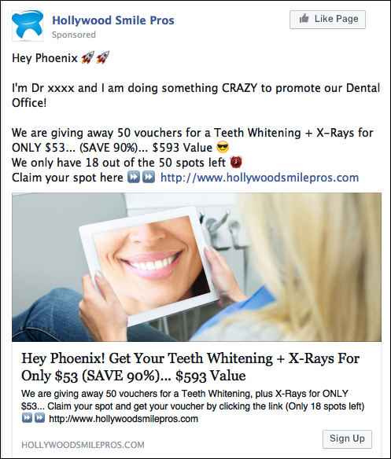
TEXT FOR AD:

Company Name: (Add Company Name)

Hey (City) 🚀🚀

I'm Dr (Name) and I am doing something CRAZY to promote our Dental Office!

We are giving away 50 vouchers for a Teeth Whitening + X-Rays for ONLY $53
(SAVE 90%)... $593 Value 😎
We only have 18 out of the 50 spots left ⏰
Claim your spot here ⏩⏩ (ClickFunnels Opt-in Page URL)

(IMAGE OR VIDEO)

Headline:
Hey (City)! Get Your Teeth Whitening + X-Rays For Only $53 (SAVE 90%)... $593 Value

News Feed Description:
We are giving away 50 vouchers for a Teeth Whitening, plus X-Rays for ONLY $53... Claim your spot and get your voucher by clicking the link
(Only 18 spots left) ⏩⏩ (ClickFunnels Opt-in Page URL)
OFFER 16: Discounted Teeth Whitening + X-Rays (BONUS: $10 OFF Special)

Main Offer: Teeth Whitening + X-Rays.. Was $593, Now $53 (Save 90%)
Thank You Page Offer: $10 OFF Special, if you schedule with office in next 5 minutes

Image Used: http://ivantraining.com/kallzu/wp-content/uploads/2020/06/smile-make-over.jpg
Video for Ad: xxxxxxxxxxxxxxxx

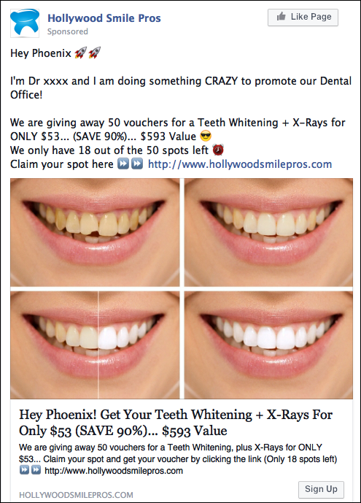
TEXT FOR AD:

Company Name: (Add Company Name)

Hey (City) 🚀🚀

I'm Dr (Name) and I am doing something CRAZY to promote our Dental Office!

We are giving away 50 vouchers for a Teeth Whitening + X-Rays for ONLY $53
(SAVE 90%)... $593 Value 😎
We only have 18 out of the 50 spots left ⏰
Claim your spot here ⏩⏩ (ClickFunnels Opt-in Page URL)

(IMAGE OR VIDEO)

Headline:
Hey (City)! Get Your Teeth Whitening + X-Rays For Only $53 (SAVE 90%)... $593 Value

News Feed Description:
We are giving away 50 vouchers for a Teeth Whitening, plus X-Rays for ONLY $53... Claim your spot and get your voucher by clicking the link
(Only 18 spots left) ⏩⏩ (ClickFunnels Opt-in Page URL)
OFFER 17: Discounted Teeth Cleaning + X-Rays + Exam (BONUS: Teeth Whitening)

Main Offer: Teeth Cleaning + X-Rays + Exam.. .. Was $556, Now Only $69 (Save 87%)
Thank You Page Offer: Free Teeth Whitening, if you schedule with office in next 5 minutes

Image Used: http://ivantraining.com/kallzu/wp-content/uploads/2020/06/EMERGENCY2.jpg
Video for Ad: xxxxxxxxxxxxxxxx

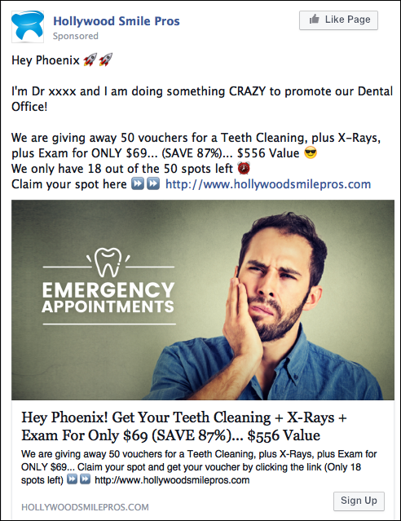
TEXT FOR AD:

Company Name: (Add Company Name)

Hey (City) 🚀🚀

I'm Dr (Name) and I am doing something CRAZY to promote our Dental Office!

We are giving away 50 vouchers for a Teeth Cleaning, plus X-Rays, plus Exam for ONLY $69
(SAVE 87%)... $556 Value 😎
We only have 18 out of the 50 spots left ⏰
Claim your spot here ⏩⏩ (ClickFunnels Opt-in Page URL)

(IMAGE OR VIDEO)

Headline:
Hey (City)! Get Your Teeth Cleaning + X-Rays + Exam For Only $69 (SAVE 87%)... $556 Value

News Feed Description:
We are giving away 50 vouchers for a Teeth Cleaning, plus X-Rays, plus Exam for ONLY $69... Claim your spot and get your voucher by clicking the link
(Only 18 spots left) ⏩⏩ (ClickFunnels Opt-in Page URL)
OFFER 18: Discounted Teeth Cleaning + X-Rays + Exam (BONUS: $10 OFF Special)

Main Offer: Teeth Cleaning + X-Rays + Exam.. .. Was $556, Now Only $69 (Save 87%)
Thank You Page Offer: $10 OFF Special, if you schedule with office in next 5 minutes

Image Used: http://ivantraining.com/kallzu/wp-content/uploads/2020/06/c349x211q85-5.jpg
Video for Ad: xxxxxxxxxxxxxxxx

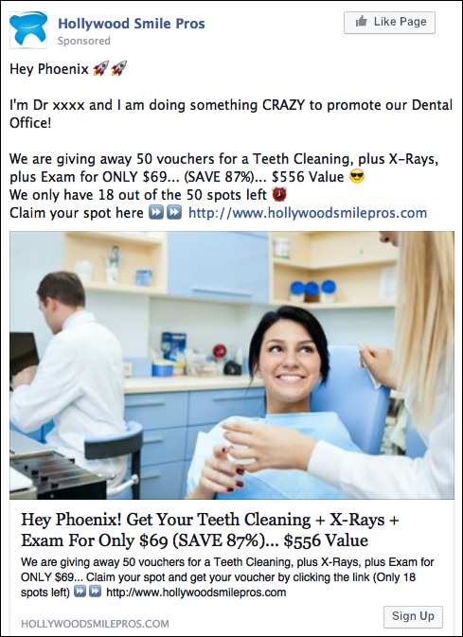

TEXT FOR AD:

Company Name: (Add Company Name)

Hey (City) 🚀🚀

I'm Dr (Name) and I am doing something CRAZY to promote our Dental Office!

We are giving away 50 vouchers for a Teeth Cleaning, plus X-Rays, plus Exam for ONLY $69...
(SAVE 87%)... $556 Value 😎
We only have 18 out of the 50 spots left ⏰
Claim your spot here ⏩⏩ (ClickFunnels Opt-in Page URL)

(IMAGE OR VIDEO)

Headline:
Hey (City)! Get Your Teeth Cleaning + X-Rays + Exam For Only $69 (SAVE 87%)... $556 Value

News Feed Description:
We are giving away 50 vouchers for a Teeth Cleaning, plus X-Rays, plus Exam for ONLY $69... Claim your spot and get your voucher by clicking the link
(Only 18 spots left) ⏩⏩ (ClickFunnels Opt-in Page URL)
OFFER 19: Discounted Teeth Whitening + X-Rays + Exam (BONUS: Teeth Whitening)

Main Offer: Teeth Whitening + X-Rays + Exam.. Was $750, Now $91 (Save 87%)
Thank You Page Offer: Free Teeth Whitening if you schedule with office in next 5 minutes

Image Used: http://ivantraining.com/kallzu/wp-content/uploads/2020/06/safety-hero.jpg
Video for Ad: xxxxxxxxxxxxxxxx

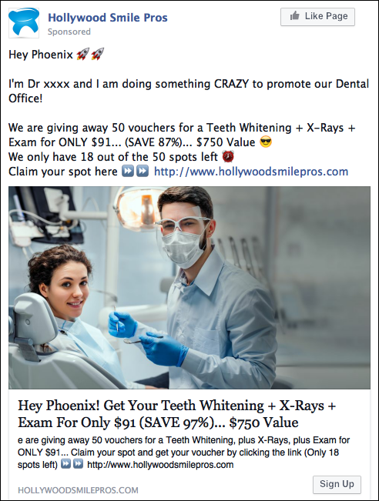
TEXT FOR AD:

Company Name: (Add Company Name)

Hey (City) 🚀🚀

I'm Dr (Name) and I am doing something CRAZY to promote our Dental Office!

We are giving away 50 vouchers for a Teeth Whitening + X-Rays + Exam for ONLY $91... (SAVE 87%)... $750 Value 😎
We only have 18 out of the 50 spots left ⏰
Claim your spot here ⏩⏩ (ClickFunnels Opt-in Page URL)

(IMAGE OR VIDEO)

Headline:
Hey (City)! Get Your Teeth Whitening + X-Rays + Exam For Only $91 (SAVE 97%)... $750 Value

News Feed Description:
We are giving away 50 vouchers for a Teeth Whitening, plus X-Rays, plus Exam for ONLY $91... Claim your spot and get your voucher by clicking the link
(Only 18 spots left) ⏩⏩ (ClickFunnels Opt-in Page URL)
OFFER 20: Discounted Teeth Whitening + X-Rays + Exam (BONUS: $10 OFF Special)

Main Offer: Teeth Whitening + X-Rays + Exam.. Was $750, Now $91 (Save 87%)
Thank You Page Offer: $10 OFF Special if you schedule with office in next 5 minutes

Image Used: http://ivantraining.com/kallzu/wp-content/uploads/2020/06/c349x211q85-4.jpg
Video for Ad: xxxxxxxxxxxxxxxx

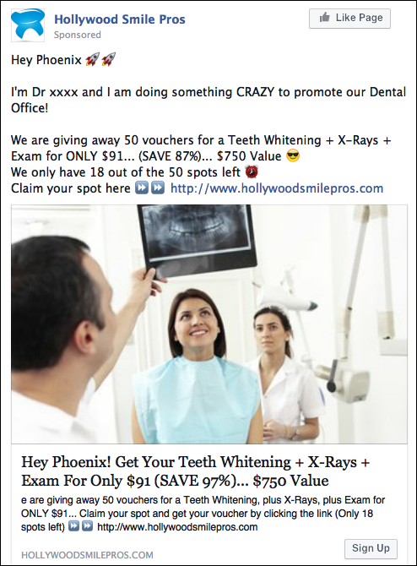
TEXT FOR AD:

Company Name: (Add Company Name)

Hey (City) 🚀🚀

I'm Dr (Name) and I am doing something CRAZY to promote our Dental Office!

We are giving away 50 vouchers for a Teeth Whitening + X-Rays + Exam for ONLY $91
(SAVE 87%)... $750 Value 😎
We only have 18 out of the 50 spots left ⏰
Claim your spot here ⏩⏩ (ClickFunnels Opt-in Page URL)

(IMAGE OR VIDEO)

Headline:
Hey (City)! Get Your Teeth Whitening + X-Rays + Exam For Only $91 (SAVE 97%)... $750 Value

News Feed Description:
We are giving away 50 vouchers for a Teeth Whitening, plus X-Rays, plus Exam for ONLY $91... Claim your spot and get your voucher by clicking the link
(Only 18 spots left) ⏩⏩ (ClickFunnels Opt-in Page URL)
MORE DENTIST TEMPLATES
(Dr Anissa Holmes - DeliveringWow.com)

Meet The Dentist

Main Offer: Meet The Dentist
Thank You Page Offer: ??

Image Used: Image of Doctor
Video for Ad: xxxxxxxxxxxxxxxx

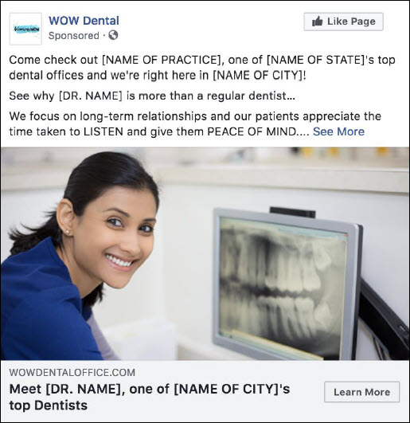
TEXT FOR AD:

Company Name: (Add Company Name)

Come check out [NAME OF PRACTICE], one of [NAME OF STATE]'s top dental offices and we're right here in [NAME OF CITY]!

Come See why [DR. NAME] is more than a regular dentist…

We focus on long-term relationships and our patients appreciate the time taken to LISTEN and give them PEACE OF MIND.

Have questions or want to book a consultation this week?

The first step is to schedule an appointment to discuss what's possible. [INSERT LINK] or give us a call at [PHONE].

We are located in at [ADDRESS].

Headline: Meet [DR. NAME], one of [NAME OF CITY]'s top Dentists
Newsfeed Description: We focus on long-term relationships and our patients appreciate...
Call to action: Learn More
Dental Implants

Main Offer: Free Consultation
Thank You Page Offer: ??

Image Used: http://ivantraining.com/kallzu/wp-content/uploads/2021/08/Dental-Implants.jpg
Video for Ad: xxxxxxxxxxxxxxxx

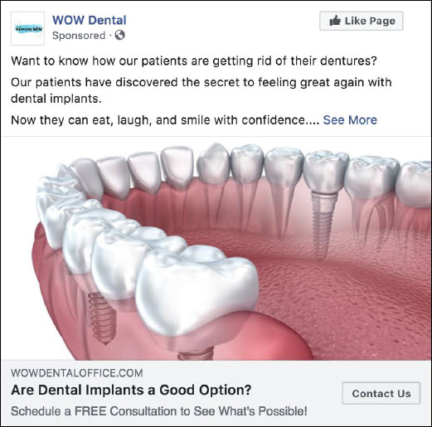
TEXT FOR AD:

Want to know how our patients are getting rid of their dentures?

Our patients have discovered the secret to feeling great again with dental implants.

Now they can eat, laugh, and smile with confidence.

Dental implants are the most comfortable, permanent and natural looking way to fix missing teeth. Getting dental implants also:
➡️Restores your smile
➡️Increases self-esteem
➡️Functions just like a natural tooth

Click HERE to schedule a FREE Implant consultation to discuss what’s possible. > > > [insert link]

Have questions or want to book a consultation this week? The next step is to give us a call at [PHONE].

We are located in [CITY OR AREA OF TOWN] at [ADDRESS].

Headline: Are Dental Implants A Good Option?
Call to Action: Contact Us
Newsfeed Description: Schedule a FREE Consultation to See What's Possible!
Invisalign

Main Offer: Free Consultation
Thank You Page Offer: ??

Image Used: http://ivantraining.com/kallzu/wp-content/uploads/2021/08/Invisalign16.jpg
Video for Ad: xxxxxxxxxxxxxxxx

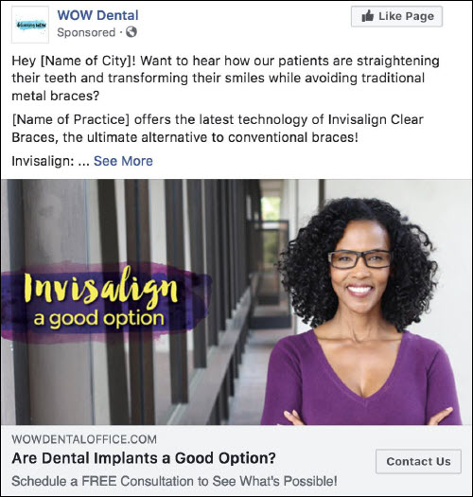
TEXT FOR AD:

Hey [Name of City]! Want to hear how our patients are straightening their teeth and transforming their smiles while avoiding traditional metal braces?

(Name of Practice] offers the latest technology of Invisalign Clear Braces, the ultimate alternative to conventional braces!

Invisalign:
➡️Clear, natural and attractive as if you’re not wearing braces
➡️Removable so easier to clean
➡️Minimal Maintenance
➡️More comfortable than metal braces

Is Invisalign a Good Option? The first step is to schedule a FREE consultation to discuss what's possible. [INSERT LINK]

Have questions or want to book a consultation this week? The next step is to give us a call at [PHONE].

We are located in [CITY OR AREA OF TOWN] at [ADDRESS].

Headline: Is Invisalign A Good Option?
Call to Action: Contact Us
Newsfeed Description: Schedule a FREE Consultation to See What's Possible!

Cosmetic Dentistry

Main Offer: FREE smile consultation
Thank You Page Offer: ??

Image Used: http://ivantraining.com/kallzu/wp-content/uploads/2021/08/CosmeticDentistry2.jpg
Video for Ad: xxxxxxxxxxxxxxxx

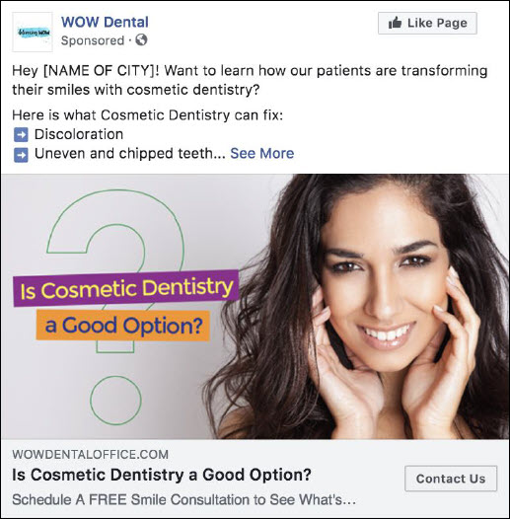
TEXT FOR AD:

Hey [NAME OF CITY]! Want to learn how our patients are transforming their smiles with cosmetic dentistry?

Here is what Cosmetic Dentistry can fix:
➡️ Discoloration
➡️ Uneven and chipped teeth
➡️ Crooked or crowded teeth
➡️ Missing or broken teeth

Is Cosmetic Dentistry a Good Option? The first step is to schedule a FREE smile consultation to discuss what's possible. [insert link]

Have questions or want to book a consultation this week? The next step is to give us a call at [PHONE].

We are located in [CITY OR AREA OF TOWN] at [ADDRESS].

Headline: Is Cosmetic Dentistry a Good Option?
Newsfeed Description: Schedule A FREE Smile Consultation to See What's Possible!
Call to action: Contact Us
Teeth Whitening

Main Offer: Book a Free Teeth Whitening Consult
Thank You Page Offer: ??

Image Used: http://ivantraining.com/kallzu/wp-content/uploads/2021/08/Teeth-Whitening.jpg
Video for Ad: xxxxxxxxxxxxxxxx

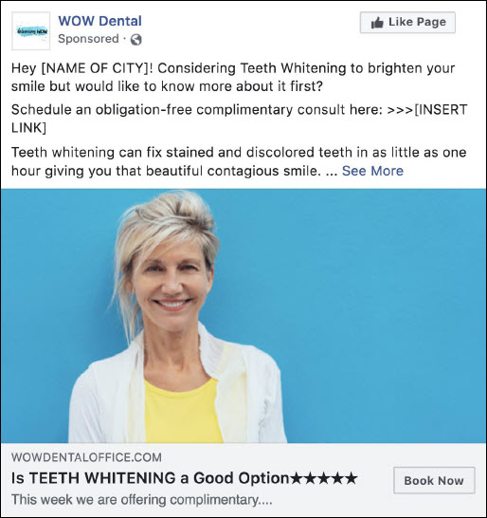
TEXT FOR AD:

Hey [NAME OF CITY]! Considering Teeth Whitening to brighten your smile but would like to know more about it first?

Schedule an obligation-free complimentary consult here: >>>[INSERT LINK]

Teeth whitening can fix stained and discolored teeth in as little as one hour giving you that beautiful contagious smile.

With [ENTER NUMBER] years of professional teeth whitening under our belt it’s safe to say that we know all about teeth whitening.

Book a free Teeth Whitening consult at our practice in [PART Of TOWN} today or give us a call at [INSERT PHONE NUMBER] to find out what we can do for you!

[INSERT LINK]

Headline: Is TEETH WHITENING a Good Option★★★★★
Description: This week we are offering complimentary....
Call to action: Book Now
Pre-Wedding Smile Consultation

Main Offer: FREE Pre-Wedding SMILE Evaluation
Thank You Page Offer: ??

Image Used: http://ivantraining.com/kallzu/wp-content/uploads/2021/08/wedding1-1024x682.jpg
Video for Ad: xxxxxxxxxxxxxxxx

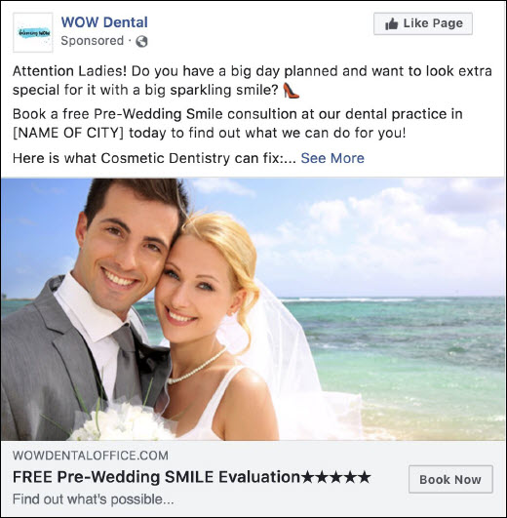
TEXT FOR AD:

Attention Ladies! Do you have a big day planned and want to look extra special for it with a big sparkling smile? 👠

Book a free Pre-Wedding Smile consultation at our dental practice in [NAME OF CITY] today to find out what we can do for you!

Here is what Cosmetic Dentistry can fix:
➡️ Discoloration
➡️ Uneven and chipped teeth
➡️ Crooked or crowded teeth
➡️ Missing or broken teeth

Have questions or want to book a consultation this week? The next step is to schedule an appointment here. [INSERT LINK] or give us a call at [PHONE].

We are located in [CITY OR AREA OF TOWN] at [ADDRESS].

Headline: FREE Pre-Wedding SMILE Evaluation★★★★★
Description: Find out what's possible…
Call to action: Book Now
Orthodontics

Main Offer: FREE Consultation
Thank You Page Offer: ??

Image Used: http://ivantraining.com/kallzu/wp-content/uploads/2021/08/Braces10.jpeg
Video for Ad: xxxxxxxxxxxxxxxx

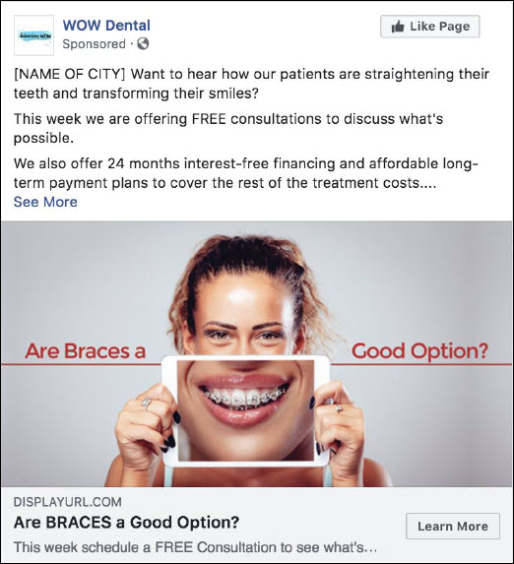
TEXT FOR AD:

[NAME OF CITY] Want to hear how our patients are straightening their teeth and transforming their smiles?

This week we are offering FREE consultations to discuss what's possible.

We also offer 24 months interest-free financing and affordable long-term payment plans to cover the rest of the treatment costs.

Now you can get Braces for as low as $[ENTER AMOUNT}/month with zero-interest!

Have questions or want to book a consultation this week? The next step is to schedule an appointment here. [INSERT LINK] or give us a call at [PHONE].

We are located in [CITY OR AREA OF TOWN] at [ADDRESS].

Headline: Are Braces a Good Option★★★★★
Call to Action: Lean More
Newsfeed Description: This week schedule a FREE Consultation to see what’s....
Six Month Smiles

Main Offer: Complimentary Consultation
Thank You Page Offer: xxx

Image Used: http://ivantraining.com/kallzu/wp-content/uploads/2021/08/Six-Month-Smiles.jpg
Video for Ad: xxxxxxxxxxxxxxxx

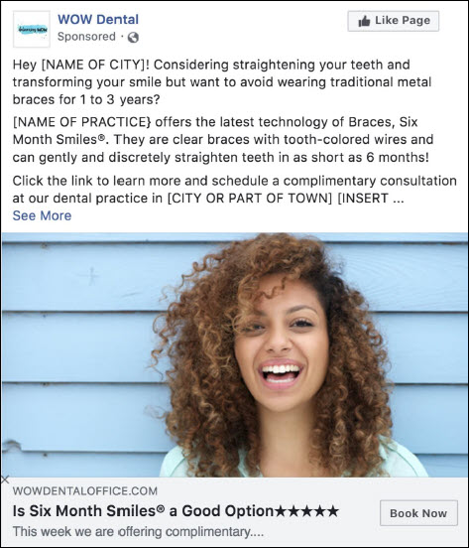
TEXT FOR AD:

Hey [NAME OF CITY]! Considering straightening your teeth and transforming your smile but want to avoid wearing traditional metal braces for 1 to 3 years?

(NAME OF PRACTICE} offers the latest technology of Braces, Six Month Smiles®. They are clear braces with tooth-colored wires and can gently and discreetly straighten teeth in as short as 6 months!

Click the link to learn more and schedule a complimentary consultation [INSERT LINK] or give us a call at [PHONE].

We are located in [CITY OR AREA OF TOWN] at [ADDRESS].

Headline: Is Six Month Smiles® a Good Option★★★★★
Call to Action: Book Now
Newsfeed Description: This week we are offering complimentary....
Pediatric Dentistry

Main Offer: Book a Consultation
Thank You Page Offer: ??

Image Used: http://ivantraining.com/kallzu/wp-content/uploads/2021/08/Pediatric-Dentistry.jpg
Video for Ad: xxxxxxxxxxxxxxxx

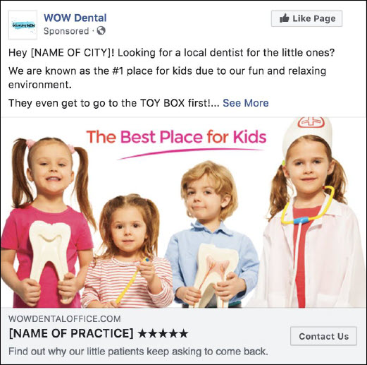
TEXT FOR AD:

Hey [NAME OF CITY]! Looking for a local dentist for the little ones?

We are known as the #1 place for kids due to our fun and relaxing environment.

They even get to go to the TOY BOX first!

We’ll make sure our patients have a positive experience at the dentist and get the best and most comfortable treatment to ensure they have healthy teeth as they continue to grow.

Have questions or want to book a consultation this week? The next step is to schedule an appointment here. [INSERT LINK] or give us a call at [PHONE].

We are located in [CITY OR AREA OF TOWN] at [ADDRESS].

Headline: [NAME OF PRACTICE] ★★★★★
Call to Action: Contact Us
Newsfeed Description: Find out why our little patients keep asking to come back.
Periodontics

Main Offer: Schedule an Appointment
Thank You Page Offer: ??

Image Used: http://ivantraining.com/kallzu/wp-content/uploads/2021/08/Periodontics.jpg
Video for Ad: xxxxxxxxxxxxxxxx

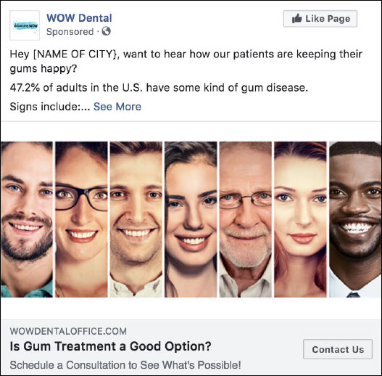
TEXT FOR AD:

Hey [NAME OF CITY}, want to hear how our patients are keeping their gums happy?

47.2% of adults in the U.S. have some kind of gum disease.

Signs include:

➡️Easily bleeding gums when brushing or flossing
➡️Swollen, bright red gums
➡️Unpleasant breath
➡️Loose or separating teeth

Hi I’m [DR. NAME}, owner of [NAME OF PRACTICE] and I have [ENTER NUMBER] years experience in the prevention, diagnosis, and treatment of gum disease.

If there are concerns about gum disease, contact us or schedule an appointment with our ⭐⭐⭐⭐⭐ dental practice today! [PHONE].

We are located in [CITY OR AREA OF TOWN] at [ADDRESS].

Headline: Is Gum Treatment a Good Option?
Newsfeed Description: Schedule a Consultation to See What's Possible!
Call To Action: Contact Us
Oral Surgery

Main Offer: Book a Consultation
Thank You Page Offer: ??

Image Used: http://ivantraining.com/kallzu/wp-content/uploads/2021/08/Oral-Surgery.jpg
Video for Ad: xxxxxxxxxxxxxxxx

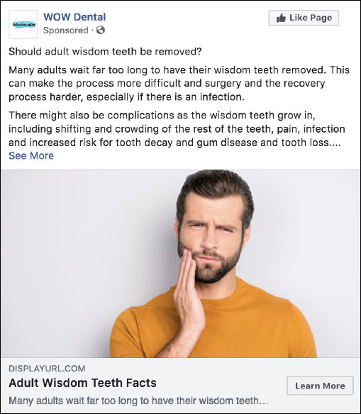
TEXT FOR AD:

Should adult wisdom teeth be removed?

Many adults wait far too long to have their wisdom teeth removed. This can make the process more difficult and surgery and the recovery process harder, especially if there is an infection.

There might also be complications as the wisdom teeth grow in, including shifting and crowding of the rest of the teeth, pain, infection and increased risk for tooth decay and gum disease and tooth loss.

Wisdom teeth are much easier to remove and the recovery is less painful if they are removed BEFORE there's a problem.

Have questions or want to book a consultation this week? The next step is to schedule an appointment here. [INSERT LINK] or give us a call at [PHONE].

We are located in [CITY OR AREA OF TOWN] at [ADDRESS].

Headline: Adult Wisdom Teeth Facts
Newsfeed Description: Many adults wait far too long to have their wisdom teeth removed.
Call To Action: Contact Us
Sweepstakes Advert/Contest/Raffle/Competition

Main Offer: ! Enter to win a FREE Teeth Cleaning + Xrays + Teeth Whitening
Thank You Page Offer: 50% Discount

Image Used: http://ivantraining.com/kallzu/wp-content/uploads/2021/08/Teeth-Whitening-1.jpg
Video for Ad: xxxxxxxxxxxxxxxx

4 Questions To Ask Your Client Before Launch

Note: Their answers will help you understand which targeting to choose for your ads

- What age and gender is your normal customer?
- What interests do they have? Which competitor brands do they like? What celebrities/artists do they follow? What magazines or blogs do they read?
- Are they single? Engaged? In a relationship? Married? Children?
- What problems are they facing? What do they want?

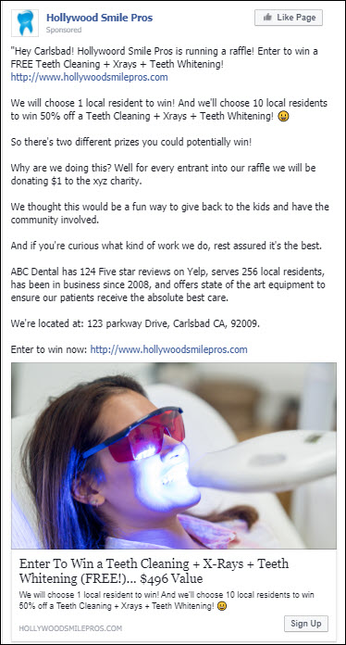

TEXT FOR AD:

"Hey Carlsbad! ABC Dental is running a raffle! Enter to win a FREE Teeth Cleaning + Xrays + Teeth Whitening! (Link)

We will choose 1 local resident to win! And we'll choose 10 local residents to win 50% off a Teeth Cleaning + Xrays + Teeth Whitening! 😀

So there's two different prizes you could potentially win!

Why are we doing this? Well for every entrant into our raffle we will be donating $1 to the (XYZ) charity.

We thought this would be a fun way to give back to the kids and have the community involved.

And if you're curious what kind of work we do, rest assured it's the best.

(Name of Practice) has (Number) Five star reviews on Yelp, serves (Number) local residents, has been in business since 2008, and offers state of the art equipment to ensure our patients receive the absolute best care.

We're located at: (Address) 123 parkway Drive, Carlsbad CA, 92009.

Enter to win now: (Link)

Headline: Enter to win a FREE Teeth Cleaning + Xrays + Teeth Whitening (FREE!)... $497 Value
Link Description: We will choose 1 local resident to win! And we'll choose 10 local residents to win 50% off a Teeth Cleaning + Xrays + Teeth Whitening! 😀
Link: http://www.hollywoodsmilepros.com
Link Caption: HollywoodSmilePros.com

Install Pixels

INDEX:

------- Facebook Pixel Introduction
------- How Pixel Work (Diagrammatic Explanation)
------- Creating Your Master Facebook Pixel
------- Installing Pixel In ClickFunnels
------- Installing Pixel Helper Extension
------- Install Pixel Events
------- Assigning Pixel To An Ad Account

Facebook Pixel Introduction

http://ivantraining.com/kallzu/fam-module-10-facebook-pixels-overview-and-installations/#offer1

Notes:

- Facebook Pixel: is a small piece of code we put on your website funnel and it transmits data to Facebook about website visitors.
- If you are running ads, you need the fb pixel
- You don't need to code or be a developer
- Allows advertisers to re-target visitors on facebook (eg: amazon)
- Allows facebook to track people outside facebook (purchases, complete registrations etc.)
- Avoid wastage of ad spend for advertisers
- Example: I send 100 people to my website selling watches, and 50 purchase... but they are all female... Would not know that without a pixel... Can now target only woman with my ads and save money.
- Allows advertisers to find out more people who does the action they want
- Example: Can create Lookalike audiences similar to people that have already purchased, which will make conversions much more profitable.

How Pixel Work (Diagrammatic Explanation)

http://ivantraining.com/kallzu/fam-module-10-facebook-pixels-overview-and-installations/#offer2

Notes:

- Billions of users on Facebook
- Facebook tracks every action and creates a unique pixel id for actions taken
- You own a website, example sells watches and have facebook pixel installed
- It tracks what every visitor does and logs the pixel id and event that took place
- Like Bob, visited the page... while Maria got to the Thank-You page after making a purchase.

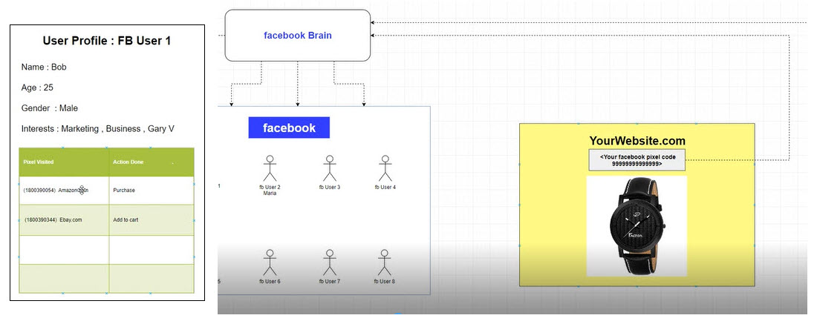

Creating Your Master Facebook Pixel

http://ivantraining.com/kallzu/fam-module-10-facebook-pixels-overview-and-installations/#offer3

Notes:

- A Facebook Pixel is like a super power which you will have.
- Once you install a pixel, that pixel will start collecting data
- Depending on the data and people who visit the pages, Facebook will be able to find more and more people who are similar to people who are becoming a LEAD.
- What is a Master Facebook Pixel?
- Most of the agencies out there, they create a pixel, use it on one client and when that client goes, they throw that pixel away.... Not how we do it!
- We use a Master Facebook Pixel... Remember, we are sticking to One Niche
- Example: Dentist niche... so even if we have 1 client or 5 clients. We are going to use the same Pixel in all these clients funnels and all these clients websites and pages.
- WHY ? .... because the more data the pixel gets, the better it can find more people
- So if you have a Dentist in San Diego and you installed the pixel in his website... Facebook is going to understand who in San Diego is visiting or converting into a Lead.
- And.. you can ask Facebook to find similar people like them in the next city like San Francisco or New York.
- So our Facebook Pixel will have that data to produce a similar audience which you can use in another location.
- And once you have multiple clients, these pixels will be Top-Level and give really quality information, and be able to produce quality audiences for you to use.
- Other agencies don't have that... you have it because you used ONE Pixel across the board.
- And that is what we are going to do: Create a Master Facebook Pixel.

How To Create the Master Facebook Pixel:

- Log in and go to Business Settings... hamburger, Business Setting
- On left... Go to Data Sources, it will then display Pixels beneath, click on it.
- On left of screen, you will see any pixels you have created.
- To create a new pixel... click on Blue "Add" button... and box pops-up called "Create a Facebook Pixel"
- Pixel name: give it a name like "Master Facebook Pixel" or "Hollywood Smile Pros Pixel" whatever makes sense to you.
- Website URL: can leave out
- Once you enter a name you click blue button "Create"... You will see pixel is created... very simple... it will display on left column of page.

How To Install Pixel on Website Pages:

- Have to get a piece of code from Facebook.
- Once you have created pixel, you can click on it to highlite Pixel, then on top right corner you click on "Open In Events Manager " to open pixel.
- We do that by finding drop-down tab "Add Events" located below the graph image, and choose "From a New Website" and window pops-up.
- Click on blue button "Install Code Manually" and copy html code... then paste it into a notepad.
- Now paste and install code into header of website... (watch next video)
- This is the code that will get installed in ALL your customers funnel pages and websites for one niche.
- If you are going to work on another niche... then you would create a new pixel just for that niche.

Installing Pixel In ClickFunnels

http://ivantraining.com/kallzu/fam-module-10-facebook-pixels-overview-and-installations/#offer4

How to Find & Copy HTML Code for Pixel:

- Log into Business Manager - click on: hamburger, Business Setting, Data Sources, Pixels... highlite pixel, Open in Events Manager,
- Below graph image - click on "Add Events", choose "From a New Website", click on blue button "Install Code Manually" and copy html code.
- Then paste it into a notepad.

Log into ClickFunnels:

- Choose funnel, choose "Opt-In Page' and click on "Edit Page"
- Top right click on "Settings" tab and find box that says "Head Tracking Code"
- Copy and Paste HTML code into this box... then scroll all the way down and click on green button that says "Save and update Settings"
- And below you will see a box hat says "funnel was successfully updated"
- Done... once installed you "Copy the URL of the funnel page" and can test it within Facebook.

How To Check If Facebook Pixel Is Working On Your Website:

- I can not find option to test in Facebook with new display.. but its not necessary... there is an easier way
- We can test using the Facebook Pixel Helper Chrome extension.
- Watch next video

Installing Pixel Helper Extension

http://ivantraining.com/kallzu/fam-module-10-facebook-pixels-overview-and-installations/#offer5

DOWNLOAD: Facebook Pixel Helper Chrome extension: CLICK HERE

Instructions:

- Facebook provide us an easier way to check if pixels are installed on website pages by providing us with a small piece of software that we install in Google Chrome browser.
- Plugin is called the Facebook Pixel Helper.. download link above
- Click on link above and click blue button 'Add to Chrome" then click on "Add Extension" and in top right corner you will see a grey image which is your Pixel Helper extension.
- Grey means, there are no pixels found, but if you visit your funnel page, it will turn blue because it is picking up a pixel on the page.
- That is how you test... blue means pixel installed... grey means no pixel.
- If you click on the blue pixel it will show you the pixel id number
- You can then check that number with the pixel in your Facebook Business Manager.
- Go to your Pixel section, the number is displayed next to the name of your pixel... compare the two, they should be the same.
- Done... pixel is active and you have double checked that pixel id is is the same.
- When you click on Pixel Helper, it will tell you how many pixels there are, and what data is being communicated to Facebook... So in this case the only data that is being communicated is "Page Views"
- Next we cover more detail and how to install Facebook "Pixel Events".
Install Pixel Events

http://ivantraining.com/kallzu/fam-module-10-facebook-pixels-overview-and-installations/#offer6

Notes:

- In this video we are going to install Pixel Events
- First lets take a look at what it looks like once you already have pixel events installed... Lets take a look at the end result.
- If you visit Lading Page and click on pixel helper, it shows the pixel id, and Page View.... which means the only activity happening on this page is recording of page view.
- And if you visit the Thank-You Page it will show Page View and "Lead"... which are the people who opted-in for the offer and became real leads.
- Why do we need this?
- First - This will allow us to track how many we got from Facebook Ads
- Second- This will allow Facebook to find more people who are converting into leads
- So Facebook will try to find a million people who are the closest match to becoming a lead, similar to the leads we have already received.
- Installing this is called a Pixel Event
- So very important to create this so we are able to create Look-A-Like audiences of Leads.

Instructions: To Install A Pixel "Lead" Event To Funnel

- We install a Pixel Lead Event in every funnel we create for our clients.
- Open Clickfunnels, choose funnel and open the Opt-In Page and make sure you have installed pixel... by going to settings and checking that pixel is pasted in... and by checking with the pixel helper.
- Do the same for Thank-You page... should be installed on both pages already.
- Next go to Thank-You Page, edit page, click on drop-down "Settings" tab and choose "Tracking Code"... (will see image like this)

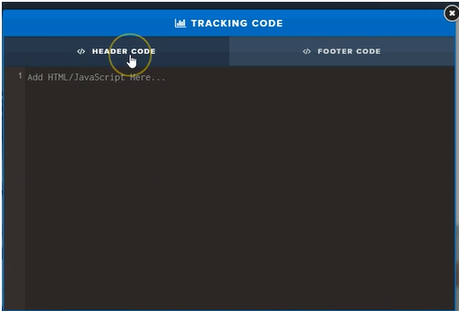

- Can remove any code in header and footer
- High-lite and make sure you are in the footer code
- Now you have to copy and paste a code from Facebook.. You find code by visiting:
- https://www.facebook.com/business/help/402791146561655?id=1205376682832142

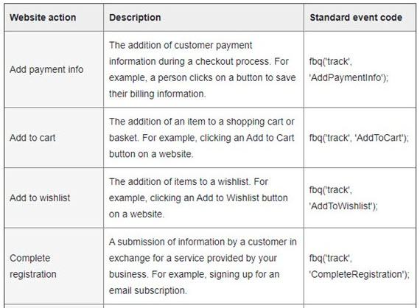
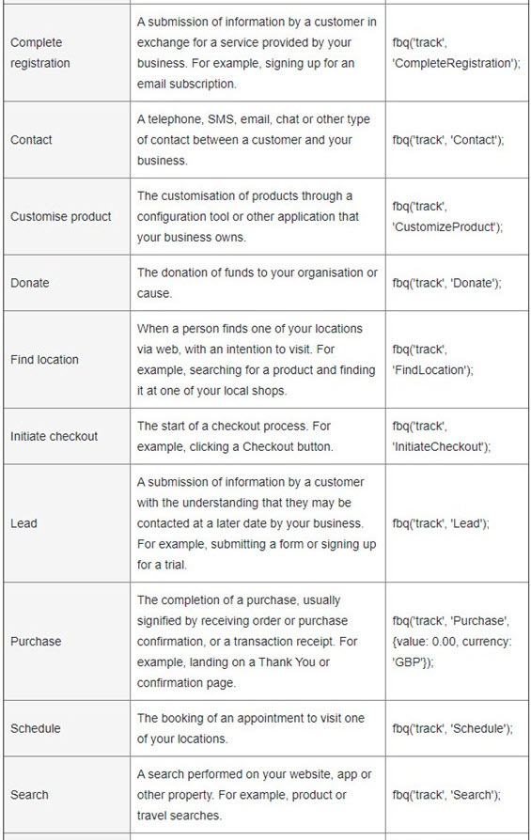

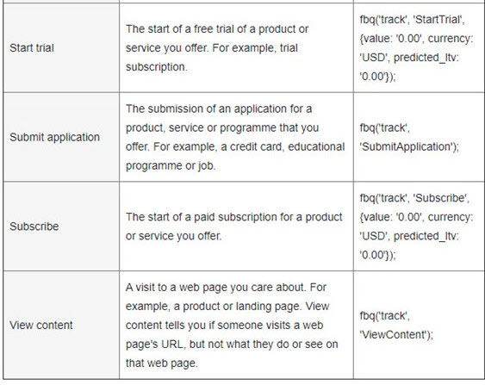

Website action Standard event code
Add payment info fbq('track', 'AddPaymentInfo');
Add to cart fbq('track', 'AddToCart');
Add to wishlist fbq('track', 'AddToWishlist');
Complete registration fbq('track', 'CompleteRegistration');
Contact fbq('track', 'Contact');
Customise product fbq('track', 'CustomizeProduct');
Donate fbq('track', 'Donate');
Find location fbq('track', 'FindLocation');
Initiate checkout fbq('track', 'InitiateCheckout');
Lead fbq('track', 'Lead');
Purchase fbq('track', 'Purchase', {value: 0.00, currency: 'GBP'});
Schedule fbq('track', 'Schedule');
Search fbq('track', 'Search');
Start trial fbq('track', 'StartTrial', {value: '0.00', currency: 'USD', predicted_ltv: '0.00'});
Submit application fbq('track', 'SubmitApplication');
Subscribe fbq('track', 'Subscribe', {value: '0.00', currency: 'USD', predicted_ltv: '0.00'});
View content fbq('track', 'ViewContent');

Copy And Paste Code Here:

- Choose the code for Lead... which is: fbq('track', 'Lead');
- Insert code in between script html like so

<script>
fbq('track', 'Lead');
</script>

- And paste into footer code section.
- Then press Save in top right corner
- Double check with pixel helper, can take up to 5 minutes.
- Done!

Assigning Pixel To An Ad Account

http://ivantraining.com/kallzu/fam-module-10-facebook-pixels-overview-and-installations/#offer7

Instructions:

- We need to connect the Master Facebook Pixel to an Ad-Account
- Go to Business Settings... Log into Business Manager, hamburger, Business Settings, Data Sources, Pixels.
- In top right will see 3 tabs named, People, Partners, Add Assets
- Start with People

People: click on it, make sure its highlighted.

- People is who will have permission to access the Pixel... currently blank so we have to add ourselves.
- To do that click on "Add People" box pops-up and will see your name on left side... just click on it.. then the box that says "Manage pixel", you have to turn it on so its blue and click on blue 'Assign" button in bottom right corner.

Partners:

- Do not have to do anything right now, in the future you may use it... skip this for now.

Connected Assets:

- Will show no assets connected... click on Add Assets, and box pops-up
- Will see your Ad-Account listed there, currently only have 1 Add-Account
- But in the future when you on-board a new clients... You will add a New Ad-Account and it will display here
- Every time you create a new Ad-Account you have to connect the Ad-Account to this Master Facebook Pixel
- Click on the Ad-Account, make sure its ticked... then click on blue Add button in bottom right.
- Ad you will get a confirmation box that says Ad-Account has been added.
- If you want to remove an Ad-Account can simply press the delete trash button
- Done!

Upload Customer Patient List + Lead List (Create Audiences & Targeting)

http://ivantraining.com/kallzu/fam-module-11-understanding-terminologies-and-structure-of-facebook-ads/#offer5

INDEX
- The Anatomy of Business Manager
- Structure of Ad Account (Diagrammatic Explanation)
- Structure of Ad Account (Real Ad Account)
- Audiences Overview (cold & warm, Interests, Age ranges)
- Uploading Email Lists & Creating Facebook Audience
- Creating Web-Retargeting Audiences from Website visitors
- Creating "Look-A-Like" Audiences
- What if you dont have a customer list and pixel list (Targeting)

------- Create custom audience from "Lead List"
------- Create custom audience from "Customer List"
------- Create Lookalike Audience from "Lead List"
------- Create Lookalike Audience from "Customer List" ...(gonna be best audience)

The Anatomy of Business Manager

http://ivantraining.com/kallzu/fam-module-11-understanding-terminologies-and-structure-of-facebook-ads/#offer1

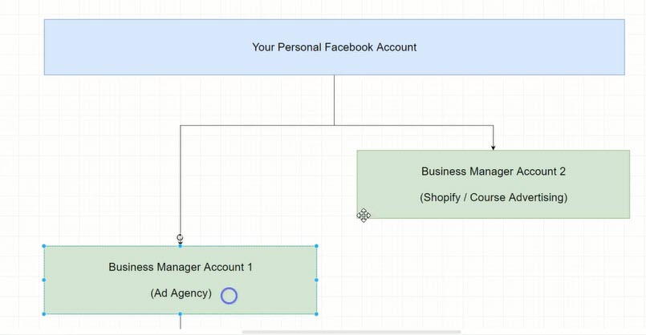

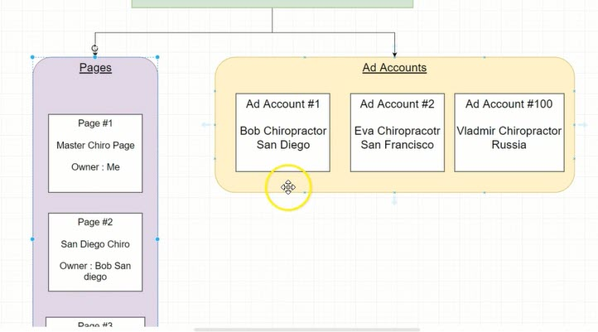
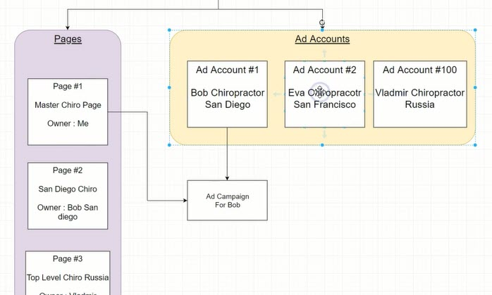

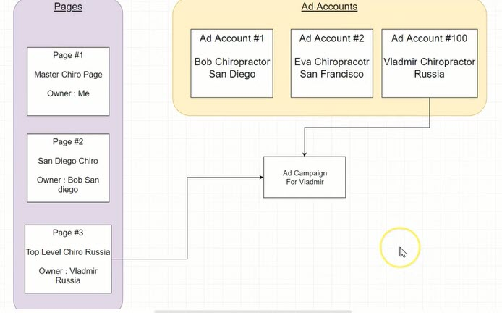

Structure of Ad Account (Diagrammatic Explanation)

http://ivantraining.com/kallzu/fam-module-11-understanding-terminologies-and-structure-of-facebook-ads/#offer2

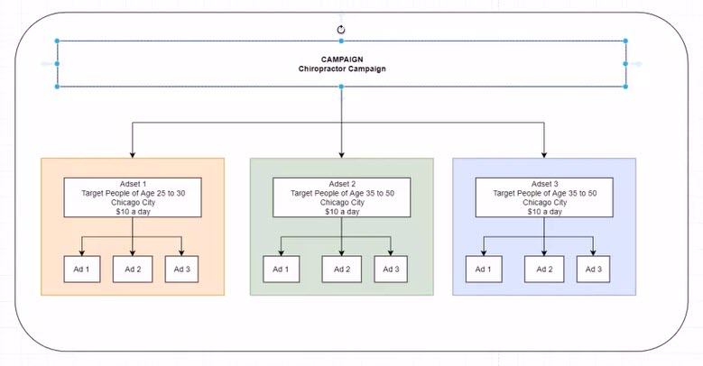

Structure of Ad Account (Real Ad Account)

http://ivantraining.com/kallzu/fam-module-11-understanding-terminologies-and-structure-of-facebook-ads/#offer3

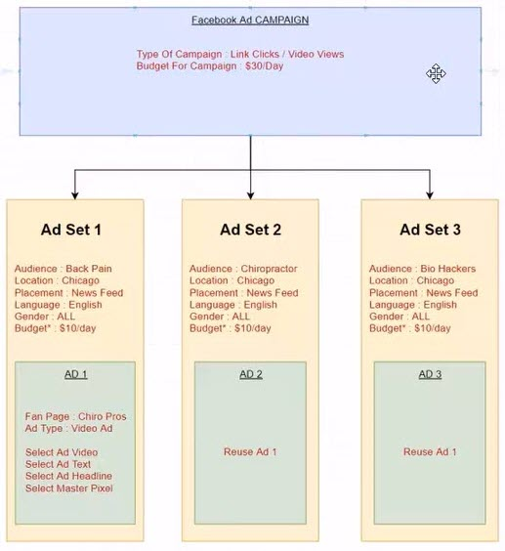
Campaign Level

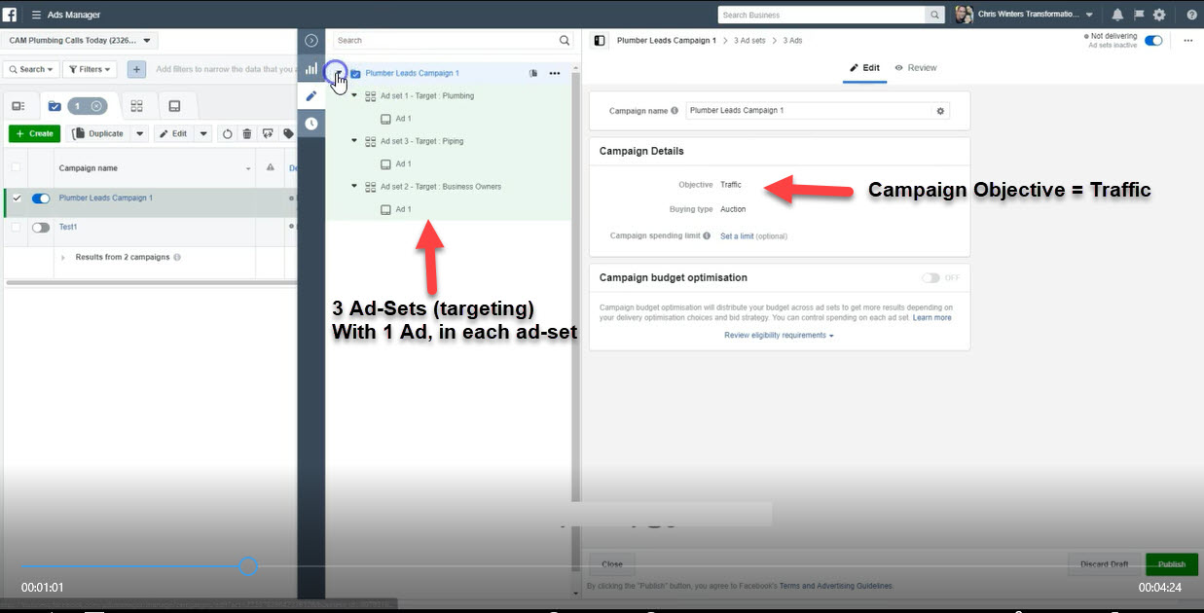

Ad-Set Level (targeting)

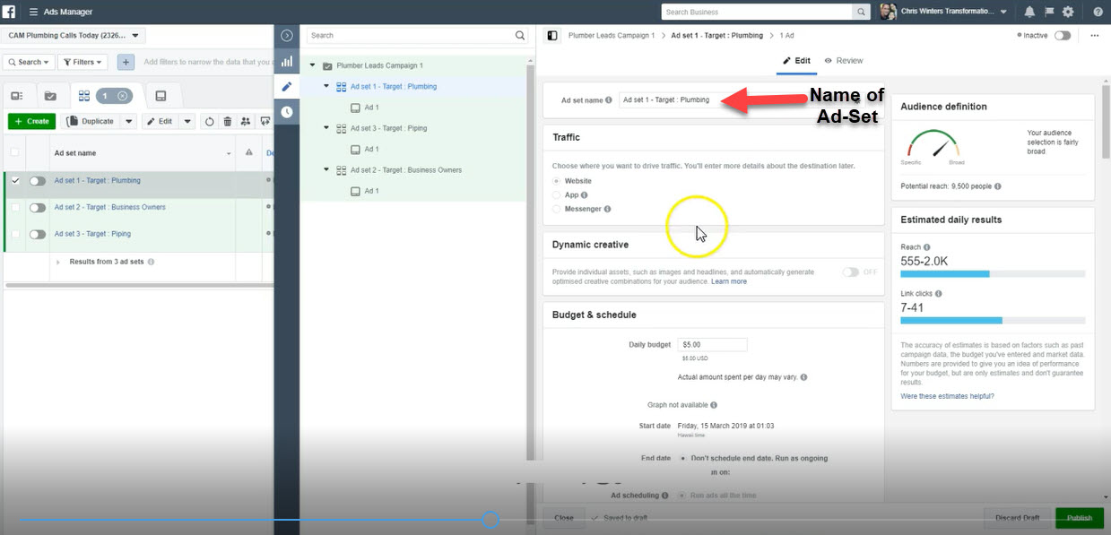

Ad Level

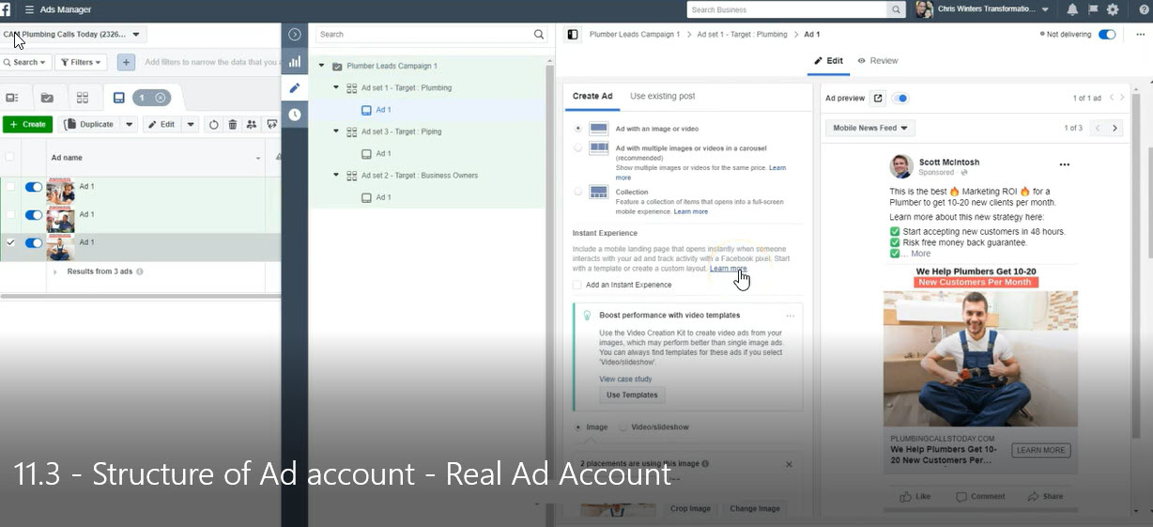

Example of Ad

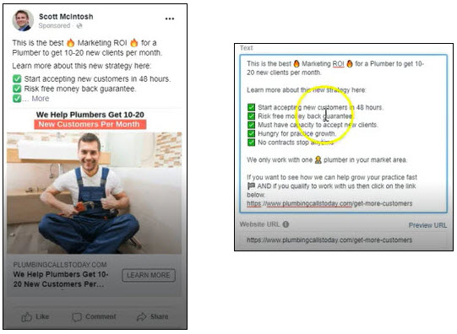

Audiences Overview
(Cold & Warm, Interests, Age ranges)

http://ivantraining.com/kallzu/fam-module-11-understanding-terminologies-and-structure-of-facebook-ads/#offer4

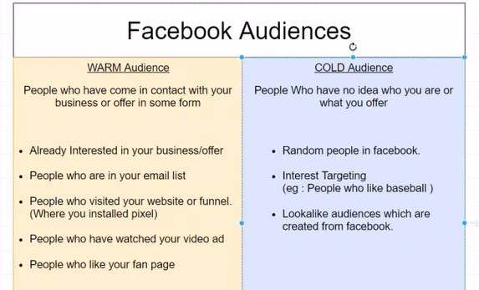

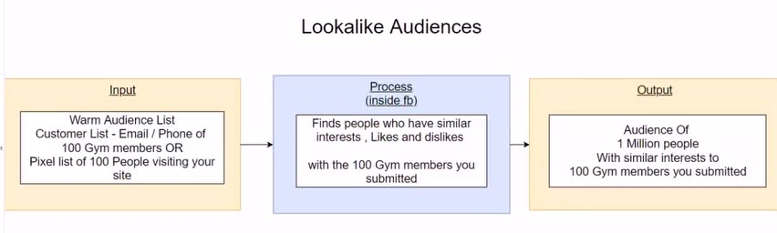

Uploading Email Lists & Creating Facebook Audience

http://ivantraining.com/kallzu/fam-module-11-understanding-terminologies-and-structure-of-facebook-ads/#offer5

Notes: "Customer Email List"

- Having a email list cuts your work in half and saves a lot of money.
- When you have a list of previous customers, you are able to Re-Target them and bring them back to the business.
- You can also create a Look-A-Like audience which will be very similar to previous customers.
- So make sure to ask for Email List from customers, so we can upload that list.
- Try to get Emails + Telephone Numbers + Name and any other data they may have... But will work with emails only if that's all they have.
- Instructions: To Create CSV File

Create a Microsoft CSV file with emails.

- Create 2 Headlines - Name, Email ....
- If you have additional info like Name $ Zip Code, you can add those or more as well.
- Copy and paste details in, then save in a CSV format.

Instructions: To Upload "Email List + Telephone #" To Facebook

- Open Business Manager.. click on Ad Accounts.. choose the AD Account you want to upload to... and click on top right button that says "Open Ads Manager"
- Now click on hamburger, expand view, under Advertise Section, select "Audiences".. page will open up
- Here if you already have a list of audiences you will see it listed.. if you don't have it will display 3 options for you to choose from.
- Select "Custom Audiences" click on blue button and window will pop up called "Create a Custom Audience"
- Select "Customer File" and you will get 3 options... Choose the second one called "Use a file that doesn't include LTV"
- Terms box will open up... accept by clicking "I Agree"... Next box will pop up that allows us to upload.
- We have already completed Step 1.. "Prepare file with your customer data"... so move onto Step 2 which is to upload file.
- Step 2 - click on the drop-down tab tab that says "Original Data Source" and choose "From customers and partners"
- Next click on "Upload File" button and upload the selected file.
- Step 3 - Name Your Audience... example "Bob, Dentist, San Diego - Customer Email List"
- Click on Next (bottom right) and window pops up called "Preview and map your data".
- And Facebook will start to map whatever you uploaded and show you a list of boxes and ask, Hey what is this column supposed to mean.. it will automatically assign a tab to it.. double check that the tabs are correct. If not click the drop-down menu and select the correct tab.
- Once done click on "Upload & Create"button and it will slowly upload list to Facebook and it will say populating.
- Facebook will take some time to identify these people, to find the correct id's of these people and associate i with this audience.
- And even if you uploaded 3,000 emails, you may find that Facebook was only able to identify 500 people... That's how it works and all depends on the algorithm finding these people.
- Once populating part is done (2-3 hrs)... you are able to run "Re-Targeting Ads" to this list and able to create "Look-A-Like" audiences based on this list.

Creating Web Re-Targeting Audiences from Website Visitors

http://ivantraining.com/kallzu/fam-module-11-understanding-terminologies-and-structure-of-facebook-ads/#offer6

Notes: "Website Visitor Audience"

- Here we will be creating a "Website Visitor Audience" from our pixels.
- First requirement is to have "Master Pixel" installed on Client Funnels that includes Landing Page & Thank You Page + Client Website if possible.
- So WHY do we need a website visitor audience?... Lets say we get 100 or more visitors to page.. We can ask Facebook, hey please make an audience similar to people that visited this website.
- WHO visits this website?... PEOPLE interested in our Offer right!
- So we can tell Facebook to create a bigger audience for us.
- ALSO we can create audiences based of people that got to the Thank-You Page.
- Which is even better as these people gave us their email addresses.. better converting... Can create Look-A-Like audience for these people.

Instructions: To Create "Website Visitor Audience"

- Business Manager, hamburger, expand view, go to Advertise Section and select "Audiences"
- Make sure you are in he right Ad account by looking at top left corner
- The click on blue drop down button "Create Audience" and choose "Custom Audience" and box will pop up.
- Select "Website Traffic" and next window will pop up called "Create a website traffic Custom Audience" and here we need to give criteria for Facebook to understand what is the nature of this audience.
- Fist select the PIXEL you want to use, select your "Master Facebook Pixel"
- Next is who should go in this audience.. by default its "All website visitors".. that is not what we want... All we want is people who visited the Landing Page & Thank You Page.
- So we click on the drop-down tab for All website visitors and choose "People who visited specific web pages"
- Then under the "URL button" add the websites page url's of your funnel pages. Copy and paste the Landing Page + Thank You page URL's.
- So what we are telling Facebook is, create an audience of people who visited the Landing Page and the Thank You Page.
- Name Your Audience - example "Chiropractic - Total Balance - All Visitors"
- Click blue button "Create Audience".. and box will pop us saying, Your Custom Audience Was Created... click blue button "Done".
- Takes you back to "Audiences Page" and new list with name will display.
- Under Size column it will say populating and it will take some time to complete.
- If you send 1,000 clicks to your website that does not mean Facebook will create a 1,000 audience, it will be a number which is way less. Facebook always under reports the size of audience, not sure why is what it is.
- That is the first audience we create.

Notes: "Lead Audience"

- Next we have to create one more audience, and this time we are only going to "include people that converted into a "LEAD"
- In other words people who landed on the Thank-You Page and actually took advantage of offer by giving us their email & tel number.
- This is the closest to our "Ideal Customer" for our local business client.
- Example: 100 people visit Landing Page and only 50 people make it to Thank-You Page.. Those 50 people are our ideal audience.
- In the future we will be able to create Look-A-Like audience of these people who are ready to give email and phone number, and we can also Exclude them from seeing further advertisements saving us money.

Instructions: To Create "Website Lead Audience" (7:11 on video)

- Make sure you are in Business Manager, hamburger expand view, Advertise Section, choose Audience"
- Same process... click on blue drop down button "Create Audience" and choose "Custom Audience" and box will pop up.
- Select "Website Traffic" and next window will pop up called "Create a website traffic Custom Audience" and here we need to give criteria for - Facebook to understand what is the nature of this audience.
- First select the PIXEL you want to use, select your "Master Facebook Pixel"
- Next is who should go in this audience.. by default its "All website visitors".. that is not what we want... All we want is people who visited the Thank You Page.
- Click on the drop-down tab for All website visitors and choose "People who visited specific web pages"
- Copy and paste Thank You page URL in.
- So what we are telling Facebook is, create an audience of people who only visited the Thank You Page.
- Name Your Audience - example "Chiropractic - Total Balance - Only Leads"
- Click blue button "Create Audience".. and box will pop us saying, Your Custom Audience Was Created... click blue button "Done".
- Now we have a audience list of "ALL VISITORS" for this funnel... PLUS a audience list of only "LEADS" for this funnel.

Creating "Look-A-Like" Audiences

http://ivantraining.com/kallzu/fam-module-11-understanding-terminologies-and-structure-of-facebook-ads/#offer7.

Notes: "Look-A-Like" Audiences

- Here we will learn how to create a "Look-A-Like audience" in Business Manager
- If you talk to anybody who runs and scales Facebook Ads, they will say the biggest money comes from Look-A-Like audiences.
- And the reason for that is Look-A-Like audiences will contain the kind of people who will resonate best with your business.
- So how is a Look-A-Like audience created?
- You need to have a warm audience.
- Warm audience can be a "List of Customers" OR it can be a "Pixel List" of people who visit your website.
- So in previous videos we created Three Lists.. 1.) List of Customers... 2.) Website Visitor Audience Pixel List... 3.) Lead Audience Pixel List
- With any one of these Lists we can now create a Look-A-Like audience
- And what Facebook is gonna do is find people who are similar to our audience and give us an audience of "1 Million people" with similar interests.
- And you can show you Ads to these people, and chances are they will convert better because these 1 million people are very similar to the 100 people on our email list and pixel lists.
- GOLDEN RULE - For Facebook to create Look-A-Like audience you need to have Minimum 100 people in that audience.
- So if i have created a funnel and have only sent 20 people to that funnel... Then Facebook will be Unable to create a good Look-A-Like audience... they may create one but it will be poor quality.

Instructions: Create "Look-A-Like" Audiences from "Email List"

- Make sure you are in Business Manager, hamburger expand view, Advertise Section, choose "Audience"
- Need to select the Warm Audience you would like to use.. one of the three lists we created
- For Example - We want to create a Look-A-Like audience from the "Email List" uploaded.
- Tick the list i am interested in on the left side of the list
- Then on the top tabs would click on Options (which are the 3 dots) and choose "Create lookalike" and click on it.... Box will pop up and have 3 steps.
- Select your lookalike source - Will automatically be selected because we ticked the box next to list we chose... Email List Audience
- Select audience location - Here we can give country or region.. example United States (NO City wide targeting here).. for regions click on browse, we do not use regions.
- Select audience size - Multiple sizes of look-a-like audiences we can create. Best to start with 1% which will give +/- 1-2 million people... the more you increase % the more people get targeted, the less accurate the audience will be.
- In advanced lessons down the line we will show you how to increase % and people... For now only go for 1%
- For "Number of Lookalike audiences"... keep it at 1
- Click on blue button "Create Audience"
- And it will revert back to "Audience Page" and you will see the newly Look-A-Like audience created.
- Will be named something like this "Lookalike (US 1%) - Bobs Chiropractic San Diego Customers"
- So what happens after this population is complete is Facebook will go ahead and find people who are similar to Bob Chiropractic San Diego Customers.
- Look-A-Like audience will have similar interests to the customers of Bobs Chiropractic local business.

Instructions: Create "Look-A-Like" from "Website Visitors Pixel List"

- GOLDEN RULE - For Facebook to create Look-A-Like audience you need to have Minimum 100 people in that audience.
- So if i have created a funnel and have only sent 20 people to that funnel... Then Facebook will be Unable to create a good Look-A-Like audience... they may create one but it will be poor quality.
- So wait until you have 100 VISITORS to Landing Page before you create this one.
- Make sure you are in Business Manager, hamburger expand view, Advertise Section, choose "Audience"
- Tick the correct list "Website Visitor List" and click on 3 dots and choose "Create lookalike" and click on it.... Box will pop up and have 3 steps.
- Select your lookalike source - Will automatically be selected because we ticked the box next to list we chose... Email List Audience
- Select audience location - Here we can give country or region.. example United States (NO City wide targeting here).. for regions click on browse, we do not use regions.
- Select audience size - Multiple sizes of look-a-like audiences we can create. Best to start with 1% which will give +/- 1-2 million people... the more you increase % the more people get targeted, the less accurate the audience will be.
- For "Number of Lookalike audiences"... keep it at 1
- Click on blue button "Create Audience"
- Audience Page will open and you will see new Look-A-Like audience created.

Instructions: Create "Look-A-Like" from "Website Leads Pixel List"

- GOLDEN RULE - For Facebook to create Look-A-Like audience you need to have Minimum 100 people in that audience.
- So if i have created a funnel and have only received 30 leads from funnel... Then Facebook will be Unable to create a good Look-A-Like audience... they may create one but it will be poor quality.
- So wait until you have 100 LEADS from Thank-You Page before you create this one.
- Make sure you are in Business Manager, hamburger expand view, Advertise Section, choose "Audience"
- Tick the correct list "Leads List" and click on 3 dots and choose "Create lookalike" and click on it.... Box will pop up and have 3 steps.
- Select your lookalike source - Will automatically be selected because we ticked the box next to list we chose... Email List Audience
- Select audience location - Here we can give country or region.. example United States (NO City wide targeting here).. for regions click on browse, we do not use regions.
- Select audience size - Multiple sizes of look-a-like audiences we can create. Best to start with 1% which will give +/- 1-2 million people... the more you increase % the more people get targeted, the less accurate the audience will be.
- For "Number of Lookalike audiences"... keep it at 1
- Click on blue button "Create Audience"
- Audience Page will open and you will see new Look-A-Like audience created.

What If You Don’t Have a Customer List and Pixel List

http://ivantraining.com/kallzu/fam-module-11-understanding-terminologies-and-structure-of-facebook-ads/#offer8

Notes: If We Have No Customer List or No Pixels Yet

- If customer has no email list or the look-a-like audience we created is not working.. Then we need to advertise to something called "Cold Interest"
- These are people who are just browsing Facebook... Facebook will find them based on their Interest.
- So we can tell Facebook, hey show my Ads to everybody who likes Chiropractic adjustments or Dentistry etc. depending on niche.
- Not every interest can be targeted through Facebook, so we have to be a bit creative and find out what interests to use.
- In this video i will show you how to search for these interests.
- Even if we have a client's email list, it is better to also test a few interest based ads as well... because one may out-perform the other.. we will not know until we test.
- So follow along and lets try to find an audience.

Instructions: On How To Find an Audience

- Business Manager, click on hamburger, expand view, under Analyse and Report Section... choose "Audience Insights"
- Box will pop-up: choose "Everyone on Facebook" and sends you to Create Audience page
- Location: by default will be country you are in.. change if necessary.
- Age: for now leave as is... Can use common sense or info collected from customer
- Gender: leave as is

INTERESTS: Research To Find Targeting... (Goal to Find 3 Audiences)

- Here you can type in interests like Chiropractic and lists will show up.. But before you put in any interest, check on the "Right hand side"
- Currently we have not typed in any interest.
- First headline is "New Audience" and this is showing you the audience size... so it's showing the size of the entire country of USA available in Facebook... 200 million... we can not advertise to that many people... What we have to do, is find people within that 200 million.
- Interest: put in a interest related to our niche... example Chiropractor and it will give list.. click one and on right under (New Audience) you will see number of people... like 50K-60K people... which is really low.
- And if you narrow it down to a city, and type in example Chicago under Location... it will drop to less than 1000 people which is too low. You do not add city in a location coz that will make things really hard... just stick with United States.
- But understand you have to go for interests that are about 300,000 for the bare minimum... a good number is about 500,000 people, you can even go for audiences 2-3 million but never go below 300,000.

FIRST INTEREST: How To Research For Interests To Target

- So we type in something related to niche like "Chiropractic" and the interests that popped up is "Chiropractic Treatment Techniques" and on right hand side wee have 400-450K people (which means country wide)... not great but OK to start the ads.
- On right side everything changed when we clicked on Chiropractic Treatment
- In other words Facebook shows us all the demographics like Age, Relationship status, Education level etc related to that interest.
- For example for this interest, the Age range for Men aged 25-43... + 35-44... + 45-54 are the most popular.. and is the same for Female.. So this is the age range we will advertise too for this interest... And write Ads geared towards these age ranges... a good insight to have. Plus 450k audience for this interest across the nation, another good insight to have.
- So this interest works... so we add this to our list.. copy and paste in a notepad file.

RESEARCH SECOND INTEREST: Get Creative When Searching for Interest to Target

- You will not always find your exact niche in this box, we where lucky enough to have for this example. Sometimes you will have to use your creativity and find out what are the things people would be interested in related to your service.
- For Example: people who go to chiropractic treatments might be interested in something related to back pain... So you type in "Back Pain"
- There is one interest listed called "Cure Back Pain Networks" so we click on it and on the right we see.. oops no people listed... so this one will not work.
- They might be interested in "Health"... so we type it in and take a look at list available... A few pop up like Health magazine.. we click on it and on right there is a huge audience of 40-45 million.. that's way too big an audience and too broad.. so that's a No.
- We take a look at all the other suggestion and decide to take a look at "Health & Wellness".. on the right we have 15M to 20M people.. That's a good audience size... if we narrow it down to City size we should get good numbers.
- We type in Chicago for example, and get 250-300K people which is perfect... So we add this as one of our interests and paste into Notepad.

TRICK TO FIND OTHER INTERESTS: Go To "Page Likes" & Research

- Once you have a interest on the right you can click on "Page Likes" and Facebook will show you a list of other pages liked by these people. Not every page will be closely related to niche but should be close.
- So when you click on page in Top Categories, it will open up that page... and you can decide if this may or may not be an interest you can target.. for you to decide.
- Check it by typing that interest into Interests tab and take a look at audience size.
- May or may-not find interest to target in this way.
- On the pages, check to see if there is a specific person advertising a lot of chiropractic things... and if they are, they are an influencer... Can then decide to target ads to their audience.
- Again, check by typing that persons name or page name into Interests tab and take a look at audience size... and decide if it is worth targeting.
- Sometimes you will find those names when checking Page Likes tab.

BOTOX EXAMPLE: Example Using Another Niche

- Example if you are searching for "Botox" and type that into Interests, you get nothing... but if you use your imagination you can easily find botox. Ask yourself, What are people really interested in when they go for botox? ... the answer is "Anti Aging"
- So what do those people read or buy, what blogs do they read? ... you have to figure out those things.
- You can also make use of Google and do a bit of research to find influences and get answers to these questions.
- Open Google and type in "Botox Magazine".. see if there are any magazines read by people interested in botox... after scrolling a b it found one called "Glamour Magazine"
- So type "Glamour" into Interests, and the list displays Glamour Magazine.. so we click on it and there are 6-7 Million people.. plus we click on "Page Likes" and it will show other interests like "Hot Mom's Club".. and other magazines we can research.
- So maybe Glamour Magazine is not a good fit for us but perhaps "Hot Mom's Club" is a good fit... or another magazine... we will not know until we test.
- Type in "Hot Mom's Club" ans we see almost no audience.. so not a good fit... carry on like this until we have 3 interests we can target.

IF YOU CANT FIND INTERESTS: AD-SETS with NO Targeting.. Just Age Based Targeting

- In that case, target the whole city for people age range 35-45 for example.
- So change out United Stated and type in City Name.. then change the Age Range
- Example: Chicago, Age Range 30-60... and we have a 1,5-2 Million audience to target.... a good interest o advertise too.
- This is called AD-SETS with NO Targeting.. its just Age Based Targeting.
- This is great for offers that involve for example Gyms, that would be interesting to a large audience.
- So if you can not find any interests... OR you feel your offer will appeal to the masses... like a Chiropractor Offer OR Dentist Offer.
- Then add it as as a interest named "No interest Targeting - Age 25-60, Chicago"
- THIRD INTEREST: No interest Targeting - Age 25-60, Chicago

THREE INTERESTS WE ARE GOING TO TARGET: For Chiropractor Campaign

- Chiropractic Treatment Techniques
- Health & Wellness
- No Interest Targeting

Business Manager Account

(We have Ad-Account, then Campaigns, then Ad-Sets, then Ads)

Website: https://business.facebook.com/
Username: ivanconsulting16@gmail.com
Password: Idp32291%

Add business details for the local office you're operating your business from.

Country - United States
Street Address - 13820 NE Airport Way
City - Portland
State/Province/Region - Oregon
ZIP/Postal Code - 97251
Business Phone Number - +1 (503) 461-4277
Website - http://www.MoreClientsConsulting.com
Business Use - Provide services to other businesses

Waterfall Campaign

http://ivantraining.com/kallzu/#offer0

INDEX

1.) The Waterfall Campaign Framework
2.) Difference between Dino Gomez campaign... VS... Waterfall campaign
3.) How much should I spend for Facebook-Ads
4.) Campaign Launch Checklist

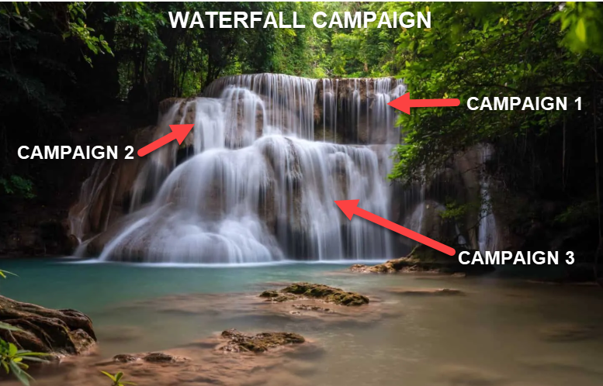
Waterfall Campaign Framework

http://ivantraining.com/kallzu/#offer0
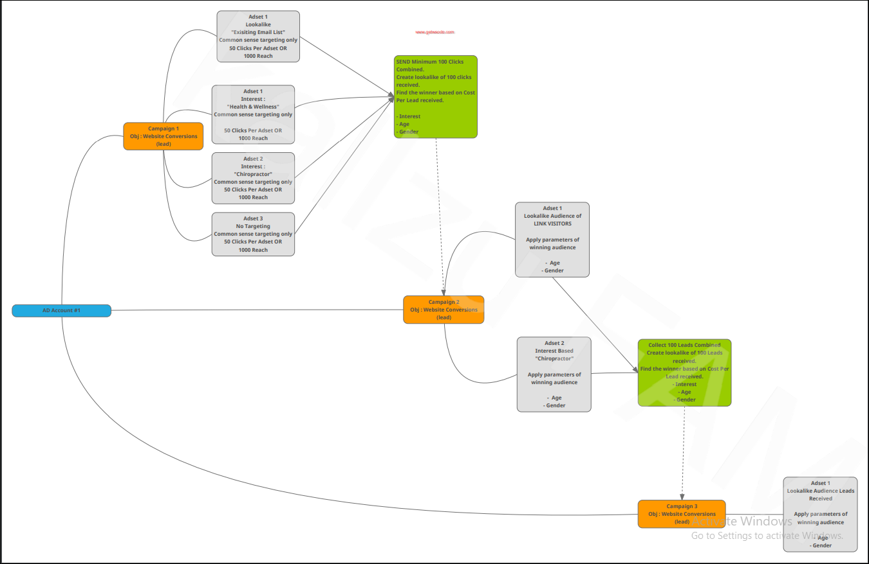

CAMPAIGN 1

- To Send "100 Unique CLICKS To Funnel"
- Create "Look-A-Like" Audience of 100 CLICKS Received
- Find Winning Offers Based On Cost-Per-Lead Received

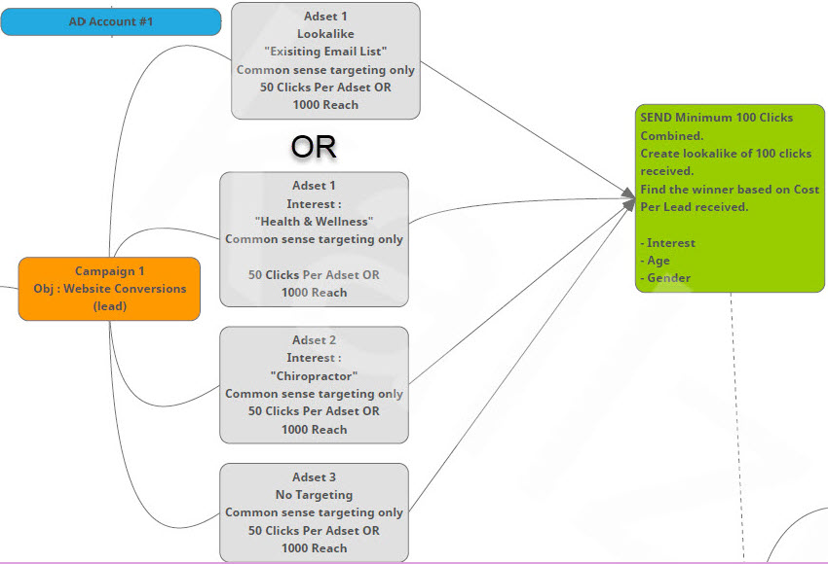

CAMPAIGN 2

- To Collect "100 LEADS" Combined From Funnel
- Create "Look-A-Like" Audience of 100 LEADS Received
- Find Winning Offers Based On Cost-Per-Lead Received
- Find Winning Offers Based On Targeting: Interest, Age, Gender
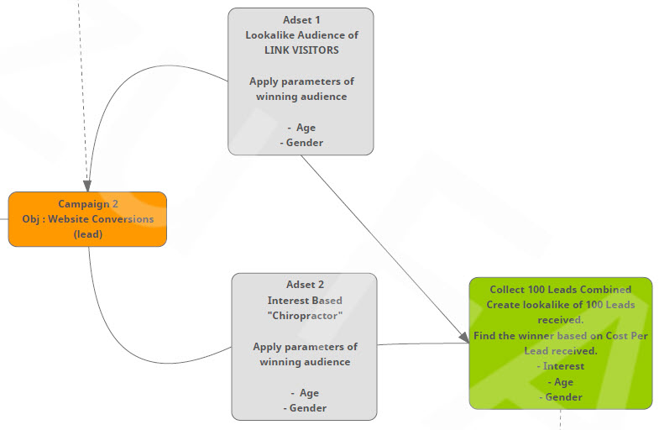

CAMPAIGN 3

- Create "Look-A-Like" Audience of 100 LEADS Received
- Apply Targeting Parameters Of Winning Audience Like: Age,
- Gender, Interest

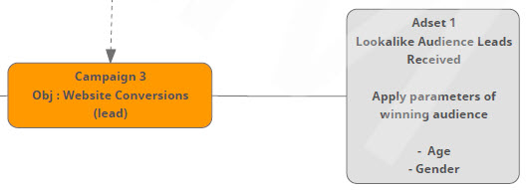

Difference Between Dino Gomez… VS... Waterfall Campaign

http://ivantraining.com/kallzu/#offer30

Dino Gomez Method:
Teaches to create 6 Ads in each Ad-Set.
This will test the Ads + Targeting within 3 Ad-Sets at once!

3 AD-SETS: To test which "Targeting" is converting and delivering the cheapest leads.
We gather the data and use this to create the next OPTIMISED AD-SET campaign.

6 ADS: To test which Ads convert the best (ie. which images & video convert) and deliver the cheapest leads.

So First Campaign: Has a Total of 18 ADS running at once.

Ivan Note:
I like this because we can test faster and get more data quickly
But you need to have the budget for this
Run this for paying customers with budget
On limited budget rather go for Waterfall campaign.

Waterfall Campaign Method:
We are testing the Targeting Only
And run 3 separate campaigns one after the other
We collect data then apply findings to the next campaigns.

FIRST CAMPAIGN
Create 3 Ad-Sets targeting 3 different interests
And only 1 Ad in each Ad-Set
We collect the data and create second campaign... (3 ADS running)

SECOND CAMPAIGN
Create Ad-Set where we run 2 Ads
The one ad is a "Look-A-Like Audience of WEBSITE VISITORS"
Second ad is an "Optimized Ad with data collected" from first campaign
We collect the data and create third campaign... (2 ADS running)

THIRD CAMPAIGN
Create Ad-Set where we run 2 ads...
The first ad is a "Look-A-Like audience of LEADS RECEIVED"
Second ad is an 'Optimized Ad with data collected from second campaign... (2 ADS running)

NOTE:
Only turn ads and campaigns off once you have a new campaign or ad doing better than the last one.
So when running Campaign 2... Leave Campaign 1 ON until we get the results
And if we get better results only then turn off Campaign 1 or Ads in campaign... So when we get to Campaign 2 & 3
We could be running 5 to 7 Ads simultaneously.

Ivan Note:
- Advantage here is you can test with a smaller budget
- On the Live Case Study Example the leads cost was fantastic
- Got really cheap leads at $2 range
- And we can always test different Ads with images and video at a later stage once we have the targeting on point.
- A bit slower but cost friendly
- Use this when offering to run Free campaigns.

TESTING: Will Depend on Budget i Have Available to Test With?

Dino Cost
18 ads x $5/$10 per day = $90/$180 per day (Testing Ads & Targeting)

Waterfall Cost
3 ads x $5/$10 per day = $15/$30 per day (Only Testing the Targeting for first campaign)
When running Campaign 2 & 3 we could be running 5 AD's

How Much Should I Spend for Facebook-Ads

http://ivantraining.com/kallzu/#offer2

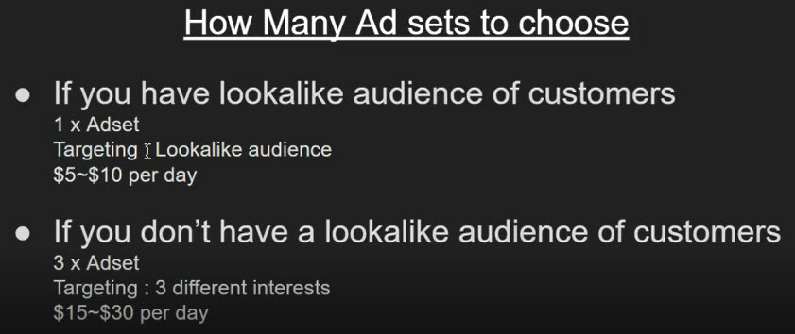

- If you have a small budget - go for $5-$10 per day
- If you have more budget go for $15 to $30 per day... (more budget will get data faster)

Campaign Launch Checklist

http://ivantraining.com/kallzu/#offer3

Campaign Launch Checklist

1. Read Facebook Ads Policies.
2. Watched & Understood Waterfall Framework.
3. The right payment method is connected. (Clients card)
4. Master Facebook Page Ready.
5. Funnel Complete and tested.
6. Master Pixel Installed in funnel.
7. Pixel Events Installed and tested using pixel helper.
8. Master Pixel connected to Ad Account.
9. Funnel Privacy Policy & Terms Updated
10. Funnel Notifications via Active Campaign Tested. (Sms , email notifications client & lead)
11. Funnel Mobile version check.
12. Funnel Visitors Audience Created.
13. Funnel Leads Audience Created.
14. Service area of your client. (city / zip codes / country etc .. )
15. Number of audiences ready. (Lookalike audience , or interests you want to target)
16. Budget allocations done.
17. Ad copy ready. (Ad text , Headline , Subheadline)
18. Video Ad uploaded to Asset library.
19. Ad copy & Funnel checked for fb ad compliance.

CREATE FIRST CAMPAIGN... (As Draft First)… THEN GO LIVE!

http://ivantraining.com/kallzu/#offer4

GOAL: Of Campaign 1
------- To Send "100 Unique CLICKS To Funnel"
------- Create "Look-A-Like" Audience of 100 CLICKS Received
------- Find Winning Offers Based On Cost-Per-Lead Received

CREATE FIRST CAMPAIGN & AD-SET
----------1.) Create New Campaign (in Draft)
----------2.) Create New Ad Set (in Draft)
----------3.) Create Ad (in Draft)
----------4.) DONE.. We Have Just Created Our First Campaign DRAFT, Now We EDIT
----------5.) Edit Campaign Level (Edit)
----------6.) Edit Ad-Set Level (Edit)
----------7.) Edit Ad Level (Edit)
----------8.) DONE.. We Have Just Completed Campaign 1 "DRAFT" Now Make It Go LIVE
----------9.) PUBLISH: Ad-Set For Review To Make It Go LIVE!
-------- 10.) DONE... Now Wait for AD To Go LIVE (24 Hours). Then Create 2nd & 3rd AD-SET.

Dark Post Advantages & Why You Should Use It
--- ---- Simply means to use the "POST ID NUMBER" when duplicating ad for other Ad Sets.
---- --- By doing this you do not have to create a new ad for each one.
--- ---- But more importantly you carry ALL the Social Proof.
-- ---- - You use the same advert and collect and display all social comments which will ……… ..xxxxxxincrease conversions.

CREATE SECOND AD-SET
1.) We only duplicate the other 2 Ad-Sets... AFTER first Ad-Set is approved!
2.) Instructions: Duplicate Ad-Set
3.) Editing Second AD-Set
4.) DONE: Second AD-SET "DRAFT" Is Complete... Now Create The Third AD-SET

CREATE THIRD AD-SET
1.) Instructions: Duplicate Ad-Set
2.) Editing Third AD-Set
3.) DONE.. Third Ad-Set 'DRAFT' Is Complete
4.) Publish: Both Ad-Set's For Review To Make Them Go LIVE!

Reading The Relevant Data From Facebook Ads-Manager
-----xxx-- How To Read The Data: What Each Column Means
----xxx--- Instructions: How To Edit Columns - Make Changes (Create Workflow Columns To ……xxx…..Analyse Data)

Number 1 Reason Why Your Campaign Will Fail… (Allow Ads to Run for Long Enough)

Data Analysis Of Campaign 1 And Bringing the CPL Further Down

Steps To Complete After Data Received (How many days?)

CREATE NEW FOURTH AD-SET… (If necessary after review, to bring CPL down further)
1.) Instructions: To Create NEW 4th Ad-Set in Campaign 1
2.) Edit: AD-SET Level
3.) Edit: AD Level
4.) DONE: How This Will Help

Final Results of Waterfall Campaign 1

GOAL: Of Campaign 1

- To Send "100 Unique CLICKS To Funnel"
- Create "Look-A-Like" Audience of 100 CLICKS Received
- Find Winning Offers Based On Cost-Per-Lead Received

CREATE FIRST CAMPAIGN & AD-SET

http://ivantraining.com/kallzu/#offer4

Create New Campaign (in Draft)

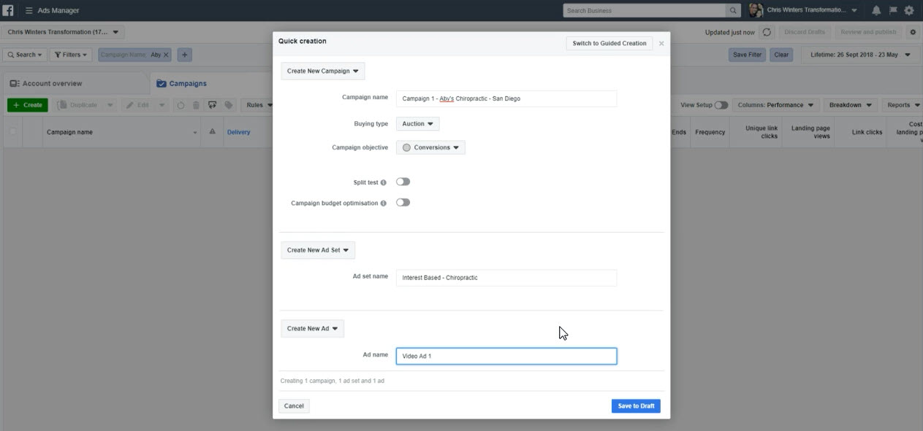

Instructions (2:09 min on video)

- Open Business Manager - go to Ads Manager
- Click on Campaigns Tab...Then click on Create button (green button)
- Window Opens Up ... make sure it's the Quick Creation window, and not the guided creation window... (like above)

Create New Campaign

- Campaign name: Campaign Name, Business Name, City Name... Example: Campaign 1 - Ivan Hollywood Smile Pros - San Diego
- Buying Type: Auction
- Campaign objective: Conversions
- Split test: keep it off
- Campaign budget optimisation: keep it off (later we will use this)

Create New Ad Set (Draft)

- Ad set name: Interest Based, Choose one interest to target & name it
- Example: Interest Based - Chiropractic ...(means people who are interested in chiropractic)
- Example: Look-a-Like Based - Dr Jon customer list ....(name like this if using look-a-like)

Create New Ad (Draft)

- Ad name: Video Ad 1 ...(example)
- Once form is filled out... Click on "Save to Draft" (bottom right)

Ivan Notes:

- Once form is filled out... Click on "Save to Draft" (bottom right)
- Facebook Ads Manager will create a draft campaign, this is the beauty of FB Ads Manger and allow you to play around with it and make changes first.
- It will only "be sent to facbook" when you click on the green "Publish" button on bottom right.
- Only publish after you have done a thorough check of campaign.

DONE.. We Have Just Created Our First Campaign DRAFT, Now We EDIT

Campaign Level: Edit

Draft Campaign Window

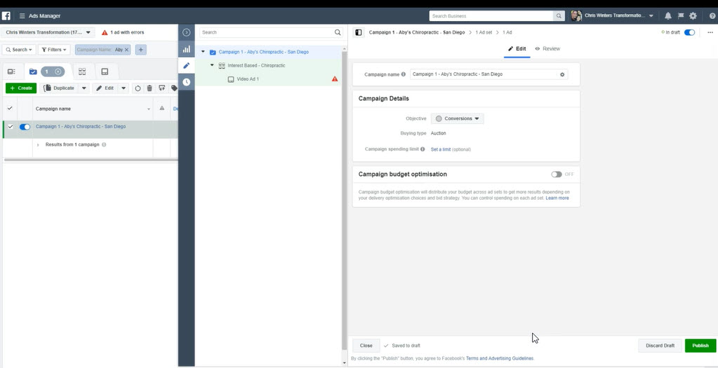

Instructions (6:18 min on video)

- Next the "Draft Editing Campaign Window" will open up... (like above)
- If it does not open up, go to Ads Manager, Campaigns Tab, Find Draft of campaign on left column and click on "Edit" to open draft campaign.
- In the middle column.. FB displays the anatomy of a campaign in hierarchy format.
- First its the "Campaign"... And inside a campaign is an "Ad Set"... And inside the ad set is a "AD"
- We start from the top and work our way down.

Campaign 1 - Ivan Hollywood Smile Pros - San Diego

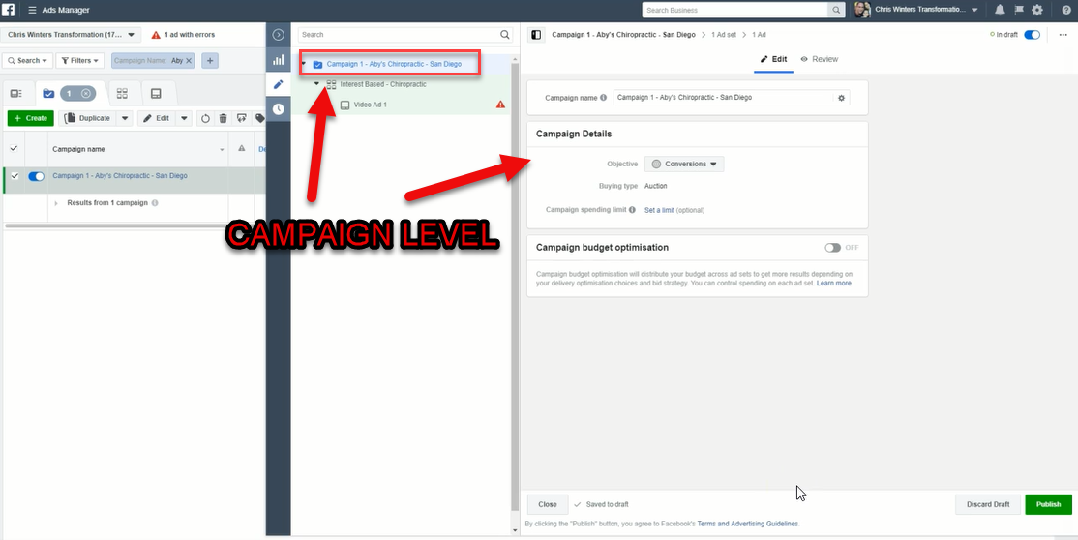

Instructions (7:15 min on video)

- Click on Campaign: and on right column we have (like image above)
- Campaign name: already named, can leave it
- Objective: Conversions... do not have to change it
- Budget type: Auction... no need to change
- Campaign spending limit: Set a limit (optional)... no need to change
- Campaign budget optimisation: OFF... leave off for now

Ad-Set Level: Edit

Interest Based – Chiropractic
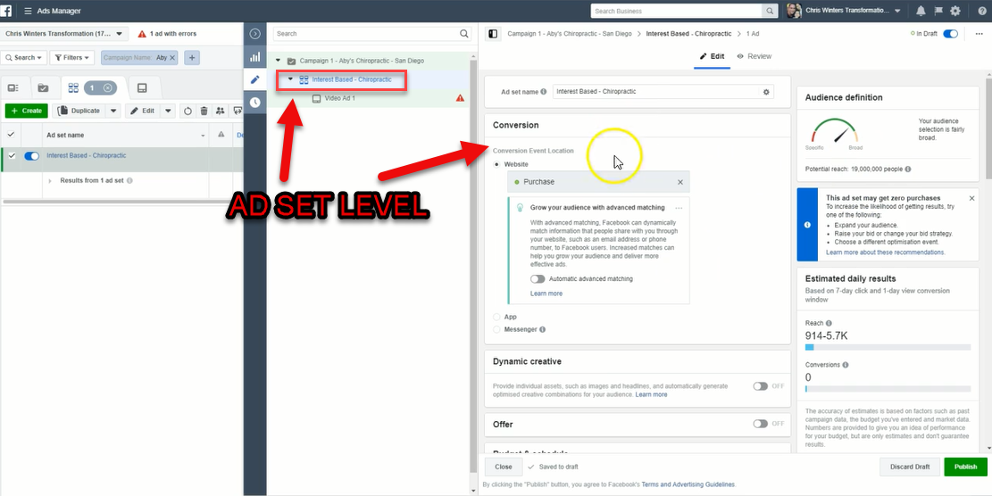

Instructions (8:11 min on video)

- Click on Ad Set: and the following displays on right column (like image above)
- Its split into 2 columns, one on the left for editing and one on the right to see changes and review.
- Lets start from the top

Ad Set Name - already given the name, leave as is

Conversion: Here we have to tell Facebook what kind of conversion we are looking for.

- We want a LEAD.. so under the headline "Conversion Event Location & Website.
- We have to remove the default that says Purchase, we must x it out and choose "LEAD" on the drop-down.
- Also make sure you are selecting it using the "CORRECT PIXEL".. together with lead it will display the pixel to be used.. choose the correct one.
- Move onto next part which is "Dynamic Creative"

Dynamic Creative: Keep it at off

Offer: Keep it at off

Budget & Schedule: We will go for $5-$10.. If we need faster data and have budget go for $15-$30

- Budget: Choose $10
- Start Date: Always start the campaign from the next day from 00:00... The reason for this is that when you start next day at 00:00 Facebook will spread ad budget $10 evenly across day.
- Notes: If you are starting a campaign with $10 budget at another time like 8pm then Facebook have only 4 hrs to spend that budget, so data will not be really optimal... Take away is to start campaign next day at 00:00
- End Date: Do not have to change the end date at all
- Ad Scheduling: Leave it as is

Audience:
- Here we will either choose a "Look-A -Like" audience if we have set one up using clients email list of existing customers. OR we will create our own audience & custom targeting.
- For Look-A Like audience we will run only one advert.
- If creating our own ads - We will create 3 Ads-Sets with one Ad in each Ad-Set using different targeting options... Total of 3 Ads for Campaign 1
- To create 3 Ad-Sets simply create the first one, then duplicate and change the targeting for each one.

Instructions for "Look-A-Like" Audience

- Go to "Custom Audience" tab and type in "lookalike"and all the lookalike audiences will appear.
- Choose the lookalike audience of the "Customer "List" you created.
- And when you select that on the right hand side you can see the audience reach will change.
- You will see its very low because in location we have South Korea country selected and need to change it to USA
- Once you change you will see audience reach has changed.

Instructions for "New Audience" Audience

- Custom Audience: leave blank and move onto "Locations Section"
- Include: On top of map.. type in city name and Facebook will show a list of city options.. select the correct city.
- Radius: It will also show a radius.. choose the radius area your customer serves like 20-40km... Facebook will now target everyone in that location..
- Location: on first tab above map... choose "People that live in this location"
- Age: choose the age range you wish to target... (example 25-60).. choose wide range to get data.
- Gender: choose all or separate depending on service.
- Languages: choose English All

Detailed Targeting Section - Instructions

- Here we are going to create 3 adverts based on 3 different targeting options
- we will create the first ad here
- then duplicate the Ad-Set and change the targeting for each one.

Detailed Targeting: type in a word like "Dentist" or "Health & Wellness" or "No Targeting".

- When you type in "Chiropractor" example there are a few options that pop up
- Two options say Chiropractor.. but if you look on the right.. the one says Job Title, which means these are people that list themselves as working chiropractors... we don't want to advertise to these people.
- The second option says Chiropractor Interest... which means people that are interested in chiropractor and these are the people we want to advertise too... So we choose this one... Always read the description on the right.
- And when you choose your targeting, the size of the audience will display on right column... For this example the audeince is very small but we are going to go with it.
- SIDE NOTE - Dino says to have a minimum of 50,000 target audience.
- Connections: we leave as is, no connections.

Placement Section - Instructions

- Here we need to tell Facebook where to place the ad.
- So we change it from Automatic Placements to "Edit Placements"
- Will give me a long list - Choose the following.
- Only show your ad in the "Feeds" of Facebook and Instagram.
- Uncheck everything, and only check Facebook feed and Instagram feed
- Scroll down and under Mobile Device - we do not change anything.

Optimisation and Delivery Section - Instructions

- Do not need to change anything
- under Conversion Window: 7 days after clicking or 1 day after" can leave as is.
- DONE.. for editing Campaign & Ad-Set... We now move onto creating AD

DONE.. for editing Campaign & Ad-Set... We now move onto creating AD

Ad Level: Edit

Video - Ad 1
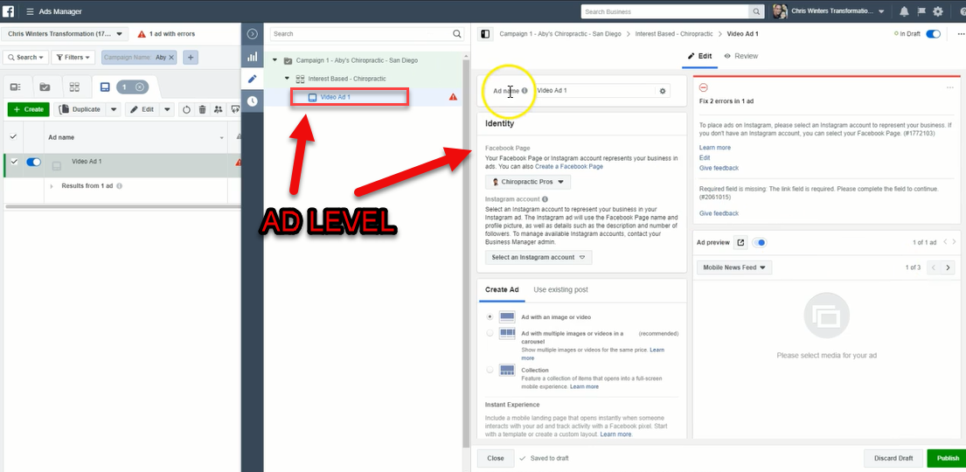

Instructions (18:32 min on video)

- Click on AD: to get to AD Settings
- Fill out form, from the top and work your way down.

Ad Name: Call it a name like "Video Ad 1"

Identity Name: Here we select the "Page" we want to advertise from for example Our Page or Clients Page.. we will be choosing our page.

- Click on drop-down arrow and choose our page, should already be set to our page.
- Next is to select an "Instagram Account"
- Facebook have a cool option that allows us to create a fake account using our Page Name.
- Click the drop-down next to Select an Instagram Account
- Will give you 3 options and click on the one that says "Use selected Page"
- Then Facebook will go ahead and create that fake account.

Create Ad: Here we are going to create the actual ad to be displayed.

- Here are 2 options, Create Ad and Use Existing Post
- For the first Ad-Set we are going to use "Create Ad"... for the next 2 ads we will use Existing Post.
- Next choose the type of ad we will create... choose "Ad with an Image or Video"

Instant Experience: skip it and move on.

Image or Video/video slide show: tick one, most of the time use video ad.

- Select Video: click on it and it will open up Video assets, upload your video and select video and click on continue. Once its added it will display preview in right column.
- There is an option to select Thumbnail.. make sure to choose a good thumbnail people will see.
- Customise Video: Click on it, Edit Video popup will display.. on left click Thumbnails and choose one... Click on "Apply Changes" button bottom right. It will apply changes in preview box on right side.
- Always go for one that looks weird or clickbaity that triggers curiousness so people will click on it and play the video.
- Customize ad by placement: Beneath video is an option to "Customize ad by placement" leave that do not tick it.. leave as is. We have already set it up to display in Facebook and Instagram feed.
- Select the link type for your ad: have 2 options, Website or Facebook Event.. We are sending people to a website so choose website.

Text: Copy the text for the ad either in Creative hub or Notepad and paste in.

- Website URL: Here we enter in the url of our Clickfunnel url or website url.. Do-not enter a bitly link here.. use the proper website url.
- Make sure the url works by clicking on the "Preview URL" button... should load website.
- Display Link: leave it as blank.
- Headline: Copy and paste that in.
- News feed link description: Copy and paste that in.
- Call to action: Select your button here to be displayed, can test them.. "Learn More" button seems to work the best.

Tracking: Make sure conversion tracking is turned on

- Facebook Pixel: make sure its turned on... by default it should be on
- AND make sure the Pixel selected is your Master Facebook Pixel...
- SUPER SUPER SUPER IMPORTANT!

DONE.. We Have Just Completed Campaign 1 "DRAFT" Now Make It Go LIVE

Publish First Ad-Set For Review To Make It Go LIVE!

- Next Step is To Review And Double Check Everything... Once Satisfied.
- Click on the button at bottom left that says "Close"
- Ads Manager window will open up.
- Click on "Campaigns"
- You will see your "Campaign 1" draft you created... will be turned on highlighted blue.
- Top right, click on "Review and Publish"
- Box pops up.. called "Review draft items".. that will show us the campaign we want to publish... will show the 3 buttons on top... Campaigns, Ad-Set and Ad.
- Once ready click on the 'Publish" button... and you will see a blue progress bar on top publishing the campaign.
- You will then see your campaign is under review... DONE!
- They should start running the next day... normally 24 hrs to review.

DONE... Now Wait for AD To Go LIVE (24 Hours)

Dark Post Advantages & Why You Should Use It

http://ivantraining.com/kallzu/#offer5

Simply means to use the "POST ID NUMBER" when duplicating ad for other Ad Sets. By doing this you do not have to create a new ad for each one... But more importantly you carry ALL the Social Proof.. you use the same advert and collect and display all social comments which will increase conversions.

Instructions: To Get "Post Id Number"

- Go To Ads Manager.. click on Campaign tab and you will find you campaign created.
- Click on campaign and you will see one Ad-Set.. open Ad-Set by clicking on it... and click on Edit to open, AD which will display on right side.
- On the right above there is a "Ad preview" button... click on it and it will give you the option to see post.
- Click on Facebook post with comments... it will open the Ad in Facebook for you.
- This is called a Dark Post, because it is hidden from your page.. when you open your Facebook Page you will not see this Ad/post.. its not visible.
- We will use this dark post, to create all our new ads.. and it will carry all the social proof we collect from the different campaigns and display for all ad-sets we create.
- Copy the "POST ID NUMBER" from dark post URL bar.. all the digits at the end of the url
- And paste into the Ad Creation Box.. when creating new Ad-Set

CREATE SECOND AD-SET

http://ivantraining.com/kallzu/#offer6

Instructions: To Duplicate Ad-Set

- We only duplicate the other 2 campaigns... AFTER first campaign is approved!
- We jump into Ads Manager.. click on Campaigns... he clicked on 1 selected button.
- Jump into campaign by clicking on the campaign name so it opens up.
- Will find first Ad-Set in there... and we push the "Duplicate" button... and box pops up called
- Duplicate ad set into: no need to change anything, Original campaign keep off and for "Number of copies of each ad-set" choose only 1.. and click "Duplicate"
- Will open up into the Ads Manager window and you will see the duplicated Ad-Set.. It will show the name with the word -Copy behind it.
- Here we can now make all the changes for Ad-Set 2... like we did for first ad-set.

Editing Second AD-Set

"AD-SET" Settings: - Click on Ad-Set tab in middle column

- Ad set name: Change name to "Interest Based - Health & Wellness"
- Everything else stays the same.. except "Detailed targeting"
- Detailed targeting: We click on "Suggestions" and choose "Health & Wellness" can even type it in.. and remove Chiropractor... So now we have changed targeting.
- Go through all the settings to make sure they are correct like check the Budget, Audience, Placement etc. but they should all be correct and carried over from duplicate.

"AD" Settings: - Click on Ad tab in middle column

- Ad name: Keep the same do not change, going to keep name the same in all ad-sets
- Identity: leave page the same
- Instagram account: leave the same
Create Ad: This is where we create Ad using with "Use existing post" tab

- Use existing post: click on tab.
- Enter Post Id: enter the Post Id Number (copy and paste it in) and press Submit.
- Will display on right preview
- Double Check: Go over everything from Ad-Set settings to Ad settings.

DONE... Second AD-SET "DRAFT" Is Complete... Now Create The Third AD-SET

CREATE THIRD AD-SET

Instructions: To Duplicate Ad-Set

- Here we are going to duplicate our Second Ad-Set.
- We jump into Ads Manager.. click on Campaigns... he clicked on 1 selected button.
- Jump into campaign by clicking on the campaign name so it opens up.
- Will find second Ad-Set in there... NOTE: choose the "Second Ad-Set" we just created and duplicate this one... because it already has the dark-post id number inserted, makes creating the third ad-set easier.
- Choose Ad-Set 2 and push the "Duplicate" button... and box pops up called
- Duplicate ad set into: no need to change anything, Original campaign keep off and for "Number of copies of each ad-set" choose only 1.. and click "Duplicate"
- Will open up into the Ads Manager window and you will see the duplicated Ad-Set.. It will show the name with the word -Copy behind it.
- Here we can now make all the changes for Ad-Set 3... like we did for last ad-set.

Editing Third AD-Set

"AD-SET" Settings: - Click on Ad-Set tab in middle column

- Ad set name: Change name to "Interest Based - No Interest Targeting"
- Side Note: No Interest Targeting - Not recommended but got great results with this one, is worth a test, is for you to decide... Only play with the Age Range here.
- Everything else stays the same.. except "Audience & "Detailed targeting"
- Create New Audience: change age range from 30-60
- Detailed targeting: Delete ALL by x-ing out any interest like Health & Wellness... must be blank... When you do this on the right side the Audience reach will be very high... Remember this is an experiment!
- Go through all the settings to make sure they are correct like check the Budget, Audience, Placement etc. but they should all be correct and carried over from duplicate.

"AD" Settings: - Click on Ad tab in middle column

- Ad name: Keep the same do not change, going to keep name the same in all ad-sets
- Identity: leave page the same
- Instagram account: leave the same
- Create Ad: This is where we create Ad using with "Use existing post" tab
- Use existing post: Double check here to make sure we are using the Post Id Number.,, Should be the same because we copied our Second Ad-Set.
- Double Check: Go over everything from Ad-Set settings to Ad settings.

DONE.. Third Ad-Set 'DRAFT' Is Complete.. NOW Make Both AD-SET's Go LIVE

Publish Both Ad-Set's For Review To Make Them Go LIVE!

- Review And Double Check Everything... Once Satisfied.
- Click on the button at bottom left that says "Close"
- Ads Manager window will open up.
- Click on "Campaigns"
- You will see both your "Campaign 2 & 3" drafts you created... will be turned on highlighted blue.
- Top right, click on "Review and Publish"
- Box pops up.. called "Review draft items".. that will show us both campaigns we want to publish... will show the 3 buttons on top... Campaigns, Ad-Set and Ad... Make sure both are chosen... Only those 2 campaigns must be chosen.
- Once ready click on the 'Publish" button... and you will see a blue progress bar on top publishing the campaign.
- You will then see your campaign is under review... DONE!
- They should start running the next day... normally 24 hrs to review.

Reading The Relevant Data From Facebook Ads-Manager

http://ivantraining.com/kallzu/#offer7

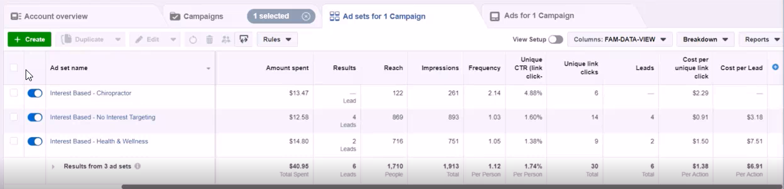

How To Read The Data: What Each Column Means

- Ad Set Name - Name of campaign & in the name we describe the "Targeting" for each Ad-Set.
- Delivery - Tells you if campaigns are running or not, and if ads were approved.
- Budget - Amount we will spend daily.
- Amount Spent - (important metric)... How much we have already spent, and Total amount spent for ALL Ad-Sets.
- Results - Displays results of campaign and depends on type of campaign you chose, example: Leads campaign or Traffic campaign etc... Ours is a "Website Conversion LEAD Campaign" and shows how many clicks were sent.
- Reach - (important metric)... Tells us how many people we reached using our ads... Because if you check our Waterfall diagram this is one of the metrics we need... We need Reach 1,000 people per Ad, to get enough data from Facebook.
- Impressions - Is how many times Facebook has shown this ad to all the people. Reach and Impressions are similar, but for example if Facebook showed person a Ad in the morning and again in the evening then that's an impression.
- Frequency - The number of times a person has seen your Ad.. they are averages so you will see decimal points.
- Relevance Score - do not see it displayed?... Is a rating on a scale of 1-10 that demonstrates how well your Facebook ad is being received by your target audience. Once an ad has received 500 impressions, Facebook will generate a relevance score for it, with 10 being the highest.
- Unique CTR (link click through rate) - This tells how many people are clicking on the link when they see your Ad.. means clicking on the link to reach your Landing Page... shown in %
- Unique Links Clicked - (important metric)... How many people have clicked onto your links... shown in numbers.
- Leads - Shows us the number of leads received.
- Cost Per Unique Link Click - What is the cost we are paying Facebook for a unique link click.
- Cost Per Lead - (most important metric)... How much does a lead cost for each Ad-Set

So that's how we read data...And we now wait until we REACH 1,000 people and then we will read the data.

INSTRUCTIONS: How To Edit Columns - Make Changes

- Here we are going to change the columns in Facebook so we are able to read the data and extract the information we need from our campaigns.
- Go to Business Settings, hamburger, Ads Manager... make sure you are in Ads Manager
- Click on top right tab drop-down that says columns and it will show the entire list of presets Facebook provides.
- You are going to create a custom column view, so you have to click on "Customise Columns" and a window will appear allowing you to edit the way Facebook displays data.
- So on the right side is the current columns setup, and you can drag and drop things, remove things and you can click on something on the left column and it will move over to right column.. and you can move things up and down on the right column.
- Below is a list of all the required columns... edit the menu so it looks like list.. once done click on 'Apply" button and you will have made changes.
- In the search bar you can type in the name to find correct tab.
- All easy to do... but for "Leads"... we will click on leads in left column and we have 4 options in tabs at the top... We need to click on Total, must be ticked.
- And when you view Leads tab on right column, it will show sub-category tabs that are ticked called "Website Leads" and "Offline Leads"... You need to remove and un-check these (remove ticks).
- For "Cost Per Lead" you type it into search bar, and 2 options appear.. Leads and second one is Leads (form)... You choose the first one Lead and tick on the tab that says "Cost"
- Then your done.. check everything and make sure it displays exactly like list below.
- TRICK - On the bottom left corner is a button that allows you to save this as a preset... Tick the box, and give it a name like "NEW DATA VIEW"... then press "Apply" button to make changes.
- So next time you have a new campaign and need to change columns in Ads Manager.. Simply click on "Columns" tab on top, and in the drop-down you will find the name of your saved preset.. click on it and save, and it will apply all changes.

Create Workflow Columns To Analyze Data

1. Campaign Name
2. Delivery
3. Ad Set Name
4. Budget
5. Amount Spent
6. Results
7. Reach
8. Impressions
9. Frequency
10. Relevance Score
11. Unique CTR (link click through rate)
12. Unique Links Clicked
13. Leads (Uncheck sub category)
14. Cost Per Unique Link Click
15. Cost Per Lead

#1 Reason Why Your Campaign Will Fail

http://ivantraining.com/kallzu/#offer8

You will fail if you stop ads too soon... And do not allow Ads to run for long enough to get accurate data... Let them run till each Ad-Set gets a minimum 1,000 Reach (that means showing each ad to a minimum of 1,000 people)... or a minimum of 50 Clicks.

And for Campaign... which consists of 3 Ad-Sets. To collectively get a minimum of 100 Clicks (unique link clicks) combined from all 3 Ad-Sets (that's 100 people Total that click on the link in the ads)... so you get accurate data.

Trust in the process! ... Once we have the data we will use it to run next "Optimised Campaign" to reduce lead cost with data obtained.

Data Analysis Of Campaign 1 And Bringing the CPL Further Down

http://ivantraining.com/kallzu/#offer9

GOAL OF CAMPAIGN 1
- To Send "100 Unique CLICKS To Funnel"
- Create "Look-A-Like" Audience of 100 CLICKS Received
- Find Winning Offers Based On Cost-Per-Lead Received

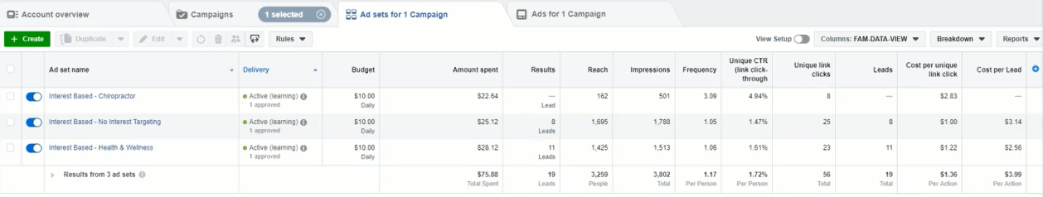
Notes

- We are currently at only 56 Clicks
- We have currently spent $75
- And we want to see if we can reduce the Cost Per Lead, or amount we spend on Facebook to get better leads for the same money.
- When to EVALUATE: ?... Look at the "Reach" column.
- When Ad-Set's have reached 1,000 Leads we can then evaluate.. In our example two of the three Ad-Set are over 1,000 Reach... So we can evaluate and take a look at what the data is telling us.
- And then decide, if we are going to switch Ad-Set's OFF because they are not generating leads or leads are too expensive... And decide if we are going to create a 4th OPTIMIZED Ad-Set with new data obtained.
- DATA in Facebook is displayed as follows:
- Campaign Level - where you get a summary of ALL "Leads" generated plus a "Cost per Lead" amount.. from ALL the Ads combined, an average Total per campaign.
- Ad-Set Level - where you see a "breakdown" of each Ad and how each one is performing individually... showing the leads generated and cost per lead for each ad.
- EVALUATION: Is done in 2 steps.
- First Step - you have to evaluate the campaign and see how it is performing. You do this by filling out the "Data Points" Analysis Form... You will use these data-points to understand the winning parameters of your campaign.
- Second Step - based on the data... Decide which Ad-Sets to pause if any.. And decide if you wish to create a New Optimised Ad-Set with new parameters from data obtained. Or whether you just want to run campaign as is until we reach 100 Clicks.... And also decide whether it is necessary to even create a second campaign... If leads are already cheap and within budget, then not necessary to create a Campaign 2.

Instructions: STEP 1 - Fill Out Form

- Download the sheet.
- Open up "Ads Manager" and click on "Campaigns" tab, then select your campaign and click on it... It will open up the Ad-Sets with data.
- Now begin filling out the form.

FORM DETAILS: (Where to Access Data)

What is your target cost per lead?
Amount you are willing to pay per lead... "$5 a Lead"

CAMPAIGN LEVEL (Must have Ad-Sets with 1,000 Reach, otherwise data will not be accurate!)

Age Range - Make sure you are in Campaign Level... Top right corner you will see a drop-down button called "Breakdown"... It will give you three options called, BY TIME, BY DELIVERY and BY ACTION... Click on "BY DELIVERY"... and it will give you a dropdown with options... Click on "Age" and data will display... Age, Amount Spent & Cost Per Lead are the important columns... Copy & paste data into spreadsheet.

Gender - Click on "Breakdown tab and choose "Gender"... Read the data, look at Amount Spent, amount of Leads Generated and Cost Per Lead... if lead cost is good for both... ADD male & female to spreadsheet.. in other words we will continue targeting both.

Device - Click on "Breakdown tab and choose "Impression Device"... will give breakdown of all devices ads are being viewed on... Look at Amount Spent.. Amount of Leads generated and Cost Per lead.. Choose the top performing devices based on Cost Per Lead and add to list.

Platform - Click on "Breakdown tab and choose "Platform"... Check Amount Spent, amount of Leads generated and Cost per Lead... If cost falls within my range choose both, if not eliminate one... add to form.
NOTE - We are done with Campaign level data, and can remove the Breakdowns... we do that by clicking on "Breakdown" tab and clicking on "Clear all breakdowns"

AD-SET LEVEL: (Click on Campaign to open up Ad-Set Level)

Which ad sets are profitable?
Look at Ad-Sets and the Amount Spent and Cost Per Lead and see which ones are working and not working, for Example:

No-Interest Targeting
Has $25.12 spent, has generated 8 Leads, at a cost of $3.14 per lead... This one is working!

Health & Wellness Targeting
Has $28.12 spent, has generated 11 Leads, at a cost of $2.56 per lead...This one is working! .... Add to form.

Which ad sets are NOT Profitable?
- Look at Ad-Sets and the Amount Spent and Cost Per Lead and see which ones are working and not working,
- Example: Chiropractor Targeting - Has $22.64 spent but NO Leads... Its not working.... Add to form.

DONE... We Have Collected ALL Data For This Campaign!

SUMMARY OF FORM - Campaign 1

General

Follow the steps after you reach at least 1000 people

● What is your target cost per lead?
A: $2 to $6... Maximum $6

Enter the data you obtained from your breakdown.

Campaign Level

1. Age range
A: 25-34 (cost per lead- $2.43)
A: 35-44 (cost per lead- $25.06) ... Too Expensive!
A: 45-54 (cost per lead- $2.72)
A: 45-54 (no leads generated)... Not-Profitable, delete age range

Decide which Age Ranges are profitable?

25-34 works and 45-54 works... so when creating new ad.. round it off and go for Age Range of 25-54.

Ivan Notes:

- FB does not let us split test age ranges within one Ad.
- So we round off and make an Optimized Ad with age range of 25-54
- I would rather split & test with 2 new optimized ads.
- As the age range of 35-44 is costing $25.06 a lead... too expensive!
- If you include expensive age range in the new Optimized Ad...
- I think it will drive the cost up too much... will mess with the profitable age ranges.
- INSTEAD: I could create TWO Optimized Ads.

2. Gender
Male / Female / Uncategorized
A: Male & Female

3. Device
Android Smartphone / Android Tablet / iPhone / Desktop / iPad / Other
A: Android Smartphone

4. Platform
Instagram / Facebook
A: Facebook

Ad-Set Level

1. Which ad sets are profitable?
A: Interest Based - No Interest Targeting
A: Interest Based - Health & Wellness

2. Which ad sets are NOT Profitable?
A: Interest Based - Chiropractor

Steps To Complete

- Turn off non profitable ad sets.
- Duplicate most profitable Adset, apply winning demographics from sheet above.
- Goal is to get to 100 quality clicks to your funnel, and while doing that get lowest cost leads from that.

Steps To Complete After Data Received

http://ivantraining.com/kallzu/#offer9

- Turn off Non Profitable Ad-Sets:
- DUPLICATE most profitable Ad-Sets... APPLY winning demographics

Turn off Non Profitable Ad-Sets

- We spend a lot of money and there is an Exception when turning off ads.
- On the Ad-Set with "Chiropractor Targeting" - We have spent $22.64, but only reached 162 people.
- But if we check "Frequency" column: It says 3.09.. Which means that our Ad was shown 3 times to these people... And yet we still got NO leads.
- In this case, even thou we have not reached 1,000 impressions... Because of the frequency, it tells us that this audience is very very small.
- And with our Ad being shown 3 times, with no leads.. We know that this targeting is NOT-WORKING and we can turn-off this Ad-Set.
- So we click on the blue-button on the left, next to Ad-Set... And turn it off (make it grey). This will stop the Ad-Set from running.

DUPLICATE most profitable Ad-Sets... (Apply winning demographics )

- For the winning Ad-Sets, we do not touch or change anything... otherwise Facebook will restart their learning process and mess with our results.
- If you go to "Delivery" column, and hover your mouse over "Active (learning)"... it will show you a Facebook Learning phase progress bar... If you make any changes it will mess with this... So leave Ad-Sets alone.
- GOAL: Of campaign is to get a minimum 100 CLICKS combined (100 people clicking on Ad to funnel)
- But if we check the Campaign we currently only have 57 Unique Clicks.
- SO, we can decide to only keep the 2 profitable Ad-Sets ON and run with them until we get to 100 Clicks...
- OR... We can decide to create another "New Ad-Set" which is a better idea, because we now have new data, and can create an optimized Ad-Set that will drive more clicks at a cheaper price... and give us leads at a cheaper price.
- We will get to our 100 Clicks faster and also test to see if we can get leads cheaper that fall within our $5 range.
- So we go ahead and create a new Ad-Set by duplicating and swapping out the parameters with data from our form.

CREATE NEW FOURTH AD-SET… (after review)

Instructions - To Create NEW Ad-Set in Campaign 1

- Make sure you are in Ads-Manager... Ad-Set Level
- Choose the best performing Ad-Set... the one with cheapest cost per lead.
- Hover over Ad-Set name and click "duplicate" button
- Window pops-up.. do not change anything and click blue bottom "Duplicate"
- Will open you up in window with all the Ad-Sets... and you should see the one just duplicated.. it will say Copy behind the name.
- Now we are going to make the changes.

AD-SET LEVEL

- Ad-set name: Keep the same but at the end of name, type in "Optimized", so we know its the optimized ad... Example of name: "Interest Based - Health & Wellness - Optimized"
- Conversion: keep it as it is.
- Dynamic creative: keep it as it is... OFF
- Offer: keep it as it is... OFF

Budget & schedule:

- Daily budget: keep it at $10
- Start date: change to next day and 00:00
- End date: keep it as is, no end date

Audience: Create new audience

- Custom Audience: leave as is, no audience.
- Location: no change, leave as is
- Age: Here we make changes... Go to form and it says 25-54, make the changes.
- Gender: Here we check form.. It says male & female, so we can leave as is.
- Language: no change here, leave as is.
- Detailed Targeting: no change here, leave it to "Health & Wellness" or the targeting we duplicated within this Ad-Set.
- Connections: no change her, leave as is

Placement:

- Edit Placements: Check the form, if it has changed then make changes or leave as is.
- Device types: Check the form... Here there is a change... We want to change it to ONLY "Android Smartphone"... So make the changes... We un-check the Desktop and leave Mobile on.. Scroll down and find drop-down tab that says "All mobile devices".. click on it and choose "Android device only".. make sure the others are unchecked. It will display 2 items namely Android Smartphones and Android Tablets... We only want Android Smartphone, so delete Tablets option.

Optimization and Delivery:

We do not have to change anything here... so skip this section.

AD LEVEL

- Before we publish this Ad-Set, first click on the AD section, by clicking on "Video Ad 1" on left column
- And check to make sure you are using an existing post (refer to dark-post video to get post-id number if needed)
- Once done, we are ready to publish... Click on the green button on bottom left corner called "Publish"
- You can also click on "Review and Publish" which is a blue button in top right corner... you can then review and press Publish button.
- And it will be submitted for review.
- Once it goes Live... the data runs quickly so in the beginning check them once per day.

DONE - How This Will Help

- OK, so we have created the new "Optimized Ad-Set" and this will help me with a lot of things.
- It will help me reach that 100 CLICKS we after for this Campaign, so i can graduate to the next level that is campaign 2, where we increase the budget and stuff and will also get quite a good number of leads

Final Results of Waterfall Campaign 1

http://ivantraining.com/kallzu/#offer10

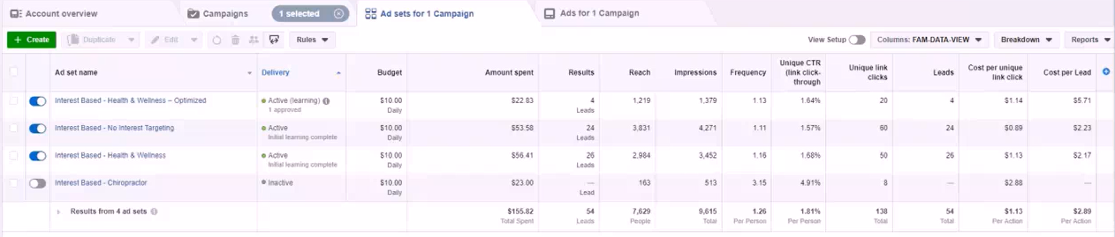

Ivan Notes

- We noticed earlier that one of our Ad-Sets was not performing at all, $25 leads.. So decided to stop this Ad and instead create a 4th Optimised Ad, using all the information we gathered from previous 3 Ads... The other 2 Ads were doing very well with only $2,50 leads.

- Surprisingly our "4th Optimized Ad" did not perform well... Our goal was to bring lead cost down applying the data we received from first 3 Ads... BUT this 4th Ad was delivering leads at over $5... Which is double of what the previous ads are doing.

- So we cancelled this 4th Optimized Ad... Even when you gather data from other Ads to create a new Optimized Ad.. the results might not be better... That's why we test and analyze.

- I think its because we included the age range of 35-44 in new Ad which had a very high lead cost of $25 and pushed the 4th Optimized Ad lead cost up too much... We can not split test 2 age ranges in one Ad...(we need to create 2 separate Ads to test 2 separate age ranges)

- The data told us that age ranges of 25-34 were profitable.. And the age range of 45-54 were profitable... But the age range of 35-44 was NOT profitable with a high cost per lead.

- When creating the 4th Ad we rounded off and created one Ad (including ALL the age ranges) of 25-54 (included the NON profitable age range)... NEXT TIME would rather try creating 2 separate Optimised Ads focusing on the 2 profitable age ranges and exclude the age range with such high lead cost... Think i would get better results this way.

Abby Notes

- What was the actual GOAL of Campaign 1
- It was not to make a campaign that is widely successful... Instead it was to acquire a minimum of 100 Clicks... and then create a Look-A-Like audience.
- Then we go to the next campaign... Campaign 2
- We got lucky with the first campaign, the cost per lead was within our range, but be warned... this will not always be the case.
- Sometimes your campaigns will barely be breaking even or only be moderately profitable.
- On Campaign 1, getting Ad-Sets to deliver leads at $2-$3 straight off, is not really easy but we got it in this case.
- After we get the data from Campaign 1, its time to roll out the next campaign.
- Also if you decide to run with Campaign 1 for a long time because its delivering cost effective leads...After a long time of running Campaign 1, you will reach an audience cap... where you will start to lose the profitability and Lead cost will go up.
- At that point its time to create your second campaign... you have to create a new audience and move forward.
- Since Campaign 1 has met our minimum criteria of 100 Clicks... We are now able to create a "Look-A-Like" audience of ALL the visitors to our Landing-Page funnel, and create a new campaign, where we will push a new Ad-Set.
- Campaign 2 will have 1-2 Ad-Sets and we will try to hit that goal of 100 Lead mark.
- When we hit that 100 Lead mark, we go to the next campaign which is Campaign 3.
- And that will conclude the whole Waterfall framework.
- Remember, not every one of you will be profitable on the Campaign 1 mark. If you are not profitable in Campaign 1... You CAN be profitable in Campaign 2... because we will be creating a bigger audience.
- So if your campaign are profitable and running leads at $2-$3 mark and you have budgeted $5 per lead... The you Do-Not have to run a new campaign as you are already profitable... Just keep Campaign 1 running.
- BUT if you see the cost per lead is increasing and about to touch that $5 mark, then you can move to the next campaign.

LAUNCHING WATERFALL CAMPAIGN 2

GOAL OF CAMPAIGN 2
------- Collect "100 LEADS" Combined From Funnel
------- Create "Look-A-Like" Audience of 100 LEADS Received
------- Find Winning Offers Based On Cost-Per-Lead Received
------- Find Winning Offers Based On Targeting: Interest, Age, Gender

When to Create a New Campaign

INSTRUCTIONS
----------1.) Create Lookalike Audience (everybody who visited the funnel)
----------2.) Create New Campaign (Draft)
----------3.) Create New Ad Set (Draft)
----------4.) Create New Ad (Draft)
----------5.) EDIT New Campaign (Edit)
----------6.) EDIT Ad Set (Edit)
----------7.) EDIT Ad (Edit)
----------8.) Publish Campaign - Make It Go LIVE!

41.) Data Analysis of Campaign 2

GOAL: Of Campaign 2

- To Send "100 Unique CLICKS To Funnel"
- Create "Look-A-Like" Audience of 100 CLICKS Received
- Find Winning Offers Based On Cost-Per-Lead Received

When to Create a New Campaign

http://ivantraining.com/kallzu/fam-module-12-facebook-ads-launching-part-2/#offer11

Notes: On When to Create a New Campaign

- Only create Campaign 2, once you have sent "100 Unique CLICKS to Funnel" from Campaign 1.
- In Campaign 1 we created 4 Ad-Sets... some of them worked and some of them didn't work but all of those Ad-Sets combined sent 144 Clicks...So we have completed goal of Campaign 1 with over 100 Clicks.
- Now you need to decide if it's necessary to create another campaign?... If you are receiving leads in the $2-$3 range and you have budgeted for $5 a lead.. Then its not necessary to run another campaign.
- But if your leads are running at $5 range and you want to bring costs down.. then run a second campaign... Analyse the data and decide if you need another campaign.

INSTRUCTIONS: To Create Campaign 2

Navigate to Audiences

- We have already created Audiences.... So we go to Business Manager, hamburger, "Audiences"... and we will see our 3 Audiences created for first campaign.
- Named as follows... "Niche, Client Name, Audience"... Example: Chiropractic - Abby's Chiropractic - All Visitors.

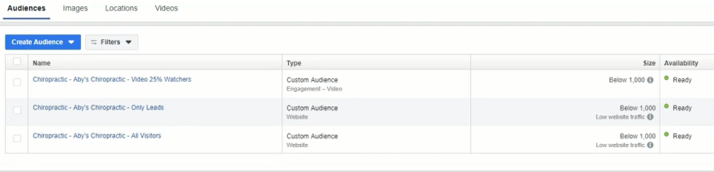

CREATE: Look-A-Like Audience

- We now need to create a "Look-A-Like Audience" of everybody who visited the funnel.
- We will be using the All visitors audience... "Chiropractic - Abby's Chiropractic - All Visitors"
- Check the box on the left of Name, and on top look for 3 dots buttons in menu, click on it and select "Create Lookalike"
- Pop-up box appears that has 3 questions.

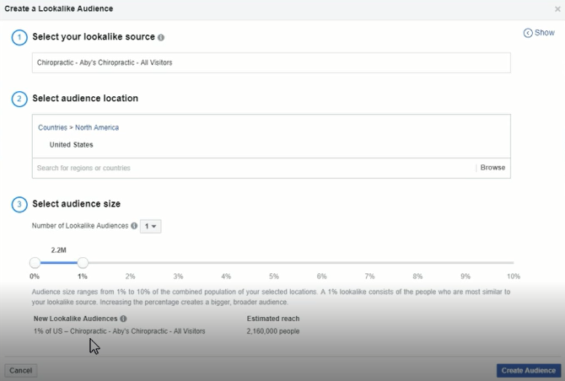

Fill Out Form

- Select your lookalike audience: already done, can leave
- Select audience location: enter country you are targeting, example: United States
- Select audience size: go with 1% ... its the closest you can get, characteristics closest to those 100 people who have already visited your funnel.
- If you look below, it says it will now create an audience of "2 million people" who are similar to those 100 people.
- Click on blue button "Create Audience"
- The window will show populating while Facebook is creating audience and will show "Ready".. once done.
- Must wait until populating is complete and it shows Ready, then we can create campaign 2... Will take about 1 hour.
- It will be displayed in Audience page, so you will now see 4 Names.. your first 3 from campaign 1 plus the Look-A-Like you just created.

NEXT: Create New Campaign (Draft)

Navigate To Ads-Manager:

- Open Business Manager... hamburger... go to "Ads Manager"
- Click on Campaigns tab... then click on "Create" button (green button)
- Window Opens Up ... make sure it's the Quick Creation window, and not the guided creation window.
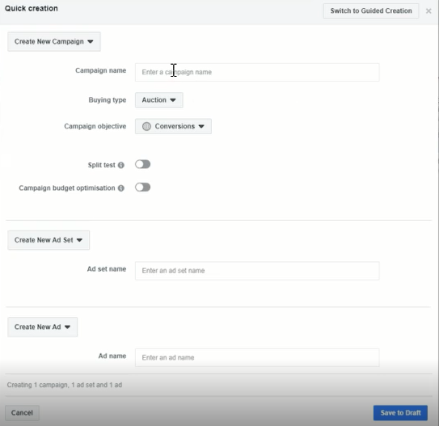

Create New Campaign: Fill Out Section

- Campaign name: Campaign Name, Business Name, City Name... Example: Campaign 2 - Ivan Hollywood Smile Pros - San Diego
- Buying Type: Auction
- Campaign objective: Conversions
- Split test: keep it off
- Campaign budget optimisation: keep it turned off, if you have the option to turn it on (later we will use this)

Create New Ad Set: Fill Out Section (Draft)

Notes:

- Have the option to create 1 or 2 Ad-Sets, the second one is optional.
- For the second Ad-Set we test again the "Interest" that is working with winning parameters.
- We already tested when we created the 4th Ad-Set in Campaign 1 which did-not work well.
- So we will not do this again.
- Instead only going to work with one Ad-Set for Look-A-Like audience.

Fill Out:
- Ad set name: Lookalike Based - Lookalike of all visitors

Create New Ad: Fill Out Section (Draft)

- Ad name: Video Ad 1 ...(example)
- Once form is filled out... Click on "Save to Draft" (bottom right)
- And it will create Campaign 2, and display as follows.

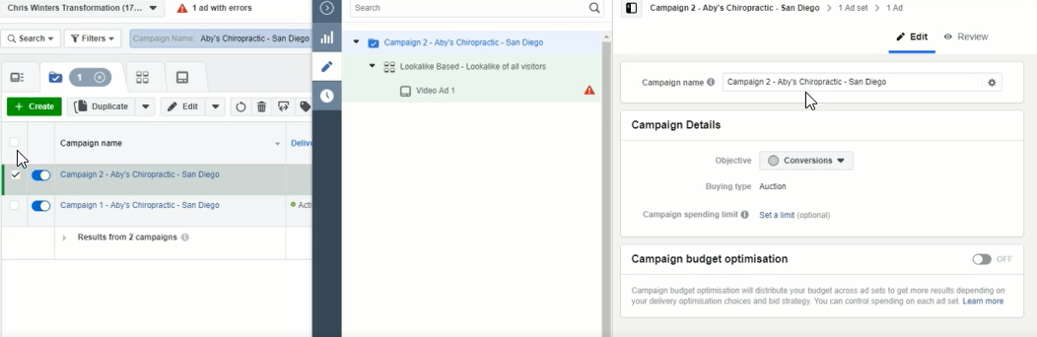

NOW: We EDIT New Campaign

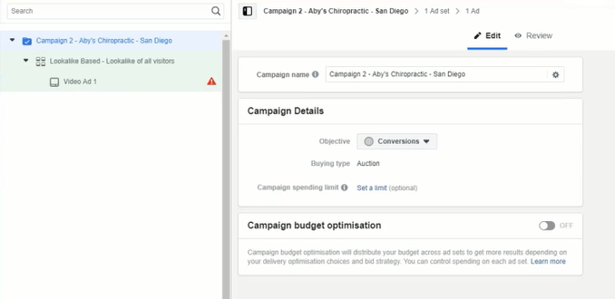

CAMPAIGN LEVEL: Edit Instructions

- Make sure you are in Campaign level... left column, top row.
- Do not need to change anything here... its already set up!
- Campaign name: already named, can leave it
- Objective: Conversions... do not have to change it
- Budget type: Auction... no need to change
- Campaign spending limit: Set a limit (optional)... no need to change
- Campaign budget optimisation: OFF... leave off for now

AD-SET LEVEL: Edit Instructions

- Make sure you are in Ad-Set level... left column, 2nd row
- Lets start from the top
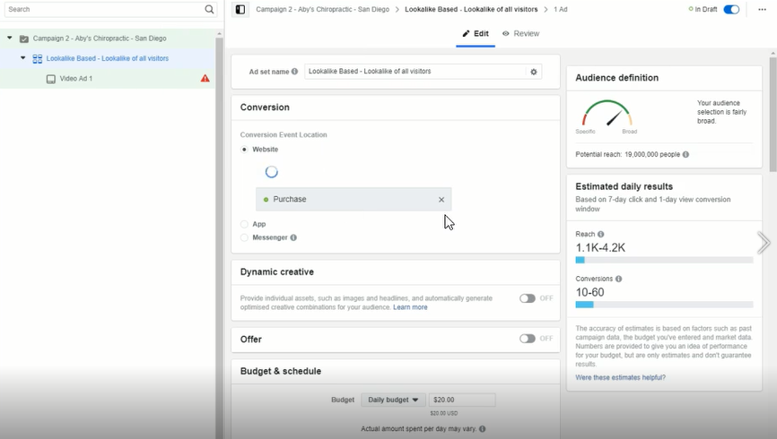

Ad Set Name: Already given the name, leave as is

Conversion: Here we have to tell Facebook what kind of conversion we are looking for.

- We have to remove the default that says Purchase, we must x it out and choose "LEAD" on the drop-down.
- Also make sure you are selecting and using the "CORRECT PIXEL".. together with lead it will display the pixel to be used.. choose the correct one.
- Move onto next part which is "Dynamic Creative"

Dynamic Creative: Keep it at off

Offer: Keep it at off

Budget & Schedule: We will go for $5-$10.. If we need faster data and have budget go for $15-$30

- Budget: Choose $10
- Start Date: Always start the campaign from the next day from 00:00... The reason for this is that when you start next day at 00:00 Facebook will spread ad budget $10 evenly across day.
- Notes: If you are starting a campaign with $10 budget at another time like 8pm then Facebook have only 4 hrs to spend that budget, so data will not be really optimal... Take away is to start campaign next day at 00:00
- End Date: Do not have to change the end date at all
- Ad Scheduling: Leave it as is

Audience: Here we will either choose "Look-A -Like" audience we created.

- Go to Audience and copy the name of the Look-A-Like audience you created
- Custom audience: Paste it into this box, it will display on drop-down, select it and it will be added... and on the right hand side ill see audience reach.. will only show 1,000 because under location it is displaying South Korea... need to change the to United States (or country you are working in)
- Location: Change from South Korea to United States.. on right it will now show 2 million.
- Locations: Change it from "Everyone in this location" to "People who live in this location"
- Choose City & Radius - Have to show the exact location and radius of where you want customers from... Above Map, type in city name, example San Diego... Then choose the "radius" (button next to city) example 40 km... And when you do that on right side will show smaller audience, example 200,000 people... will vary depending on city size and radius.
- Age: input the correct age from parameters obtained from first campaign... Refer to Data Form.. (our example was 25-54)
- Gender: input the correct age parameters obtained from first campaign
- (our example was male & female, so we select ALL)
- Languages: choose English All

Detailed Targeting

- Do NOT-use any detailed targeting when you are using a Look-A-Like audience... Leave this section as is.
- Connections: we leave as is, no changes.

Placement

- By default the box that's ticked is "Automatic Placements"
- We are going to change that to 'Edit Placements".. so select box.
- Then choose only the Newsfeed of Facebook & Instagram.. un-check all the other boxes.

Optimisation and Delivery

- Do not need to change anything
- Conversion Window: 7 days after clicking or 1 day after" can leave as is.

THAT'S "AD-SET" LEVEL EDITING COMPLETE... MOVE TO AD LEVEL

AD LEVEL: Edit Instructions

- Make sure you are in Ad level... left column, 3rd row
- Lets start from the top

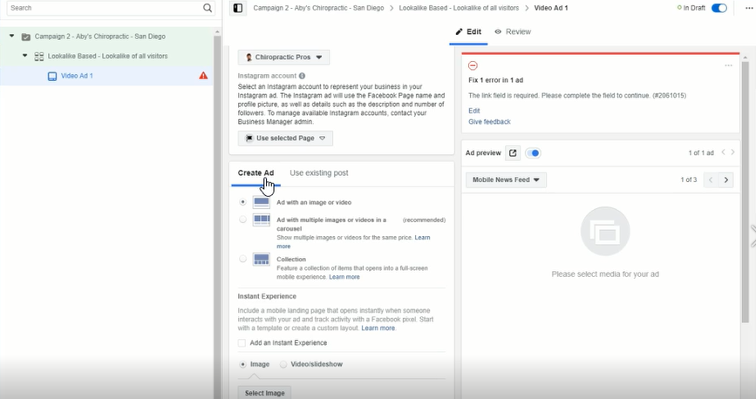

Ad name: Keep the same do not change, going to keep name the same in all ad-sets

Identity: Here first step is we select the Facebook Page, which is already selected "Hollywood Smile Pros" .... no need to change.

Instagram account: click on "Use Selected Page"

Create Ad: This is where we create Ad using dark post ID Number

- Use existing post: Click on "use existing post tab", then click on "Enter Post Id" and paste it in... then press "Submit" button... and it will display on right side.
- Click Here - for instructions on how to retrieve post id number.

Tracking: Make sure conversion tracking is turned on

- Very Very important!
- Facebook Pixel: make sure its turned on... and correct pixel is selected
- Campaign is now complete!

DOUBLE CHECK EVERYTHING - By Doing a Quick Check From The Top, Start At Campaign Level and Work Down To Ad Level.

Once Happy Click on The "Publish" button.

Publish Campaign - Make It Go LIVE!

- This will create your draft, then a box pops-up with three tabs on-top showing, Campaign, Ad-Set, and Ad... you can again review if you want.
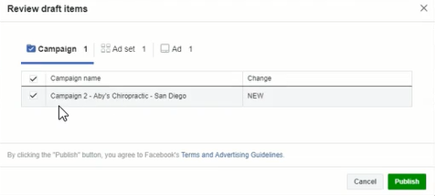
- The click "Publish" button, and now your draft goes LIVE and gets submitted to Facebook for review and publishing.
- This normally takes 24 hours and you campaign should start running the next day.
- Once the campaign is now running.
- GOAL: is to wait for this campaign to get to 1,000 Reach (show our ad to 1,000 people).. it will take about 2-3 days for this
- Then we are ready for review, and can read the data.

Data Analysis of Campaign 2

http://ivantraining.com/kallzu/fam-module-12-facebook-ads-launching-part-2/#offer12

Campaign 1 & 2: Overview Level + Breakdown

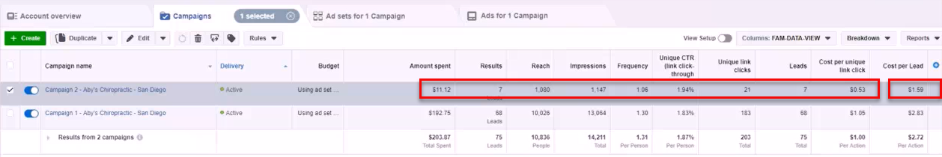

Campaign 1: Ad-Set Level Breakdown (4 Ads)

EVALUATE DATA: CAMPAIGN 2

- GOAL: Make sure Campaign 2 has been shown to at least 1,000 people... so we have a "Reach" of over 1,000 people... only then can we evaluate.
- Navigate to Ads-Manager - go to Business-Manager, hamburger, Ads-Manager
- Now lets take a look at the data for Campaign 2

CAMPAIGN 2: DATA

- Spent $11,12 on campaign so far.
- 21 people Clicked on the link in ad.
- 7 became Leads.. (reached our thank-you page)
- Cost per Lead = $1.59 .... Fantastic result!... (we want leads at between $2-$5)
- We have beaten all 4 ad-sets in campaign 1... So Now, this is our winning campaign!
- NOW - we wait till both campaigns generate at least 100 LEADS, then we can proceed to final campaign.
- Campaign 3 - is our best campaign as we will be creating a Look-A-Like audience, and targeting people that actually give us their emails and become Leads... this is the kind of people we want.
LAUNCHING WATERFALL CAMPAIGN 3
The Golden Campaign!

GOAL OF CAMPAIGN 3
------- Create "Look-A-Like" Audience of 100 LEADS Received.
------- Apply Targeting Parameters Of Winning Audience Like: Age, Gender, Interest

Do You Really Want To Start a New Campaign?

INSTRUCTIONS
----------1.) Confirm 100 Leads Collected From Campaign 1 & 2
----------2.) Turn OFF Ad-Sets That Are Costing Too Much
----------3.) CREATE: Look-A-Like Audience (converted into a LEAD, reached Thank-You Page)
----------4.) Create New Campaign (Draft)
----------5.) Create New Ad Set (Draft)
----------6.) Create New Ad (Draft)
----------7.) EDIT New Campaign (Edit)
----------8.) EDIT Ad Set (Edit)
----------9.) EDIT Ad (Edit)
---------10.) Publish Campaign - Make It Go LIVE!

Data Analysis & Scaling of Campaign 3

GOAL: Of Campaign 3

- Create "Look-A-Like" Audience of 100 LEADS Received
- Apply Targeting Parameters Of Winning Audience Like: Age Gender, Interest

Do You Really Want To Start a New Campaign?

- For this campaign it is not really necessary.
- The reason being the cost per lead on Campaign 1 is ONLY $2.73
- And for Campaign 2, cost per lead is ONLY $2.66
- Which falls well within our range of $5 per lead we are willing to spend)
- If you are in Ads-Manager and tick both campaigns on the left, and click on Ad-Sets tab at top... You open up all Ad-Sets and it will show Cost per Lead for each Ad and on the right can check lead cost.

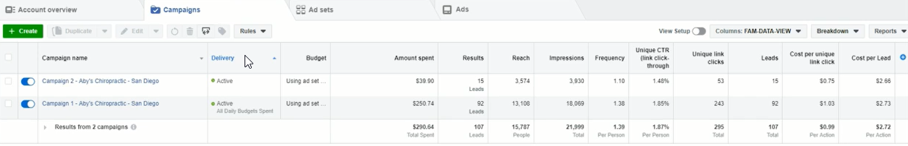

- You will see that the Ad-Set called "Interest Based - No Interest Targeting" is the cheapest lead per cost of ONLY $2,02 which is actually an Ad-Set from Campaign 1
- So based on these numbers... Do i really have to go for Campaign 3... Answer is NO but we are going to go ahead and create one for demonstration purposes.
- The criteria you need to keep in mind is that if you see you cost per lead increasing in Campaign 2, and you want to further bring it down.. you will then go for Campaign 3.

INSTRUCTIONS: To Create Campaign 3

Instructions: To Confirm 100 Leads Collected From Campaign 1 & 2

- We are going to be launching our 3rd Campaign of our Waterfall framework which is Campaign 3 which is a website conversion campaign.
- The requirements to start this campaign is, you need to have at least 100 LEADS collected combined from Campaign 1 & 2

- So here is the first 2 campaigns and as you can see the Lead number is 107...
- You also need to ensure this number is correct by checking your Clickfunnel stats (log into funnel & click on Stats in top right.. enter a date range, click "Apply Filter" and you check stats)
- There will be some minor differences from Facebook to Clickfunnels, for example when we check Clickfunnels it shows 105 Leads... but still very close.
- So we have collected 105 to 107 Leads and that is now confirmed.
- We can now go ahead and start Campaign 3.

Turn OFF Ad-Sets That Are Costing Too Much

- Step 1 - Is to turn off Ad-Sets that are costing too much... So Ad-Set called "Interest Based - Health & Wellness" with lead cost of $2.77 gets turned OFF.
- The other 2 Ad-Sets stay ON with a lead cost of $2.02 and $2.66
- So let’s go ahead and create Campaign 3

CREATE: Look-A-Like Audience (converted into a LEAD)

- We now need to create a "Look-A-Like Audience" of everybody who converted into a LEAD and got to the thank-you page of our funnel.
- Go to Audiences (Business Manager, hamburger, Audiences)
- We will see the audeinces we have already created: All Visitors, Only Leads & Video 25% Watchers (i did not see a training video for Video 25%)
- We will be using the "Only Leads" interest to create Look-A-Like audience, so we tick box on left side that say "Chiropractic - Aby's Chiropractic - Only Leads" and on top look for 3 dots buttons in menu, click on it and select "Create Lookalike"
- Pop-up box appears that has 3 questions.

Fill Out Form

- Select your lookalike audience: already done, can leave
- Select audience location: enter country you are targeting, example: United States
- Select audience size: go with 1% ... its the closest you can get, characteristics closest to those 100 people who have already visited your funnel.
- If you look below, it says it will now create an audience of "2 million people" who are similar to those 100 people.
- Click on blue button "Create Audience"
- The window will show populating while Facebook is creating audience and will show "Ready".. once done.
- Must wait until populating is complete and it shows Ready, then we can create campaign 2... Will take about 1 hour.
- It will be displayed in Audience page, so you will now see the name of look-a-like audience you just created.

Create New Campaign (Draft)

Navigate To Ads-Manager:

- Open Business Manager... hamburger... go to "Ads Manager"
- Click on Campaigns tab.. the click on "Create" button (green button)
- Window Opens Up ... make sure it's the Quick Creation window, and not the guided creation window.

Create New Campaign: Fill Out Section

- Campaign name: Campaign Name, Business Name, City Name... Example: Campaign 3 - Ivan Hollywood Smile Pros - San Diego
- Buying Type: Auction
- Campaign objective: Conversions
- Split test: keep it off
- Campaign budget optimisation: keep it turned off, if you have the option to turn it off... if Facebook make it mandatory, (i will have an update video for you)

Create New Ad Set: (Draft)

- Fill Out Section
- Ad set name: Lookalike Based - Lookalike of all LEADS

Create New Ad: (Draft)

- Fill Out Section
- Ad name: Video Ad 1 ...(example)
- Once form is filled out... Click on "Save to Draft" (bottom right)
- And it will create Campaign 2, and display as follows.

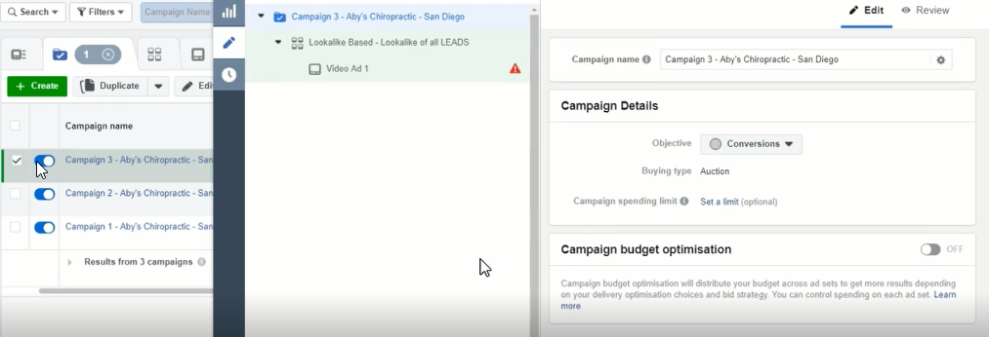

EDIT: New Campaign

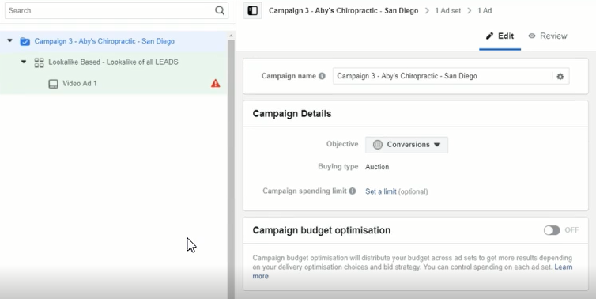

Edit Instructions

- Make sure you are in Campaign level... left column, top row.
- Do not need to change anything here... its already set up!
- Campaign name: already named, can leave it
- Objective: Conversions... do not have to change it
- Budget type: Auction... no need to change
- Campaign spending limit: Set a limit (optional)... no need to change
- Campaign budget optimisation: OFF... leave off for now

EDIT: Ad Set

Edit Instructions

- Make sure you are in Ad-Set level... left column, 2nd row.
- Lets start from the top

Ad Set Name: Already given the name, leave as is

Conversion: Here we have to tell Facebook what kind of conversion we are looking for.

- We have to remove the default that says Purchase, we must x it out and choose "LEAD" on the drop-down.
- Also make sure you are selecting and using the "CORRECT PIXEL".. together with lead it will display the pixel to be used.. choose the correct one.
- Move onto next part which is "Dynamic Creative"

Dynamic Creative: Keep it at off

Offer: Keep it at off

Budget & Schedule: We will go for $5-$10.. If we need faster data and have budget go for $15-$30

- Budget: Choose $10 or more... Since this is a look-a-like audience of Leads.. we can go for $20 or $30
- Start Date: Always start the campaign from the next day from 00:00... The reason for this is that when you start next day at 00:00 Facebook will spread ad budget $10 evenly across day.
- Notes: If you are starting a campaign with $10 budget at another time like 8pm then Facebook have only 4 hrs to spend that budget, so data will not be really optimal... Take away is to start campaign next day at 00:00
- End Date: Do not have to change the end date at all
- Ad Scheduling: Leave it as is

Audience: Here we will either choose "Look-A -Like" audience we created.

- Go to Audience and copy the name of the Look-A-Like audience you created
- Custom audience: Paste it into this box, it will display on drop-down, select it and it will be added... and on the right hand side ill see audience reach.. will only show 1,000 because under location it is displaying South Korea... need to change the to United States (or country you are working in)
- Location: Change from South Korea to United States.. on right it will now show 2 million.
- Locations: Change it from "Everyone in this location" to "People who live in this location"
- Choose City & Radius - Have to show the exact location and radius of where you want customers from... Above Map, type in city name, example San Diego... Then choose the "radius" (button next to city) example 40 km... And when you do that on right side will show smaller audience, example 200,000 people... will vary depending on city size and radius.
- Age: input the correct age from parameters obtained from first campaign... Refer to Data Form.. (our example was 25-54)
- Gender: input the correct age parameters obtained from first campaign
- (our example was male & female, so we select ALL)
- Languages: choose English All

Detailed Targeting

- Do NOT-use any detailed targeting when you are using a Look-A-Like audience... Leave this section as is.
- Connections: we leave as is, no changes.

Placement

- By default the box that's ticked is "Automatic Placements"
- We are going to change that to 'Edit Placements".. so select box.
- Then choose only the Newsfeed of Facebook & Instagram.. un-check all the other boxes.

Optimisation and Delivery

- Do not need to change anything
- Conversion Window: 7 days after clicking or 1 day after" can leave as is.
- THAT'S "AD-SET" LEVEL EDITING COMPLETE... MOVE TO AD LEVEL

EDIT: Ad-Level

- Make sure you are in Ad level... left column, 3rd row
- Lets start from the top

Ad name: Keep the same do not change, going to keep name the same in all ad-sets

Identity: Here first step is we select the Facebook Page, which is already selected "Hollywood Smile Pros" .... no need to change.

Instagram account: click on "Use Selected Page"

Create Ad: This is where we create Ad using dark post ID Number

- Use existing post: Click on "use existing post tab", then click on "Enter Post Id" and paste it in... then press "Submit" button... and it will display on right side.
- Click Here - for instructions on how to retrieve post id number.

Tracking: Make sure conversion tracking is turned on

- Very Very important!
- Facebook Pixel: make sure its turned on... and correct pixel is selected
- Campaign is now complete!

DOUBLE CHECK EVERYTHING

- By Doing a Quick Check From The Top
- Start At Campaign Level and Work Down To Ad Level
- Once Happy Click on The "Publish" button.

Publish Campaign - Make It Go LIVE!

- This will create your draft, then a box pops-up with three tabs on-top showing, Campaign, Ad-Set, and Ad... you can again review if you want.

- The click "Publish" button, and now your draft goes LIVE and gets submitted to Facebook for review and publishing.
- This normally takes 24 hours and you campaign should start running the next day.
- Once the campaign is now running.
- GOAL: is to wait for this campaign to get to 1,000 Reach (show our ad to 1,000 people).. it will take about 2-3 days for this
- Then we are ready for review, and can read the data.
- And can then turn Ad-Sets on and off based on the cost per lead.

Data Analysis & Scaling of Campaign 3

http://ivantraining.com/kallzu/fam-module-12-facebook-ads-launching-part-2/#offer14

Campaign 1, 2 & 3: Overview Level + Breakdown

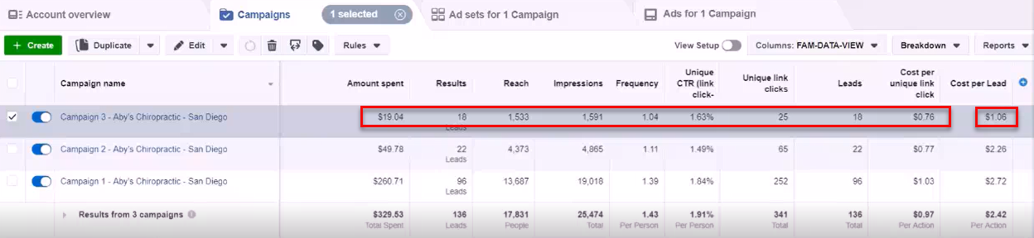

Campaign 1: Ad-Set Level Breakdown (4 Ads)

EVALUATE DATA: CAMPAIGN 3 - The GOLDEN CAMPAIGN

- GOAL: Make sure Campaign 3 has been shown to at least 1,000 people... so we have a "Reach" of over 1,000 people... only then can we evaluate.
- Navigate to Ads-Manager - go to Business-Manager, hamburger, Ads-Manager
- Now let’s take a look at the data for Campaign 3

CAMPAIGN 3: DATA

- Spent $19,04 on campaign so far.
- 25 people Clicked on the link in ad.
- 18 became Leads.. (reached our thank-you page)... that's insane conversions... around a 70% conversion rate!
- Cost per Lead = $1.06 = Fantastic Result!... (we want leads at between $2-$5)... crazy cheap leads! ... and suspect leads will get even cheaper as Facebook has not optimized fully yet, is still learning... Compare the lead cost from Campaign 1 to 3
- Campaign 1: Lead cost - $2.72
- Campaign 2: Lead cost - $2.26 (this one seems to have gone up from our last evaluation) probably increased a bit when we spent more budget, and is now giving us true lead cost.
- Campaign 3: Lead cost - $1.06

What Made This Possible?

- With Campaign 2 & 3, we generated 118 Leads.
- And we were able to create a Look-A-Like audience of LEADS with similarities to those 118 people.
- And are the kind of people most likely to subscribe to something related to Dentistry/Chiropractic.

Now Turn OFF Campaign 1 & 2

- Do this by un-checking these campaigns (make boxes grey and switch them off)
- From a cost perspective it does not make sense to keep them running when we have Campaign 3.
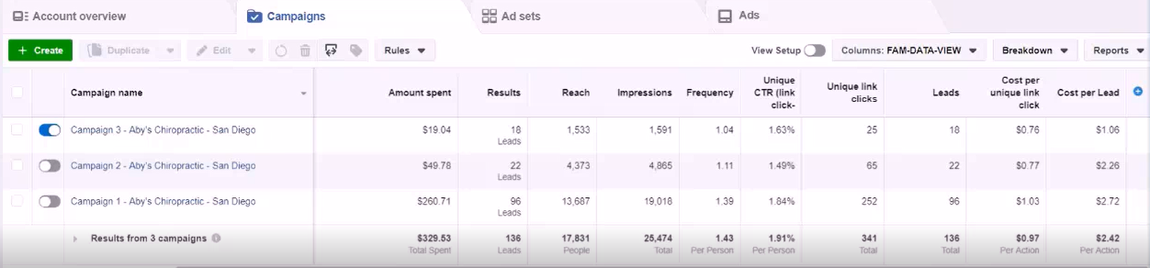

SPECIAL NOTE: When Turning Off Campaigns & Ad-Sets:

- You only turn ads off
- IF you have a new campaign that is already running and working better than the last ones.
- Do not turn off campaigns and assume the new one you just created will work.
- DO-NOT Do That.
- Instead you run a new campaign first, while the others are running.. Read the data once you have 1,000 Reach.
- And IF, it has better numbers, ONLY THEN turn off other campaigns.

If We Take a Look At Our Results:

- ALL three campaigns are actually working.
- Leads are coming in at under $3, and our budget per lead is $5.
- So we could actually leave all 3 of them on
- BUT... Campaign 3 is working the best, so we can now turn off Campaign 1 and Campaign 2.
- And instead increase the "Ad Budget" on Campaign 3 to produce more leads faster at cheaper prices.

Increase Daily Budget:

- This campaign has been running for a day.
- Change daily budget from $10 to $14.

Only Increase Budget by 40% Increments at a Time!

- Reason only 40% is Facebook has something called a learning process
- And when that process is being done, Facebook is trying to get the best kind of leads under 7 days.
- If you increase the budget too much then Facebook will lose that learning process
- And will have to start the learning process all over again, and this may increase your cost per lead and mess with your previous results.
- So to keep cost per lead steady.
- Only increase by 40%

End of Waterfall Campaign:

- So we have our Golden Campaign - Its running great and producing leads at very cheap prices.
- We keep running with this campaign.

And that completes the Waterfall Campaign method.

The Brand You Created (The Beast)

http://ivantraining.com/kallzu/fam-module-12-facebook-ads-launching-part-2/#offer15

Notes:

- If you have launched a successful Waterfall Campaign with Campaign 3 of waterfall framework, you have created a Beast.
- Your Fan Page and Facebook Pixel and all that, contains great DATA which is connected to your niche.

So Here Is How a Normal Local Ad Agency Newbie Works:

- Or how current Facebook courses teach it... i don't know why, i hate it... Here is what they do.
- They will go to a local business, they will sign them up as a client, then they will gain access to their Facebook Page and Facebook Pixel
- And then they will run ads for this client.
- And since they do not have a framework.
- Most will probably fail... And the client will say, "We no longer want your service anymore".

But Never For Us... WHY?

- Because, we use our own Facebook Page, we use our Brand .. we will end up creating our own Brand.
- If you take a look at Aby's Facebook Page "Chiropractic Pros'.. no time has been spent editing the page.. all he did was create the page and load a profile picture and banner.. And this is probably the worst page on Facebook.
- BUT... look at the video views... Over 6,000 video views with 60 people that liked it and 19 comments.
- And if you click on the Likes, (box pops up with all the names)
- You can invite these people to LIKE your page.
- Everybody on this list is people who have some sort of back problem who needs services from a Chiropractor.

So What Have We Basically Created?

- We have created a BRAND...a page which is related to your niche.
- And you can organically create Offers to people who like your page.
- You can create E-Commerce Offers.
- You can create CPA Offers and push that through your brand.
- So you will have your OWN BRAND to work with.
- And not have to rely on somebody else's brand all the time.

Second Biggest Advantage: You Never Have To Start From Scratch!

- Let's just assume you landed a new client in San Francisco
- You would go and create a new Ad-Account.
- And inside that Ad-Account you will be connecting YOUR MASTER FACEBOOK PIXEL

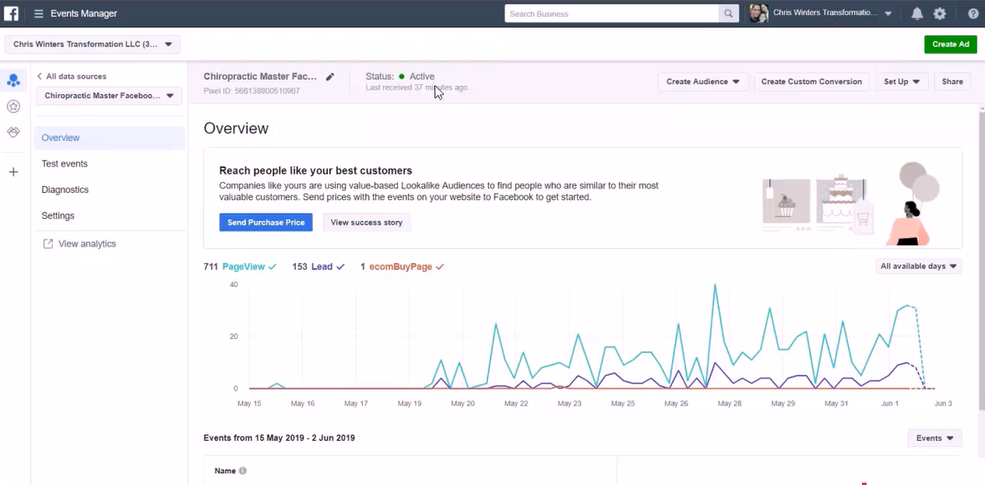

- Remember we created something called the "Master Facebook Pixel"
- And this will be used in ALL your new clients Funnels and Ad-Accounts
- So this Pixel is out there collecting data about your niche.
- So this Pixel knows, "Who is converting into Leads" and who is not.
- So what we will do when in a new clients Ad-Account is create a Look-A-Like audeince.

New Client Ad-Account: Create Look-A-Like Audience (video 3:17)

- We can create a "Look-A-Like Audience" in new clients account... from data obtained from previous clients campaign.

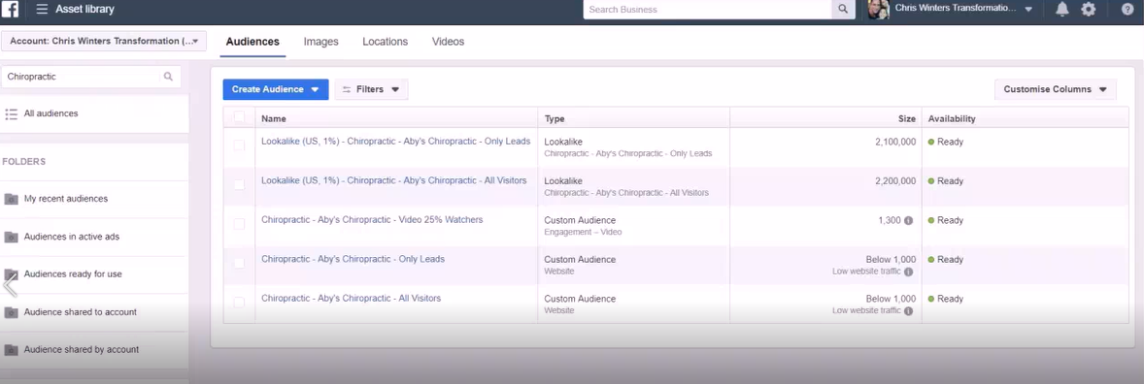

- We go to "Asset Library, Audiences".
- We are able to create a "Custom Audience" of everybody who visited the Thank-You Page of our San Diego funnel... (refer to videos to create)
- So you will be able to Re-Create these audiences in the NEW Ad-Account.
- And you will be able to create this exact "Look-A-Like" audience inside that new ad-account.
- And when you do that, you are able to target for that City.
- So we know that this "Lookalike (US 1%) - Chiropractic - Aby's Chiropractic - Only Leads" audience is 2 million in size and contains the entire United States.
- This contains people who opted into a Chiropractic Offer, across the entire Unites States.
- But in our Ad, we only targeted the city of San Diego.

When We Get A New Client: All We Do Is Target a New City (San Francisco)... (video 4:25)

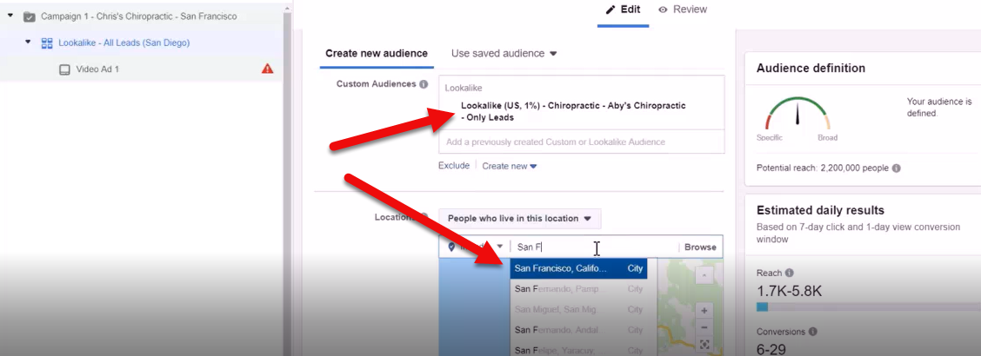

- We go to "Ad-Set Level" and go to
- Custom Audience: - and we use our "Lookalike (US 1%) - Chiropractic - Aby's Chiropractic - Only Leads" audience... then we go to
- Location: and simply change the city name to "San Francisco"
- Audience Size: on the right will change to 140,000 people (a lot of people)
- These people will be closely related to the people in San Diego who became Leads.

So With New Clients: You Will NOT Have To Start All The Way From Scratch

- You will NOT have to run through Campaign 1,2 ,3... because you already have the data.
- Now Listen... YOU will be able to do this across the entire United States
- That's the power you have... When you use your own Master Facebook Page and Master Facebook Pixel.
- Can-not stress the importance of this enough.
- Hope you understand the potential and hope you are screaming with excitement, right now!

Getting Paid

http://ivantraining.com/kallzu/fam-module-13-getting-paid/

INDEX:

----------1.) When to stop free trial
----------2.) Different ways of processing payments
----------3.) Adding local business client to business manager
----------4.) How To Add Your Credit Card To Facebook (Walk through for client)
----------5.) Using Credit card authorization forms

When To Stop Free Trial

http://ivantraining.com/kallzu/fam-module-13-getting-paid/#offer1

Notes:

- How to move from trial campaign to paid client.
- When starting you will be spending your own money for a trail campaign
- Have to limit the amount of leads supplied for free, which you need to decide... Maximum 20, never more than 20 free leads.
- In some niches, the cost per lead will be higher... In those cases go for a lower number, for you to decide.
- Need to know how much a lead is worth... use your Opportunity Sheet and figure that out and make decisions based on that.
- Maximum 20 leads, then ask client to pay up.
- Has to be mentioned when discussing handshake agreement, so client understands once 20 leads have been supplied.
- Its time to start paying for leads... including the 20 leads which have been sent.

Different Ways of Processing Payments

http://ivantraining.com/kallzu/fam-module-13-getting-paid/#offer2

Notes:

- What charges are involved?
- First - Facebook Ads charge (paid to Facebook to display adverts)
- Second- Your Service Charge, (paid per lead, per month, retainer etc.)
- Can be paid directly by client... OR... We can do it for client.
- Can send client a "Credit Card Authorization Form" that they fill out supplying their credit card details.
- Problem with that is clients do not want to share their credit card details.
- Second Option (Recommended Option) - To add client to my Business Manager, assign an account to him and ask them to add their own credit card details to that account.
- Show client a video, walking them through the process. (supplied below)
- Then they need to pay you... Best way is to use PayPal Invoice... (Demo video in Module 5 on how to create invoice)

Adding Local Business Client to Business Manager

http://ivantraining.com/kallzu/fam-module-13-getting-paid/#offer3

Notes: Recommended Option

How to add client to Business Manager

- Log into Business Manager, then Business Settings.. should land on People Page.. if not go to "People" page.
- Click on blue "Add" button, and box pops up.
- Enter Email Addresses - Add clients email address
- Assign business role - Employee Access will turned on by default, leave it... Click on show advanced options (drop down arrow)
- Turn on Finance Editor (turn on blue button).. Important to do, this is the only way customer can add credit card.
- Click on "Next"... new window pops up called Assign Access.

Assign Access window - This is where you give client access to certain Ad Accounts & Pages.

- We are only giving them access to their own Ad Account.
- On left click on "Ad-Account" - Select the Ad-Account under name, and on right choose "Manage Ad-Account" and turn it on (make it blue)
- Click on blue button "Invite" and box pops up saying "Invitation Sent".. then press Done.
- Facebook will then send an email to client, tell client if using Gmail it may land in the Promotions or Social folder.
- Email headline will read something like: "More Clients Consulting has invited you to work on their business on Facebook"

Email will look like this:

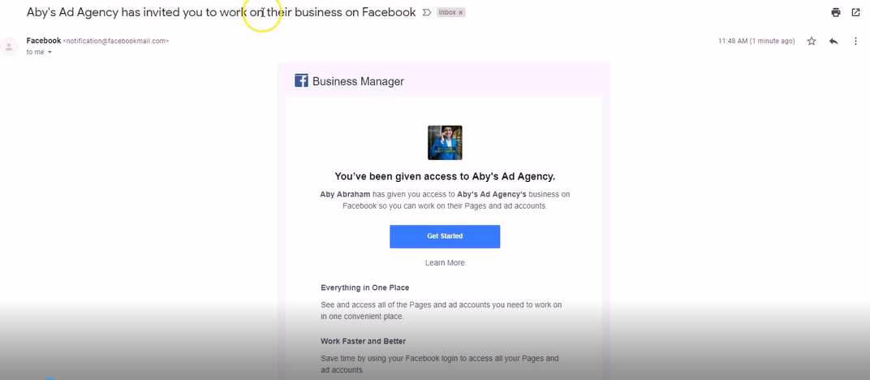

- Client clicks on Get Started
- Enters their name.. and click Continue
- Then Facebook asks for Facebook login password.. then click "Verify with Facebook"
- Facebook will verify then they will gain access (will automatically open up Business Manager account)
- Next Step is to click on hamburger, then Business Settings
- Click on Ad-Accounts on left, and they will see their Ad-Account in first column which i have given them access to.
- In top right corner, they need to click on drop-down menu called "Open in Ads-Manager"...and choose "View Payment Methods"
- Window will pop up and here they can Add their credit card details.
- Click on "Add Payment Method" enter details and click on "Continue"
- Clients card is now added
- If i used my own card initially to pay, then i need to remove my card from this Ad-Account
- Go back to View Payment Methods, check to make sure clients card has been added, then click "Remove" button next to my card to remove card.
- Now the clients card will be charged to run Ads
- Also when client finishes email verification... You will see their name added under "People"
- And if you click on their name, on the right can also see the assets they have access to.
- Now if client decides to stop working with you, you can easily remove access to Ad-Account and pause all ads.
- But still keep all the data in your pixels and Master Facebook Page.
- That's the advantage of using this model.

How To Add Your Credit Card To Facebook (Walk through for client)

http://ivantraining.com/kallzu/fam-module-13-getting-paid/#offer4

Summary of Steps:

- Step 1 - Locate email
- Step 2 - Fill out form and verify Facebook account
- Step 3 - Navigate to correct place to add your credit card
- Step 4 - Add your credit card

Instructions: Follow Along With Video

STEP 1: Find Email

- Hi, here's how you can you can add your credit card to Facebook so that you can pay for the Ads directly to Facebook
- We have sent you an email from Facebook which should be in your email inbox
- If you don't see it in your Primary inbox, then check your Social inbox.
- The email will look something like this.
- Email headline will read: "More Clients Consulting has invited you to work on their business on Facebook"

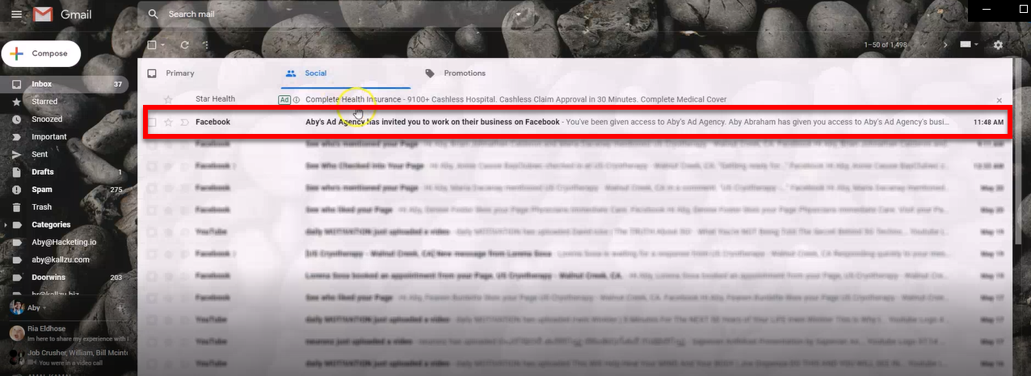

- Once you find the email... Click on it to open the email.
- Email will look like this.
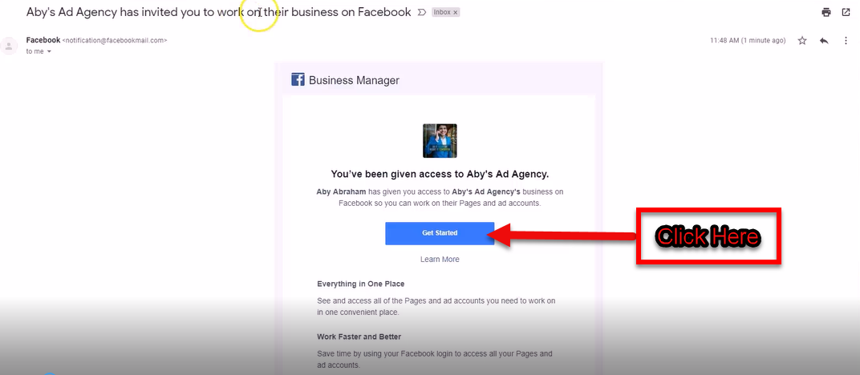

STEP 2: Fill Out Form And Verify Facebook Account

- You need to click on blue button that says "Get Started" in the email.
- Which will open a window like this.

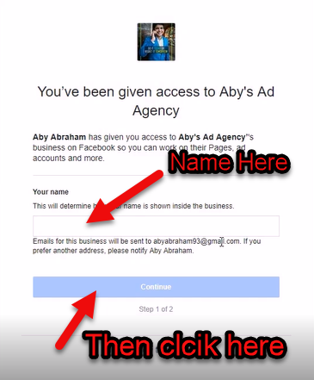

- The first thing you have to do is, Add your name... and click on "Continue"
- Next box pops, up that looks like this.
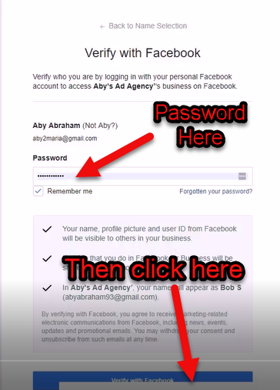

- Enter your Facebook account login password.
- Click on "Verify with Facebook"
- Then Facebook will verify that its actually you.
- Once verification process is complete, it will automatically open our Facebook portal.
- Looks like this.

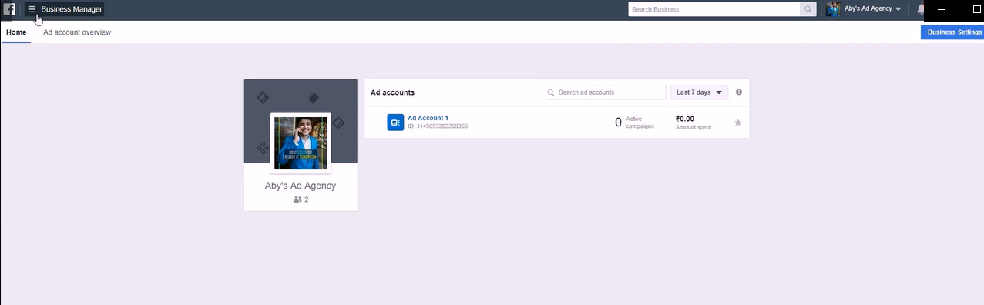

STEP 3: Navigate To Correct Place To Ad Your Credit Card

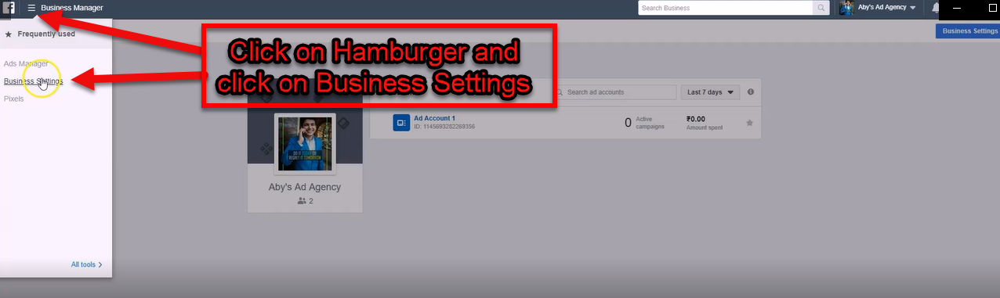

- In top left corner click on "Business Manager" button.
- And select "Business Settings"
- The Business Settings page will open up.

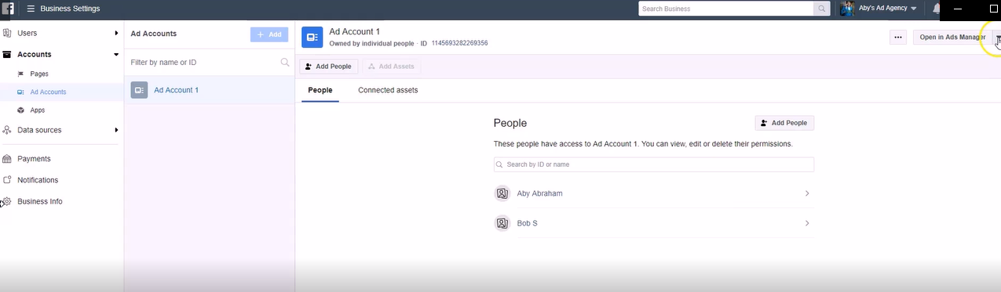

- From Business Settings page, on left click on "Add Accounts"
- Then choose and click on the correct ad account dedicated for you, will be named after you or your business.

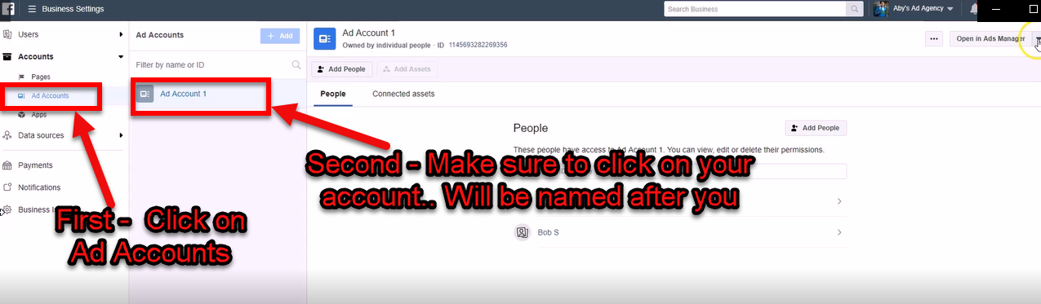

- To add your credit card to this Ad Account.
- All you do is go to top right corner and click on the drop-down button that says "Open in Ads Manager"
- Then choose and click on the option that says "View Payment Methods"

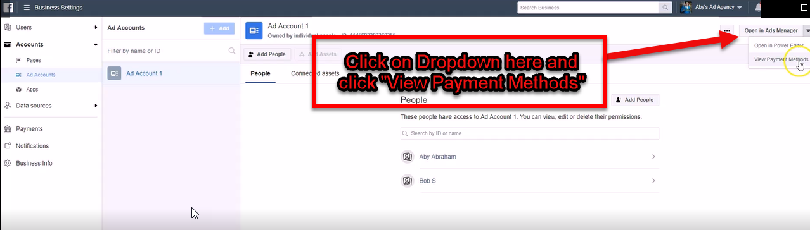

- And box will pop up that looks like this.
- Here you click on "Add Payment Method"
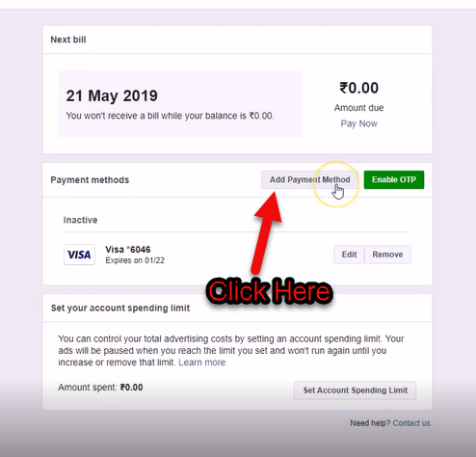

- And next window pops up.
- Here you add your credit card details.
- This information will be given straight to Facebook.
- NOTE: Our Agency and team members, will not be able to view or change the credit card numbers you have entered.
- So your credit card details are secure with one of the biggest companies in the world, Facebook.
- Once you have added your credit card, click on the blue button that says "Continue".

STEP 4: Ad Your Credit Card Details

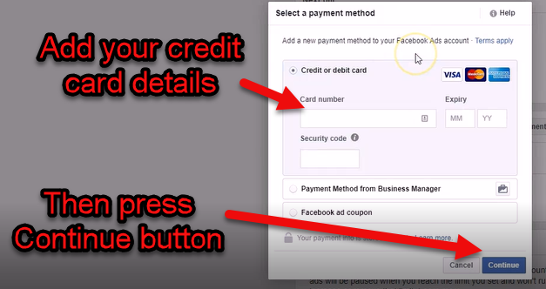

- Job Done - You have successfully added your credit card.
- And we will be able to continue advertising and sending you great leads.
- Let me know via Facebook Messenger once you have completed this task.
- You can message me at https://www.messenger.com/t/IvanduPlessis21
- Looking forward to a great business ahead... Thank you 🙂

Using Credit Card Authorization Forms

http://ivantraining.com/kallzu/fam-module-13-getting-paid/#offer5

Download Form:

http://ivantraining.com/kallzu/wp-content/uploads/2020/09/M13.6-Credit-Card-Authorization-Form.docx

Notes:

- Quick Disclaimer: Not lawyers can not give you legal advice, check with own lawyers about usage of a credit card authorization form
- This is the easiest way to add a clients credit card to an Ad Account
- However not a preferred way.
- There are a few challenges when using an authorization form.
- Firstly is the stigma from local business owners to give there credit card number to you.
- Second when you add a credit card to your account, if client for some reason decides to dispute the credit charges from facebook... it may effect your Ad-Account.
- That is why we don't always prefer the authorization form method.
- We always prefer the method where client adds card by themselves.
- Use the credit card authorization form only if you have to.

Instructions:

- Template has been provided for download in Word format.
- Edit document by adding our details first like company name, address, phone number, etc.
- Leave spots open where client needs to fill out.
- Convert to PDF for download
- Then head to HelloSign - https://www.hellosign.com
- Templates: On left click on templates
- Create a Link: click on create a link
- Upload Form: by clicking on Add File, or you can just drag and drop.
- What Role Needs To Sign: type in "Client"
- Prepare Doc For Signing: click on blue button
- Form Opens: box pops up with form
- Sign Date: click on top that says "Sign Date" and add date
- Client Name: click on top that says "Textbox" and add where clients name must go.
- Placeholder Text: can name the box like "Your Full Name Here" by going to advanced features and click on Label (optional)
- Check Box: On top click "check box" and add to each Account Type (boxes available to tick) 5:06 min in video... Make sure Required button is turned off.. important otherwise they are required to tick all boxes.. keep it off.
- Card Holder Name: Add a textbox & include placeholder that says "Name on credit card"
- Credit Card Number: Add a textbox & include placeholder that says "Credit Card Number"
- Expiry Date: Add a textbox & include placeholder that says "MM / YY"
- CVV 2: Add a textbox & include placeholder that says "CVV 2
- Signature: On top click on "Signature" and add box\
- Date: On top click on "Sign Date" and add box
- Once Form Is Complete: Click on top right blue button "Continue"
- Add a Title: name the form, call it "Credit Card Authorization: More Patients Consulting"
- Create Link: then click on "create link"
- And what HelloSign is going to do, is create a unique link which you can give to all your clients whenever you want to collect there credit card
- Link: Simply copy and paste link provided... Do-Not click on "Activate in person signing"

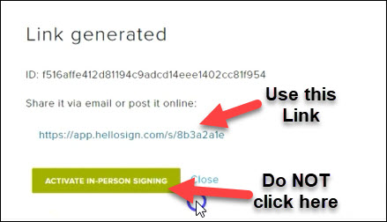

- Test: to test open an incognito window, copy and paste link
- Enter Email: Page opens that will be named your form... and asks for a valid email
- HelloSign Email: gets sent to email address provided
- Click on Link: They click on blue button that says "review document"
- Document Opens: and they are able to edit and sign document.
- I Agree: once done, they click on continue and then click on "I Agree"
- Document Signed: the form is then signed and stored in HelloSign.. am sure i will receive an email too.
- For Me to Access Form: i visit HelloSign and click on "Completed" where i will find signed form.
- Preview: click on form and dropdown and choose "Preview" to view form.
- Signed Authority: This document gives me signed authority to charge clients credit card
- Careful: As mentioned, be careful when you handle other peoples credit cards
- Preferred Method: have client add his own credit card.
How To Create Re-Targeting Facebook Ads (CAM2 – Module 5)

http://ivantraining.com/kallzu/module-5-facebook-re-targeting-ads/

INDEX

------ Introduction to Re-Targeting
------ Creating a Re-Targeting Audience
------ Anatomy of a Facebook Ad
------ Why Test Multiple Ads

Introduction to Re-Targeting

