
The Fastest Way to 6 Figures without a Boss is "30 Day Agency"... PERIOD!
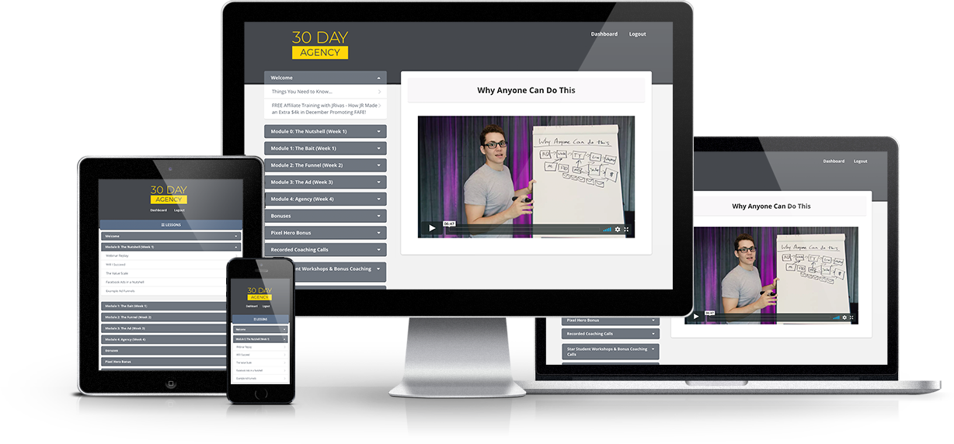
24/7 Lifetime Access. Work at Your Own Pace.

Introducing 30 Day Agency
30 Day Agency is a proven and tested 4 week implementation program that teaches you how to start a wildly profitable 6-figure Agency business and help you get your first client in 30 days.

It doesn't matter if you don't have any tech skills or any previous business experience. Everything you need to know is provided step-by-step in this training program.

Battle tested and proven results
The methods taught in the 30 Day Agency program have been battle tested and proven with over 2,400 students around the world.

The program has helped hundreds of people quit their jobs, and created dozens of people making $10,000 or more per month.

These students are awarded the "$10K Club Award" for their success with the program.
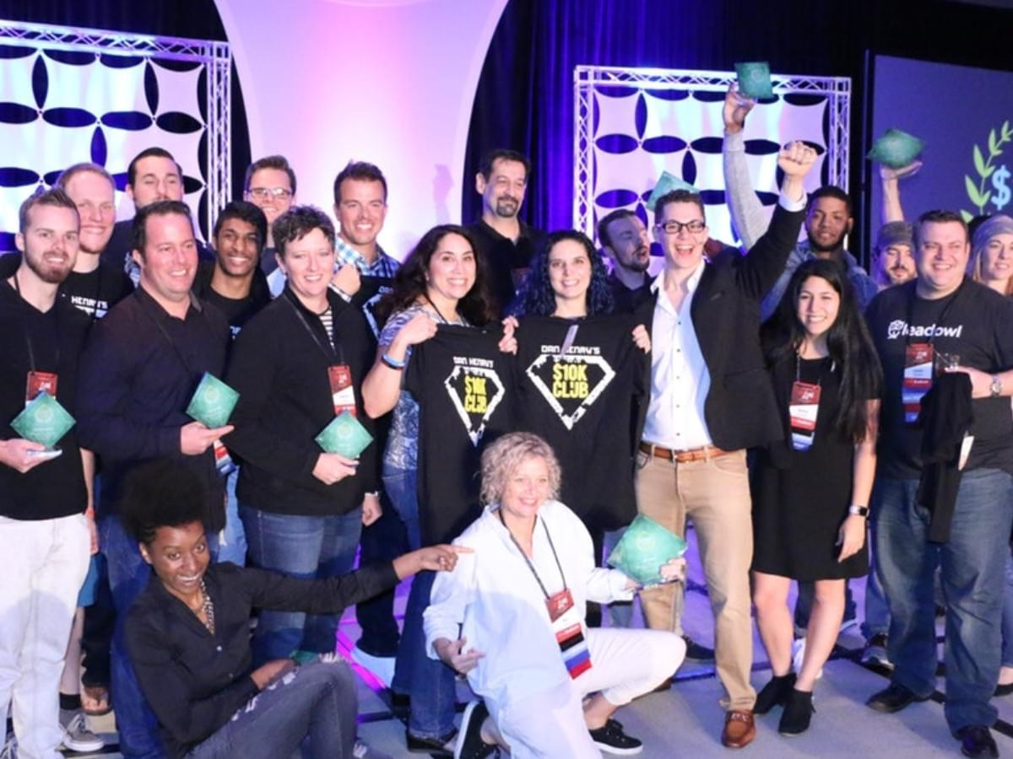
When You Join 30 Day Agency, You
Get Full & Immediate Access To:

Module 1: Getting Results For Clients-

Mastering the A.C.T method for any business!
*Finding winning offers that work for any business
*Advertise: Creating ads on Facebook and Instagram
*Capture: Creating the Capture Pages
*Transform: Getting the info to the clients so they can make the sale


Module 2: Landing Your First Client

All about getting that first trial client!
*How to set up your entire new business in 24 hours (and how to accept payments)
*Tricks of the trade: How to get trial clients fast
* Choosing the right clients and how to structure the deal for success
*How to onboard your first client


Module 3: Scaling To Multiple Clients

Growing your business with paid clients
*How to create a winning case study/ sales funnel that attracts paying clients
*How to create a winning ACT funnel to attract new clients
*How to close prospects on the phone and get paid
*7 ways to find new clients every day
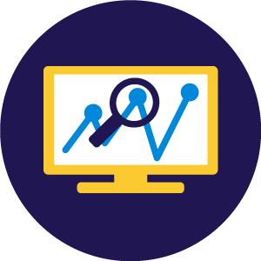

Module 4: Managing Your Agency

How to run, automate, and outsource your agency
*How to manage multiple clients
*How to automate your ad campaigns to save you time
*How to outsource logistics and customer service
Here's a summary of everything you get...
This is not your typical "course". We provide you with everything you need to be successful

The Complete 30 Day Agency Program
So you can run winning ads for yourself, clients, and even high end offers... ($2,997 Value)
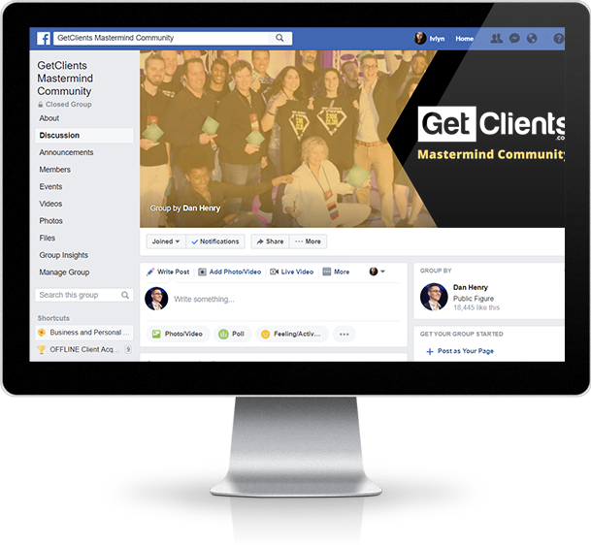

Access to the Get Clients Private Mastermind Group
So you can strategize and get help from previous students that are killing it. Over 2,300 members and extremely active!
($2,997 Value)

Ad Critique Videos
So you can see the little details in what people did right and wrong when creating ads so yo can create better advertisements for your clients.
($997 Value)
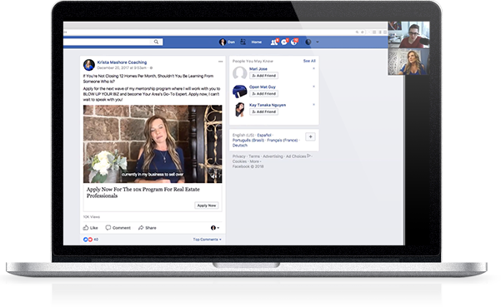


Sample Proposals, Contracts, and On-Boarding Videos
So you can bring on new clients with ease and get them set up properly.
($497 Value)

Winning Offers Cheat Sheet
So you can have a list of winning offers to reference when creating campaigns for your clients. ($997 Value)
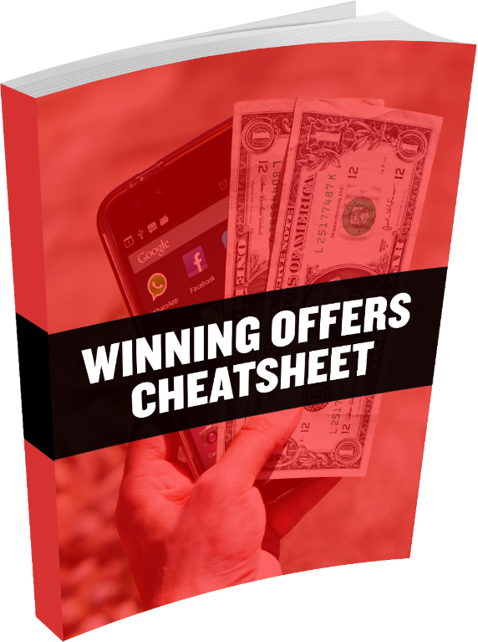
But WAIT! That's Not All...


Bonus #1:Realtime Client Walkthroughs
So you can reference my winning ads and follow the process step by step while creating your client campaigns
($1,997 Value)
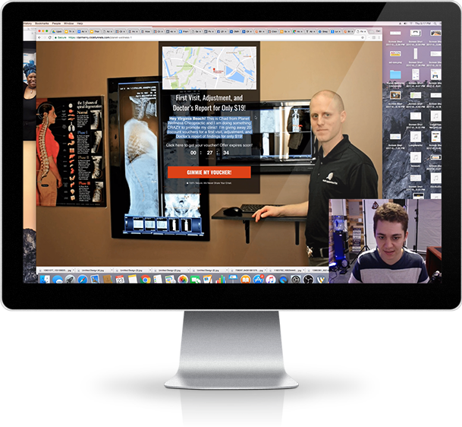

Bonus #2: Automated Case Study Funnel
So you can get potential clients to schedule a call with you and sell them on your services
($997 Value)
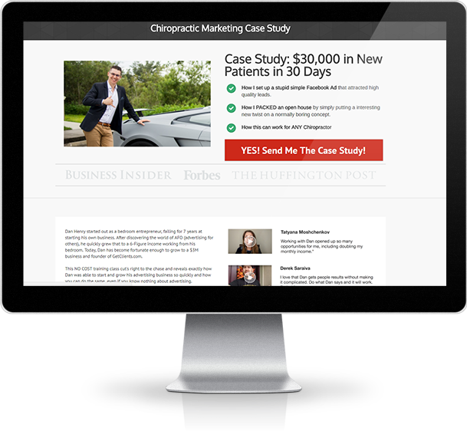

Bonus #3: 30 Day Client Acquisition Calendar
So you can get results fast and land a ton of clients in 30 days ($1997 Value)
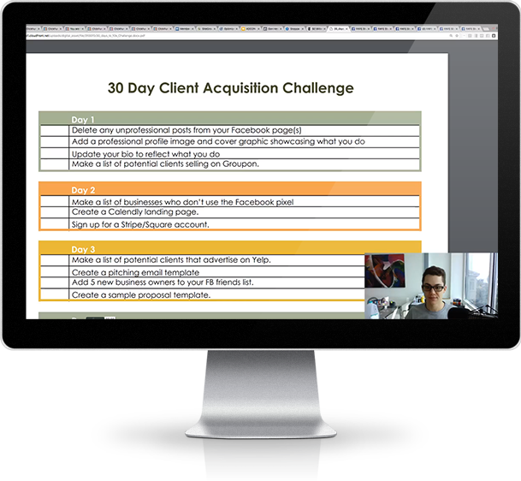

100% Money Back Guarantee!
Our training program is proven with over 500 testimonials and over 2,300 happy students. We are serious about our program and want you to be serious too. Therefore, as long as you do the homework and show that you made an effort, we will refund your money 100% if you are not happy with the program within 14 days of purchase.
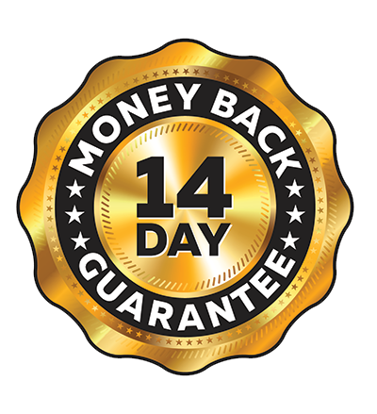
This Offer Expires SOON!
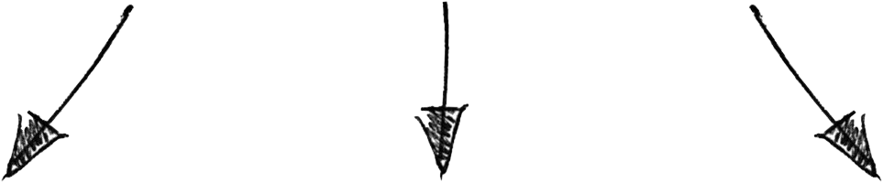
Today Only $6,000
$1997 One Time (Save $391) or
4 Payments of $597!
CLICK HERE TO ENROLL NOW
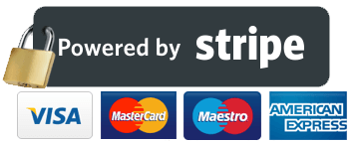
100% SECURE Processing
Over 500 Student Testimonials...
See more student reviews
50x Return on Investment in Only 45 Days
Joined 10k Club in 8 Days
Personal Trainer Makes $25,000 a Month
900% Revenue Increase
9x Monthly Family Income
10k Club Funds Cookie Dough Shop
$10,000 in First Month
6 Figure Agency in One Year
$5,000 in First Month
$-2,000 to 6 Figure Agency
$12,000 in 2 Weeks
15 Consistent Retainer Clients in Only 8 Months
$78,000 in Only 3 Months
3X Gym Membership Revenue
Landed 25k International contract
Earns 5 Figures Monthly By Working Part Time
This Offer Expires SOON!
Today Only $6,000
$1997 One Time (Save $391) or
4 Payments of $597!
CLICK HERE TO ENROLL NOW
100% SECURE Processing

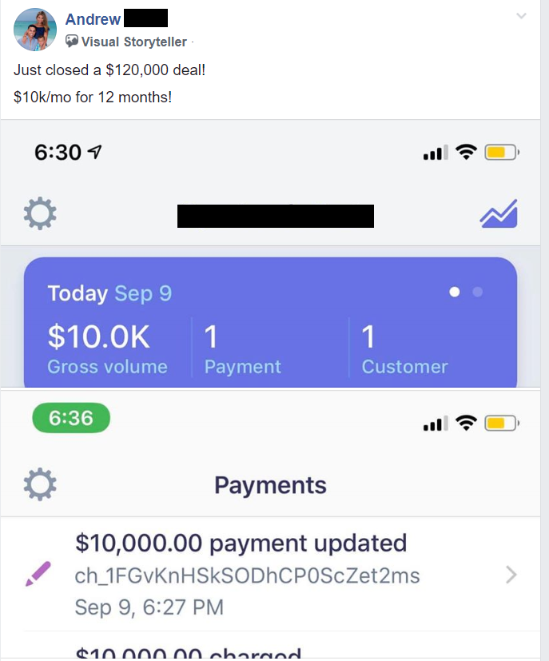
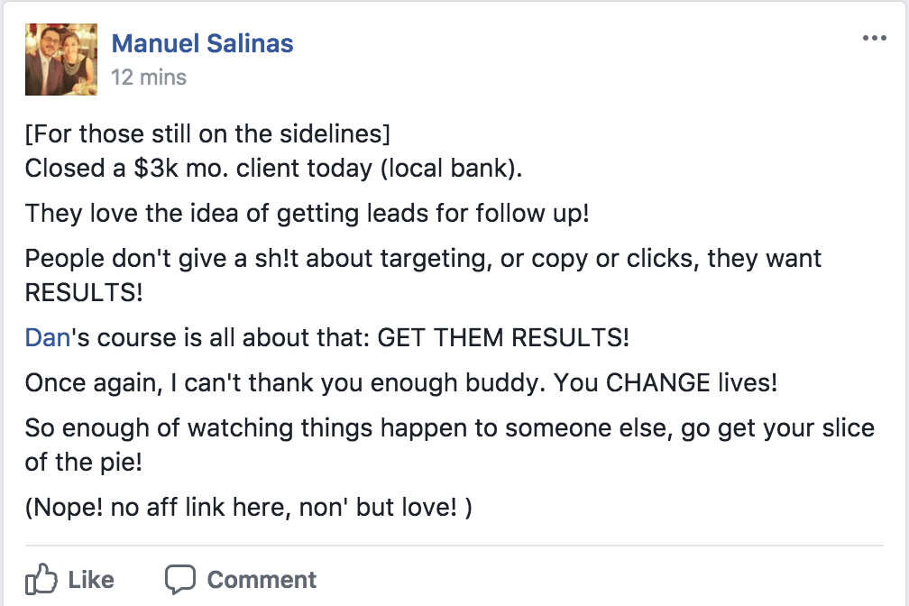

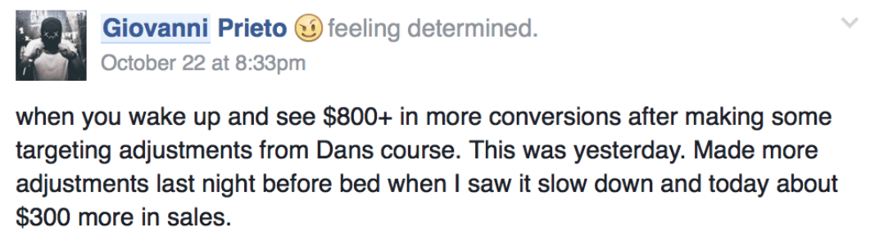
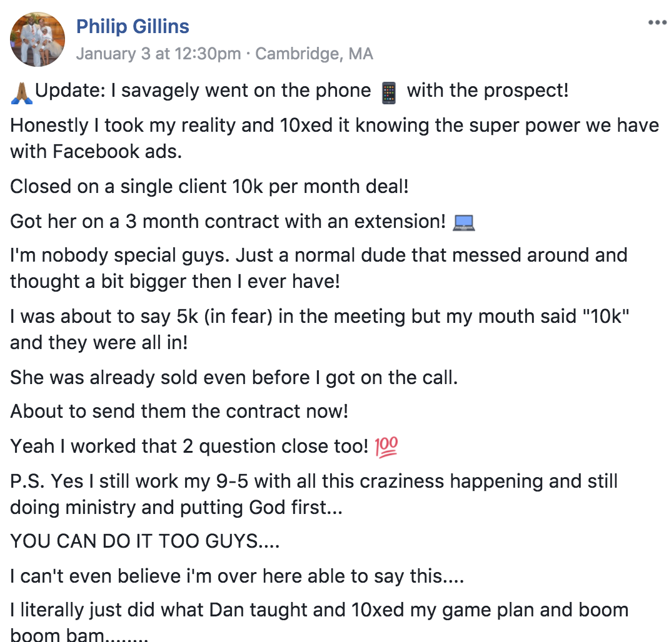

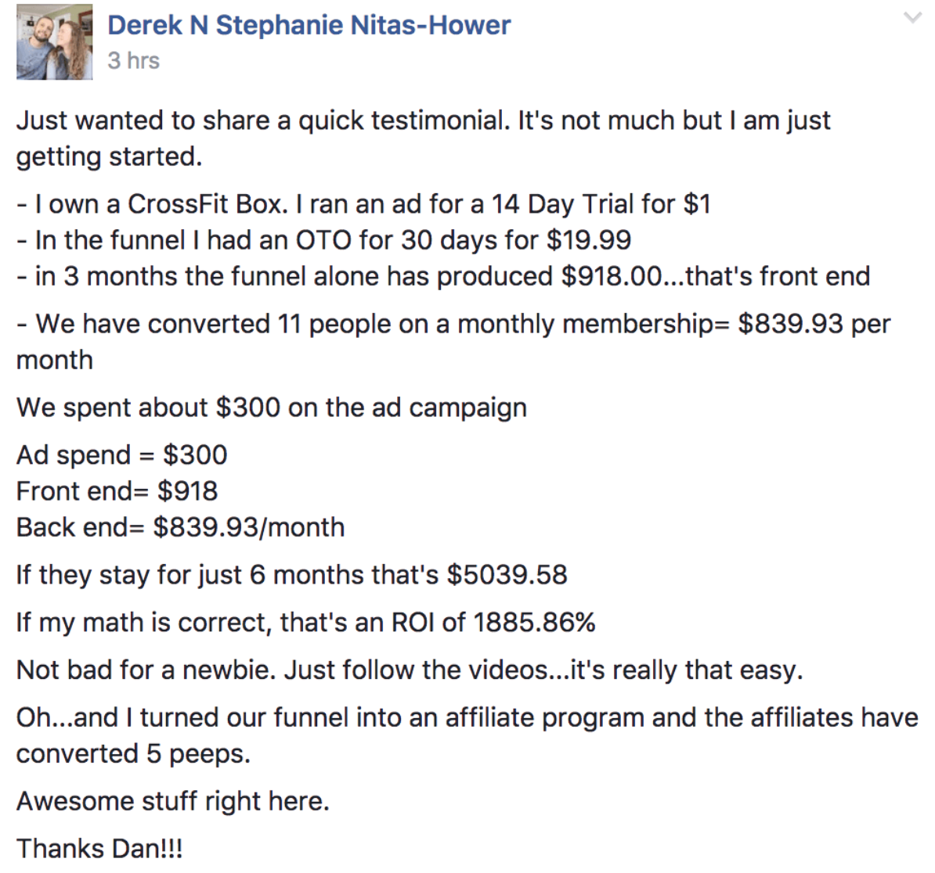
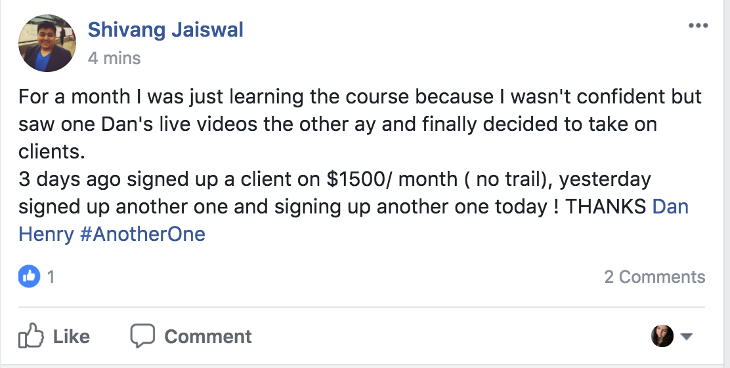
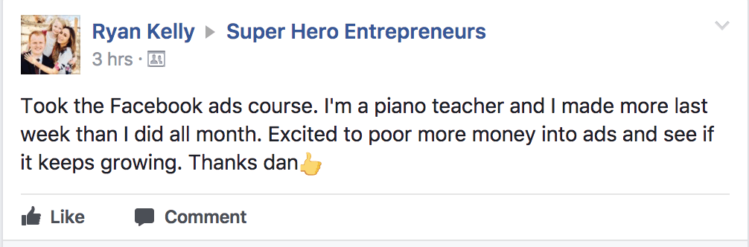
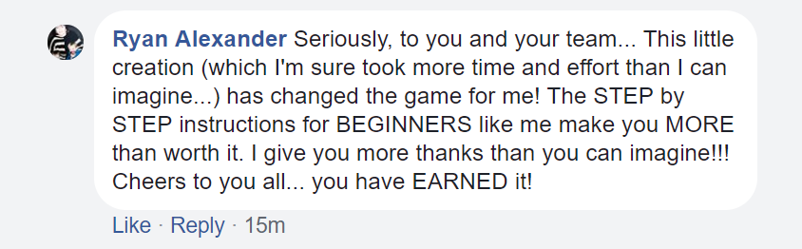
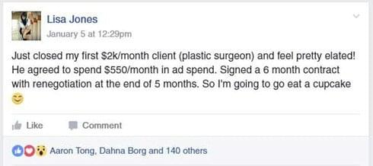
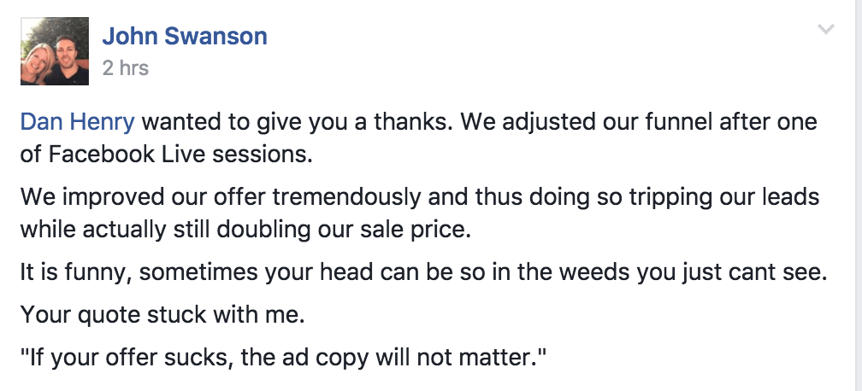
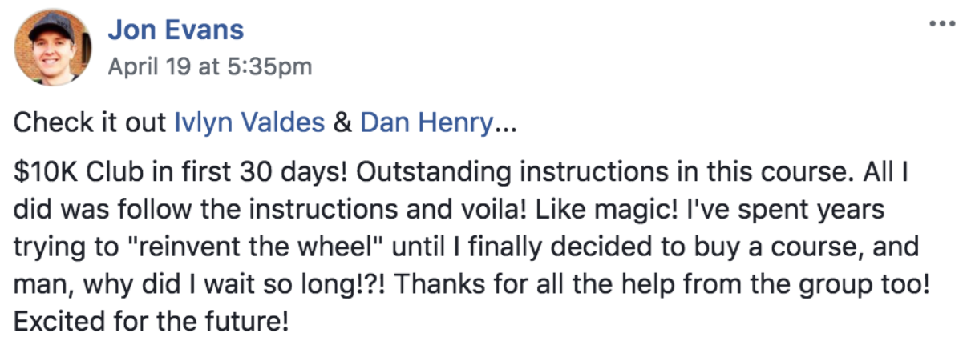
This Offer Expires SOON!
Today Only $3,000
$1997 One Time (Save $391) or
4 Payments of $597!
CLICK HERE TO ENROLL NOW
100% SECURE Processing
Frequently Asked Questions
Q1. "HOW DO I KNOW THIS WILL WORK FOR ME?"
That's a fantastic question. 30 Day Agency is a program that is extremely different than the other program online. I know this because I have purchased almost every single program on their market on advertising and starting an online business. I did that to see where others are failing, to make sure that mine was of utmost excellence. I found one very common theme among ALL of these programs. No matter what they said in their marketing, when you got to the course they ALL assume you have a basic understanding of marketing or the told required to market a business. I don't assume that you know anything. I've made this program 100% beginner friendly. The fact is that I have hundreds of success stories from people making $50,000 and even $100,000 per month with this blueprint. Over 80% of those people are complete beginners.
I was blessed with a very specific talent. That talent is to take something complicated and explain it simply so that anyone can understand. When I was 16 years old, I was asked by my martial arts instructor to teach our children's program. Even though there were tons of older and more experienced instructors at the school, my instructor chose me because he saw this talent in me. That year, we had more world champion children come out of our school than any other year prior. I don't know how I got this talent, I can only assume I was blessed with it, but it's my life's mission to use this talent to help other people lives and teach them what I know.
The bottom line is, if you are a complete beginner, this course is for you. If you're experienced, this course is also for you, because I'm going to show you how to cut the amount of work you do by 80%. There are so many ways to do things easier and faster than people realize, and I've become a master at that and I'd like to pass that knowledge on to you.
If you're wondering if this program will work, the total and complete answer is YES. We have a track record to prove that, and our results speak for themselves. If you're still skeptical, we have a 100% money back guarantee. Simply try the program out, follow the steps and if you're not satisfied you will get a 100% refund
Q2. "WHY IS IT SO EXPENSIVE?"
If you think this program is too expensive then you may be thinking about it in terms of a collection of videos or simply information, not in terms of what this program can do for you, your income and your family.
The reason you would purchase this program is not to get a set number of videos or specific information, but for the results it can generate for you. You may think that $997 is expensive for an online course, but I have to ask you this ... is $997 too expensive of an investment for creating a 6-figure income for you and your family?
Think about this ... according to Forbes, the average college education costs $57,000 and takes four years to complete. Plus you are paying massive interest if you take out a student loan. In fact, student loans are the second largest investment an US citizen can make next to a home mortgage, also according to Forbes. However, the average earnings of a college graduate the year after graduating college is $47,000. That's only if they actually get a job!
When you purchase 30 Day Agency for $997, you're investing in something that will get you much more than that. In fact, it only takes only 3 clients to make $54,000 per year. Just THREE! And you can get started within 30 days, not 4 years. Not to mention how many people who have gone to college are now in debt and unemployed. It's all about perspective.
The 30 Day Agency program is completely fluff free. It gets to the point and gets to the point fast. We also have a 100% 14 day money back guarantee. College does not and has never come with a money back guarantee, nor a track record of producing real-life tangible results.
What you're paying for here is the blueprint, the shortcut, the proven system. I did this by myself and it took seven years of marketing knowledge, trial, error and failure to become an overnight success. My students, on the other hand, have become overnight successes in just a few weeks to a few months.
So the real cost of this information is seven years of life, blood, sweat and tears. That's the real cost. But I'm giving it all to you for $997.
If you still think this program is too expensive, then perhaps this program is not for you.
Q3. "WHO IS THIS DAN HENRY GUY AND WHY HIM?"
Hi, my name is Dan Henry and here is exactly why you should listen to me.
I could list out all the awards I've won, the million dollar plaques hanging on my wall, the stages I've been asked to speak on, and all that stuff you probably don't care about. But instead, I'd like to tell you exactly why you should listen to me ... really listen to me.
For seven years, I tried to be a successful entrepreneur. I tried every business you can think of. I had an Italian ice cart, I traveled around to carnivals doing airbrush tattoos, I owned two small bars, a T-shirt company, I was a blogger ... I have literally done everything.
No matter what I did, it was always a struggle to make decent money, and more importantly, scale that to consistent money without massive investment and massive time. Once I learned how to advertise online, which I learned from promoting my nightclub, I realized this was a skill that most businesses would pay for. I realized that because at my absolute lowest point when I couldn't even pay the electric bill, my wife and I went out on the side of the road and tried to sell water bottles for $1 just to keep the lights on.
We came back shattered after not even selling a single bottle. My wife looked me in the eyes and said, "Dan, we don't have time to start another business, we can't invest any more money. Why don't you take the skill you're good at, advertising, and do it for other businesses and simply charge for that service? That way you don't have to worry about all of the logistics and parts of running the business that they have to worry about--the hard parts. They pay you and your job is done."
Thanks to my wife's suggestion, 30 days later we had $10,000 in the bank.
Now I ask you, what's better than getting paid to advertise for a business that you don't have to own? Or that you don't have to listen to whining employees? One that you don't have to pay the county for licensing or worry about paying rent? It's the perfect business.
And so, my goal in this program is to teach you not only what's helped me to become successful, but what's helped hundreds of others to become successful as well, and that is the art of advertising.
You learn this skill, and you charge for this skill. Simple.
I know this works because I have taught it to hundreds of people who have turned it into a 6-figure income in a very short time.
If you're ready to get started and join the $10K Club yourself, then lets get you started.
Q4: "ARE THERE ANY HIDDEN COSTS?"
No. Once you purchase this program, it is a complete roadmap for what you need to know to create a 6-figure income for you and your family using online advertising.
Many programs have continual products you need to purchase to make the initial product work, that is not the case with this program. However, to be completely transparent, there will be some tools you can purchase that will make life a lot easier when running an ad agency. I use several of these tools myself, just like a plumber or a carpenter has a tool belt. Many of these tools are free, but there are a few that you will help you get much better results for your clients and make your life easier.
While it's possible to run an ad agency for $0, it limits the type of ads you can run to get your client results. But put it this way, even if you buy every single tool you need, which I show you in this course, when you land just one client you'll not only cover the investment of this course, but for several months worth of the tools you needed to make your agency run smoother. It's a complete no-brainer.
Q5: "HOW MUCH TIME WILL THIS COURSE TAKE?"
The reason the course is called 30 Day Agency, is because it will take about 30 days to complete. The course is work-at-your-own-pace, so we've actually had some students binge watch the videos and complete it in a matter of days. I don't recommend this because I think you should allow time to implement what you're learning and really let the information sink in, so a week is the shortest time span I would recommend.
The course was developed with the end goal in mind, so I don't ramble on for hours upon hours with meaningless and unnecessary information. I myself hate taking courses and programs that don't get to the point. So this course gets right to the point. There will be no wasted minutes as every single second of the course is filled with valuable information to help you succeed.
Therefore, the course is as long as it needs to be to get the job done. Once again you can work at your own pace and complete the course as fast or as slow as you wish.
Q5-B: HOW MUCH TIME DO I NEED TO TAKE FOR MANAGING CLIENTS?
30 Day Agency teaches you how to choose the right clients that will not consistently bug you, make your life hard, or annoy you.
As long as you are bringing them leads and sales they will be happy and should not be taking your time. I teach how to pick the clients that don't take a lot of time, and also how to automate your ads and out source 90% of the work.
Once you have an ad converting, the ad requires maybe 2 hours per month of attention
Q6: "WHAT DO I ACTUALLY GET WHEN I JOIN?"
That's a fantastic question, and you should always know every single thing you get when you enroll in a program. I've put together a complete list of everything you get that can be found at the top of this page!
Q7: "I'VE DONE THESE COURSES BEFORE AND THEY DON'T GET COMPLETED OR I DON'T GET ANY RESULTS WITH THEM?"
I completely understand because I've had that same experience with other courses as well. Here's why this one is different. Most courses are created by people that had a very brief success (or sometimes no success at all) in the subject they are teaching. They are not taught by top experts that have used a method over and over and seen results with it consistently. They also aren't taught by people that have passed this information on to others and had hundreds of success stories using the same exact method.
That's where 30 Day Agency is different. Not only is this a proven method that I've created and done myself but it's been used by hundreds of my students that have found success as well. If it didn't work then we would not have all these success stories. As long as you follow the plan and implement, you will get results.
As well, most courses go out of date regularly. Here are two reasons why this course never goes out of date: First, we constantly update the course, and that's the most obvious reason; and second, the methods we teach are very simple and to the point and generally don't need constant updating.
Why? When you're running complicated ads for events, coaching, digital products, e-commerce, etc., the changes that happen with Facebook become vitally important to your success. But when you're running a simple ad for a local gym or restaurant, those ads very rarely change. What works in the world of local business marketing has worked for decades.
That's why you keep seeing the "free teeth cleaning" offer in your mailbox for the past 60 years. Because it works. What's working now with local business marketing has been working since the day I started my agency. However, new tools and features are added all the time to Facebook that make life easier, so we constantly update the course with real-life examples of these new Facebook features in action for our clients.
Finally, the other reason we get results with this program is because we have a group of 2,400 people there to help you 24 hours a day, seven days per week. This is not just a private community for anyone who buys this course, this is our family. A real-life family and once you enroll in this program and connect with these people inside our private community, you'll know exactly why.
When you join this program you'll notice it is far beyond anything else you have ever purchased or seen online. The program is not just good or even great. It is a results-making machine.
Q8: "HOW DOES THE REFUND GUARANTEE WORK?"
When you join 30 Day Agency, you are 100% covered and protected by our 14-day money back guarantee.
Here's how it works. This program shows you a step-by-step blueprint to starting your own profitable online advertising business and getting your first high ticket client.
This program works because we have had hundreds of people get massive success with it through consistent results. Each and every week, we have 1-5 people join the 10K Club. However, if for some strange reason this program doesn't work for you, we are willing to give you a full refund of the entire purchase.
This program gets results, and if you don't get results, you get refunded. Simple as that. There is absolutely no risk to you; all the risk is on my shoulders. I'm that confident in this program that I'm willing to offer you this guarantee.
What are the conditions for the money back guarantee? Very simple. All I ask is that you actually complete the program. Meaning you go through all the modules, you post in the group and ask a few questions if you're having trouble and you reach out if you're struggling. If you do those things and still don't get results, we will give you a 100% full refund guaranteed as long as you request it within 30 days of the purchase. I don't care if it's 13 days 23 hours and 59 minutes. You will get a refund.
Like I said, this is risk-free, and the only possible way you can lose is by not giving it a shot.
Q9: "WHAT KIND OF SUPPORT DO I GET IN THIS PROGRAM?"
That's a great question, and here's the answer. We've specifically designed our Facebook community to be as helpful as possible. When you go through the program, you'll have the opportunity to post in the group and ask questions if you don't understand something. If you're having trouble with an ad, you'll be able to get feedback from your fellow members as well. This is an invaluable tool that will assist you in growing your agency today, tomorrow, and for years to come.
You have lifetime access to this group and it's available 24 hours a day, 7 days per week, 365 days a year. Here's a screenshot from inside the group showing how active it is...
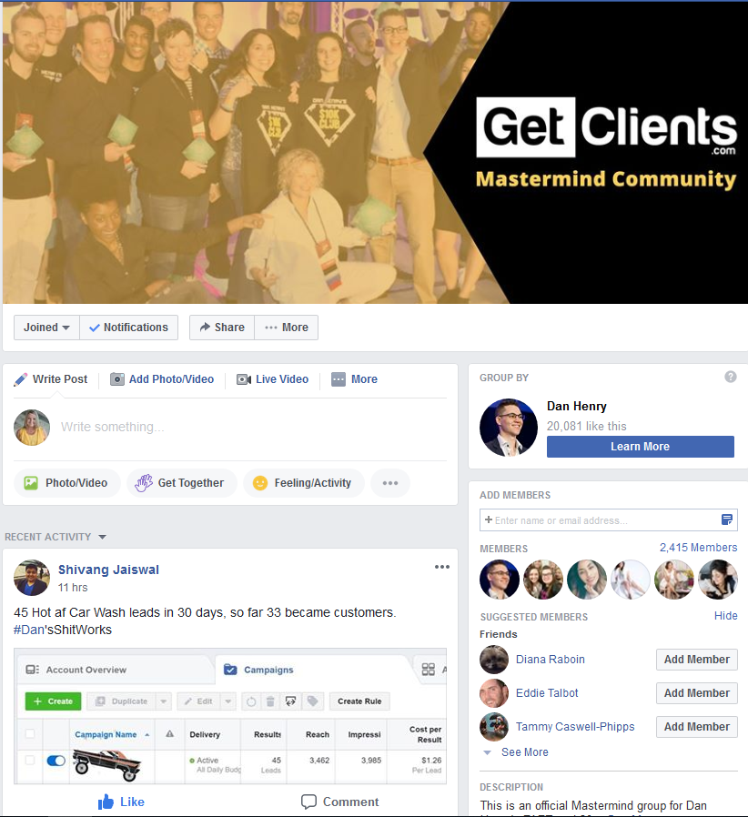
You'll See we have hundreds of active posts each and every day, and the group is by no means dead. In fact, it's one of the most active groups I've seen tied to an online product.
Inside of the program, we have a video that shows you how to get the most out of our private group and how to ask questions so that you get the best feedback and support possible. If you're still struggling, you can email support and we will hook you up with a student that we feel can help you in the group. We try to respond within 24 to 48 hours, excluding holidays.
Dan also frequently answers questions in the group and goes live to answer major questions and add ongoing value. He does this frequently and is 100% committed to your success.
Q10: "WHEN DOES THIS PROGRAM START AND WHAT HAPPENS IF I MISS A CLASS OR GO ON VACATION?"
The 30 Day Agency program is delivered through pre-recorded videos, PDF files and downloadable funnels. It is available 24/7/365.
It doesn't matter if you're on vacation or you decide to travel the world for eight months and then come back to your business. All of the content will be ready and waiting for you including any updated content that you get 100% free of charge.
You have lifetime access so you can never possibly fall behind. Once you sign up, you can get started immediately, right after you click the buy button and create your account. You'll have access within seconds. You can start tonight and begin taking action before the sun rises. The best time to start is, of course, right now.
Q11: "WHAT PRICE DO I CHARGE? HOW DO I GET REPEAT CLIENTS?"
The price you charge depends entirely on the amount of revenue you can realistically bring your client. We have an entire breakdown in the program on how to price your services. The average price our students charge is $1,500 while some charge upwards of $10,00 per client and some charge as low as $500.
To give you an example, if you are running ads for a mortgage broker that exclusively does million dollar homes, $10,000 per month is a drop in the bucket if you're securing him 10 loans per month.
On the other hand, we have some students who charge $500 per month for local restaurants. The ad needed for a restaurant is extremely simple and always works, and there is an unlimited supply of restaurants out there! Imagine if you had 50 restaurants all running the same ad, and all you had to do is just change a few words for each ad for the appropriate restaurant ... that's quite an income! We break all this down and show you exactly how to find a client that works for you and your lifestyle inside the program.
As far as getting more clients, the truth is, once you have a few the referrals come in whether you want them or not. None of our students that have a handful of clients have any problems getting more clients. The trick is to get those first few clients and this course covers that in more detail than you could possibly imagine.
We also show you how to scale if you're so ambitious that you want to get upwards of 50 or 100 clients, and several of our students do have huge agencies such as that.
Bottom line, this course will change your life as it has changed so many others.
Q12: "IS THERE A PAYMENT PLAN TO HELP SPLIT THE PAYMENTS UP AND MAKE IT MORE AFFORDABLE?"
Yes, the 30 Day Agency program can be purchased either with one payment of $997 or two payments of $597. You'll pay $597 today and $597 thirty days from now if you choose the payment plan. If you choose to pay $997 one time, you'll save an additional two hundred dollars in addition to the massive discount I'm giving you during this launch.
Please remember that landing a single client more than pays for this program. And that client will pay you each and every month, not just the first month. The program, community, and support you receive are identical whether you choose the payment plan or the one-time payment. Nothing changes other than the payment term.
Q13: "AM I TOO YOUNG OR TOO OLD FOR THIS?"
There is only two requirements that is needed to do this program: You must know how to use the internet and be 18 years old or older.
If you know how to navigate your social media profile such as Facebook, then you're good to go. Obviously, we don't recommend that children do this as we want them to enjoy their childhood. If you're 10 years old, please know this program is not for you.
However, if you're 16 years old and you are looking to become an entrepreneur, this program is perfect for you. In fact, one student in our group is from England and is sixteen years old and has active paying clients.
If you feel you are too old for this program, that is absolutely not true as long as you are not on your deathbed! If you have a Facebook account and you know how to use it, then knowing how to use Facebook ads is a skill that can be taught and will be taught well inside this program.
Q14: "WHAT IF I'M NOT READY NOW? CAN YOU HOLD MY SPOT FOR A FEW MONTHS?"
NO. This is a limited-time offer and it is 100% going away. When the countdown timer hits zero (which is happening very soon), this page will come offline, the free trainings will come offline, the enrollment page will come offline, and the massive discount I've offered during this promotion will also come offline.
If you would like to purchase this program for the full price of $5,000 you can do so simply by emailing support. If you see me at a live event, I usually sell this from the stage for $3,000 which you're more than welcome to purchase. However, if you want to get in for $997 then you'll need to enroll on this page right here and right now. There will be absolutely NO exceptions. And if you miss this offer even by a second, it will cost you $4,000 in savings.
If you're serious about becoming a success, making more money and changing your life and your family for the better, then the time is right here right now.
There will never be a perfect time, and believe me, if you're waiting for a perfect time you'll wake up one day in a retirement home wishing you lived life in the now and not tomorrow because before you know it there will be no tomorrow.
If you want to be a failure, then embrace procrastination. If you want to be a success, then embrace action. The time to take action is now.
Q15: "WILL THIS WORK IN MY COUNTRY?"
We have thousands of students from all over the world--the United States, Canada, Australia, New Zealand, Europe, South America, and Asia. This program is not only proven to work worldwide, but there is no reason you cannot take on clients in any country you choose.
Here's a recent example of one of our students from Singapore that did very well...
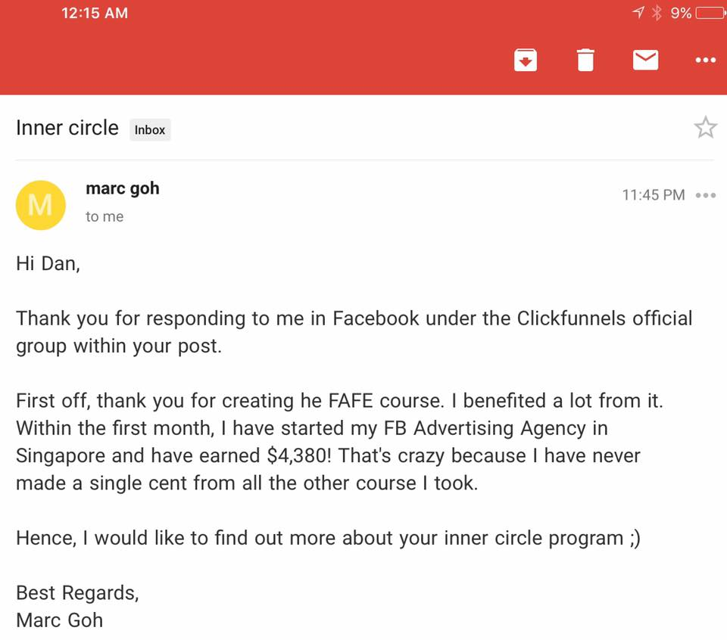
If Marcus from Singapore can do it, YOU can do it!
Q16: "CAN I BUY ONLY A PORTION OF THE PROGRAM BECAUSE I ONLY NEED HELP WITH ______?"
No. This is a complete program that's designed to get you from point A to point B. There's no splitting it up. If you were to purchase a home, you wouldn't ask for a discount if you didn't intend to use the garage. This is a systematic approach to success and you need all parts of it to become successful.
You may think that you are already good at one portion of this process that is covered in the course, but you'll quickly find out that the students that took the longest to find success were the ones that thought the same.
I have not only designed this program to show you new ways of becoming successful but also to show you how to become better at the ways you may already know. Remember, the program is not just based on my experience, but it's the experience of 2,400 other members.
I recently updated the program based off of what's working for thousands of agencies, not just what worked in my agency. The program will never be split up or offered by module. You can offer me as much money as you want for a certain lesson or module and the answer will always be no.
You must be totally and completely committed to this program if you want to become successful.
Q17: "DO I GET ONE-ON-ONE ACCESS TO DAN HENRY PERSONALLY?"
The 30 Day Agency program is an online course created by me personally, Dan Henry. All the information is my best stuff and I don't hold anything back. There's no difference between me teaching you what I know in the lessons, and what I would tell you personally if we were discussing the same tactic or subject.
Not to mention that out of all of the people that have become successful, none of them have had one-on-one access to me. In fact, one of the students that hit the 50K Club for reaching $50,000 per month in revenue, I did not even know his name until he reached out to me to tell me of his success.
This program was designed to get you results without having to talk to me personally. I put a lot of hard work and years of experience into making that a reality. As far as getting feedback from me, I regularly comment and post in the group and answer questions. I cannot guarantee that I will answer every question but I do answer questions frequently.
I also broadcast live inside our group from time to time and address the common questions I've seen popping up. So to answer your question, no, you do not get any one-on-one access or personal time with me included with this program. My one-on-one consulting fee is $30,000 and it is my CMO program where I become your Chief Marketing Officer. If you think that this is just a made up number, it's not. I have dozens of people in my program that pay $30,000 every year to get on one-on-one access to me.
This program is an entire, straight to the point, step-by-step program delivered to you in the exact same way that I would deliver it to you if we were speaking on-on-one. It's literally like me sitting down with you and telling you exactly what to do. All you have to do is listen and implement.
It will cost you $30,000 for me to sit down and teach this to you in person, but you get it all for only $997 inside this program. You don't have to leave your home. You don't have to jump on a plane and come out and meet me. And you can do it whenever and wherever you'd like.
Q18: "DAN HENRY STARTED HIS AGENCY BY HIMSELF, WHY DO I NEED TO BUY HIS PROGRAM? CAN'T I DO IT ALONE TOO?"
Investing in 30 Day Agency is like getting a personal one-on-one helicopter ride to the top of the mountain. You don't have to climb it yourself. I must remind you that it took me seven years and multiple businesses to learn what I know. It also took nearly a decade of studying advertising to learn what I know. That all culminated in a moment of complete clarity for me and allowed me to develop a very simple step-by-step process to not only becoming successful, but becoming successful even if you are a complete beginner!
So, if you want to go through the same struggles, blood, sweat and tears I had to go through, by all means, you can do that. But if you want me to give you the cheat codes, then this is the program for you.
We've had multiple students try to go out on their own and failed for several months, then finally bought the program and had immediate success. That's because this program has been refined and developed over the past three years. Every few months, I look at my existing batch of students and I see where they're struggling and then I revise the course to help them just a little bit more in that one area.
The results? To date, we have cut our questions and support tickets and failures by 90 percent. That's because the content has been specifically tailored to get results and overcome any struggles you may have, no matter what experience you have or where you are geographically or from what walk of life you come from.
This is an MBA in advertising success and generating more income. The bottom line is this...
You need help and this program WILL get you where you want to be.
Q19: "I AM PRETTY GOOD AT FACEBOOK ADS. WILL I LEARN ANYTHING NEW?"
If you have already taken another Facebook ad courses, or run ads yourself, it's highly likely that you are familiar with things like . . .
Lead magnets, targeting, landing pages, etc.
I teach all these things as well. The difference is, I teach you how to do them extremely well. Let's be honest here, if you knew how to do them well, you wouldn't even be on this page.
I teach you how to make sales with ads, not just get a lead or something else that means nothing without an actual ROI (Like Facebook Page Likes or comments)
The course really focuses on generating sales for clients, and all the things that happen before and after the ad that really matter. An ad that converts, is one that converts in terms of ROI.
My student Jessie Kost had been running Facebook Ads for well over a year. She was used to getting webinar registrations for $5 or more. After enrolling, she now gets them for around 70 cents!
Q20: "HOW LONG UNTIL I START MAKING SOME MONEY?"
That depends on you, I have students who go through the course and within days get results.
This totally depends on you. Something people make money within a week, some take longer.
I'll give you 2 quick examples . . .
Cory Ellerbroek is a chiropractor from Texas. Cory bought my course the same week he was planning on closing down his practice because he just didn't have enough patients.
He put my enrollment fee on his last credit card. A week later, he got 12 NEW patients.
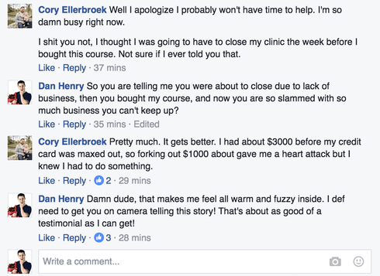
Today, he is thinking of expanding.
My first interview with him talking about his success is below . . .
But let's take a look at another student, JR.
JR didn't make a dime for 3 months after enrolling.
Mainly because he kept skimming the course material, but after he revisited the course and dove in head first, he became my first student to hit the $10k Club.
That means he is now making over $10,000 per month in personal income with his Facebook Ads agency.
So as you can see, some simply take longer than others.
But either way, if you put in the work, it can pay off.
Q21: "WHAT IF I DON’T HAVE AN EMAIL LIST? AND WHAT IF I DON’T HAVE A WEBSITE?"
The good news is you don't need an email list or website to start running Facebook Ads for yourself or others.
You will need landing page software such as Click Funnels, but they have a two week free trial and I show you how to get a client right away.
You don't need an email list, and neither does your client if you're running an agency.
You could begin building your list with the techniques I teach in the course, but if you're running ads for a local businesses, it's not required.
You also don't need a website for your agency. You can easily throw up a one page professional bio in Click Funnels, but most of my students don't have a need for it.
Q22: "DO WE HAVE LIFETIME ACCESS TO THE COURSE? WHAT ABOUT UPDATES?"
Yes you do! You have lifetime access to the course and all available updates to the course.
I am always updating the course with new content and once you are in you get all future updates.

